Northern Outremer
Principality of Antioch
Established
Founder
Religious Leadership
Population Demographic

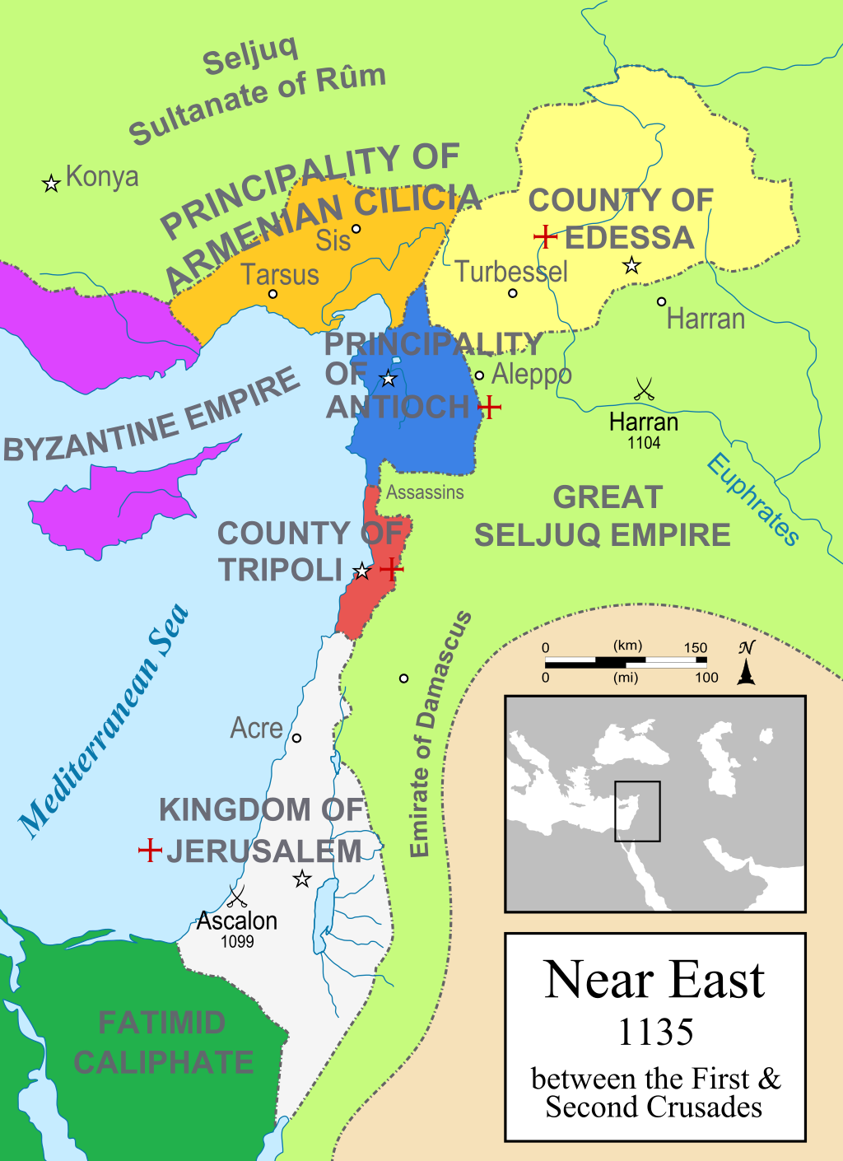

County of Edessa
Established
Founder
Religious Leadership
Population Demographic

County of Tripoli
Established
Founder
Religious Leadership
Population Demographic

