Champions of the North
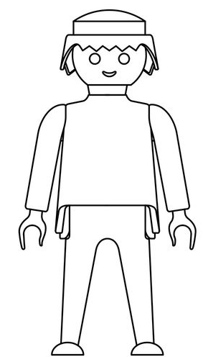

Decide who you think the top three rulers were from the north of Outremer. Design what you think they should look like and around them write down their achievements.

