The Career of Il-Ghazi

Il-Ghazi was a Turkish warlord who inherited the governorship of Jerusalem from his father in 1091. He ruled the city with his brother, Sokmen, until they were both driven out by the Fatimid vizier, al-Afdal, in 1098, shortly before the city’s fall to the crusading army.

When his brother died, Il-Ghazi claimed the family’s territory, but had to take Mardin by force from his nephew, Ibrahim in 1108. From this point on, he acted in his own interests, sometimes attacking Christians, sometimes other Muslims. For example, he attempted a siege on Edessa in 1110, but defeated al-Bursuqi of Mosul in 1114, with the help of his nephew, Balak. He was briefly captured by a rival Muslim governor, Khir-Khan, and even worked together with the Franks and other Muslims to repel the Seljuk Bursuk.

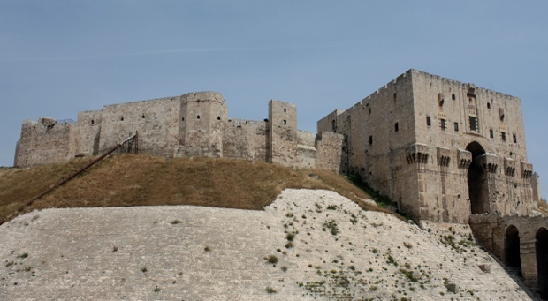
Il-Ghazi gained Aleppo in 1117. He then became involved in the affairs of Roger of Antioch, when the latter captured the fortress of Azaz. Roger now had a number of fortresses near Aleppo and the city called for aid from Il-Ghazi, who summoned an army, which one source claims exceeded 40,000 men. Tughtekin of Damascus also began to summon forces. In command of Aleppo’s soldiers was a qadi (Islamic judge) named Ibn al-Khashshab, known for his preaching of jihad. Meanwhile, Roger brought his army, full of reliable Armenian soldiers, to Artah, having sent a request for help from Baldwin II. Some of his advisors recommended he remain in the city, others that he advance. As it turned out, both Roger and Il-Ghazi declined to wait.
The citadel at Aleppo

On June 28, the battle began after the Muslim forces encircled Roger’s Antiochene force, which Il-Ghazi achieved by taking his army across terrain the Christian army thought was impassable. Roger’s army did not have time to organise itself before it realised what was happening. His Turcopoles (men of mixed Turkish and Greek stock) took flight first but ended up running into Roger’s own battle line. Meanwhile, wind kicked up dust causing more confusion. Roger was killed by a sword smashed from below into his nose and up through to the brain. Antioch’s army was wiped out and at least 500 prisoners were slaughtered by Il-Ghazi. Many of Antioch’s nobles disappear from record at this time, presumably killed. Roger was the first (though not the last) Latin ruler to fall in battle in the East and the defeat shocked the Christians of Outremer.

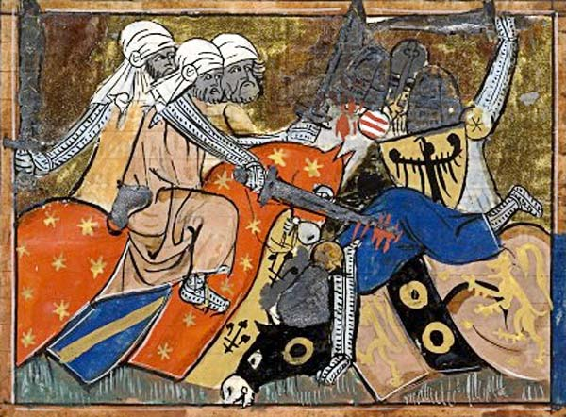
Thomas Asbridge describes the battle as follows:
‘Just before first light on 28 June 1119 Prince Roger of Antioch gathered his army in readiness for battle…[He] could have waited for reinforcements from his Latin neighbours, including Baldwin [II of Jerusalem]….Unbeknownst to the prince, however, on the preceding evening scouts had revealed the Christians position to Il-ghazi [the Turkish commander].
Depiction of a scene from the Battle of the Field of Blood
…as the battle was joined along the line, a contingent of Turcopoles [Greek/Turkish Christian mercenaries] stationed on the left wing buckled and their rout splintered the Latin formation. Outnumbered and encircled, the Antiochenes were gradually overrun.
…One Latin eyewitness described how, “fighting energetically…[Prince Roger] was struck by a [Muslim] sword through the middle of his brain, and settling his debt with death [beneath] the Holy Cross he gave up his body to the earth and his soul to heaven.”
…A Muslim living in Damascus described it as “one of [Islam’s] finest victories”, noting that, strewn across the battleground, the enemy’s slain horses resembled hedgehogs “because of the quantity of arrows sticking into them.” So terrible was this defeat, so great the number of Christian dead, that the Antiochenes thereafter dubbed the site ‘Ager Sanguinis’, the Field of Blood.’
[T. Asbridge, The Crusades, pp. 163-165]

After the Battle of the Field of Blood, Antioch lay open to conquest at the hands of Il-Ghazi. Fortunately for the Franks, Il-Ghazi was preoccupied taking back the fortress of Artah. Furthermore, his army lacked direction owing to his prolonged bouts of drunkenness. Baldwin II hurried north, along with Pons of Tripoli and his forces, and bringing the True Cross. Baldwin was excepted as prince of Antioch until the rightful heir, Bohemund II, came of age. He gathered all the forces he could, including Edessene troops, and met Il-Ghazi’s forces, now reinforced by Toghtekin’s Damascenes and local Bedouin tribesmen, near Zardana. Thus followed the Battle of Hab in 1120. It was not a majorly decisive one but proved enough to force the Muslim army to withdraw. Baldwin had done enough to keep Antioch intact but the nobility were decimated.

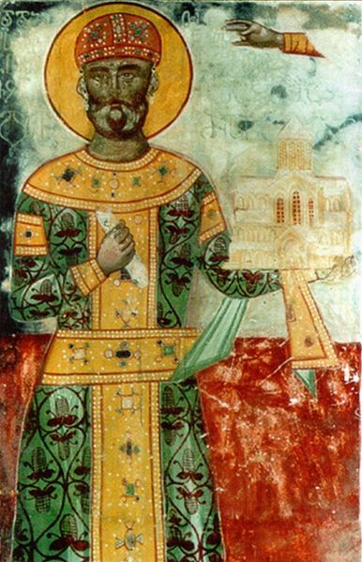
Il-Ghazi never again reached the heights of 1119. But his military career was not quite over. In 1120 he pillaged Edessan territory, before advancing into the Kingdom of Georgia in 1121. However, he was unfortunate enough to come up against King David IV of Georgia, who had spent a great deal of energy reforming the Georgian army to combat Seljuk supremacy. David won a crushing victory at the Battle of Didgori (regarded by Georgians as their greatest military victory ever). Perhaps as many as 400,000 Seljuks were killed, but Il-Ghazi escaped, although he was wounded. In a strange turn of events, around 100 Frankish knights happened to be fighting for David’s army – whether they were mercenaries or sent from Outremer is not known. It was these knights who broke through Il-Ghazi’s battle line, leading to a nasty head wound for the Turkish general.
Fresco of David IV

In 1122, Il-Ghazi, along with his nephew, Balak captured Joscelin I of Edessa. Soon, Baldwin II would join Joscelin in the same jail cell, but Il-Ghazi died before this came to pass. Balak took over Aleppo, whilst Il-Ghazi’s sons shared Mardin.

Task: Select an event from Il-Ghazi’s career that might be associated with the following images. You can only use an event once:






