The Iliad – Book 1

Line 1
Annotate this line with any points of interest during our class discussion:

Sing, goddess, of the wrath of Achilles, Peleus’ son.

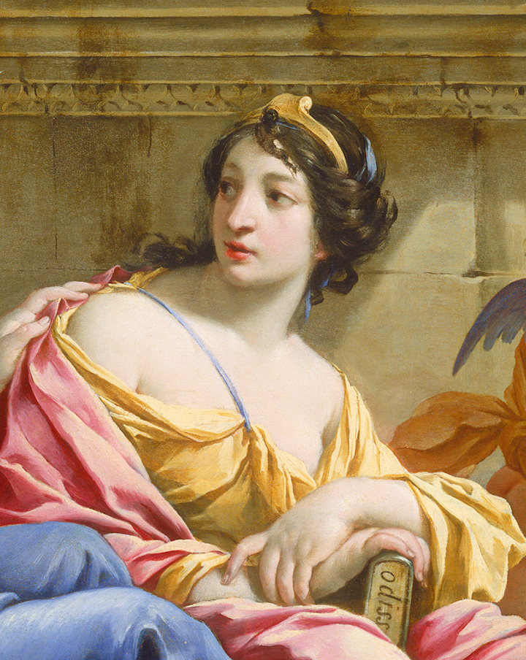

The Muse, Calliope, by Simon Vouet.

Read lines 1-52
What do the opening lines suggest about the role the following characters played in the tragedy of the Iliad? What impression do you have of each?

Character | Role in the tragedy: | First impression:
Zeus
Apollo
Achilles
Agamemnon
Chryses

List all the epithets you have seen so far, alongside the characters:

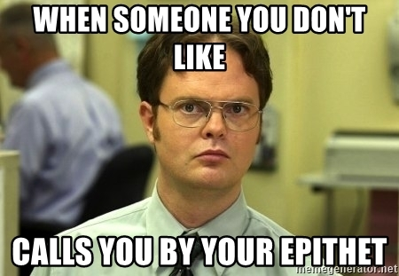

Read lines 53-243
Why do you think that it is Achilles who calls together the Achaeans?

What is Calchas worried about? Who does he hope will protect him?

Summarise the arguments Agamemnon and Achilles make against one another:
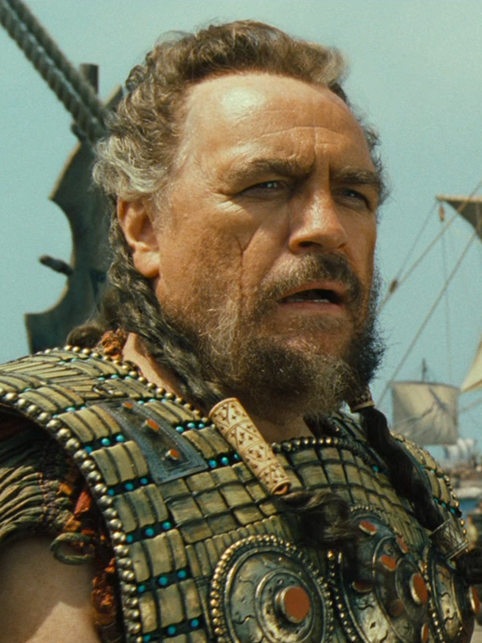

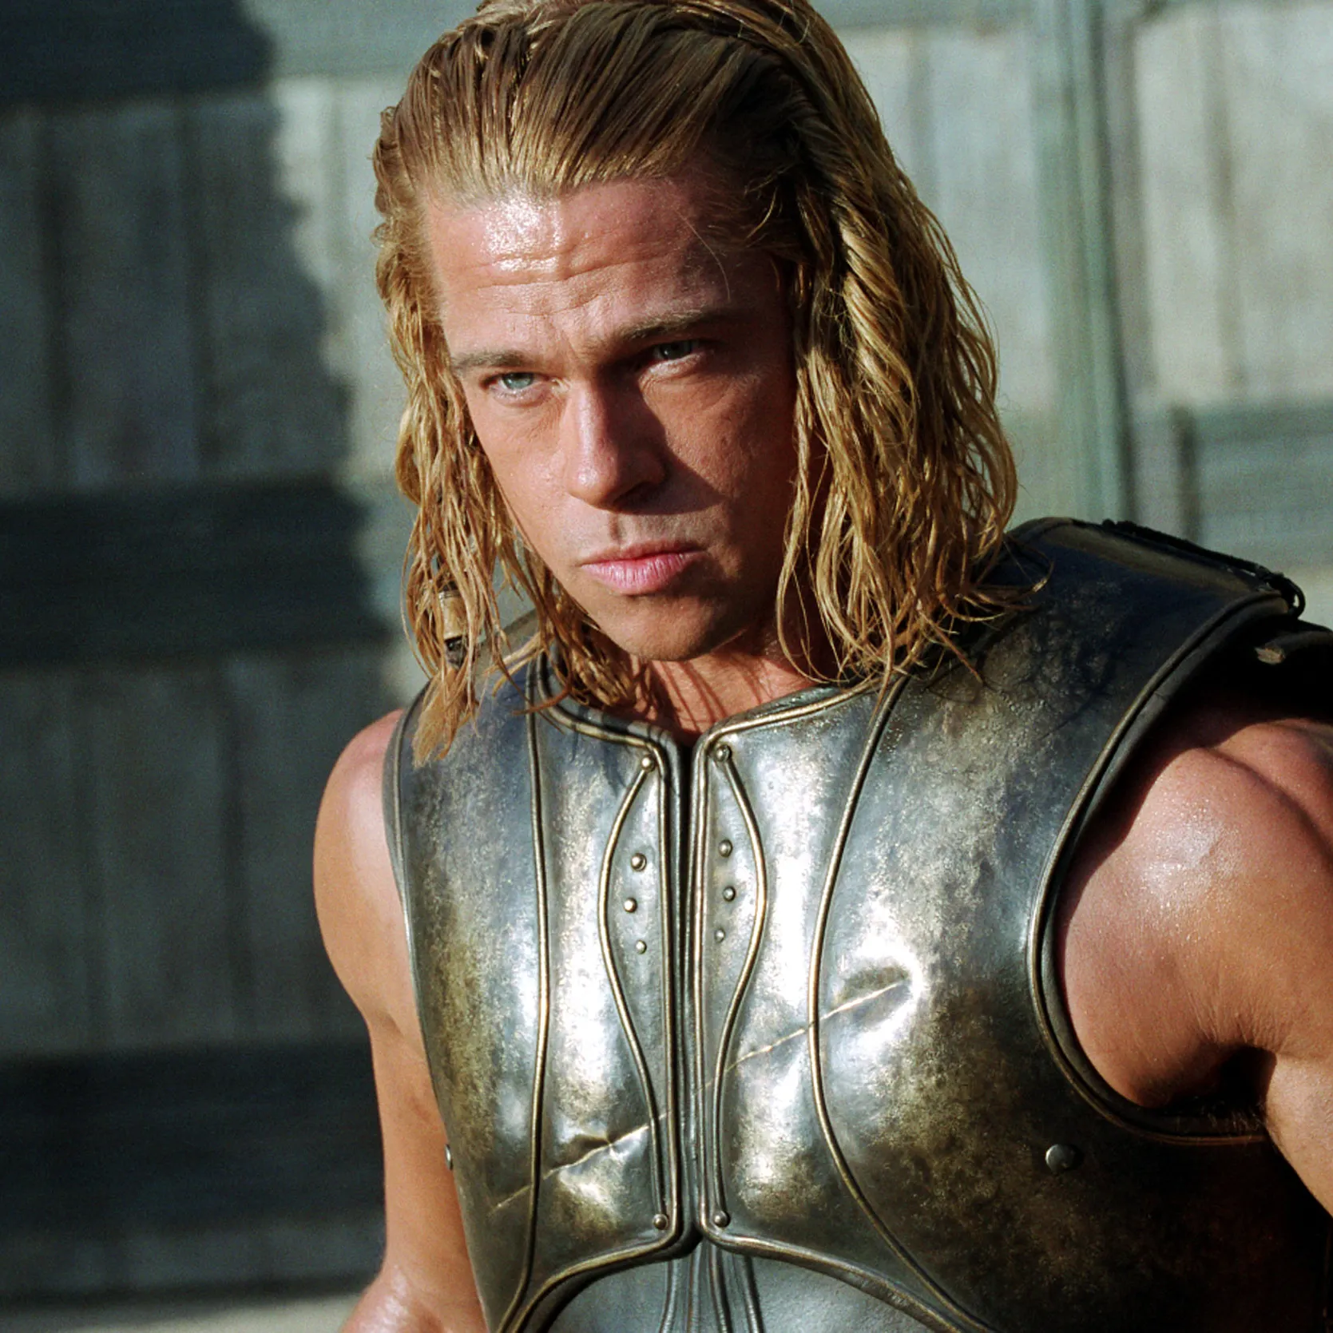

Select your four favourite insults from the argument and make them into memes of your choice:
Stick Awesome Meme Here | Stick Awesome Meme Here
Stick Awesome Meme Here | Stick Awesome Meme Here

You can find a good meme generator here:

Why do you think Hera sends Athena, rather than going herself? You can suggest more than one reason.

Read lines 244-348
Why does Nestor bring up the centauromachy (the famous fight between the Lapiths and the centaurs)?

What reason does Nestor give for the following advice?
Advice | Reason
Agamemnon should not steal Briseis from Achilles.
Achilles should not attempt to fight Agamemnon

To what extent to do you think that Agamemnon and Achilles address Nestor’s points?

Are you surprised by Achilles’ response? Explain you answer.

Are you surprised that Nestor is ignored? Explain your answer.

Which of the following statements do you think best describe Agamemnon’s reason for sending heralds to Achilles’ tent?
‘He was scared to have to fight Achilles.’

‘Using servants would demonstrate his royal status.’

‘He knew Achilles would not kill innocent Achaeans.’

Be prepared to defend your choice.
Read lines 349-427
What important part of Achilles’ retelling of the story do we learn? Annotate around it with the details he supplies.

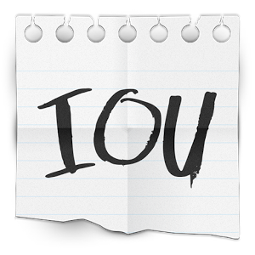
Why does Zeus owe Thetis a favour?

Read lines 428-487
Imagine this passage is all we have left of ancient Greek writing. Compose a short guide to Greek religion and piety from this:
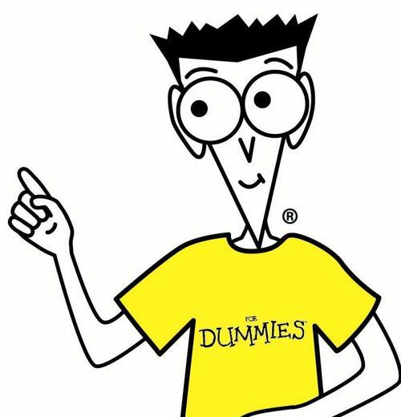
Greek Religion


Read lines 488-611
What do we learn about the relationship of these gods?


Thetis

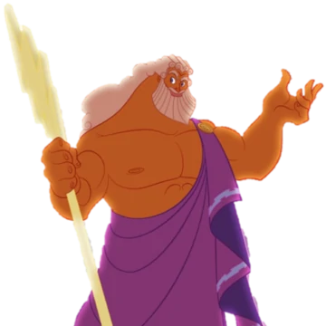

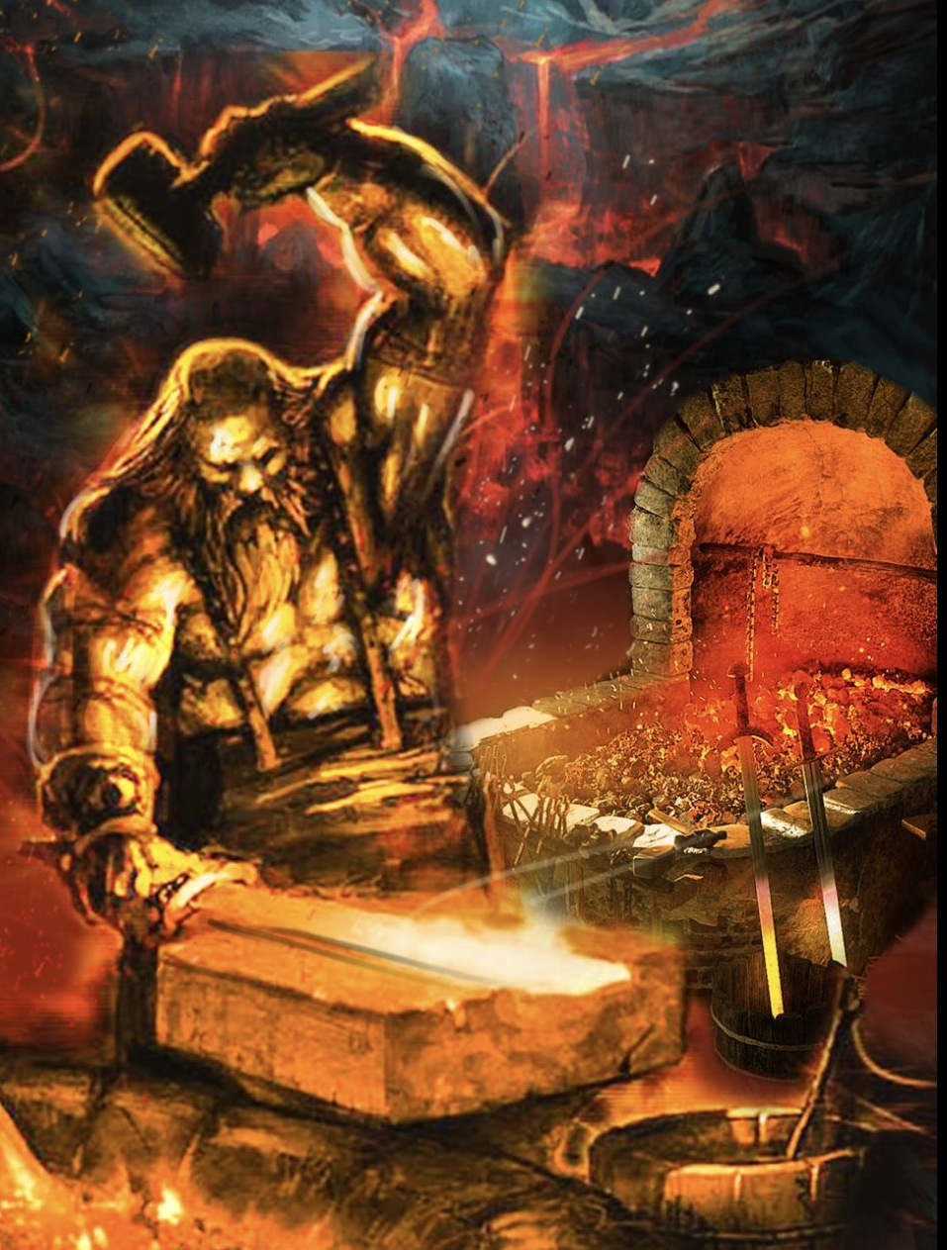
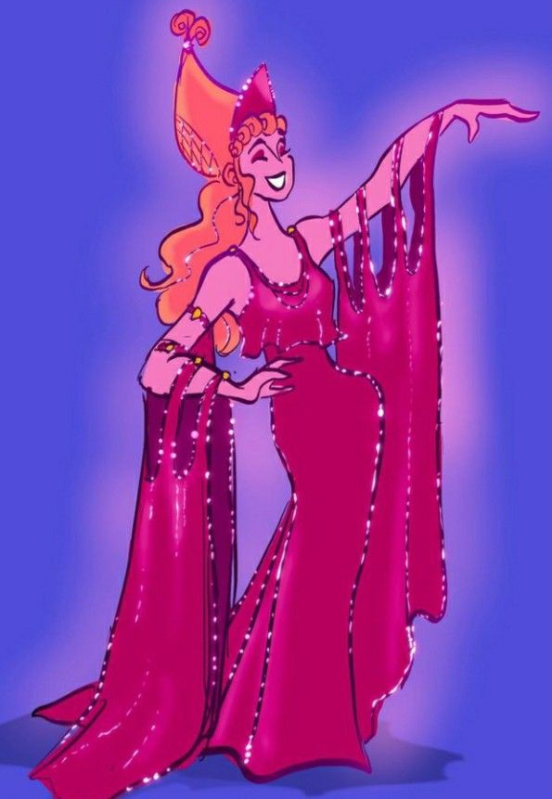
Zeus

Hephaestus
Hera

List all the ways that the gods behave in a similar way to mortals in this passage:

Appendix: ate, Goddess of Folly

Context
You probably won’t be surprised to learn that this goddess is a sister of Eris, whose trick with the golden apple started the whole mess the Achaeans and Trojans find themselves in.

The goddess has a bad track record; it was she who persuaded Zeus to swear that a great mortal descended from him would be born on the very day of the oath (Zeus hoped it would be Heracles but it turned out to be Eurystheus). Zeus flung Ate by the hair out of Olympus, but it is said that rather than wandering on the earth, she walks on men’s heads, causing mischief.

When Achilles relates the events of Book 1 to his mother, Thetis, he says:
Make wide-ruling Agamemnon son of Atreus realise the delusion (ate) he is under…

You can see the Ate is lurking in the background of the Iliad. But what Achilles does not recognise is that he will become the greatest victim of blind folly. By the time you have finished studying the Iliad, you should be able to return to the table below and demonstrate how many other characters also succumb to her:
Character | Folly in the Iliad
Agamemnon
Achilles
Patroclus
Hector
Paris
Helen

