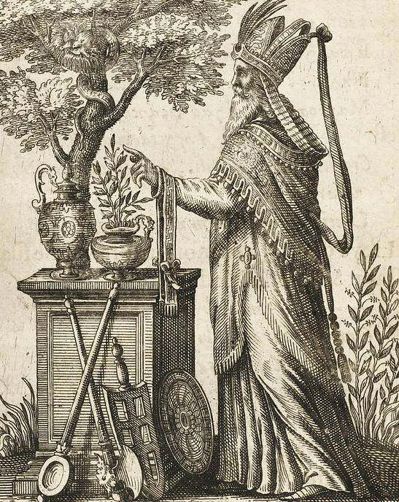
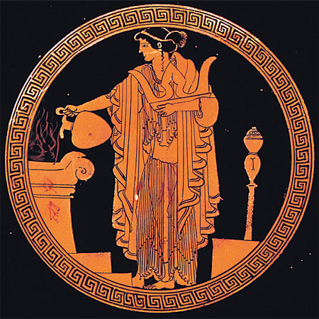

Mantis

Hiereus/Hiereia


A Greek priest was called a ‘hiereus’ (pl. ‘hiereis) and a priestess was called a ‘hiereia’ (pl. ‘hiereiai’) (meaning ‘one who sacrifices to the gods’). Gods usually had a male priest and goddesses had a female priestess, but there were notable exceptions. At Delphi, Apollo had both.
Unlike modern priests, Greek priests had no training and might only serve for a single year or even festival (some were for life though). It was one way a citizen could show they were valuable to their city (‘polis’). They did not hold special services or spread the word about their god but simply oversaw the correct rituals when needed and took care of the temple.
A priest’s importance depended on where their temple was located, and which deity was honoured. Some brought special honours, such as the priest of Dionysus at Athens, who sat on a throne during their drama festival: The City Dionysia. At Olympia, the only woman permitted to watch the Olympic games was the priestess of Demeter.
The Greek ‘mantis’ (pl. ‘manteis’) was a soothsayer who read the entrails of animals and bird signs to predict the future. This was not an official role; anyone could claim to be a soothsayer but those who had success in their predications would earn a reputation for themselves and possible make a career out of it.
They could look at the entrails of an animal sacrificed and inspect them for blemishes (a bad omen). They also watched the flight of birds (called ‘augury’). Some manteis accompanied armies and read the omens before battle was joined.

Mantis

Hiereus/Hiereia

A Greek priest was called a ‘hiereus’ (pl. ‘hiereis) and a priestess was called a ‘hiereia’ (pl. ‘hiereiai’) (meaning ‘one who sacrifices to the gods’). Gods usually had a male priest and goddesses had a female priestess, but there were notable exceptions. At Delphi, Apollo had both.
Unlike modern priests, Greek priests had no training and might only serve for a single year or even festival (some were for life though). It was one way a citizen could show they were valuable to their city (‘polis’). They did not hold special services or spread the word about their god but simply oversaw the correct rituals when needed and took care of the temple.
A priest’s importance depended on where their temple was located, and which deity was honoured. Some brought special honours, such as the priest of Dionysus at Athens, who sat on a throne during their drama festival: The City Dionysia. At Olympia, the only woman permitted to watch the Olympic games was the priestess of Demeter.
The Greek ‘mantis’ (pl. ‘manteis’) was a soothsayer who read the entrails of animals and bird signs to predict the future. This was not an official role; anyone could claim to be a soothsayer but those who had success in their predications would earn a reputation for themselves and possible make a career out of it.
They could look at the entrails of an animal sacrificed and inspect them for blemishes (a bad omen). They also watched the flight of birds (called ‘augury’). Some manteis accompanied armies and read the omens before battle was joined.

