The Family of Augustus

Augustus was born into the famous Julian family via his mother, Atia, who was the niece of Julius Caesar. He was named at birth Gaius Octavius after his father, who was from an equestrian family and so Augustus was unlikely to rise very high in Roman politics. That was until the shocking revelation that Julius Caesar had adopted him as his heir in his will, which was opened and read when Caesar was assassinated. He changed his name to match his new legal father, calling himself Gaius Julius Caesar Octavianus. The name ‘Augustus’ would be granted to him later by the senate.
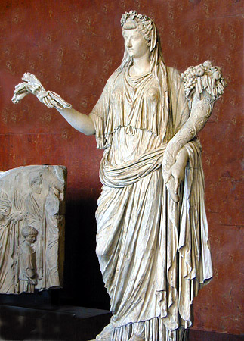
Marriages
Augustus’ first marriage was to Scribonia. Little is known about her family, but her father may have been a senator. She also married two consuls prior to her marriage to Augustus. This produced Augustus’ only child, his daughter Julia (the Elder). The marriage cannot have been a happy one (purely political), since Augustus divorced Scribonia on the day of Julia’s birth.

This is sharply contrasted to his marriage to Livia, who came from the Claudian family (leading to the Julio-Claudian dynasty of emperors). Livia already had two sons, Tiberius and Drusus, both of whom served as useful generals under Augustus’ rule. Livia herself served as a model wife. Here the biographer Suetonius explains the importance of the domestic role played by her and Augustus’ other female relatives:
Statue of Livia in the guise of Ops with a cornucopia.

They say that he always slept on a low and plainly furnished bed. Except on special occasions he wore common clothes for the house,⁠ made by his sister, wife, daughter or granddaughters.
[Life of Augustus, 73]
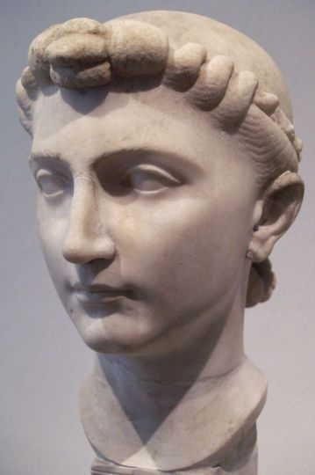
Livia herself avoided wearing anything too elaborate but this should not fool us; she was extremely powerful with her own estates and clients to manage. When Augustus died, she was granted her own matching title: Augusta.

Julia the Elder

Augustus’ only child was remarkable. All three of her marriages were important. She married her cousin, Marcellus, who was also the nephew to Augustus. It seems that Augustus had eyed him up as his heir and wanted to bring him even closer. Marcellus himself was the son of Augustus’ sister, Octavia. Along with Tiberius, Marcellus served as a general under Augustus in Spain. Tragically, he died in 23 BC and he was the first to have his ashes placed in Augustus Mausoleum in the Campus Martias.
Bust of Julia the Elder
A reconstruction of Augustus’ Mausoleum, which was set up in the Campus Martias.

Next, Julia married Agrippa, Augustus’ childhood friend and the general who had helped Augustus defeat Mark Antony and Cleopatra at the Battle of Actium in 31 BC. The marriage produced five grandchildren for Augustus (see below) despite Agrippa being 25 years older than Julia! Augustus clearly intended for Agrippa to be his heir after the death of Marcellus (the two may have been rivals whilst Marcellus lived) but he too died well before Augustus, passing away in 12 BC

During this second marriage, Julia was already beginning to attract allegations of sexual affairs. These only increased during her third marriage to Tiberius. In 2 BC Augustus wrote on behalf of Tiberius, issuing her a divorce. She was exiled to an island instead of being executed and her mother, Scribonia went with her. Augustus had passed laws about sexual conduct and he felt that he could not appear to be restoring Rome’s morality if he let his own daughter’s conduct slide.
A 19th Century painting of Julia the Elder in exile
Grandchildren
Augustus had two granddaughters: Julia the Younger and Agrippina. Julia was exiled on similar grounds to her mother in 8 AD, after an affair with a senator. Agrippina would later go on to marry Germanicus, another Julio-Claudian, and through this marriage produced the third emperor of Rome: Caligula.

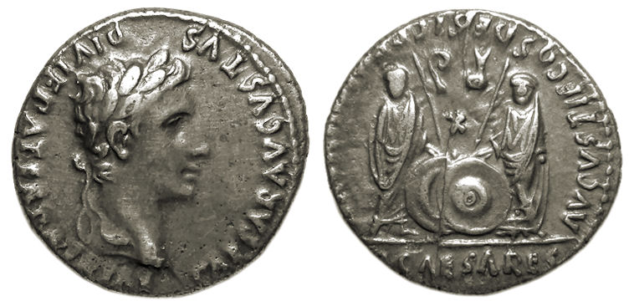
Augustus named his two eldest grandson, Gaius and Lucius, as his heirs. Augustus produced coins with them on, indicating his dynastic plans. Gaius served as a general in the East where he managed a peace treaty with the Parthians. He held the consulship in 1 AD. His brother, Lucius, who was following on a similar career path, died in the following year. Gaius was dead by 4 AD and Augustus could not seem to find an heir that would outlive him!

Augustus’ final grandson, Agrippa Postumus was adopted out of desperation, alongside the more dependable general, Augsutus’ stepson, Tiberius (his brother Drusus had already died in 9 BC). In AD 6, whilst Tiberius was commanding the army on the northern frontier, Agrippa Postumus was exiled for poor conduct (the precise details are unclear). When Augustus died in 14 AD, the only possible heir was Tiberius. Rumours circulated that Augustus had visited Agrippa Postumus just before he died, but Agrippa Postumus was swiftly executed to eliminate any rival to Tiberius, who became the second emperor of Rome.
An Augustan coin featuring Gaius and Lucius naming them as ‘Princes of the Youth’

