Periphetes
Theseus was travelling through Epidaurus. Here lurked a bandit named Periphetes, son of Hephaestus and a local woman, Anticleia. Like his father, Periphetes was lame in one leg. He also had a single eye like a cyclops. But he was a ferocious villain, who would jump out and beat travellers to death with a bronze club. Fortunately, Theseus spotted the bandit before he could pounce and wrestled with him, before beating him to death with his own club. This weapon Theseus claimed as his own for future labours and he is often depicted with it (sometimes it appears as a stout traveller’s staff).
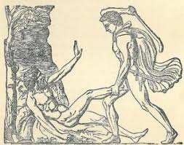

Question
How many parallels can you already find in this adventure and the labours of Heracles?

Sinis
At the Isthmus of Corinth Theseus comes across a second bandit named Sinis, the pine-bender. According to Pseudo-Apollodorus, this villain would force passers-by to bend pine trees and then allow them to be flung into the air when the tree was released. However, Diodorus Siculus claims that the methodology was more gruesome: he would tie victims to two bent pine trees and when the trees were released they would tear the person in two. Theseus defeated Sinis at his own game. In one account, he persuaded Sinis to help him bend a pine and then used it to fling the bandit in the air, whilst an alternative tale has him tie Sinis up and rip him into two with the pine.
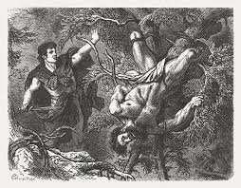
However, Sinis had a beautiful daughter named Perigune. When her father had been killed, she fled but Theseus pursued her. She hid in some shrubs until Theseus called to her that he would treat her honourably. She bore him a son named Melanippus before marrying another local prince.

Question
How many examples can you think of involving a hero opposed to someone but in love with their daughter?

Crommyonian Sow
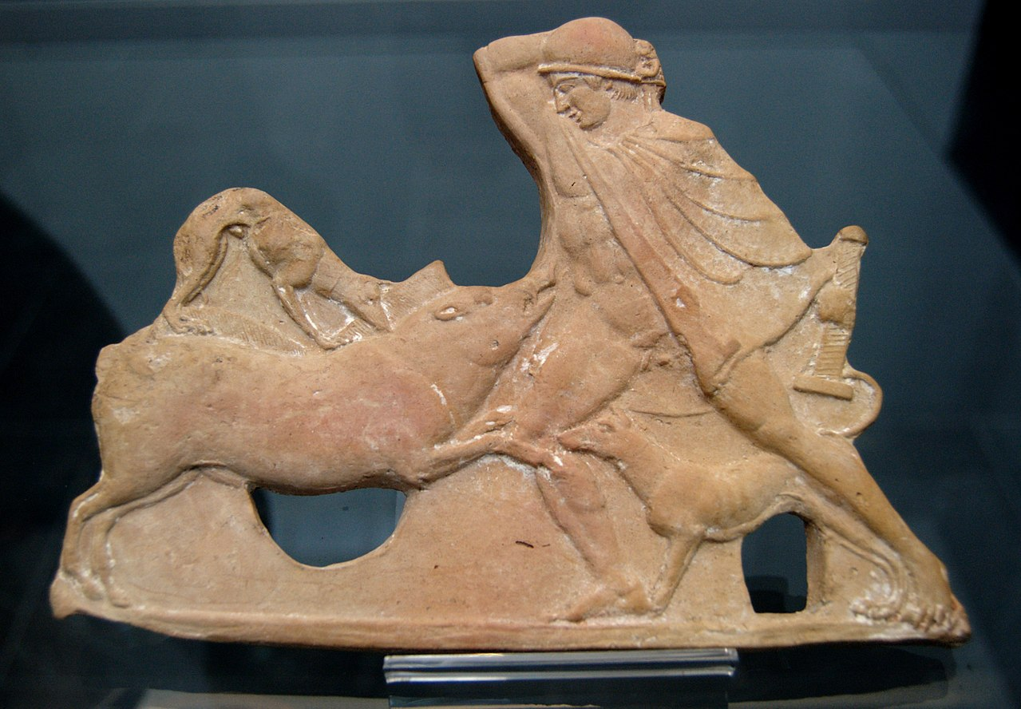
According to Plutarch, Theseus sought out a monster for his next labour, thinking that ‘brave men ought to attack villainous men only in self-defence’ but that he ‘should seek occasion to risk his life in battle with nobler beasts.’ And so, he sought out a ferocious wild pig which had been terrorising Crommyon and killing the inhabitants there. This sow was said to be the offspring of the Typhon, a snake-like monster, and Echidna, who was also part snake. In fact, this couple had produced many of the monsters in mythology, such as the Lernaean Hydra, Cerberus, Orthus (Geryon’s two-headed dog), and the Chimera. Theseus slew the sow, but in an unusual alternate version provided by Plutarch, the ‘sow’ was simply the nickname for a female thief in the region, known for her murderous and uncivilised nature.
The Greek geographer Strabo claims that this sow was the mother of the Calydonian Boar. Later, Theseus, along with his dear friend Pirithous, went on this hunt, the victory of which was shared between the huntress Atalanta and Meleager of Calydon.

Question
Plutarch suggests that this labour differed from Theseus’ fight with the bandits on his journey, but then suggests this ‘sow’ might have been one. Which do you think fits best in this tale, an interlude against a monster or a continuation of fighting bandits?

Sciron
According to some, Sciron was the son of Pelops, founder of the Olympic games and grandfather of Agamemnon and Menelaus. By the time Theseus encountered him, he was an elderly man who used to sit alongside a cliff by the Isthmus of Corinth. Any travellers happening to pass by this narrow path he would compel to wash his feet and, whilst they did so, would kick them off the cliff. Waiting below in the water was a giant turtle, which consumed all who went by. In typical fashion, Theseus killed him in his own preferred manner of killing others and sent him hurtling down the cliff to his doom.

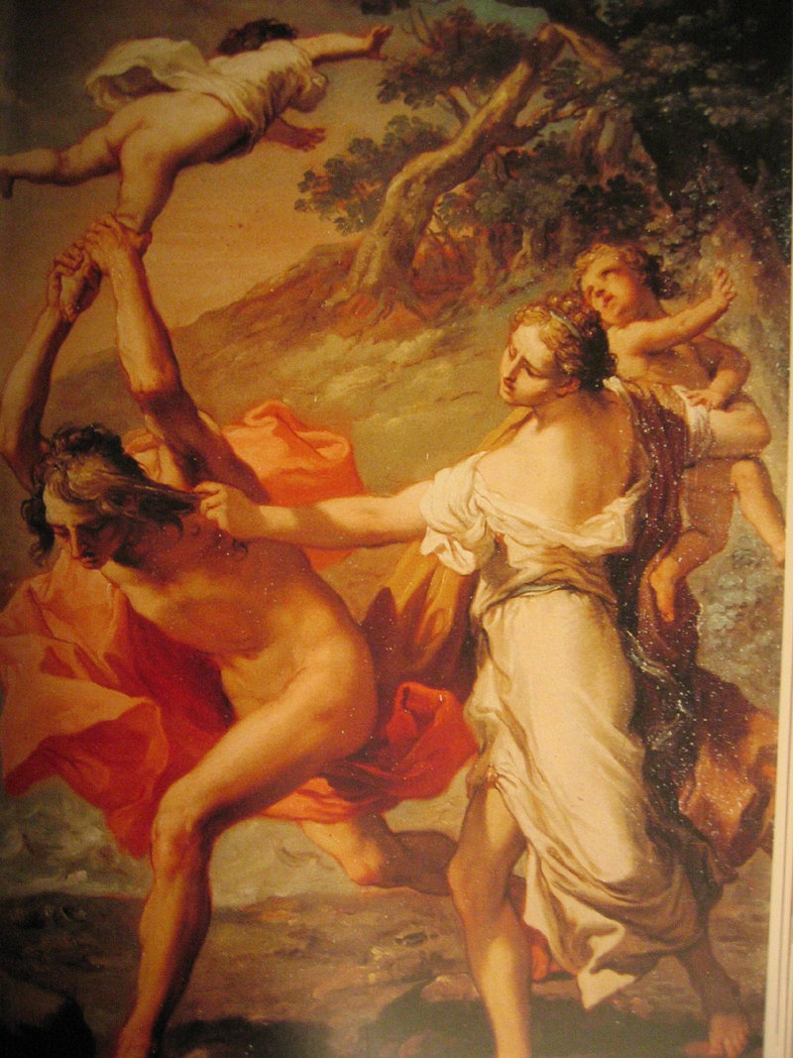
The Greek historian Pausanias connects this site to another famous story in mythology: the transformation of Ino. She had been raising Dionysus, her sister Semele’s son, which incurred the wrath of Hera (jealous because Zeus was the father). And so Hera drove Ino’s husband, Athamas, insane and the man slew his son Learchus. To escape her husband’s rage, Ino threw herself and her son, Melicertes, into the sea and the two were transformed into divine beings (Odysseus later encounters Ino out at sea). Pausanias claims that the rock from which she threw herself became cursed and was the very spot Sciron chose to terrorise travellers.

Questions
The giant turtle could easily have been omitted from the story, but do you think it was worth including by the storytellers?
Why is it appropriate for such a dark story to centre around one of Pelops’ sons?

Cercyon
Theseus’ next stop was Eleusis, where King Cercyon ruled. He was in the habit of wrestling all those who tried to pass by and by this manner killed his opponents. However, if anyone defeated him, they would become King of Eleusis. Pausanias wrote about this as follows:

‘He is said to have treated strangers wickedly, especially in wrestling with them against their will. So even to my day the place is called the Wrestling Ground of Cercyon … Cercyon is said to have killed all those who tried a bout with him except Theseus, who outmatched him mainly by his skill. For Theseus was the first to discover the art of wrestling, and through him afterwards was established the teaching of the arts. Before him men used in wrestling only size and strength of body.’
[Pausanias, Description of Greece, 1.39.3]

Questions
How many examples of wrestling can you remember from mythology so far?
Why does this story have Theseus ‘discover the art of wrestling’? Think about his Athenian decent.

Procrustes
Now on the plains of Eleusis, Theseus encountered Damastes, also known as Procrustes (‘the stretcher’), who was in possession of two beds: one small and one large. Anyone who passed by would be made to lie on one of the beds. If a person was too short for the large bed he would use a mallet to stretch him out, but if the person was too tall for the small bed he would chop off his feet and head with an axe. Theseus, however, gave him similar treatment and chopped off his head with the axe. At this point Plutarch observed the similarities between Heracles and Theseus in these regards:

‘And he did this in imitation of Heracles. For that hero punished those who offered him violence in the manner in which they had plotted to serve him, and therefore sacrificed Busiris, wrestled Antaeus to death, slew Cycnus in single combat, and killed Termerus by dashing in his skull… Thus Theseus also went on his way chastising the wicked, who were visited with the same violence from him which they were visiting upon others, and suffered justice after the manner of their own injustice.’
[Plutarch, Life of Theseus, 11]

Questions
In this labour, Plutarch makes it explicit that Heracles and Theseus’ fights against bandits are worthy of comparison. Which set of stories do you prefer and why?

The Bull of Marathon
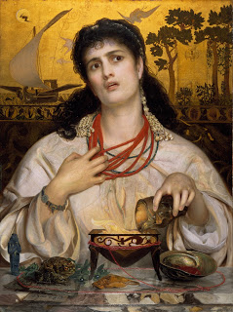
Theseus finally made it to Athens only to find that his father, Aegeus, had married the witch, Medea, and was under her control. Medea had helped Jason retrieve the Golden Fleece before Jason had abandoned her. She eventually made her way to Athens and had a son, Medus with Aegeus. She knew full well who Theseus was, even if his father did not, and was determined to protect her own son’s inheritance. And so she arranged for this new-comer to prove his heroism by setting him the task of vanquishing the bull that Heracles had once captured for King Eurystheus, only to let loose on the plains of Marathon near Athens. Theseus tracked the bull, grappled with it and brought it back to a grateful Aegeus, who sacrificed it to Apollo.
Thwarted, Medea decided to use her own black arts and concocted a poison for Theseus to drink during the meal after the sacrifice. During this meal, Theseus revealed his father’s sword, pretending to draw it for carving the meat. In his excitement, Aegeus knocked over the poison and Medea was exposed. She fled Athens and Theseus became the heir to its throne.

Questions
The Athenian playwright Euripides wrote a tragedy about Medea. Do you think that she is worthy of our sympathy?

The Minotaur
Now King Minos of Crete had placed a terrible burden on the Athenians after the murder of his son, Androgeus. He had been killed out of jealousy by the Athenians after the young man won every event in an athletic contest hosted by Aegeus (another account has it that he was killed by the Cretan Bull whilst in Athens). Minos was too powerful for the Athenians to resist so they agreed to send seven boys and seven girls from Athens every ninth year to be thrown to the Minotaur.

This monster was the offspring of Minos’ wife, Pasiphae, and a bull. Poseidon had sent this bull (it was, in fact, the Cretan Bull!) as a sign that Minos was the rightful king of Crete and Minos had said he would sacrifice the bull in thanks to the sea god. But he substituted it for another bull and so Poseidon had his revenge by driving Pasiphae mad with an unholy passion. The minotaur was born: a man with the head of a bull.

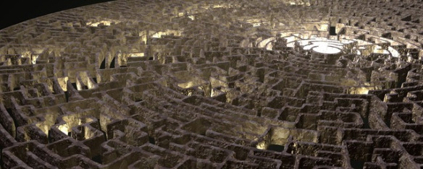
Minos consulted the oracle at Delphi, who told him to get the greatest craftsman, Daedalus, to fashion a maze, which became known as the Labyrinth, in which to keep the minotaur.
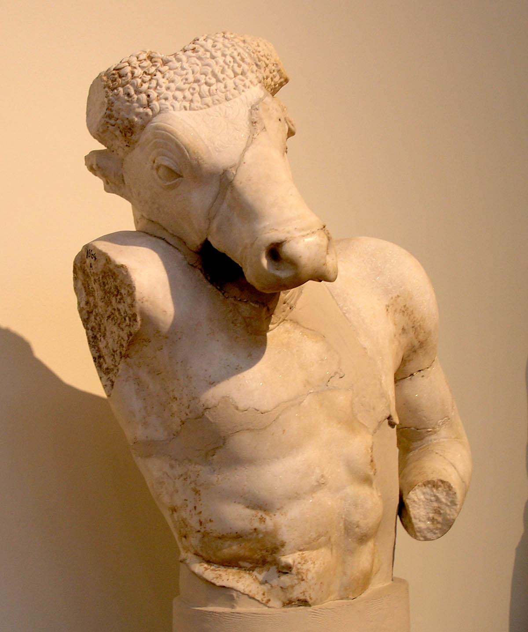
On the third cycle, Theseus volunteered himself to go and, boasting to his father that he would kill the minotaur, said that if he returned successfully then their ship would bear a white sail, whereas it had always sailed with a black one. When Theseus arrived in Crete, he and Minos’ daughter, Ariadne, fell in love. Ariadne agreed to help Theseus and gave him a ball of string and a sword to smuggle into the Labyrinth.

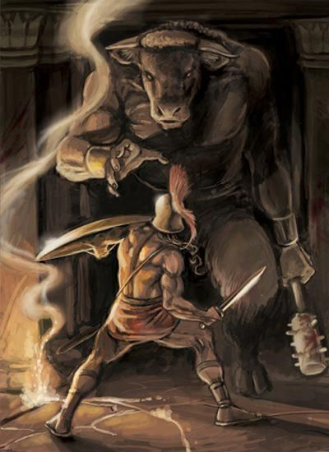
Theseus tied one end of his thread to the door of the Labyrinth and made his way down to the middle of the maze, leaving the string as a trail. When he encountered the creature, the two fought ferociously until Theseus stabbed his sword through the Minotaur’s throat. Following the thread back to safety, he fled Crete with the Athenian youths, Ariadne and her sister Phaedra. To ensure the Cretans did not pursue them, Theseus smashed in the bottoms of their ships.

They stopped at the island of Naxos. In the earliest version we have, written by Hesiod, Theseus abandoned Ariadne here, who was found by the god Dionysus. Some accounts explain that here Dionysus fell in love with Ariadne and demanded her from Theseus, who was then told by Athena he must give her up. According to Plutarch some assert that she did bear Theseus sons named Oenopion and Staphylus.

Grief stricken, Theseus forgot to let down the ship’s black sail and fly a white one. Aegeus saw this from afar and, thinking his son dead, he threw himself from the city walls into the sea, which became known as the ‘Aegean Sea.’ The Athenians pledged to honour Apollo every year after Theseus’ mission and maintained the ship for generation after generation,
not least because they sent their delegation to Apollo at Delphi in this ship each year. When parts of the ship decayed, the Athenians replaced these slowly over time, leading to the philosophical question known as the ‘Ship of Theseus Paradox.’

Question
What is it that makes this one of the most memorable stories in mythology?

The Theseus Kylix
Annotate this famous wine cup (kylix) to show which scene represents each of Theseus’ labours:

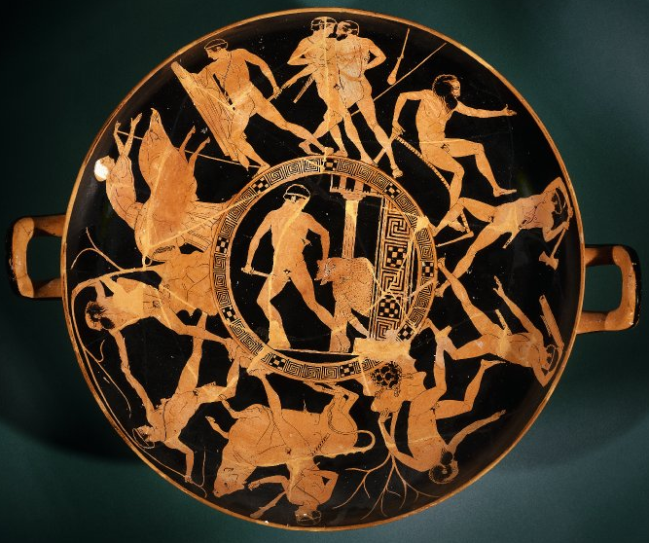

Theseus, King of Athens
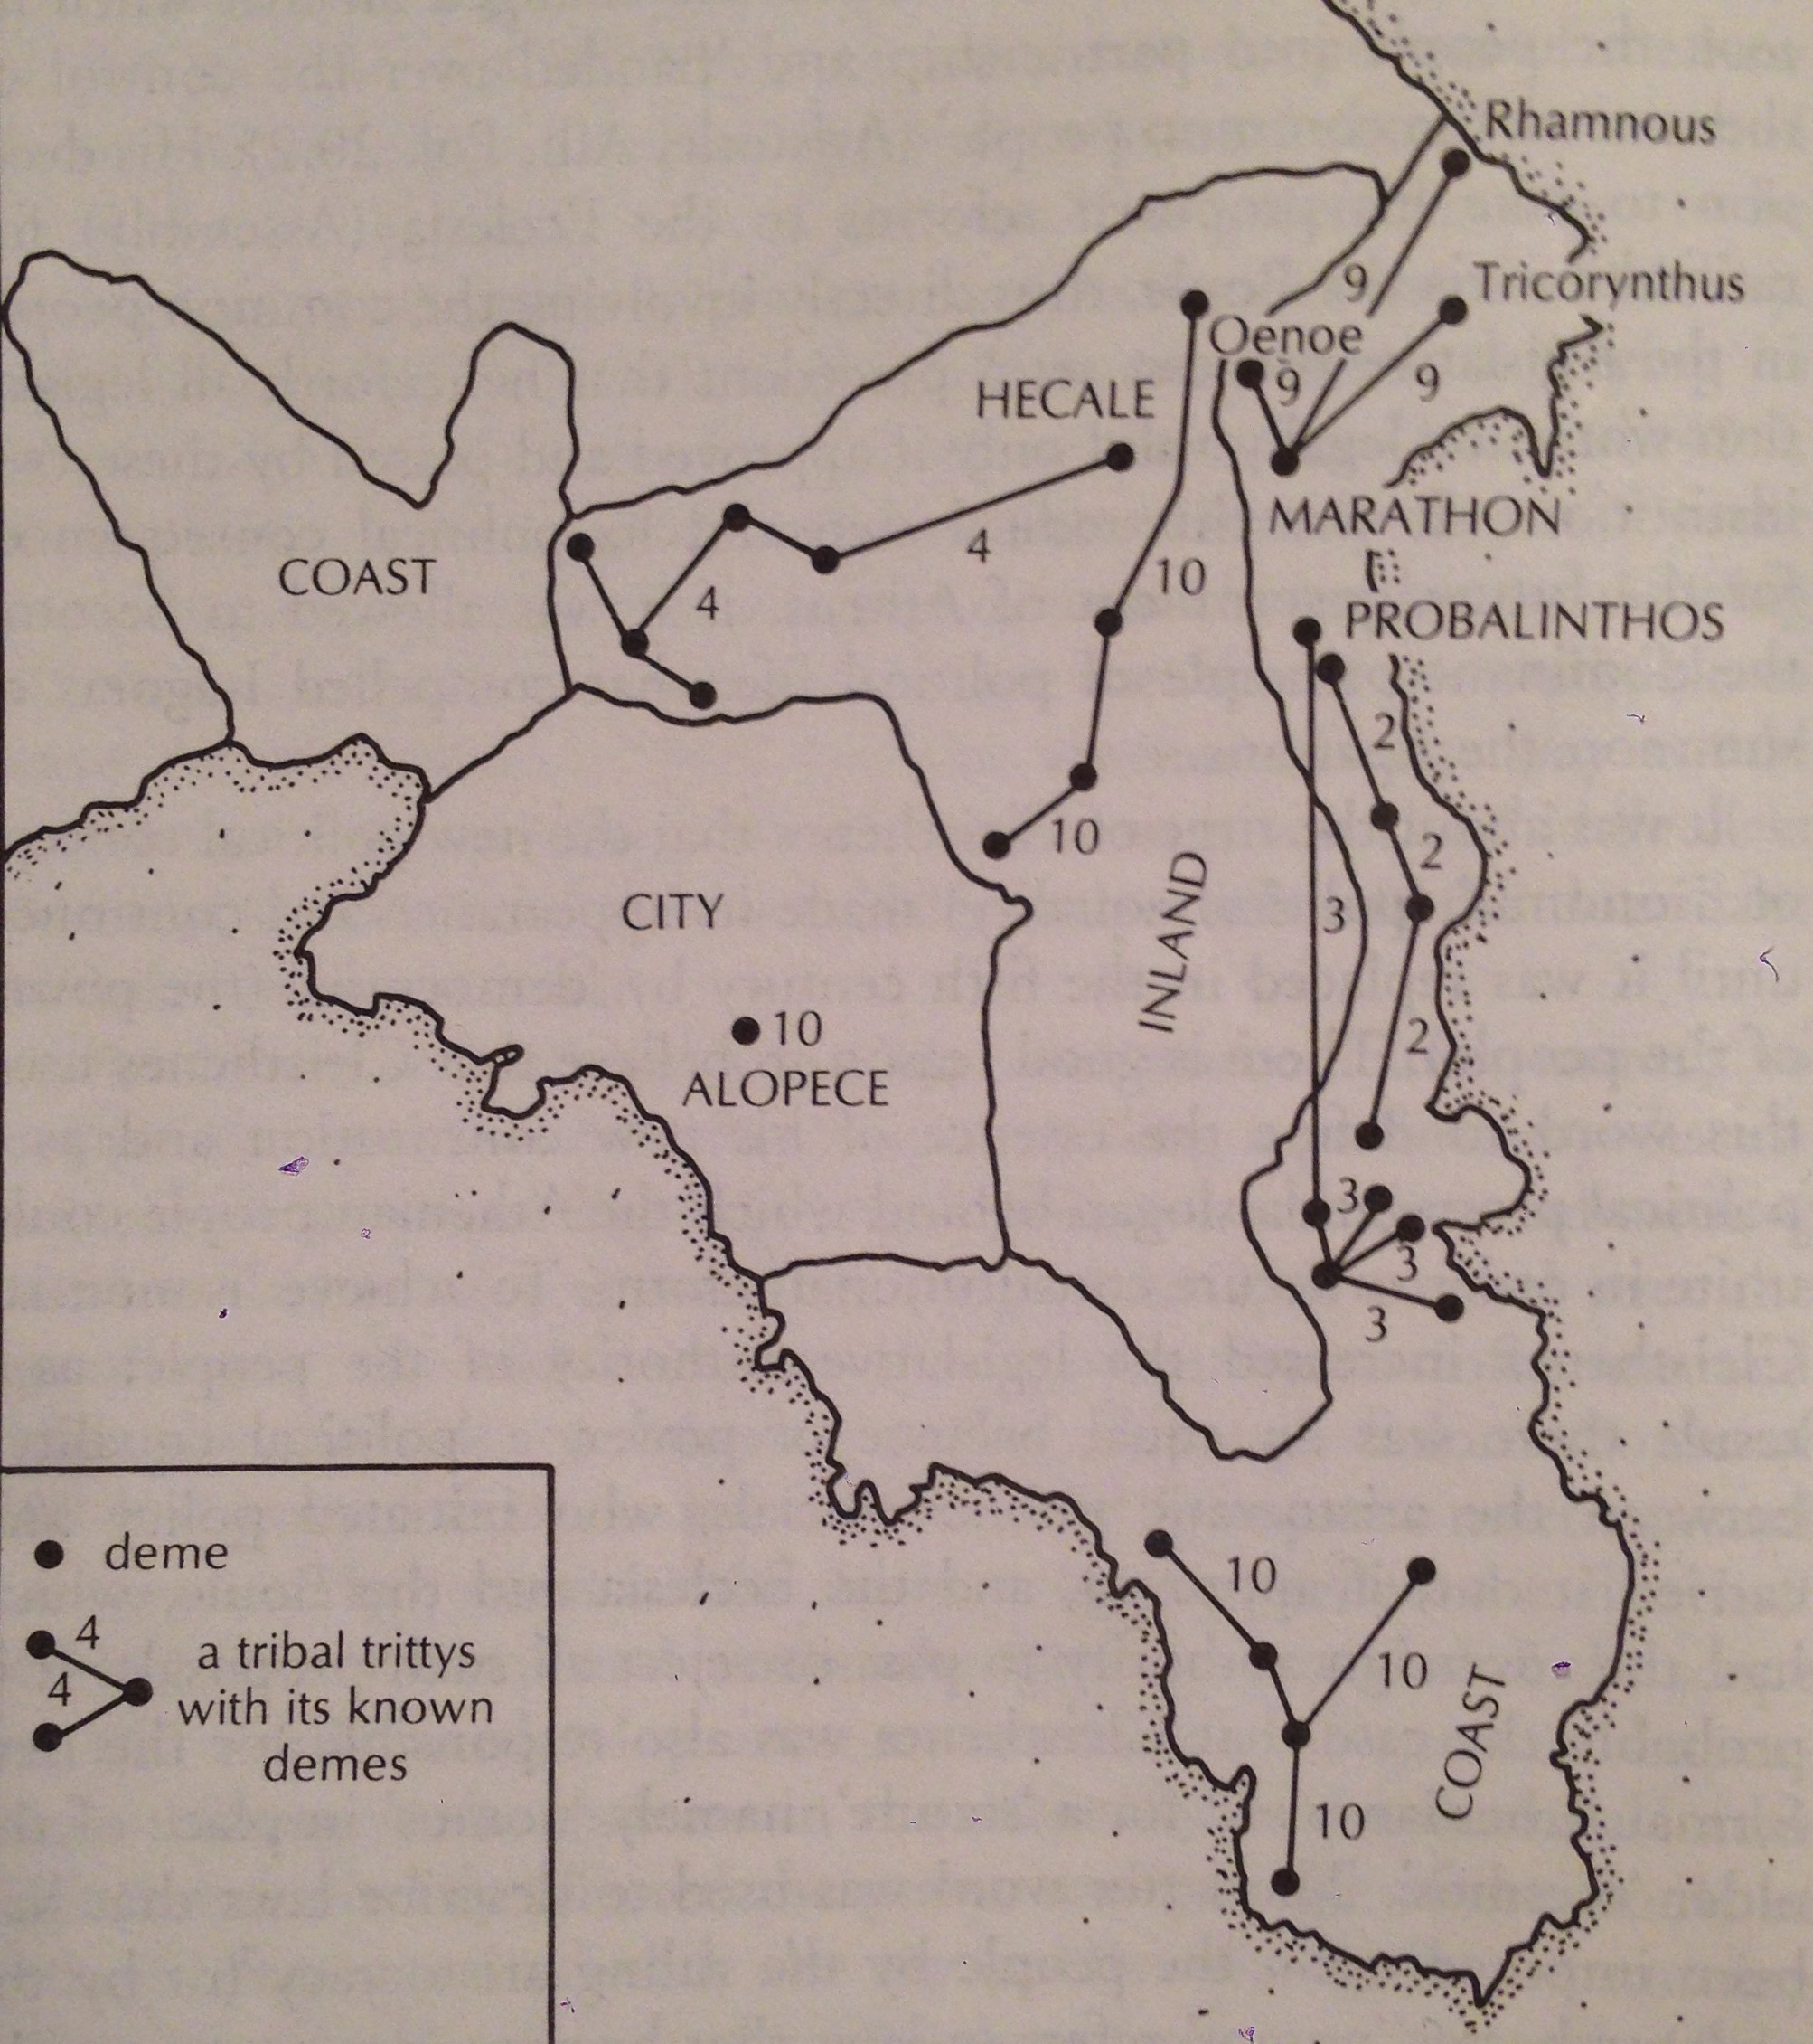
Theseus’ adventures did not stop with his return from Crete: he shared many adventures with Pirithous, king of the Lapiths, and fought against the Amazons, whilst also marrying their queen, Hippolyta.
But the Athenians credited Theseus with founding many of Athens’ iconic institutions. They claimed that it was he who brought democracy to the town of Attica, promising that they would have no kings if they entered into an alliance with Athens. This left all the inhabitants of Attica as ‘Athenians’ who had the right to vote. Theseus would lead them in war but otherwise they would have equal say in their affairs. Theseus built a council chamber and town hall in Athens and started the Panatheneic Games. In this sense, Theseus came to be considered a ‘founder’ of Athens, since he changed it into the famous town we know about today.
The tribes of Attica around Athens

When Theseus died, he was buried near the gymnasium of the city. Plutarch, a biographer of his, states that this ‘his tomb is a sanctuary and place of refuge for runaway slaves and all men of low estate who are afraid of men in power, since Theseus was a champion and helper of such during his life.” The Athenians honoured him as a demigod, a practice reinforced by the soldiers who fought the Persians at Marathon, who thought they saw his spirit rushing into battle with them.

Question
In reality, all these things came into being in the 5th Century BC, many centuries after the mythic Theseus was said to have lived. Why would the Athenians want to give Theseus the credit for all of this?

