Theseus’ Early Life

The Birth of Theseus
Aegeus, King of Athens, was sensibly taking the matter of an heir very seriously. He had failed to have a single child. Therefore, he travelled to Delphi to consult Apollo’s sibyl. The oracle, as always, gave cryptic advice:
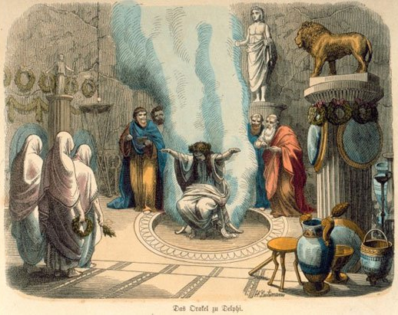
"The bulging mouth of the wineskin, O best of men, Loose not until thou hast reached the height of Athens."

A confused Aegeus decided to visit King Pittheus of Troezen on his return, for this king was famed for his interpretation of oracles. Pittheus understood the meaning but did not explain it to Aegeus. Rather, he got Aegeus drunk and then persuaded him to sleep with his daughter, Aethra. That night, Aethra also received a message from Athena, who told her to wade to the nearby island of Sphairia. There, Poseidon emerged and slept
with her, and so the child she conceived that night had both human and divine traits.

Theseus and Aethra
Aegeus departed for Athens, but he greatly feared for his unborn child, since his nephews were plotting to overthrow him and would surely try to kill any child he had. He buried his sword, shield and sandals underneath a rock and told Aethra that if a son was indeed born to them both that he should be taken to this rock and would be able to lift it and take the items. Until then, Aethra was told to keep the son, Theseus’, identity secret.

Meanwhile, when Theseus was seven years old, Heracles came to visit Pittheus. Whilst dining, Heracles set aside his famous lion skin. But the young children that were there all ran away in terror. All except Theseus, who went and grabbed an axe, returning to attack the lion.

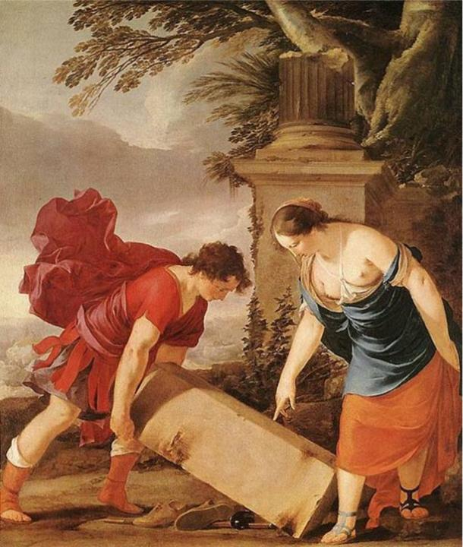
Now Aethra had waited until Theseus had grown up and displayed both strength and wisdom. She then took him to the rock and told him of his true parentage. Theseus easily lifted the rock onto his shoulder. He then set out for Athens, having been told to keep his identity secret until he could safely tell his father. His mother and grandfather advised him to travel by sea, telling him that the route by land was full of dangerous bandits and monsters:

“For truly that age produced men who, in work of hand and speed of foot and vigour of body, were extraordinary and energetic, but they used their powers for nothing that was just or valuable… Some of these creatures Heracles cut off and destroyed as he went about, but some escaped his notice as he passed by, crouching down and shrinking back, and were overlooked in their cowardice. And when Heracles met with calamity and, after the slaying of Iphitus, went to Lydia… in the regions of Greece the old crimes burst forth and broke out anew, there being none to rebuke and none to restrain them.”
[Plutarch, Life of Theseus, 6.5]

But Theseus was eager for the challenge and opportunity to emulate the great Heracles…

