

The Calydonian Boar
Once, King Oeneus of Calydon forgot to include Artemis in his sacrifices at the annual harvest festival. So the goddess sent a monstrous boar to rampage throughout his countryside. The king offered the hide and tusks of the boar to whoever could slay it, which attracted a large collection of heroes, including Theseus and Pirithous.
The King’s own son, Meleager joined the hunt. The Fates had foretold that that he would only live until a log burning on the fire took to perish. So Meleager’s mother, Althaea, took it out, doused it and kept it hidden. A woman, named Atalanta, known for her running speed, also joined the hunt. Ironically, Atalanta had been brought up by Artemis after she was abandoned as a child. Consequently, she was a skilled huntress herself and had taken a vow of chastity (she once killed two centaurs who tried to rape her).
Many men refused to hunt alongside Atalanta but Meleager, smitten by her beauty, convinced the main party to include her. It was indeed Atalanta who first wounded the boar with her bow before Meleager finished it off. Meleager decided to give the boar’s hide to Atalanta. Meleager’s uncles stole
this out of envy and so
Meleager slew them, as
well as Iphicles (Heracle’s
half-brother) after he
insulted Atalanta. Since
Meleager had killed her
brothers, Althaea took the
fateful log and burned it,
bringing her son’s life to
an end.

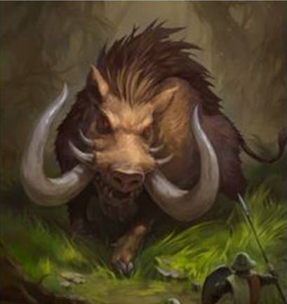

Crommyonian Sow


- Mother of the Calydonian Boar
- Ravaged the countryside of Crommyon
- Slain by Theseus during his early travels.


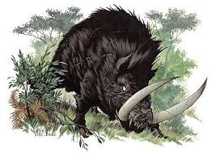



Leda
Leda was the queen of Sparta and wife of Tyndareus. Desiring to make love to her, Zeus disguised himself as a swan and then fell into her arms from a pursuing eagle. The same night Leda made love to this swan, she also slept with her husband too. Strangely, she produced two eggs, each with one child of Zeus and one child of Tyndareus. Two daughters came of one egg: Helen (daughter of Zeus) and Clytemnestra (daughter of Tyndareus). Two sons came from the other: Polydeuces (son of Zeus) and Castor (son of Tyndareus). Together, the boys were known as the Dioscuri.

Ixion’s Crimes
Once Ixion, king of the Lapiths, married Dia but without paying the dowry to her father, Deioneus. So Deioneus stole some of Ixion’s horses. Ixion retaliated, first inviting his father-in-law to a feast and then pushing him into a bed of burning coals.
Ixion was driven mad, whilst all the neighbouring Greeks refused to ritually cleanse him of the sin, since he had violated ties of xenia and become the first Greek to kill a kinsman. He lived as an outlaw until Zeus himself took him to Olympus.
Ixion began to lust after Hera, but Zeus was wise to this development and made a cloud in the shape of his wife, called Nephele. Ixion slept with this phantom and produced a son, Centaurus. Zeus blasted Ixion with a thunderbolt and instructed Hermes to bind Ixion to a perpetually spinning fiery wheel for all eternity. In later myths he was kept in this state in Tartarus (hell).



The Birth of the Centaurs
In one version of the story, the centaurs were the offspring of Ixion and Nephele (a phantom cloud of Hera made by Zeus). In another version, the offspring was Centaurus, a deformed, hunched child who, rejected by men, lived in isolation on Mount Pelion. Here, he mated with the Magnesian mares living there are produced the centaurs, sometimes called the Ixionidae in mythology.

Pirithous the Cow Rustler
Word of a young hero named Theseus’ exploits reached Pirithous’ ears. He decided to test out Theseus’ courage and strength by rustling some of Theseus’ cattle on the plains of Marathon. Theseus set out in pursuit and the two met in battle, armed. But they were so impressed with one another that they took an oath of friendship instead. Then the two of them attended the Calydonian Boar hunt together.


The Wedding of Pirithous and Hippodamia
Pirithous, King of Larissa and its people, the Lapiths, was set to marry a woman named Hippodamia (also known as Deidamia). Amongst the guests at the wedding feast were the centaurs, for in all versions of the tale they were the kin of the Lapiths. Some say that Pirithous and the centaurs shared the same father: Ixion. Others have it that the centaurs and the Lapiths were cousins, offspring of two twins: Centaurus and Lapithes.
During the feast, the centaurs became drunk as they were unaccustomed to drinking wine. They attempted to carry off Hippodamia, the maidens of the Lapiths and their young boys as well. But at this moment, Theseus arrived as a guest of his friend Pirithous. In the struggle, the centaurs were defeated and Theseus slew the most ferocious of the centaurs, Eurytus.
In the battle a Lapith named Caeneus was killed. He had once been a woman, Caenis, who was raped by Poseidon but then offered a single wish. She was so ashamed and determined to never allow this to happen again that she had asked to be turned into a man. This was done with the added bonus of impregnable skin. But the centaurs crushed him to death with pine trees and rocks!

Theseus and Pirithous in the Underworld
Pirithous had a single son, Polypoetes, by his wife, Hippodamia, who died shortly after giving birth. So he travelled to Athens to see his friend Theseus for comfort, only to find that Theseus too had just lost his wife, Phaedra, daughter of King Minos.
The two decided that, as sons of gods, they ought to claim daughters of Zeus as their wives. They stole 13-year-old Helen of Sparta for Theseus to have as his wife when she was old enough to marry. But Pirithous aimed higher and the two men headed down into the underworld to try an abduct Persephone. The two appeared before Hades and even sat down at his banquet table on stone seats. But they quickly learnt that they could not rise, now bound by the stone itself. The Furies then appeared to torture the two men.
Heracles came upon them both on his final labour to capture Cerberus and used his strength to break the rock that held him in place. But the ground shook when he tried to free Pirithous and so he remained captive.
When Theseus returned to Athens he found that Helen had been freed by her brothers, Castor and Polydeuces. Helen had been left with Theseus’ mother, Aethra. The twins took Aethra back to act as a slave for Helen and when Helen fled to Troy she took Aethra. She was only freed when one of her grandsons recognised her after Troy was taken and petitioned Agamemnon for her freedom.




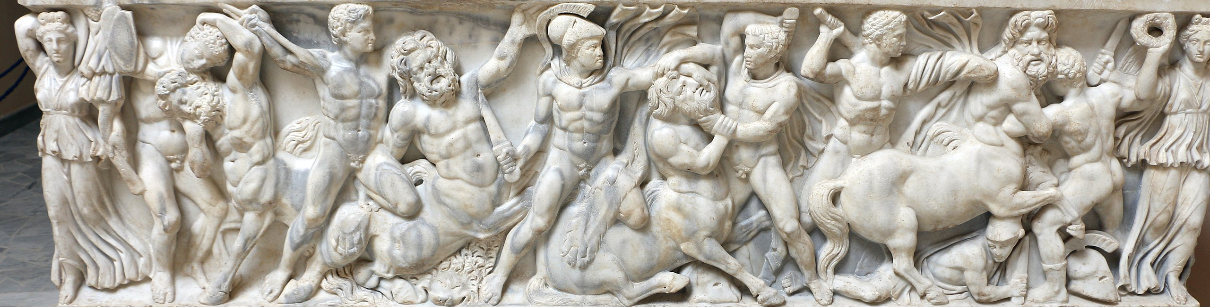


Nestor Reminisces
I have never seen the like of them since, men such as Pirithous, and Dryas, the people’s shepherd, Caeneus, Exadius, godlike Polyphemus [not the cyclops!], and Aegeus’ son Theseus, one of the immortals. They were the mightiest of earth-born men; the mightiest and struggled with the mightiest, the centaurs that live among the mountains, whom they utterly destroyed.
[Homer, Iliad, 1]

The Amazons
There are many, varying accounts of Hippolyta, Queen of the Amazons, although they all begin with Heracles’ ninth labour: the task of capturing Hippolyta’s girdle. In most accounts Theseus accompanied his friend Heracles. According to one, he carried off Hippolyta’s sister, Antiope, during the fight that ensued during this labour. Another version has Heracles give her to Theseus as a gift, and still another tells of how she fell in love with Theseus and betrayed the Amazons.
Enraged, the Amazons retaliated by attacking Athens but they were repelled in battle by the Athenians led by Theseus and Heracles. It is said that Antiope died fighting alongside Theseus. However, another tale tells us that Theseus had ditched Antiope for his second wife, Phaedra, and so the Amazonian attack was retributory. Regardless, Antiope is the only Amazon to marry in mythology. Theseus had a son with her named Hippolytus.

Orpheus performs in the Underworld
Tantalus did not reach for the ever-retreating water: Ixion’s wheel was stilled: the vultures did not pluck at Tityus’ liver … and you, Sisyphus, perched there, on your rock. Then they say, for the first time, the faces of the Furies were wet with tears, won over by his song: the king of the deep, and his royal bride, could not bear to refuse his prayer, and called for Eurydice.
[Ovid, Metamorphoses, 10]

