Characterisation

Question: ‘Whom do you admire more as hero, Theseus or Romulus? Use Plutarch’s account as a starting point and your own knowledge in your answer.
Theseus  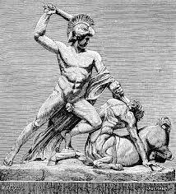 | Romulus  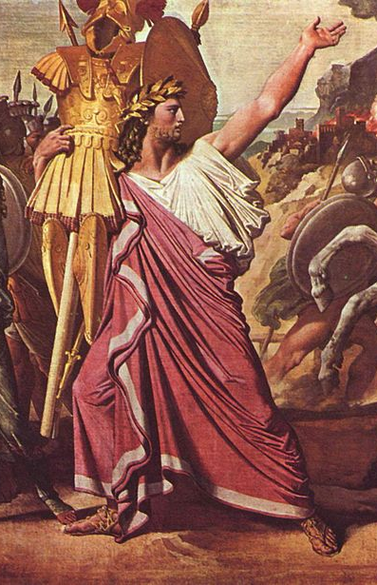
Theseus Romulus
Fighter
Ruler
Politician
Legacy

