Volcanoes Holiday Homework
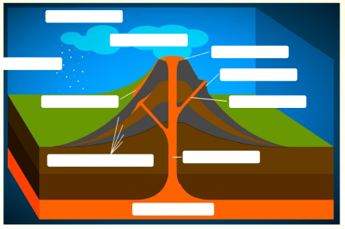

- Label the diagram above using the following:
  - Main vent
  - Secondary vent
  - Crater
  - Secondary cone
  - Layers of ash and lava
  - Ash clouds
  - Ash
  - Volcanic bombs
  - Magma chamber
  - Lava flows

- Create a glossary of the following keywords:
  - Andesitic lava
  - Basaltic lava
  - Composite volcano
  - Crater
  - Hot spot
  - Lahar
  - Lava
  - Magma
  - Magma chamber
  - Magma plume
  - nuées ardentes
  - Pyroclastic flow
  - Rhyolitic lava
  - Shield volcano
  - Subduction
  - Tephra
  - Vent
  - Volcanic arc
  - Volcanic bombs
  - Volcanic landslide

- Find out what a composite and a shield volcano are and complete the table below to summarise their key characteristics and formation:

 | Composite volcano | Shield volcano
Diagram
Characteristics (appearance, type of lava emitted, explosivity, frequency of eruptions)
Formation (types of plate boundaries)
Examples (real life cases of this type of volcano)

Stella (optional): stretch yourself further by finding out about other types of volcanoes too (e.g. fissure and caldera). Add these as new columns to your table (I recommend having your page landscape if doing this) or create a new table.

- Answer the true or false questions below, completing research for any that you are unsure of:
Statement | True | False
A dormant volcano will never erupt again
A steep-sided volcanic cone built from both lava and pyroclastic materials e.g. ash is a composite volcano
Lava is a cooled extrusive magma
A magma chamber is the subterranean cavity containing the liquid and semi-liquid magma which feeds a volcano
The ‘Ring of Fire’ is found around the edge of the Atlantic Ocean
The Mid-Atlantic Ridge is the result of sea-floor spreading
A pyroclastic flow is composed of 50% lava and 50% ash
There are approximately 1500 active volcanoes in the world
Lava is usually between 700° and 1600°C when it is erupted
Hawaiian volcanoes, e.g. Mauna Loa, have infrequent, very explosive eruptions
Fewer than one quarter of all the volcanoes in the world are located around the Ring of Fire
Yellowstone is a dormant supervolcano
Geysers are springs which throw boiling water high in the air. They are the result of trapped water underground being heated by magma
Volcanic soils are generally infertile
There is rarely any seismic activity (earthquakes or tremors) associated with eruptions
Due to the high concentration of volcanoes, Iceland is able to use geothermal energy to heat water.
Shield volcanoes are associated with fluid basic lava.
In some countries, volcanoes provide income from tourism
Composite volcanoes are found on constructive plate margins
A crater filled with solid lava is called a caldera

- Complete research about the Soufriere Hills volcano and create a summary fact sheet about Soufriere Hills including:
  - Formation
  - Primary effects
  - Secondary effects
  - Short-term responses
  - Long-term responses
  - Monitoring of Soufriere Hills
NB try and start pushing yourself beyond GCSE now by using higher level websites. BBC Bitesize is a good starting point but this is also a bit basic. Try websites such as:
http://www.bgs.ac.uk/discoveringGeology/hazards/volcanoes/eruptions.html
- (optional) Create a 3D model of the Soufriere Hills volcano so that you can identify its key features and link it to plate boundaries. Instructions and the template are available from:
http://www.bgs.ac.uk/discoveringGeology/hazards/volcanoes/models/montserrat.html

- Find out how each of the following can be used to monitor and predict volcanoes:
  - Earthquake activity
  - Tiltmeters
  - GPS
  - Digital cameras
  - Spider robots
  - Historical events/hazard mapping

- Complete some research about how the Hawaiian volcanoes formed and also the recent Hawaiian volcanic eruptions. What have the effects and responses been to this event?

