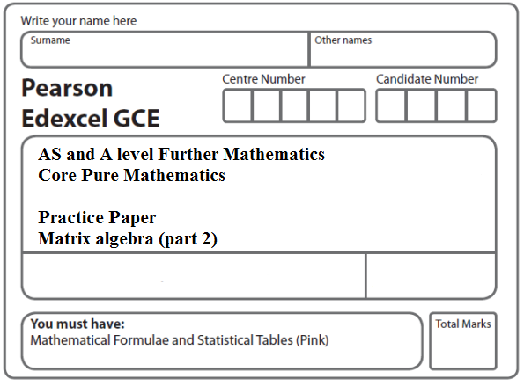

**Instructions**

* Use black ink or ball-point pen.
* If pencil is used for diagrams/sketches/graphs it must be dark (HB or B).
* Fill in the boxes at the top of this page with your name, centre number and candidate number.
* Answer all the questions and ensure that your answers to parts of questions are clearly labelled.
* Answer the questions in the spaces provided – there may be more space than you need.
* You should show sufficient working to make your methods clear. Answers without working may not gain full credit.
* Inexact answers should be given to three significant figures unless otherwise stated.

**Information**

* A booklet ‘Mathematical Formulae and Statistical Tables’ is provided.
* There are 9 questions in this question paper. The total mark for this paper is 100.
* The marks for each question are shown in brackets – use this as a guide as to how much time to spend on each question.
* Calculators must not be used for questions marked with a * sign.

**Advice**

• Read each question carefully before you start to answer it.

• Try to answer every question.

• Check your answers if you have time at the end.

• If you change your mind about an answer, cross it out and put your new answer and any working underneath.

**1*.*** (i)



(*a*) Describe fully the single transformation represented by the matrix **A**.

**(2)**

The matrix **B** represents an enlargement, scale factor –2, with centre the origin.

(*b*) Write down the matrix **B**.

**(1)**

(ii)

, where *k* is a positive constant.

Triangle *T* has an area of 16 square units.

Triangle *T* is transformed onto the triangle *Tʹ* by the transformation represented by the   
matrix **M**.

Given that the area of the triangle *Tʹ* is 224 square units, find the value of *k*.

**(3)**

**(Total 6 marks)**

**___________________________________________________________________________**

**2. **, 

The transformation represented by **B** followed by the transformation represented by **A** is equivalent to the transformation represented by **P**.

(*a*) Find the matrix **P**.

**(2)**

Triangle *T* is transformed to the triangle *T*´ by the transformation represented by **P**.

Given that the area of triangle *T*´ is 24 square units,

(*b*)find the area of triangle *T*.

**(3)**

Triangle *T*´ is transformed to the original triangle *T* by the matrix represented by **Q**.

(*c*) Find the matrix **Q**.

**(2)**

**(Total 7 marks)**

**___________________________________________________________________________**

**3.** **X** = , where *a* is a constant.

(*a*) Find the value of *a* for which the matrix **X** is singular.

**(2)**

**Y** = .

(*b*) Find **Y**−1.

**(2)**

The transformation represented by **Y** maps the point *A* onto the point *B*.

Given that *B* has coordinates (1 – *λ* , 7*λ* – 2), where *λ* is a constant,

(*c*) find, in terms of *λ*, the coordinates of point *A*.

**(4)**

**(Total 8 marks)**

**___________________________________________________________________________**

**4.** (i) **A** = , where *k* is a real constant.

Given that **A** is a singular matrix, find the possible values of *k*.

**(4)**

(ii) **B** = 

A triangle *T* is transformed onto a triangle *T'* by the transformation represented by the matrix **B**.

The vertices of triangle *T'* have coordinates (0, 0), (−20, 6) and (10*c*, 6*c*), where *c* is a positive constant.

The area of triangle *T'* is 135 square units.

(*a*) Find the matrix **B**–1.

**(2)**

(*b*) Find the coordinates of the vertices of the triangle *T*, in terms of *c* where necessary.

**(3)**

(*c*) Find the value of *c*.

**(3)**

**(Total 12 marks)**

**___________________________________________________________________________**

**5.** (i) In each of the following cases, find a 2 × 2 matrix that represents

(*a*) a reflection in the line *y* = –*x*,

(*b*) a rotation of 135° anticlockwise about (0, 0),

(*c*) a reflection in the line *y* = –*x* followed by a rotation of 135° anticlockwise about   
(0, 0).

**(4)**

(ii) The triangle *T* has vertices at the points (1, *k*), (3, 0) and (11, 0), where *k* is a constant. Triangle *T* is transformed onto the triangle *T*ʹ by the matrix



Given that the area of triangle *T*ʹ is 364 square units, find the value of *k*.

**(6)**

**(Total 10 marks)**

**___________________________________________________________________________**

**6.**

**A** = 

and **I** is the 2 × 2 identity matrix.

(*a*) Prove that

**A**2 = 7**A** + 2**I**

**(2)**

(*b*)Hence show that

**A**–1 = (**A** – 7**I**)

**(2)**

The transformation represented by **A** maps the point *P* onto the point *Q*.

Given that *Q* has coordinates (2*k* + 8, –2*k* – 5), where *k* is a constant,

(*c*)find, in terms of *k*, the coordinates of *P*.

**(4)**

**(Total 8 marks)**

**___________________________________________________________________________**

**7.** **A** = .

(*a*) Show that **A** is non-singular.

**(2)**

(*b*) Find **B** such that **BA**2 = **A**.

**(4)**

**(Total 6 marks)**

**___________________________________________________________________________**

**8.** **A** = 

(*a*) Find det **A**.

**(1)**

(*b*) Find **A**–1.

**(2)**

The triangle *R* is transformed to the triangle *S* by the matrix **A**.

Given that the area of triangle *S* is 72 square units,

(*c*) find the area of triangle *R*.

**(2)**

The triangle *S* has vertices at the points (0, 4), (8, 16) and (12, 4).

(*d*) Find the coordinates of the vertices of *R*.

**(4)**

**(Total 9 marks)**

**___________________________________________________________________________**

**9. M** = .

(*a*) Find det **M**.

**(1)**

The transformation represented by **M** maps the point *S*(2*a* – 7, *a* – 1), where *a* is a constant, onto the point *S* ′(25, –14).

(*b*) Find the value of *a*.

**(3)**

The point *R* has coordinates (6, 0).

Given that *O* is the origin,

(*c*) find the area of triangle *ORS*.

**(2)**

Triangle *ORS* is mapped onto triangle *OR'S '* by the transformation represented by **M**.

(*d*) Find the area of triangle *OR'S '*.

**(2)**

Given that

**A** =

(*e*) describe fully the single geometrical transformation represented by **A**.

**(2)**

The transformation represented by **A** followed by the transformation represented by **B** is equivalent to the transformation represented by **M**.

(*f*) Find **B**.

**(4)**

**(Total 14 marks)**

**TOTAL FOR PAPER: 100 MARKS**