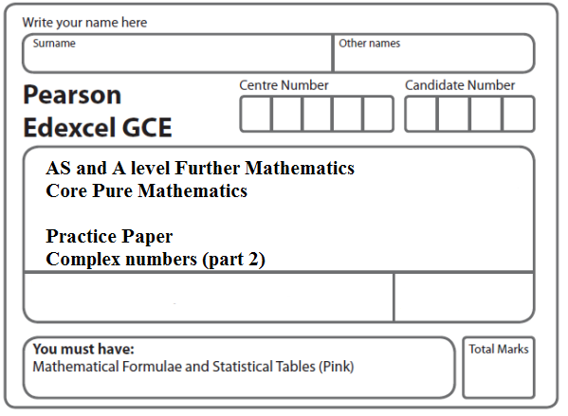

**Instructions**

* Use black ink or ball-point pen.
* If pencil is used for diagrams/sketches/graphs it must be dark (HB or B).
* Fill in the boxes at the top of this page with your name, centre number and candidate number.
* Answer all the questions and ensure that your answers to parts of questions are clearly labelled.
* Answer the questions in the spaces provided – there may be more space than you need.
* You should show sufficient working to make your methods clear. Answers without working may not gain full credit.
* Inexact answers should be given to three significant figures unless otherwise stated.

**Information**

* A booklet ‘Mathematical Formulae and Statistical Tables’ is provided.
* There are 11 questions in this question paper. The total mark for this paper is 100.
* The marks for each question are shown in brackets – use this as a guide as to how much time to spend on each question.
* Calculators must not be used for questions marked with a * sign.

**Advice**

• Read each question carefully before you start to answer it.

• Try to answer every question.

• Check your answers if you have time at the end.

• If you change your mind about an answer, cross it out and put your new answer and any working underneath.

**1.** *z* = .

Find, in the form *a* + i*b* where *a*, *b* ∈ ℝ,

(*a*) *z*,

**(2)**

(*b*) *z*2.

**(2)**

Given that *z* is a complex root of the quadratic equation *x*2 + *px* + *q* = 0, where *p* and *q* are real integers,

(*c*)find the value of *p* and the value of *q*.

**(3)**

**(Total 7 marks)**

**___________________________________________________________________________**

**2.** f(*x*) = (4*x*2 + 9)(*x*2 − 6*x* + 34).

(*a*) Find the four roots of f (x) = 0.

Give your answers in the form *x* = *p* + i*q* , where *p* and *q* are real.

**(5)**

(*b*) Show these four roots on a single Argand diagram.

**(2)**

**(Total 7 marks)**

**___________________________________________________________________________**

**3.** The roots of the equation

*z*3 − 8*z*2 + 22*z* − 20 = 0

are ,  and  .

(*a*) Given that  = 3 + i, find  and .

**(4)**

(*b*) Show, on a single Argand diagram, the points representing ,  and .

**(2)**

**(Total 6 marks)**

**___________________________________________________________________________**

**4.** Given that 4 and 2i – 3 are roots of the equation

*x*3 + *ax*2 + *bx* – 52 = 0

where *a* and *b* are real constants,

(*a*)write down the third root of the equation,

**(1)**

(*b*)find the value of *a* and the value of *b*.

**(5)**

**(Total 6 marks)**

**___________________________________________________________________________**

**5.** Given that *z* = *x* + i*y*, find the value of *x* and the value of *y* such that

*z* + 3i*z*\* = −1 + 13i

where *z*\* is the complex conjugate of *z*.

**(Total 7 marks)**

**___________________________________________________________________________**

**6.** A complex number *z* is given by *z* = *a* + 2i,

where *a* is a non-zero real number.

(*a*)Find *z*2 + 2*z* in the form *x* + i*y* where *x* and *y* are real expressions in terms of *a.*

**(4)**

Given that *z*2 + 2*z* is real,

(*b*)find the value of *a*.

**(1)**

Using this value for *a*,

(*c*)find the values of the modulus and argument of *z*, giving the argument in radians, and giving your answers to 3 significant figures.

**(3)**

(*d*)Show the points *P*, *Q* and *R*, representing the complex numbers *z*, *z*2 and *z*2 + 2*z* respectively, on a single Argand diagram with origin *O.*

**(3)**

(*e*)Describe fully the geometrical relationship between the line segments *OP* and *QR*.

**(2)**

**(Total 13 marks)**

**___________________________________________________________________________**

**7.**  *z*1 = 2 + 3i, *z*2 = 3 + 2i, *z*3 = *a + b*i, *a*, *b* ∈ ℝ

(*a*) Find the exact value of |*z*1 + *z*2|.

**(2)**

Given that *w* = ,

(*b*)find *w* in terms of *a* and *b*, giving your answer in the form *x +* i*y*, *x*, *y* ∈ ℝ

**(4)**

Given also that *w* = ,

(*c*) find the value of *a* and the value of *b*,

**(3)**

(*d*) find arg *w*, giving your answer in radians to 3 decimal places.

**(2)**

**(Total 11 marks)**

**___________________________________________________________________________**

**8.** *z* = 2 − i√3.

(*a*) Calculate arg *z*, giving your answer in radians to 2 decimal places.

**(2)**

Use algebra to express

(*b*) *z* + *z*2 in the form *a* + *b*i√3, where *a* and *b* are integers,

**(3)**

(*c*)  in the form *c* + *d*i√3, where *c* and *d* are integers.

**(4)**

Given that *w = λ* – 3i,

where *λ* is a real constant, and arg (4 – 5i + 3*w*) = –,

(*d*) find the value of *λ*.

**(2)**

**(Total 11 marks)**

**___________________________________________________________________________**

**9.***z* = – 24 – 7i

(*a*) Show *z* on an Argand diagram.

**(1)**

(*b*) Calculate arg *z*, giving your answer in radians to 2 decimal places.

**(2)**

It is given that *w* = *a* + *b*i, *a* ∈ ℝ, *b* ∈ ℝ.

Given also that ⎜*w*⎜= 4 and arg *w* = ,

(*c*) find the values of *a* and *b*,

**(3)**

(*d*) find the value of ⎜*zw*⎜.

**(3)**

**(Total 9 marks)**

**___________________________________________________________________________**

**10.** The point *P* represents a complex number *z* on an Argand diagram such that

⏐*z* − 6i⏐= 2⏐*z* − 3⏐.

(*a*) Show that, as *z* varies, the locus of *P* is a circle, stating the radius and the coordinates of the centre of this circle.

**(6)**

The point *Q* represents a complex number *z* on an Argand diagram such that

arg (*z* − 6) = .

(*b*) Sketch, on the same Argand diagram, the locus of *P* and the locus of *Q* as *z* varies.

**(4)**

(*c*) Find the complex number for which both ⏐*z* − 6i⏐= 2⏐*z* − 3⏐ and arg (*z* − 6) = .

**(4)**

**(Total 14 marks)**

**___________________________________________________________________________**

**11.** The complex number *w* is given by

*w* = 10 – 5i

(*a*) Find .

**(1)**

(*b*) Find arg *w*, giving your answer in radians to 2 decimal places

**(2)**

The complex numbers *z* and *w* satisfy the equation

(2 + i)(*z* + 3i) = *w*

(*c*)Use algebra to find *z*, giving your answer in the form *a* + *b*i,

where *a* and *b* are real numbers.

**(4)**

Given that

arg(*λ* + 9i + *w*) = 

where *λ* is a real constant,

(*d*) find the value of *λ*.

**(2)**

**(Total 9 marks)**

**TOTAL FOR PAPER: 100 MARKS**