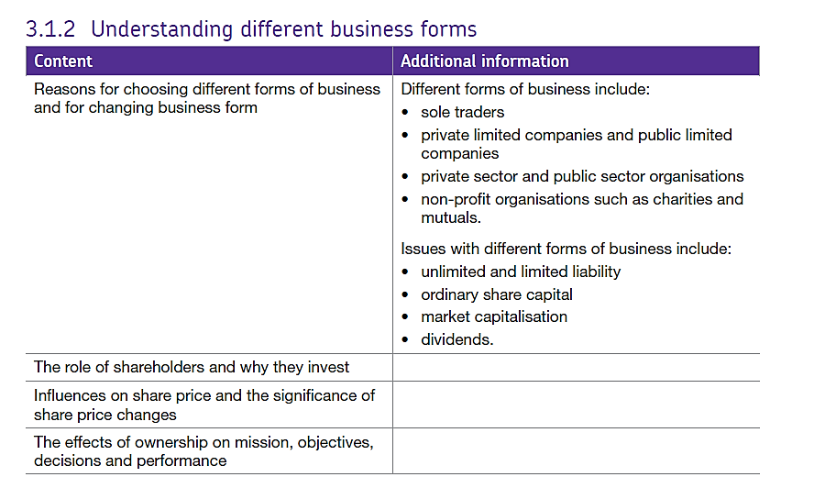3.1.2 Forms of business

## Forms of Business.

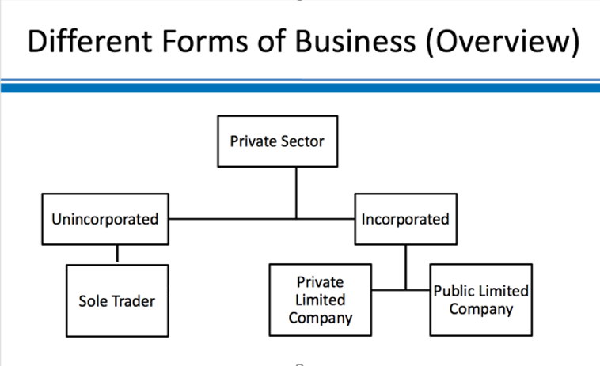In this part of the course we will be thinking about the different ways in which businesses can organise themselves – the different forms business can take. Businesses in the private sector can be thought of in two main ways:

(1) incorporated businesses

(2) unincorporated businesses.

### Unincorporated:

* The owner is the business - no legal difference
* Owner has **unlimited liability** for business actions (including debts)
* Most unincorporated businesses operate as sole traders
* A small number operate as partnerships

### Incorporated:

* There is a **legal difference** between the business (company) and the owners
* The company has a separate legal identity from the owners
* Owners (shareholders) have limited liability
* Most incorporated businesses are private limited companies (Ltds)
* Some are public limited companies (Plcs)

#### The most important difference between incorporated and unincorporated businesses is who is **liable** for the debts of the business if it fails?

The answer to this question lies in limited liability.

Limited liability is an **important protection for shareholders** in an incorporated company because the company has a separate legal identity - the shareholders are not the same as the business. This means shareholders can only lose the value of the investment they’ve made in the company.

An **incorporated** business is a **separate legal entity, i**t exists separate from its owners (shareholders) so the company is liable for its debts but the owners are not.

**Unincorporated** businesses have unlimited liability. An unincorporated business is **inseparable** from the business owners so the owners must pay any business debts.

This is the most important drawback of being an unincorporated business (e.g. sole trader) - the owner is liable for the debts of the business. If the business fails and is left owing money to suppliers, the bank or the Government, these debts have to be paid by the business owners who may lose their home to pay for them.

You might ask, therefore, why would anyone set up as a sole trader or partnership when setting up a private company is so quick and cheap?

## Unincorporated Businesses - Sole Traders

The most common type of unincorporated business is the sole trader. A sole trader is just an **individual owning the business on his/her own**.  Remember that a sole trader can also employ people – but those employees don’t share in the ownership of the business.  The sole trader owns all the business assets personally and is personally responsible for the business debts.  **Crucially - a sole trader has unlimited liability.** The main benefits and drawbacks of operating as a sole trader can be summarised as follows:

### Advantages of being a sole trader:

* Quick & easy to set up – business can always be transferred to a limited company once launched
* Simple to run – owner has complete control over decision-making
* Minimal paperwork
* Easy to close / shut down

### Drawbacks of being a sole trader:

* Full personal liability – “unlimited liability”
* Harder to raise finance – sole traders often have limited funds of their own and security against which to raise loans
* The business is the owner – the business suffers if the owner becomes ill, loses interest etc.

## Incorporated Businesses – limited companies – with limited liability

There are two main kinds of incorporated business (i.e. company):

### 1. Private Limited Company

Key points to remember:

* Most popular form of incorporated business
* Company is privately-owned
* Shares cannot be traded publicly
* Usually just 1 or a few shareholders
* Quick & cheap to set up and administer

### 2. Public Limited Company

Key points to remember:

* Minimum share capital £50,000
* Shares may be traded on a public stock market (but don't have to be)
* Usually many shareholders
* More detailed disclosure of information required
* More costly to administer

The owners of any limited company are called shareholders.

When a business becomes a PLC it issues **share capital**. This is the total value of the shares on the day they are issued. After this time the share price will go up and down as people trade their shares. The money does not come in and out of the company it just changes hands between person A and person B. If the shares increase in value then the firm’s shares will be worth more and if they decrease then the shares are worth less. The current value of all the shares in known as **market capitalisation**.

For example if a firm has issued 30 million shares and they are trading at £12.50 then the market capitalisation is £12.50 x 30,000,000 = £375,000,000.

If a firm wants to have more share capital they can have a **rights issue** which allows current shareholders the right to buy more shares at the current market price.

#### Why do people have shares?

PLC shareholders can be members of the public or can be institutional investors e.g. a finance management fund (managing people’s pensions etc.). Shareholders in both private and public limited companies earn their rewards from two aspects of their business ownership: **dividends**and **capital growth:**

#### Dividends

* Dividends are **payments made to shareholders** by the company from earned profits, firms don’t pay out all their profits as dividends and a potential investor can look at the proportion of profit paid as dividend by looking at the dividend cover – how well a firm’s dividends are covered by its profits. E.g. if the dividend cover was 4 then 25% of the firm’s profits have been paid as dividends.
* Amount paid is “per share” – e.g. £1 per share held
* Normally no requirement to pay dividends, but most quoted companies do

#### Capital Growth (also known as Capital Gain)

* Arises from an increase in the value of the business
* Reflected in an increase in a share price
* Only realised when a share is sold (the price paid)
* No guarantee that a shareholding will increase in value – business value can change both ways

## Non-profit organisations.

Not every business organisation exists to earn profits for its owners. Other organisations engage in business-related activities, but their aims and objectives are different.

Common examples of "not-for-profit" organisations are:

* Mutual businesses
* Social enterprises
* Charities

#### Mutual Businesses

Mutual businesses don't have shareholders or other owners. They exist only to serve their "members". There are very few of these left now but several building societies are mutuals e.g. Nationwide Building Society which is run on behalf of members who have taken out mortgages or held savings accounts there.  Another example of a mutual business is the RAC.

#### Social Enterprises

Social enterprises are businesses with primarily **social objectives** whose surpluses are principally reinvested for that purpose in the business or community, rather than being driven by the need to maximise profit for shareholders and owners'.

In other words, a social enterprise is a **proper business** that makes its money in a **socially responsible way**. These ventures are not necessarily formed to reinvest all profits into the communities. Social entrepreneurs can make a good profit themselves. However, their business model is also designed to benefit others. Well known examples of social enterprises include Divine Chocolate, the Eden Project and fair-trade coffee company Cafedirect.

#### Charities

Many charities undertake business activities. These range from running high street charity shops to operating services and fund-raising events. Charities have to ensure that the proceeds earned from these activities are spent in accordance with the stated aims of the charity. Their activities are regulated by the Charity Commission.

## Private sector and public sector organisations

Some businesses are not owned by private individuals and groups but are run and funded by the Government. These Government –funded businesses are said to be in the **public sector** and are funded from the taxes which people pay to the Government. For example the Government runs Network Rail which maintains all the railway tracks in the UK, they also provide education and healthcare. Any business which is not run and funded by the Government is in the **private sector**.

## Effects of ownership on mission and objectives.

In the private sector there is a lot of pressure from shareholders to increase profits and improve company performance, this means there is constant pressure to drive down costs and increase profit margins. This can become the focus of the business and the firm may find it different to prioritise objectives which don’t focus on this.