Price sensitivity – elasticity

Price sensitivity refers to the relationship between price and demand for a firm’s products – i.e. **what happens to demand if a firm changes its prices.** For most products a change in price will result in a fall in demand and, when shown on a diagram the price and sales data would look like this.

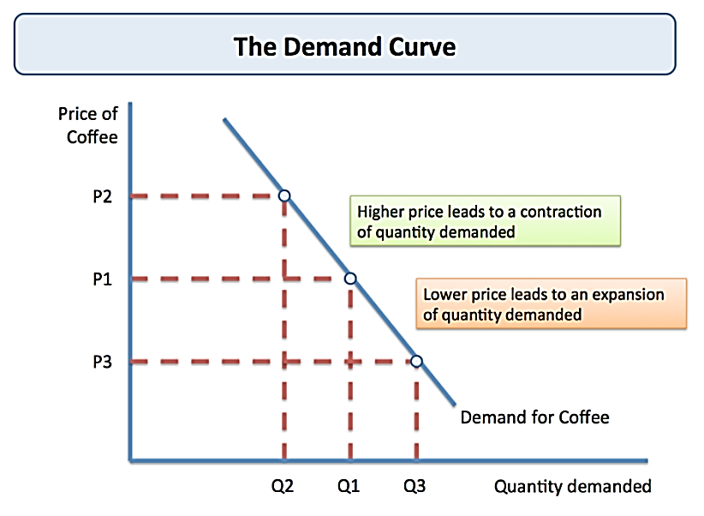

If a product has a high degree of price sensitivity, then the firm would expect a change in the price to generate a significant change in demand. If this **% change in demand is greater than the % change in price,** then the demand is said to be **price elastic** i.e. it is very sensitive to any changes.

If the product has a low degree of price sensitivity then the firm would expect a change in price to have little impact on demand. If the **% change in demand is lower than the % change in price,** then the product is said to have **price inelastic** demand i.e. it is not very sensitive to change in price.

A product’s price elasticity (PED) can be calculated using the formula

**% change in quantity demanded**

**% change in price**

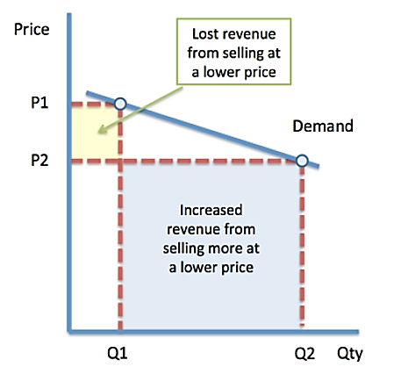

**A product with price elastic demand will have a result greater than + or - 1** e.g. a value of -3.5 indicates price elastic demand.

On a diagram it would look something like this – where price has fallen from P1 to P2 and Demand has increased from Quantity (Q) 1 to Quantity (Q) 2.

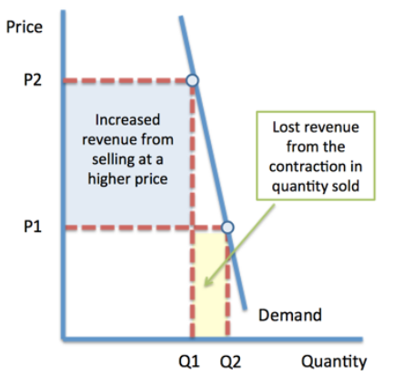

**A product with price inelastic demand will have a result of less than + or - 1** e.g. a value of 0.8 shows that a product has price inelastic demand.

On a diagram it would look something like this – as you can see the demand curve is much more vertical suggesting that the change in quantity demanded is much smaller – i.e. the change in demand is less than the % change in price.



 

 