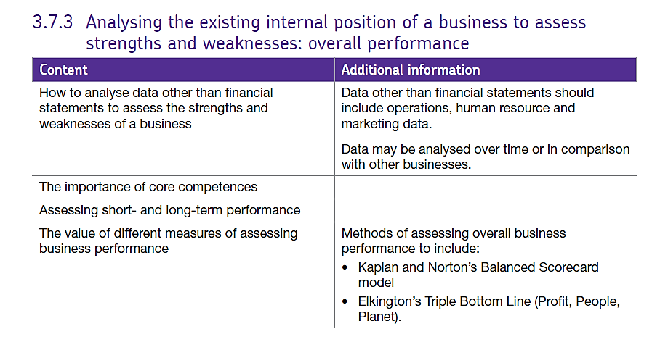3.7.3 (a) Assessing performance.

# What data do businesses assess other than the financial statements?

Businesses can look at their marketing, HR or operations management performance.

## Marketing:

* Brand loyalty and repeat customers – who may not spend as much but who come back time and time again – this could be viewed as a success for the firm’s marketing
* It may be possible to calculate how much it costs them to bring in a certain number of new customers – from looking at the correlation between advertising expenditure and increased demand.
* Market share figures can be useful but, if market share gains are based on e.g. a competitor going bankrupt then the figures may be misleading.
* Gross profit margins on some products will differ but the higher the better
* What % of total sales are from new products and what % are from older products. If a new store opens that many people will visit it to have a look but they may not come back so figures need to be seen in the longer term.

## Human Resources.

* Human resources departments look at their (key performance indicators), these include:
* Absenteeism – how frequently are people absent? Are there patterns of absenteeism?
* Levels of job satisfaction – if staff are not happy at work they will not be as productive and customer satisfaction will be affected, in a hard HRM system it may be hard to quantify this.
* Retention rate / Staff turnover – how often are staff leaving – or, how long do they stay – firms could compare this to the cost of recruitment.
* Training budgets – is the cost of training being recouped in sales or improvements in productivity – if not, why not?
* Ease of promotion within the firm – is there diversity of management? Can good staff make progress through the company or are there very few opportunities so good staff may leave.

## Operations

* Quality; how many products are being made which can’t be sold? Are here complaints about quality? If customers are returning products because of poor quality – is this being addressed?
* Productivity, the firm will monitor productivity to see if productivity is being maintained or improving – or, even worse, falling. Lower rates of productivity increase costs so firms always want to maintain or improve in this area.
* Managing time efficiently, sometimes investment in technology can significantly speed up the production process and streamline processes which will reduce costs in the long term.
* Managing waste, this can be linked to quality both of inputs, processes and design, faulty components or designs which have been rushed lead to increased wastage and stuck which cannot be used or sold is wasted capital.

Measuring performance will differ depending on the types of organisation. In a hospital for example it would be very different to being in a small food manufacturer – there is no one solution for everybody. It’s also important to remember that there may be an external force acting upon any one piece of information and so the firm should always look at a range of data. For example, a fire at a supplier warehouse may mean an alternative source has to be found for raw materials and those supplied may not be of the same quality causing excess wastage – this would be temporary and so has to be looked at in context.

# Core competencies.

**These are sills within the business – strengths of the business which enable it to successfully differentiate itself from other firms.**

## **Identifying Core Competencies**

Core competencies in any business can be identified as:

1. **Providing potential access to a wide variety of markets**

The key core competencies here are those that enable the creation of new products & services.

**For example: Why has Saga established such a strong leadership in supplying financial services (e.g. insurance) and holidays to the older generation?**

* Core Competencies that enable Saga to enter apparently different markets:
* Clear distinctive brand proposition that focuses solely on a closely-defined customer group
* Leading direct marketing skills - database management; direct-mailing campaigns; call centre sales conversion
* Skills in customer relationship management

**(2)  Making a significant contribution to perceived customer benefits of the end product**

Core competencies are the skills that enable a business to deliver a **fundamental customer benefit -** in other words: what is it that causes customers to choose one product over another? To identify core competencies in a particular market, ask questions such as "why is the customer willing to pay more or less for one product or service than another?" "What is a customer actually paying for?

**For example: Why were Tesco so successful in capturing leadership of the market for online grocery shopping?**

Core competencies that mean customers value the Tesco.com experience so highly:

* Designing and implementing supply systems that effectively link existing shops with the Tesco.com web site
* Ability to design and deliver a "customer interface" that personalises online shopping and makes it more efficient
* Reliable and efficient delivery infrastructure (product picking, distribution, customer satisfaction handling)

**(3)  Difficult for competitors to imitate**

A core competence should be "competitively unique”. In many industries, most skills can be considered a prerequisite for participation and do not provide any significant competitor differentiation. To qualify as "core", a competence should be something that other competitors wish they had within their own business.

**For example: Why does Dell have such a strong position in the personal computer market?**

Core competencies that are difficult for the competition to imitate:

* Online customer "bespoking" of each computer built (mass customisation).
* Minimisation of working capital in the production process
* High manufacturing and distribution quality - reliable products at competitive prices

A competence which is central to the business's operations but which is not exceptional in some way should not be considered as a core competence, as it will not differentiate the business from any other similar businesses.

For example, a process which uses common computer components and is staffed by people with only basic training cannot be regarded as a core competence. Such a process is highly unlikely to generate a differentiated advantage over rival businesses. However, it is possible to develop such a process into a core competence with suitable investment in equipment and training, it’s therefore logical that using resources that are standardised or easily available will not enable a business to achieve a competitive advantage over rivals.

# Short term and long term performance.

Short-termism arises when a business prioritises short-term rather than long-term performance.

Management who can be described as "short-termist" tend to emphasise certain performance measures, such as:

* Share price
* Revenue growth
* Gross & operating profit
* Unit costs & productivity
* Return on capital employed

As a possible consequence, other more longer-term measures of business performance might become less important, such as:

* Market share
* Quality
* Innovation
* Brand reputation
* Development of employee skills & experience
* Social responsibility & sustainability

## Possible Indicators of Short-termism

How might you tell that the management of a business have a short-termist outlook? Potential indicators might include:

* Management bonuses and other financial incentives based on achievement of short-term objectives
* Low or falling investment in R&D (including compared with competitors)
* High dividend payments rather than reinvesting profits
* Overuse of takeovers rather than internal growth

## Reasons Why Short-Termism Has Become More Prevalent

It is often argued that too many firms, particularly quoted companies, have become increasingly short-termist (although there are some notable exceptions such as Unilever plc).

Possible reasons include:

* Stock market (investor) focus on latest financial performance
* Reliance on bonuses based on short-term performance (including to attract new management)
* Frequent changes in leadership & strategy (e.g. through takeover or as a result of falling share prices)

## Why is short-term planning and assessment a problem?

The firm may miss signs of long range change in its market – they may not be looking at market research and seeing that customer demands are changing or that sales overall are growing but in the short term there has been a dip – maybe due to a new competitor which people are trying out.

There may be a short-term manufacturing problem which affects the Income statement for a particular year e.g. with the Samsung Note 7 or the VW emissions – but the effects are often really not noticeable in the long-term accounts.

If firms are too short term they may over react to issues – they become reactive rather than proactive and it is therefore difficult to be a market leader in the long-term as all decisions are based on ‘now’ rather than in the 7 – 10 year future period.