|  |
| --- |
| Name: _______________________________________________ |
|  |
|  |
|  |
|  |
| **Enzymes** |
|  |
| **Date:** |
|  |
|  |
|  |
|  |
| **Time:** |
|  |
| **Total marks available:** 27 |
|  |
| **Total marks achieved:** ______ |
|  |
|  |
|  |
|  |
|  |
|  |
|  |
|  |
|  |
|  |
|  |
|  |
|  |
|  |
|  |
|  |
|  |
|  |
|  |
|  |
|  |
|  |
|  |
|  |
|  |
|  |

**Questions**

**Q1.**

When banana flesh is cut or mashed up, a chemical compound called catechol is released which reacts with oxygen to form brown melanin. This reaction is catalysed by the enzyme polyphenol oxidase.



A student investigated the rate of this reaction by using a colorimeter to measure the rate of appearance of the brown colour.

The diagram below shows a colorimeter.

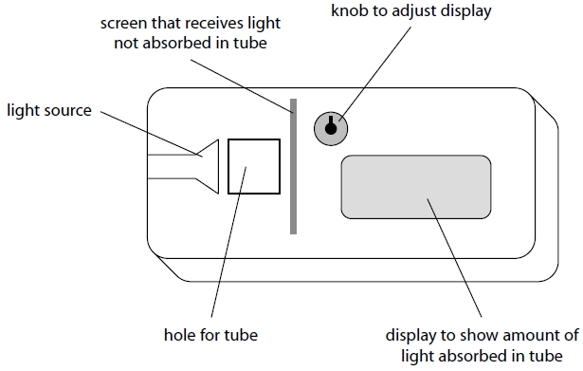

(a)  The student recorded absorbance in the colorimeter every 10 seconds for 60 seconds. He repeated the process and calculated the mean for each 10-second period. The results are shown in the table.

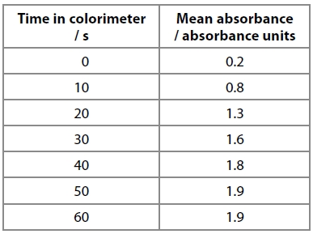

(i)  Calculate the mean rate for the first 20 seconds of this reaction.

**(3)**

Answer ...........................................................

(ii)  Explain why the mean rate changes after the first 20 seconds of this reaction.

**(3)**

.............................................................................................................................................

.............................................................................................................................................

.............................................................................................................................................

.............................................................................................................................................

.............................................................................................................................................

.............................................................................................................................................

(iii)  Describe how the initial rate of reaction could be obtained from a graph of this data. You may use a diagram to illustrate your answer.

**(3)**

.............................................................................................................................................

.............................................................................................................................................

.............................................................................................................................................

.............................................................................................................................................

.............................................................................................................................................

.............................................................................................................................................

(b)  Many fruits turn brown when they are cut open and this is a major cause of food wastage.

(i)  Explain why it is only when fruits are cut open that they are likely to turn brown.

**(2)**

.............................................................................................................................................

.............................................................................................................................................

.............................................................................................................................................

.............................................................................................................................................

(ii)  Explain why the addition of lemon juice, which contains citric acid, will often stop fruits turning brown.

**(3)**

.............................................................................................................................................

.............................................................................................................................................

.............................................................................................................................................

.............................................................................................................................................

.............................................................................................................................................

.............................................................................................................................................

**(Total for question = 14 marks)**

**Q2.**

Lysozyme is an enzyme found in tears. Lysozyme can destroy some bacteria by   
breaking down the polysaccharide chains that form part of their cell walls.

The graph below shows the effect of increasing the concentration of lysozyme on   
the initial rate of destruction of bacteria.

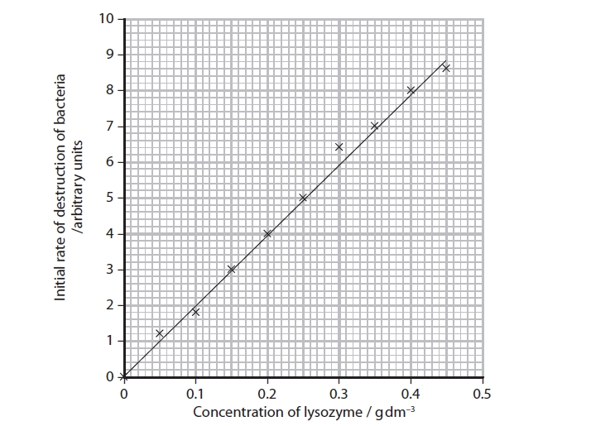

(i)  Using the information in the graph, explain the effect of the concentration of   
      lysozyme on the initial rate of destruction of bacteria.

**(3)**

.............................................................................................................................................

.............................................................................................................................................

.............................................................................................................................................

.............................................................................................................................................

.............................................................................................................................................

.............................................................................................................................................

.............................................................................................................................................

.............................................................................................................................................

(ii)  Suggest why some of the data points in the graph do not fit on a straight line.

**(1)**

.............................................................................................................................................

.............................................................................................................................................

.............................................................................................................................................

.............................................................................................................................................

**Q3.**

The diagram shows the energy changes during an enzyme-controlled reaction.

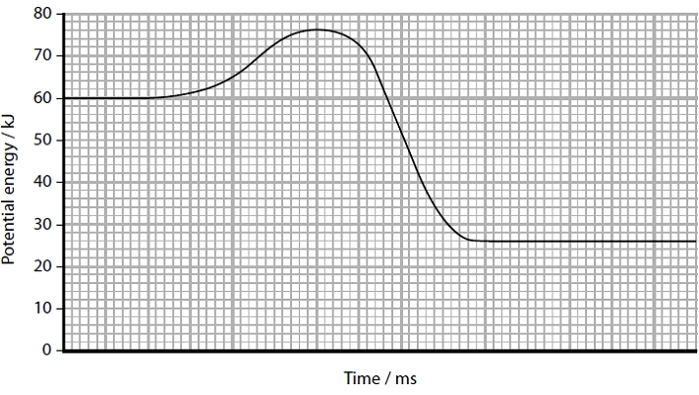

Calculate the activation energy for this reaction.

**(2)**

Answer ........................................................... kJ

**(Total for question = 2 marks)**

**Q4.**

Saquinavir is a drug used in the treatment of HIV.

It binds very precisely to the active site of a HIV protease enzyme and inhibits its action.

Saquinavir is described as peptidomimetic because it is a small protein-like chain designed to resemble a peptide.

Analyse this information to explain what sort of enzyme inhibitor Saquinavir is likely to be.

**(2)**

.............................................................................................................................................

.............................................................................................................................................

.............................................................................................................................................

.............................................................................................................................................

**Q5.**

Lysozyme is an enzyme found in tears. Lysozyme can destroy some bacteria by   
breaking down the polysaccharide chains that form part of their cell walls.

Temperature affects the activity of lysozyme.

Suggest why increasing the temperature above 45 °C causes a decrease in the   
activity of lysozyme.

**(2)**

.............................................................................................................................................

.............................................................................................................................................

.............................................................................................................................................

.............................................................................................................................................

.............................................................................................................................................

.............................................................................................................................................

.............................................................................................................................................

.............................................................................................................................................

**Q6.**

Lysozyme is an enzyme found in tears. Lysozyme can destroy some bacteria by   
breaking down the polysaccharide chains that form part of their cell walls.

The primary structure of lysozyme is a specific sequence of 129 amino acids.

Two of the amino acids that make up the active site are in positions 35 and 52 in   
the primary structure.

Suggest how these two amino acids could be brought closer together to form   
part of the active site of this enzyme.

**(3)**

.............................................................................................................................................

.............................................................................................................................................

.............................................................................................................................................

.............................................................................................................................................

.............................................................................................................................................

.............................................................................................................................................

.............................................................................................................................................

.............................................................................................................................................

.............................................................................................................................................

**Q1.**No Examiner's Report available for this question

**Q2.**

***(i)***

It was very disappointing to see that so many candidates did not read the question carefully and answer the question asked.

Almost all candidates correctly described the nature of the positive correlation shown by the data, so gaining the first mark point. However, for most candidates this was the maximum mark achieved. Most candidates approached this from a describe and manipulate the data point of view and gave lengthy descriptions and calculations of the data. This was because the word "explain" within the rubric of the question was overlooked and most candidates merely described the data.

Some candidates did attempt to discuss the facts that there would be more active sites available, that there would be more collisions between enzyme and substrate or that there would be no enzyme-substrate complexes formed. Some recognised that enzymes lower activation energies and that in this context the enzyme concentration was the limiting factor, or that the substrate concentration must have been in excess when calculating the initial rate.

This response gained all three available marks.

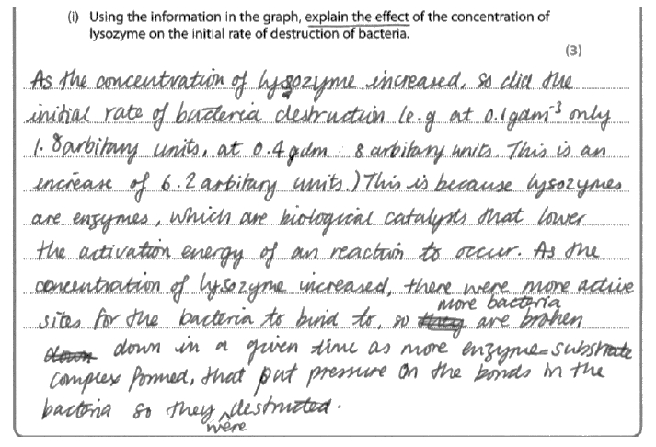

**Results Plus: Examiner Comments**

Credit was given to this response, for the maximum of three marks, for:

• recognition that the enzyme increases the rate of reaction;  
• enzymes lower the activation energy required for the reaction;  
• the higher concentration of enzymes means there are more active sites available;  
• more enzyme substrate complexes can be formed.

This response gained just one mark.

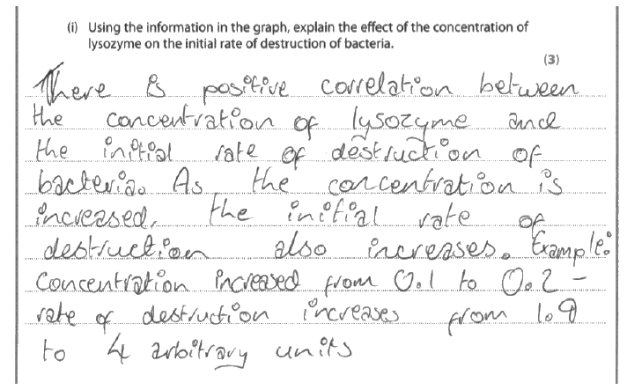

**Results Plus: Examiner Comments**

This response is a typical example of the many responses that gained one mark for recognising that the enzyme caused an increase in the rate of destruction of the bacteria in a description of the data instead of an explanation of the effect asked for in the question.

**Results Plus: Examiner Tip**

Just because you are provided with data don't assume that the question is asking you to describe the data - particularly when the question asks you to **explain** the effect!

***(ii)***

Many candidates stated correctly that the explanation was due to anomalies and so gained the mark. Others chose to appropriately describe inaccuracies in measuring or random errors. However, a significant number of candidates focussed on a description that it is a line of best fit, or just used the term outliers which gained no credit.

One mark for this response.

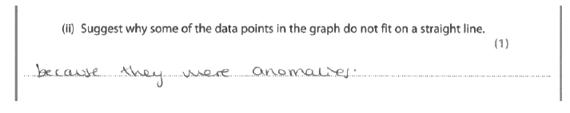

**Results Plus: Examiner Comments**

This is a typical example of the many correct responses to this question.

This response gained no marks.

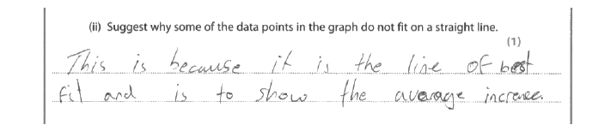

**Results Plus: Examiner Comments**

This example is typical of those who failed to get the mark having concentrated on the line and not on why there may be variation in the results.

**Q3.**No Examiner's Report available for this question

**Q4.**No Examiner's Report available for this question

**Q5.**

A common error here was the discussion that the enzyme would be denatured, rather than specifically mentioning the active site. Nevertheless, many then went on to correctly identify that the active site shape would change and this would prevent the formation of enzyme/substrate complexes. As a result over 50% of candidates gained the maximum two marks for this question.

This response gained both available marks.

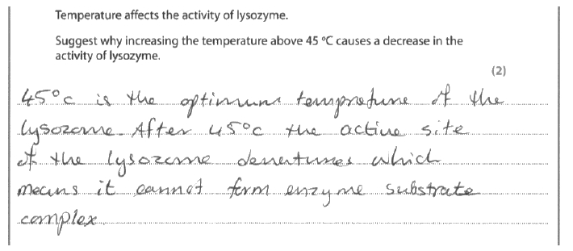

**Results Plus: Examiner Comments**

This response clearly shows the effect on the enzymes active site and the reason this then decreases the activity of the enzyme.

This response gained no marks.

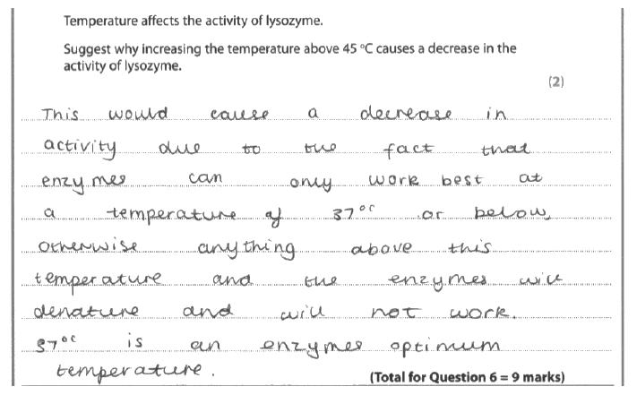

**Results Plus: Examiner Comments**

This is a typical example of a response that did not go beyond a GCSE level response to include some AS level explanation of cause and effect that would have been relevant to this question.

**Results Plus: Examiner Tip**

Just stating that an enzyme is denatured is not sufficient information for AS level Biology in a topic that has been covering the structure and functioning of proteins.

This response gained no marks.

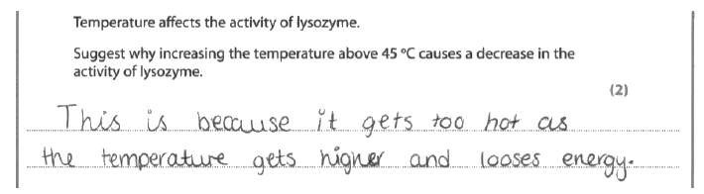

**Results Plus: Examiner Comments**

This candidate was clearly confused about the relationship between temperature and energy and made no reference to the enzyme itself.

**Q6.**

This question gained a full spread of marks with similar numbers scoring 0, 1, 2 or 3 marks.

Many candidates appreciated that folding of the primary structure or the formation of the secondary and tertiary structures was relevant to bring the amino acids closer together. Correct mention of the bonds involved in this process was often seen. However, this was occasionally penalised with the mention of peptide bonds between the relevant two amino acids.

Only approximately 20% of candidates appreciated and described the idea of bonding between R groups. This meant that most candidates effectively limited themselves to a maximum of two marks.

A significant number of candidates approached this question from the point of view that a change in the amino acid sequence was brought about by deletion, substitution or hydrolysis (by mutation or genetic engineering), so bringing the amino acids closer together. This gained no credit.

This response gained all three available marks.

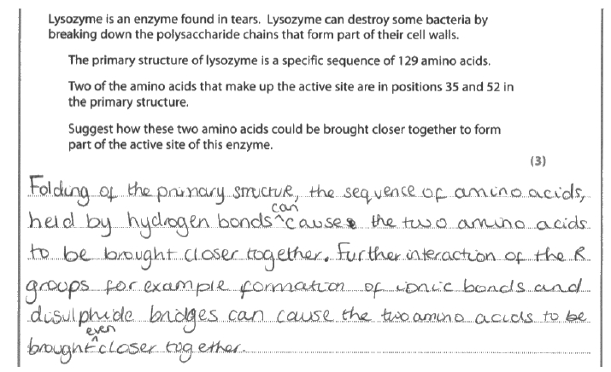

**Results Plus: Examiner Comments**

Credit was given for:

• recognition of the folding of the primary structure  
• naming bonds involved  
• recognising that bonds form between the R groups of the amino acids.

This response failed to score any marks.

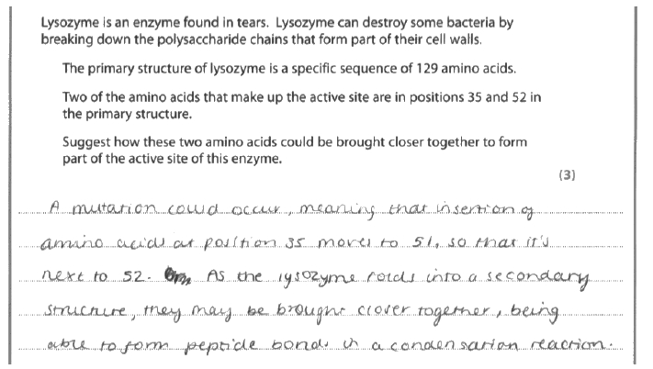

**Results Plus: Examiner Comments**

This is an example of the common error of thinking that a mutation (or genetic engineering) would be the cause of bringing the amino acids close together in the final structure of the enzyme.

**Mark Scheme**

Q1.

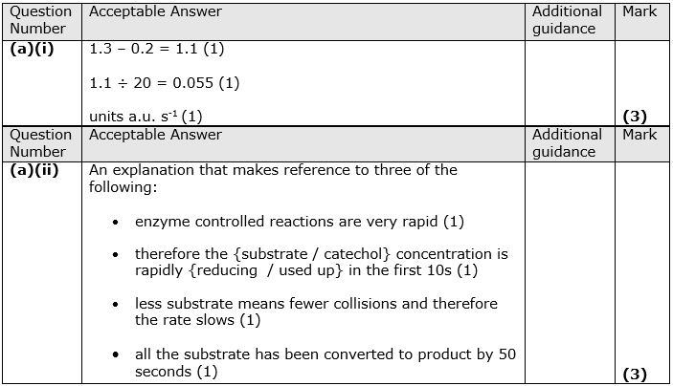

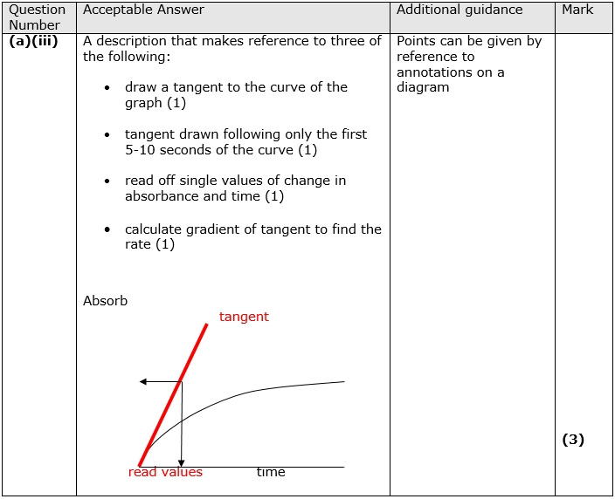

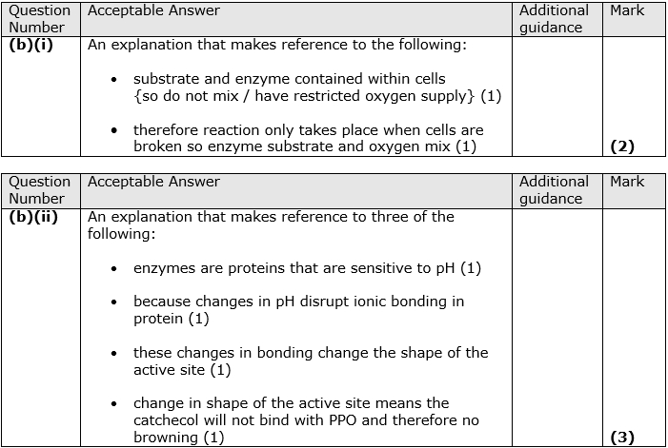

**Q2.**

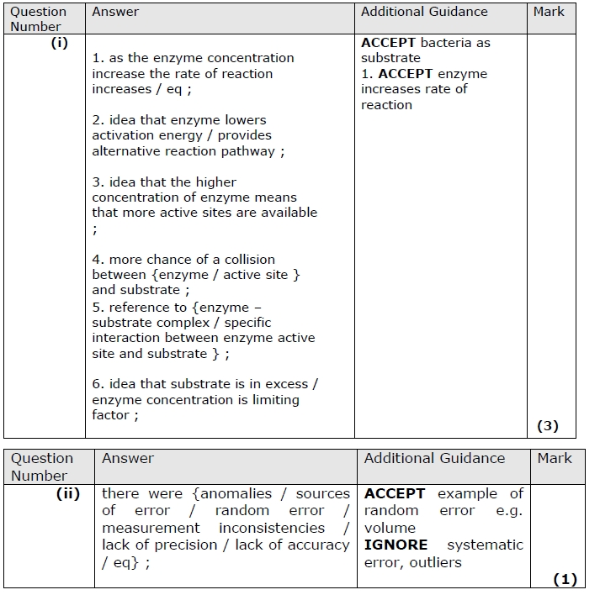

**Q3.**

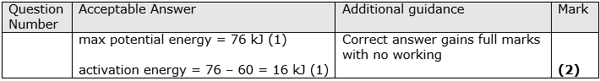

**Q4.**

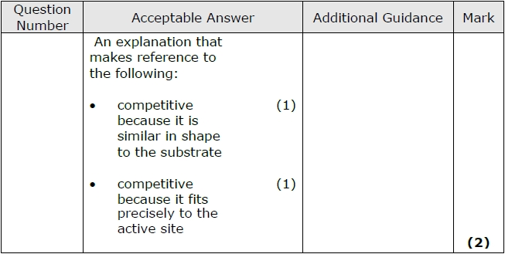

**Q5.**

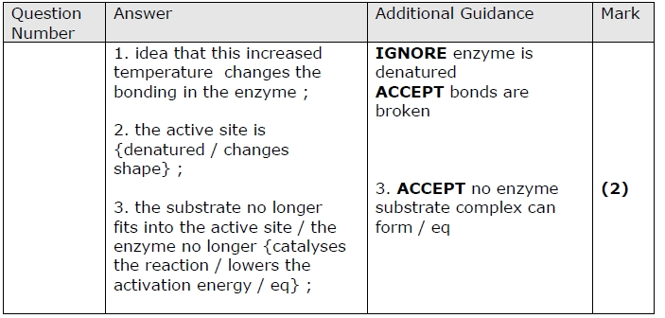

**Q6.**

