# Bubble sort

* The bubble sort algorithm works through iteration
* This means that the data is repeatedly checked through
* Items in a collection of data are swapped by comparing consecutive elements – if the next element is smaller than the current, swap them
* This is repeated until the data is in order

## Pseudocode

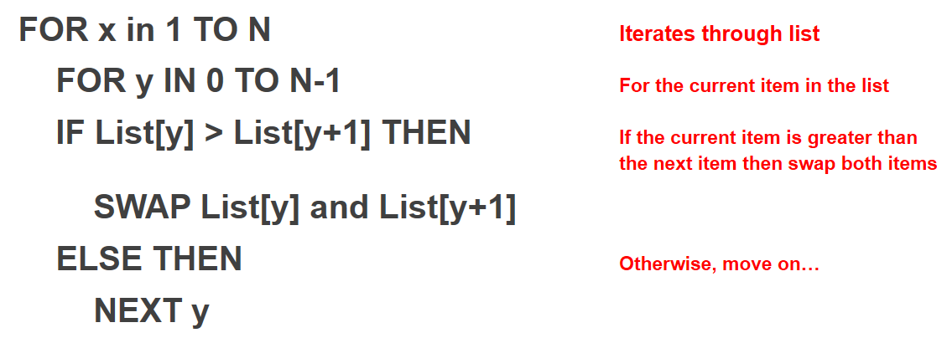

**Key Learning Point:** Merge sort is “divide and conquer” – data is divided, sorted into lists, and sorted from there