

**Higher IGCSE (9 – 1) Revision Pack**

**Ratio**

**Name --------------------------------**

**Questions**

**Q1.**

The perimeter of a triangle is 90 cm.  
 The lengths of the sides of the triangle are in the ratios 3 : 5 : 7.

Work out the length of the longest side of the triangle.

........................................................... cm

**(Total for question = 5 marks)**

**Q2.**

Jack, Kate and Lila share some money in the ratios 5 : 9 : 6  
 In total, Jack and Kate receive £56

Work out the amount of money Lila receives.

£...........................................................

**(Total for question = 3 marks)**

**Q3.**

Work out the difference between the largest share and the smallest share when 3450 yen is divided in the ratios 2 : 6 : 7

........................................................... yen

**(Total for question = 3 marks)**

**Q4.**

A school has 840 pupils and 40 teachers.

(a)  Find the ratio of the number of pupils to the number of teachers.   
Give your ratio in the form *n* : 1

........................................................... : 1

**(2)**

In Year 11 at the school, the ratio of the number of pupils who study Chemistry to the number of pupils who study Physics is 3 : 2

(b)  105 pupils in Year 11 study Chemistry.   
Work out the number of pupils in Year 11 who study Physics.

...........................................................

**(2)**

For the 105 pupils who study Chemistry, the ratio of the number of boys to the number of girls is 4 : 3

(c)  Work out the number of girls in Year 11 who study Chemistry.

...........................................................

**(2)**

**(Total for Question is 6 marks)**

**Q5.**

In a school, there is a total of 640 children.   
The ratio of the number of girls to the number of boys is 7 : 9

How many boys are there in this school?

...........................................................

**(Total for question = 2 marks)**

**Q6.**

Louis makes a model of a plane.

The wingspan of the model is 50 centimetres.   
The wingspan of the real plane is 80 metres.

(a)  Work out the scale of the model.

Give your answer in the form 1: *n*

1: ...........................................................

**(2)**

The length of the real plane is 72 metres.

(b)  Work out the length of the model.

Give your answer in centimetres.

........................................................... centimetres

**(2)**

**(Total for question = 4 marks)**

**Q7.**

There are 90 counters in a bag.   
Each counter in the bag is either red or blue so that

the number of red counters : the number of blue counters = 2 : 13

Li is going to put some more red counters in the bag so that

the probability of taking at random a red counter from the bag is

Work out the number of red counters that Li is going to put in the bag.

**(Total for question = 4 marks)**

**Q8.**

(a) There are 32 students in a class.   
All the students are either left-handed or right-handed.  
The ratio of the number of left-handed students to the number of right-handed  
students is 1 : 7

Work out the number of right-handed students.

...........................................................

**(2)**

(b) Sajid makes a scale model of a lorry.   
He uses a scale of 1 : 32  
The length of Sajid's model lorry is 45 cm.  
Chitra makes a scale model of the same lorry.  
She uses a scale of 1 : 72

Work out the length of Chitra's model lorry.

........................................................... cm

**(3)**

**(Total for question is 5 marks)**

**Q9.**

Jalin lives in England.   
He does a search on the internet and sees the same type of camera on sale in France and in America.

In France, the camera costs 126 euros.   
In America, the camera costs $165.24

Jalin finds out these exchange rates.

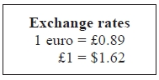

How much cheaper is the camera in America than in France?   
Give your answer in pounds (£).

£ ...........................................................

**(Total for Question is 4 marks)**

**Q10.**

Bhavin, Max and Imran share 6000 rupees in the ratios 2 : 3 : 7

Imran then gives of his share of the money to Bhavin.

What percentage of the 6000 rupees does Bhavin now have?   
Give your answer correct to the nearest whole number.

........................................................... %

**(Total for question = 5 marks)**

**Q11.**

There are 80 counters in a bag.   
The counters are either red or blue.

The ratio of the number of red counters to the number of blue counters is 3 : 1

Michael takes 15% of the red counters out of the bag.

Alison takes of the blue counters out of the bag.

How many counters are now in the bag?

...........................................................

**(Total for question = 5 marks)**

**Q12.**

Rachel, Mario and Sanjit share some money in the ratios 4 : 3 : 9   
Mario receives £96   
Work out the difference between the amount received by Rachel and the amount received by Sanjit.

£ ...........................................................

**(Total for question = 3 marks)**

**Q13.**

Manu, Liam and Ned share £420 in the rations 4 : 5 : 3   
Liam then gives Ned £75

Express the amount of money that Ned now has as a percentage of the £420   
Give your answer correct to the nearest whole number.

........................................................... %

**(Total for question = 4 marks)**

**Q14.**

Mortar mix is made by mixing cement, sand and quicklime in the ratio 1 : 2 : 3

(a)   Work out the volume of sand needed to make 2.1 m3 of mortar mix.

........................................................... m3

**(2)**

Julie has 0.75 m3 of quicklime.

She has plenty of sand and cement.

(b)   Work out the greatest volume of mortar mix she could make.

........................................................... m3

**(2)**

**(Total for Question is 4 marks)**

**Q15.**

The lengths of the sides of a triangle are in the ratios 2 : 6 : 7   
The length of the longest side of the triangle is 24.5 cm.

Work out the perimeter of the triangle.

........................................................... cm

**(Total for question = 3 marks)**

**Q16.**

In the 2012 Paralympic Games, the total number of gold and silver medals won by Brazil was 35   
The ratio of the number of gold medals that Brazil won to the number of silver medals that Brazil won was 3 : 2

How many silver medals were won by Brazil?

...........................................................

**(Total for Question is 2 marks)**

**Q17.**

Here is a list of ingredients needed to make 16 cookies.

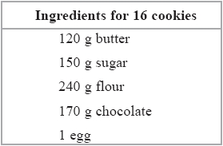

Max wants to make 40 cookies.

(a)  How much flour does Max need?

........................................................... g

**(2)**

Abby made cookies to sell at a school fair.   
She used 600 g of butter.

(b)  How many cookies did she make?

...........................................................

**(2)**

(c)  Find the ratio of the weight of sugar to the weight of flour in the list of ingredients.

Give your answer in the form 1: *n*

1 : ...........................................................

**(2)**

**(Total for question = 6 marks)**

**Q18.**

A shop, *Furniture 4U*, had a sale.

(a) In the sale, normal prices were reduced by 15%.

(i) The normal price of a table was $280

Work out the sale price of the table.

$...........................................................

(ii) The normal price of a chair was reduced in the sale by $24

Work out the normal price of the chair.

$...........................................................

**(6)**

(b) Ruth, Suha and Yasmin went to the sale.   
The amounts of money spent by Ruth, Suha and Yasmin were in the ratios 2 : 3 : 7  
Ruth and Suha spent a total of $320 in the sale.

Work out the amount of money Yasmin spent in the sale.

$...........................................................

**(3)**

**(Total for question = 9 marks)**

**Q19.**

There are 20 students in a class.  
 12 of the students are girls.

Find the ratio of the number of girls to the number of boys.  
 Give your ratio in the form *n* : 1

...........................................................: 1

**(Total for question = 2 marks)**

**Q20.**

A lion is 224 cm long.

Simon makes a scale model of the lion.   
He uses a scale of 1 : 8

(a)  Work out the length of the scale model.

........................................................... cm

**(2)**

In 2010, there were 411 Asiatic lions in India.   
In 2015, there were 523 Asiatic lions in India.

(b)  Work out the percentage increase in the number of Asiatic lions in India from 2010 to 2015

Give your answer correct to 1 decimal place.

........................................................... %

**(3)**

**(Total for question = 5 marks)**

**Q21.**

On a map, 4 centimetres represents a real distance of 1 kilometre.

(a)  On the map, the distance between two points is 14 cm.   
Work out the real distance between these two points.   
Give your answer in kilometres.

........................................................... km

**(2)**

(b)  Work out the scale of the map in the form 1: *n*

1 : ...........................................................

**(2)**

**(Total for Question is 4 marks)**

**Mark Scheme**

Q1.

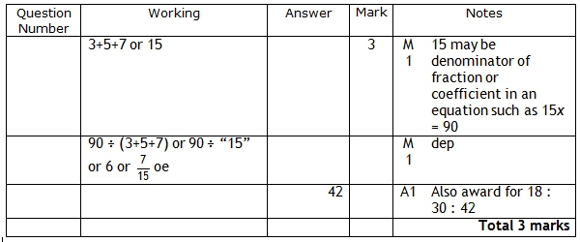

**Q2.**

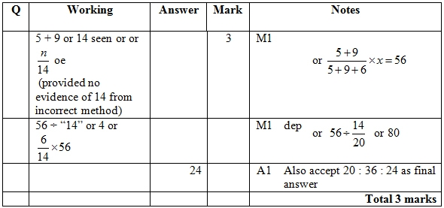

**Q3.**

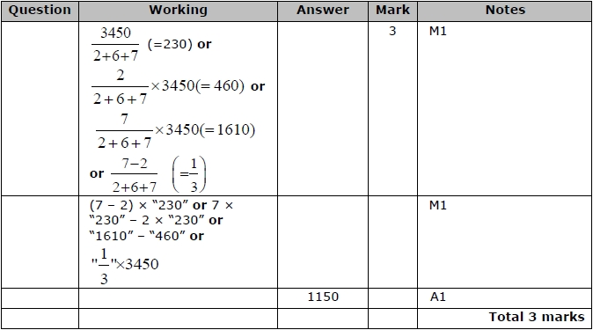

**Q4.**

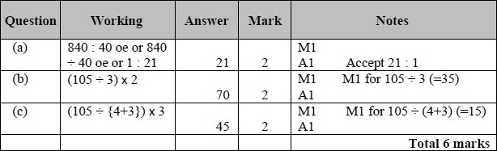

**Q5.**

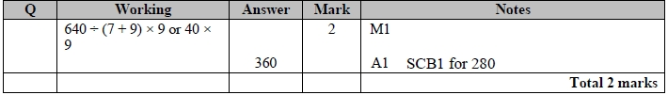

**Q6.**

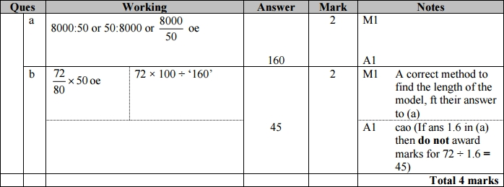

**Q7.**

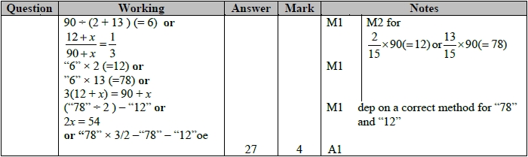

**Q8.**

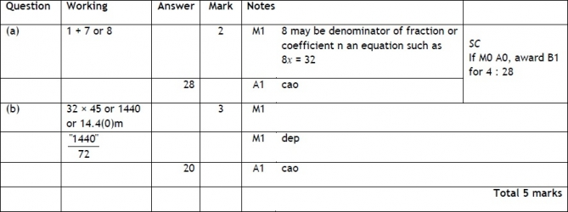

**Q9.**

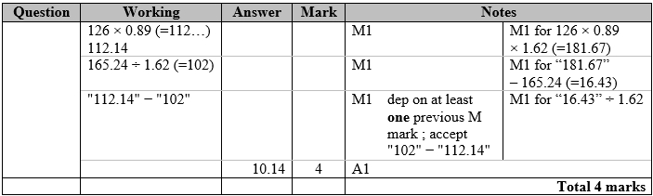

**Q10.**

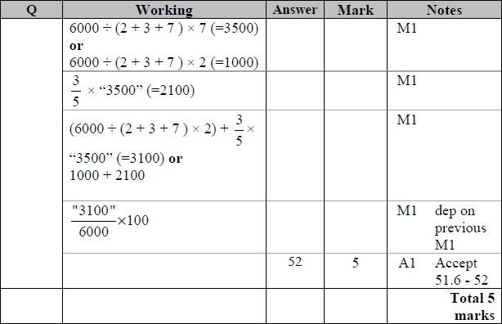

**Q11.**

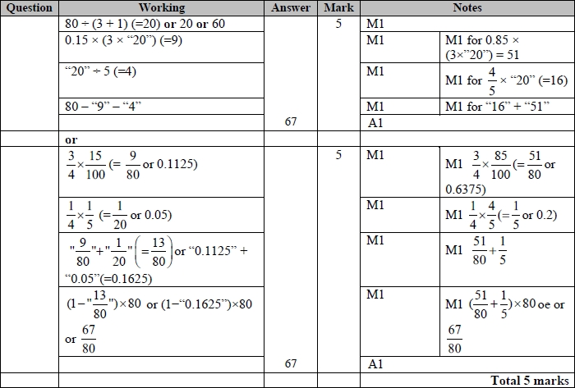

**Q12.**

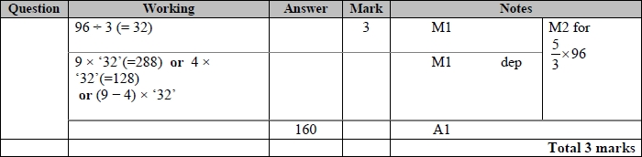

**Q13.**

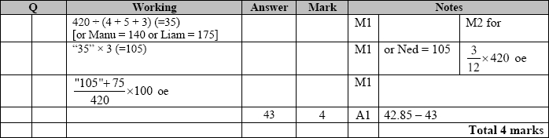

**Q14.**

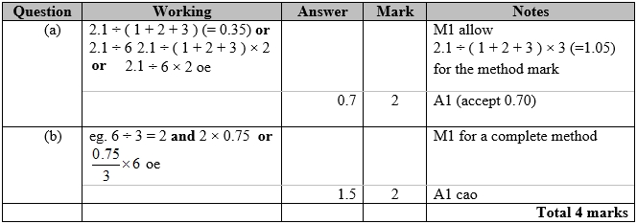

**Q15.**

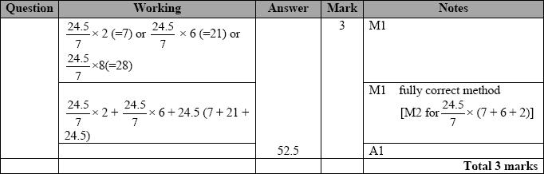

**Q16.**

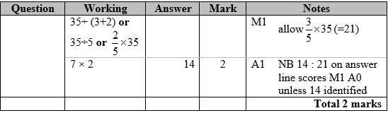

**Q17.**

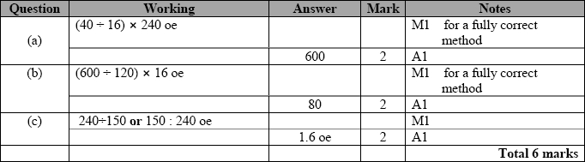

**Q18.**

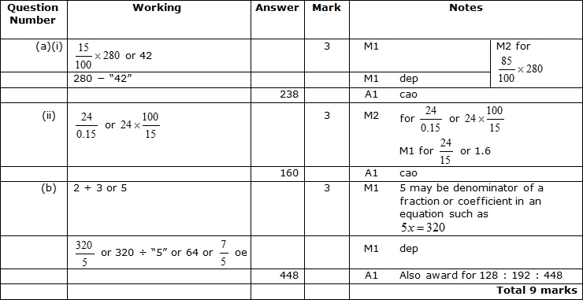

**Q19.**

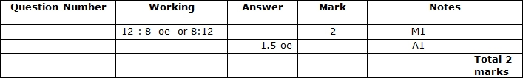

**Q20.**

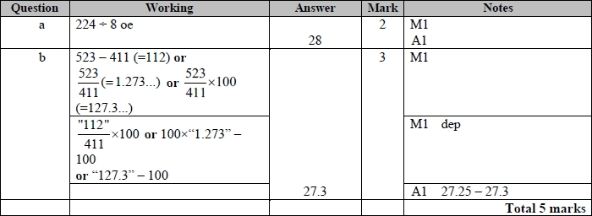

**Q21.**

