

Lower 4 Religious Studies

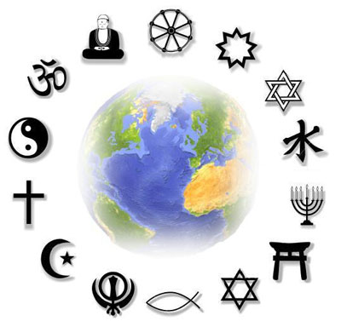

Revision Booklet

Revision Checklist

|  |  |  |  |
| --- | --- | --- | --- |
| Topic | Revise 1 | Revise 2 | Consolidate |
| Hinduism – Concept of God (p.3) |  |  |  |
| Hinduism – Reincarnation (p.4) |  |  |  |
| Hinduism – The Caste system |  |  |  |
| Hinduism – The Ramayana and the festival of Diwali |  |  |  |
| Buddhism - The Life of the Buddha |  |  |  |
| Buddhism – The Four Noble Truths |  |  |  |
| Buddhism – The Eightfold Path |  |  |  |
| Buddhism - The Five Precepts/Pansils |  |  |  |
| Buddhism - Anicca and Anatta |  |  |  |
| Sikhism – Life and teachings of Guru Nanak |  |  |  |
| Sikhism – Guru Granth Sahib |  |  |  |
| Sikhism – the 5 Ks |  |  |  |
| The core beliefs and practices of AT LEAST TWO other ‘minority’ religions. (p.17) |  |  |  |



Key Terms – Use this space to write any key terms that you need to remember.

Hinduism – Concept of God



Key Terms:

**Monotheism:** Belief in one God.

**Polytheism:** Belief in more than one God.

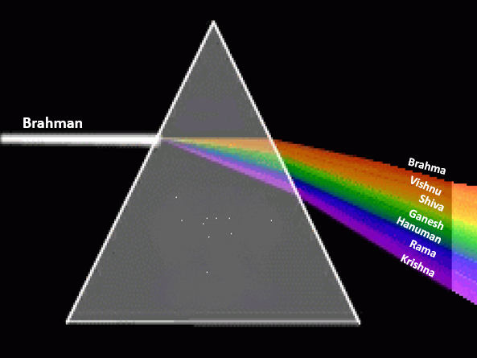Q. What do these pictures show us about the Hindu concept of God?

…………………………………………………

…………………………………………………

…………………………………………………

…………………………………………………

…………………………………………………

…………………………………………………

…………………………………………………

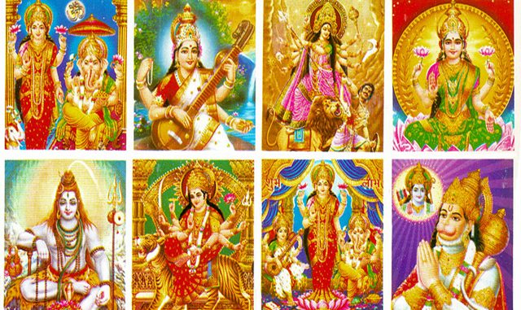…………………………………………………

…………………………………………………

…………………………………………………

…………………………………………………

…………………………………………………

…………………………………………………

…………………………………………………

…………………………………………………

…………………………………………………

Q. Do you think Hindus are **monotheists** or **polytheists**?

…………………………………………………………………………………………………………………..

…………………………………………………………………………………………………………………..

…………………………………………………………………………………………………………………..

…………………………………………………………………………………………………………………..

…………………………………………………………………………………………………………………..

…………………………………………………………………………………………………………………..

Hinduism – Reincarnation

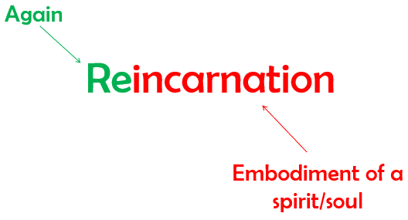

Key Terms

Being born again into

another body after death.

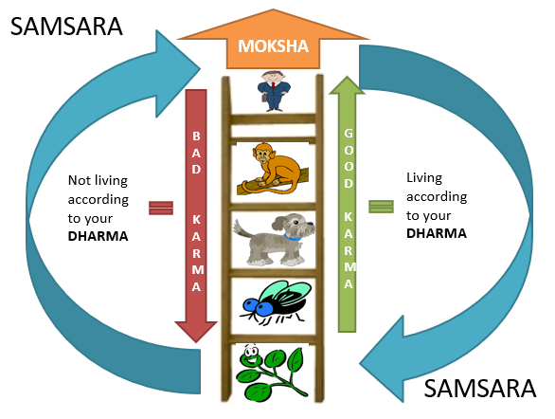Hindus believe that the Atman (soul) goes through many lives in many different bodies. Use the diagram below to help you explain the other four key terms:

Samsara

Dharma

Karma Moksha

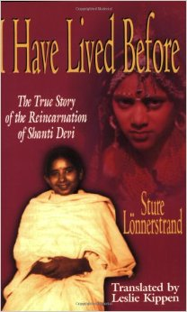

Q. Why do some Hindus see the story of Shanti Devi as proof of reincarnation?

…………………………………………………………………………………….

…………………………………………………………………………………….

…………………………………………………………………………………….

…………………………………………………………………………………….

…………………………………………………………………………………….

…………………………………………………………………………………….

Hinduism – The Caste System

As explained above, Hindus believe that the life you are born into is dependent on the karma you have generated within your previous life/lives. There is a hierarchy (ladder) of different lives with human beings at the top. However, they also believe that there are different ‘ranks’ of being human called a ‘caste’ or ‘varna’.

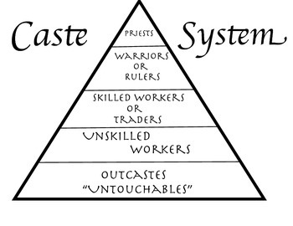Each caste has a different dharma, known as their varnashramadharma. What does this mean?

…………………………………….

…………………………………….

…………………………………….

…………………………………….

…………………………………….

…………………………………….

…………………………………….

How do Hindus view people in the other castes and what do they believe the relationships between the castes should be?

…………………………………………………………………………………………………………………..

…………………………………………………………………………………………………………………..

…………………………………………………………………………………………………………………..

…………………………………………………………………………………………………………………..

…………………………………………………………………………………………………………………..

…………………………………………………………………………………………………………………..

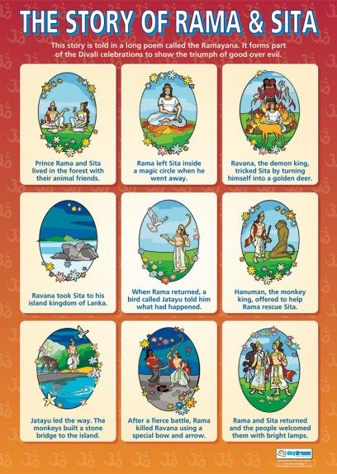Hinduism – The Ramayana

Hinduism – Diwali

The Hindu festival of Diwali remembers and celebrates the story of the Ramayana. On the page below, complete the mind map explaining how the festival is celebrated:

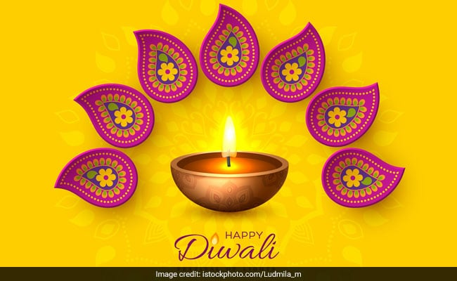

Buddhism – Life of the Buddha

Siddartha Gautama, who later became the Buddha, began his life as a prince who lived the perfect life. His father shielded him from anything bad and he grew up knowing only pleasure and happiness. One day however, he left the palace walls for the first time and saw three things which changed his life:

1.

2.

3.

4. He then met a holy man who inspired him to leave the palace and his family to seek the truth.

Q. After seeing the four sights, why was the Buddha inspired to seek truth?

…………………………………………………………………………………………………………………..

…………………………………………………………………………………………………………………..

…………………………………………………………………………………………………………………..

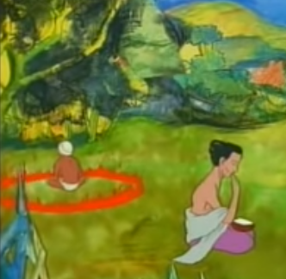What happened to the Buddha after leaving the palace? Describe what is going on in the two pictures below and what the outcome was. (YouTube – Life of the Buddha animated)

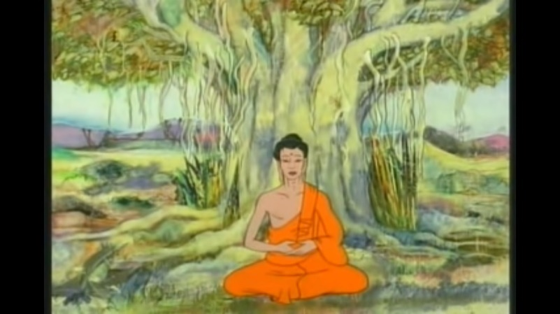

Buddhism – The Four Noble Truths

After achieving enlightenment, the Buddha gave his first teachings which are the foundation of Buddhism: the Four Noble Truths:

1.

2.

3.

4.

The fourth noble truth is then expanded into the noble eightfold path:

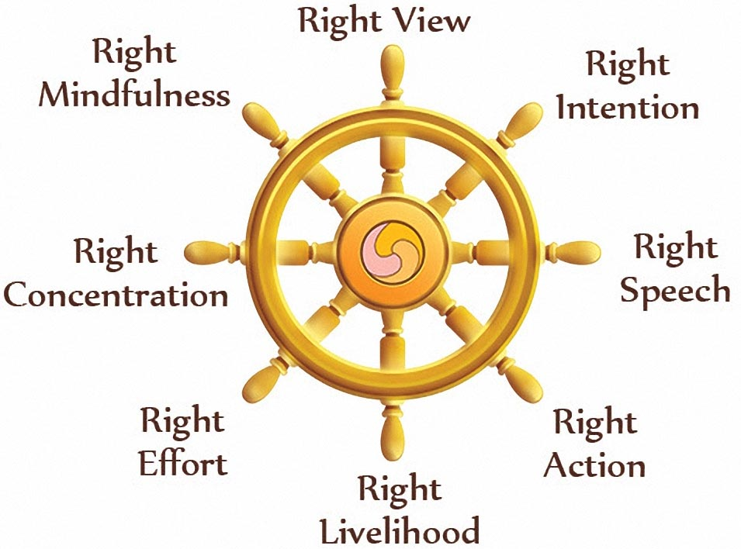

Buddhism – The Five Precepts/Pansils

As well as the eightfold path, the Buddha taught five precepts (pansils) that Buddhist must live by:

1.

2.

3.

4.

5.

Buddhism – Anicca and Anatta

The Buddhist understanding of the world is underpinned by their concepts of anicca and anatta. Below, explain what each of these means. The pictures may help you remember:

Anicca:

Anatta:

Sikhism – Life of Guru Nanak

If you need a reminder of this story, you can watch the video on YouTube if you type in: The Life of Guru Nanak (Animation Divx)

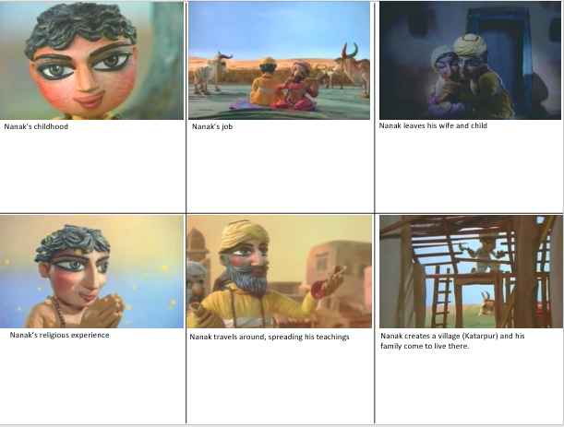

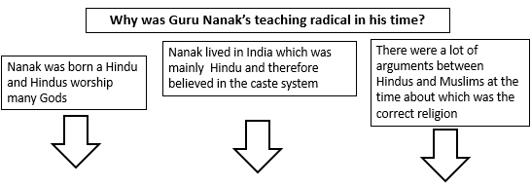

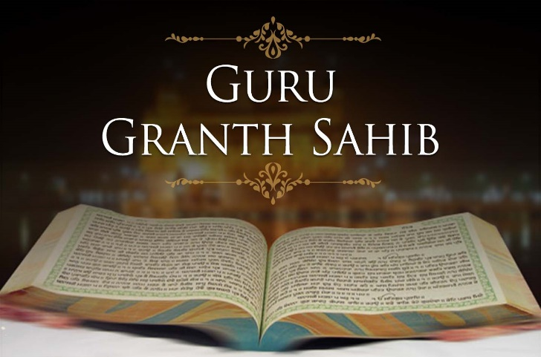Sikhism – Guru Granth Sahib

Q. Why do Sikhs believe the Guru Granth Sahib to be so important?

……………………………………………...……………

...…………………………………………………………

..…………………………………………………………

…………………………………………………………………………………………………………………..

…………………………………………………………………………………………………………………..

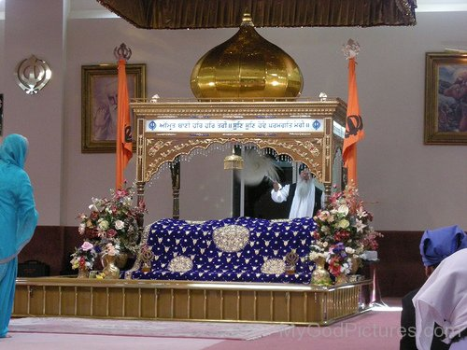

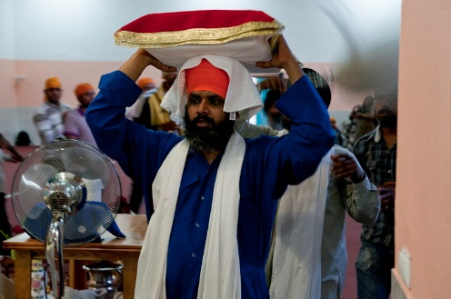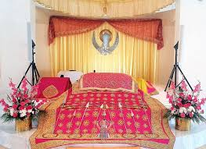

Sikhism – The 5 Ks

Below are the names of the 5 Ks, a picture of each of them and their significance. Can you correctly match each group of 3?

Kangha

It is a highly visible symbol of membership of the group and indicates that one is willing to accept God's gift as God intended.

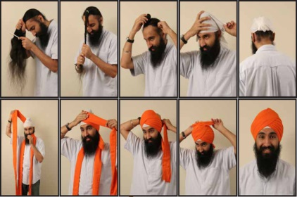

It is a symbol of God having no beginning or end and therefore acts as a reminder that a Sikh should not do anything of which God would not approve.

Kirpan

It symbolises a clean mind and body and the importance of looking after the body which God has created.



Kesh



Kangha

Kachera

It symbolises that a Sikh should fight against injustice and evil in the world. It also shows that Sikhs are to be defenders of the weak.

Kara



Kachera

It is a symbol of modesty.