

**Higher IGCSE (9 – 1) Revision Pack**

**Bearings 1**

**Name --------------------------------**

**Questions**

**Q1.**

The bearing of a ship from a lighthouse is 050°

Work out the bearing of the lighthouse from the ship.

...........................................................°

**(Total for Question is 2 marks)**

**Q2.**

Here is a map.  
The map shows two towns, Burford and Hightown.

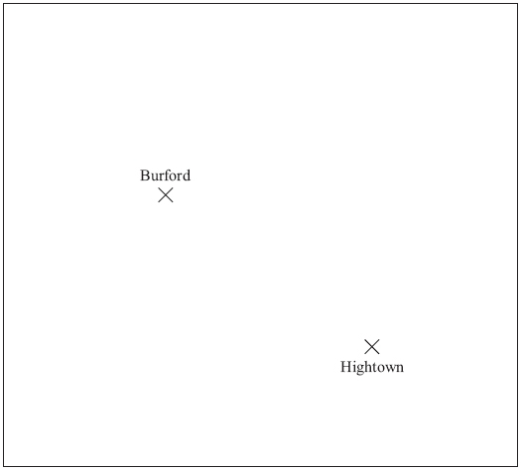  
                                                                                       Scale: 1 cm represents 10 km

A company is going to build a warehouse.

The warehouse will be less than 30 km from Burford **and** less than 50 km from Hightown.

Shade the region on the map where the company can build the warehouse.

**(Total for Question is 3 marks)**

**Q3.**

The diagram shows the position of two churches, *A* and *B*.

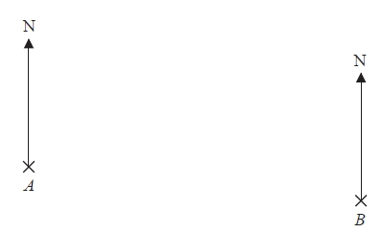

Church *C* is on a bearing of 130° from church *A*.   
Church *C* is on a bearing of 245° from church *B*.

In the space above, draw an accurate diagram to show the position of church *C*.

Mark the position of church *C* with a cross ().   
Label it *C*.

**(Total for question = 3 marks)**

**Q4.**

The diagram shows the positions of a lighthouse and a harbour on a map.

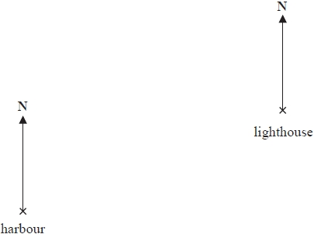

A boat is on a bearing of

300° from the lighthouse

040° from the harbour.

(a) On the diagram, mark with a cross (×) the position of the boat.   
Label the boat *B*.

**(3)**

The scale of the map is 1 cm represents 50 000 cm.

(b)  Work out the real distance from the harbour to the lighthouse.   
Give your answer in km.

...........................................................km

**(2)**

**(Total for question = 5 marks)**

**Q5.**

Manchester airport is on a bearing of 330° from a London airport.

(a)  Find the bearing of the London airport from Manchester airport.

...........................................................°

**(2)**

The London airport is 200 miles from Manchester airport.

A plane leaves Manchester airport at 10 am to fly to the London airport.   
The plane flies at an average speed of 120 mph.

(b)  What time does the plane arrive at the London airport?

...........................................................

**(4)**

**(Total for question = 6 marks)**

**Q6.**

The accurate scale drawing shows a map of an island.

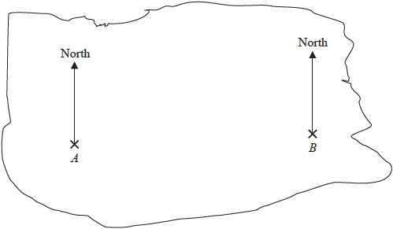

*A* and *B* are points on the island.   
The real distance, in kilometres, between *A* and *B* is 56 km.

Treasure is buried at point *C* on the island.   
Point *C* is 35 km from *A* and on a bearing of 300° from *B*.

Mark the point *C* with a cross ().

**(Total for question = 5 marks)**

**Q7.**

The diagram shows the positions of three points, *A*, *B* and *C*, on a map.

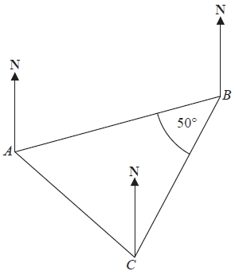

The bearing of *B* from *A* is 070°

Angle *ABC* is 50°   
*AB* = *CB*

Work out the bearing of *C* from *A*.

........................................................... °

**(Total for question is 3 marks)**

**Q8.**

The diagram shows the positions of three turbines *A*, *B* and *C*.

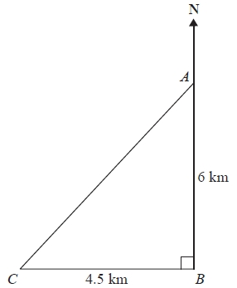

Diagram **NOT** accurately drawn

*A* is 6 km due north of turbine *B*.   
*C* is 4.5 km due west of turbine *B*.

(a) Calculate the distance *AC*.

...........................................................km

**(3)**

(b) Calculate the bearing of *C* from *A*.   
Give your answer correct to the nearest degree.

...........................................................°

**(4)**

**(Total for Question is 7 marks)**

**Q9.**

The diagram shows the positions of two lighthouses, *A* and *B*, on a map.

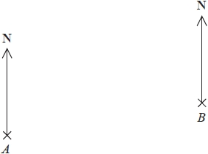

A ship is on a bearing of 070° from *A*.   
The ship is also on a bearing of 320° from *B*.

Mark the position of the ship with a cross (×) and label it *C*.

**(Total for question = 3 marks)**

**Q10.**

The diagram shows the positions of a lighthouse *L*, a yacht *Y* and a tanker *T* on a map.

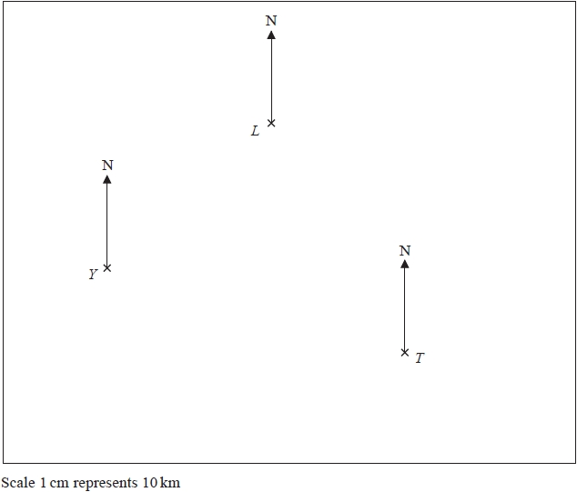

(a)  Measure the bearing of *L* from *Y*.

........................................................... °

**(1)**

The tanker, *T*, sails 80 km on a bearing of 320°.

(b)  Find the distance, in km, between the tanker and the lighthouse when the tanker is closest to the lighthouse.

........................................................... km

**(2)**

**(Total for question = 3 marks)**

**Q11.**

**\*** Here is a map.  
    The position of a ship, S, is marked on the map.

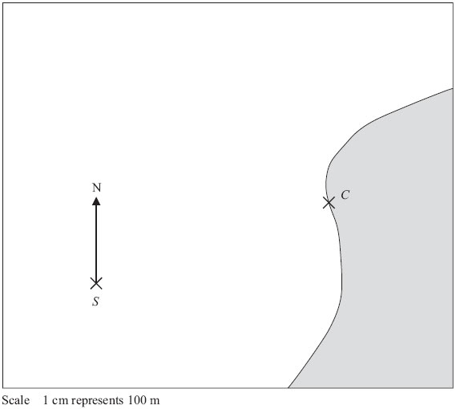

Point *C* is on the coast.  
 Ships must not sail closer than 500 m to point *C*.

The ship sails on a bearing of 037°

Will the ship sail closer than 500 m to point *C*?  
 You must explain your answer.

**(Total for Question is 3 marks)**

**Q12.**

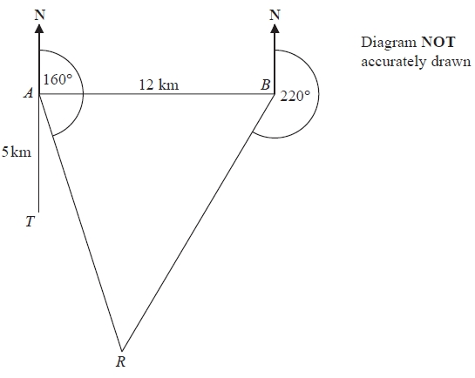

There is a coastguard station at point *A* and at point *B*.   
*B* is due East of *A*.   
The distance from *A* to *B* is 12 km.

There is a rowing boat at point *R*.   
*R* is on a bearing of 160° from A.   
*R* is on a bearing of 220° from B.

There is a speedboat at point *T*.   
*T* is 5 km due South of *A*.

Work out the shortest distance from *T* to *R*.   
Give your answer correct to 1 decimal place.   
You must show all your working.

...........................................................km

**(Total for question = 5 marks)**

**Q13.**

The diagram shows the position of town *A*.

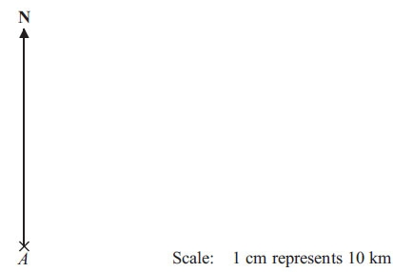

Town *B* is 64 km from town *A* on a bearing of 070°.

Mark the position of town *B*, with a cross (×).  
 Use a scale of 1 cm represents 10 km.

**(Total for Question is 2 marks)**

**Q14.**

The diagram shows the position of two boats, *B* and *C*.

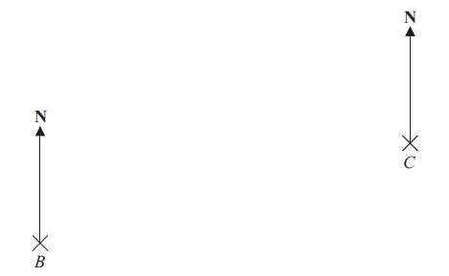

Boat *T* is on a bearing of 060° from boat *B*.  
 Boat *T* is on a bearing of 285° from boat *C*.

In the space above, draw an accurate diagram to show the position of boat *T*.

Mark the position of boat *T* with a cross (×).  
 Label it *T*.

**(Total for Question is 3 marks)**

**Q15.**

The diagram shows the positions of a tower and a tree.

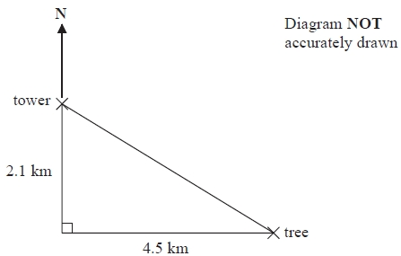

The tree is 2.1 km South of the tower and 4.5 km East of the tower.

(a) Work out the distance between the tower and the tree.   
Give your answer correct to one decimal place.

...........................................................km

**(3)**

(b) Work out the bearing of the tree from the tower.   
Give your answer correct to the nearest degree.

...........................................................°

**(4)**

**(Total for Question is 7 marks)**

**Q16.**

The diagram shows the position of a lighthouse *L* and a harbour *H*.

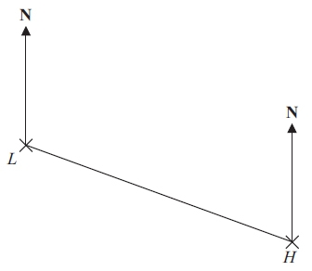

The scale of the diagram is 1 cm represents 5 km.

(a) Work out the real distance between *L* and *H*.

. . . . . . . . . . . . . . . . . . . . . . km

**(1)**

(b) Measure the bearing of *H* from *L*.

. . . . . . . . . . . . . . . . . . . . . . °

**(1)**

A boat *B* is 20 km from *H* on a bearing of 040°.

(c) On the diagram, mark the position of boat *B* with a cross (×).  
Label it *B*.

**(2)**

**(Total for Question is 4 marks)**