Year 2 Sociology

**Paper 3: Crime and Deviance with Theory & Methods**

 Booklet 7 part 4: Globalisation and crime in contemporary society; the media and crime; green crime; human rights and state crimes.

Part 3 – green crime.

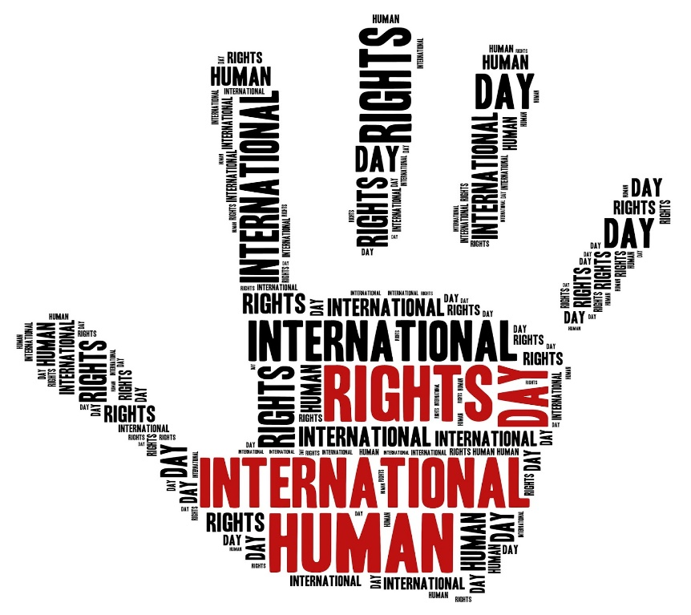

Name ______________________________

Specification Content:

What you need to know for **Crime and Deviance** in your Paper 3 exam.

Students are expected to be familiar with sociological explanations of the following content:

* globalisation and crime in contemporary society; the media and crime; green crime; human rights and state crimes

|  |  |  |  |  |  |
| --- | --- | --- | --- | --- | --- |
| **Questions may be based specifically on the following areas:** | | Do I have completed Notes? | Have I made revision Notes? | Have I memorised this info? | Have I practised exam style questions? |
| Globalisation | Globalisation and crime in contemporary society, eg transnational organised crime, global criminal organisations, global capitalism and crimes of the powerful.  **Castells, Held, Taylor, Hobbs & Dunningham, Glenny** |  |  |  |  |
| Media | The media and crime, eg media representations of crime, the media as a cause of crime and moral panics.  **S.Cohen, Young, Jewkes, McRobbie & Thornton** |  |  |  |  |
| Green crime | Green crime, eg types of green crime and green criminology.  **South, Beck, White** |  |  |  |  |
| Human rights | Human rights and state crimes, eg war, genocide and torture, and human rights abuses.  **McLaughlin, H & J Schwendinger** |  |  |  |  |

Exam Structure:

**These topics will appear in paper 3 of the A’Level.** 2 hour written exam 80 marks in total (50 for this bit)

* 33.3% of A-level

Crime and Deviance: short answer and extended writing, 50 marks (4 marks, 6 marks, 10 marks, 30 marks)

Marxists and critical criminologists would claim that traditional criminology focusses on crimes of the streets ignoring ‘crimes of the suites’ (those committed by big business). State crime is like corporate crime in that it is another example of crimes of the powerful. The state is responsible for making and enforcing the law but also sometimes breaks the law.

Definition of state crime?

Green and Ward

McLaughlin – 4 categories of State Crime?

Examples of State Crime?

How do we define it? It is not *straightforward* to define.

*Chambliss* suggests that we define state crime as ‘acts defined by law as criminal and committed by state officials in pursuit of their jobs as representatives of the state’. But this is a problem if we use a state’s own domestic law to define state crime. Something may be illegal on one side of the border but legal on another. States could make laws which would allow them to commit harmful acts. Eg German Nazi state passed a law that it was legal to compulsorily sterilise the disabled.

A trangressive approach

Like with green crime perhaps we need a transgressive approach to state crime. This would define crime outside the usual boundaries of simply defining crime as law breaking. Should we be focussing on zemiology (study of harms) if social harms are committed, even if not ‘against the law’ are these crimes?

Schwendinger & Schwendinger and Green and Ward suggest that we should define a state crime as a violation of human rights. They argue that the sociologists role is to defend human rights. If states practice imperialism., racism, sexism or economic exploitations deny people their basic rights. If we accept a legal definition (that crimes are simply whatever the state says they are) then this may be too limited. A *transgressive* approach avoids us being subservient to the state’s interests.

BUT Stanley Cohen criticises this view saying that some state crimes (genocide, torture) are clearly crimes, we should not define all harmful acts as criminal, even if they are morally acceptable – for example economic exploitation.

How to we explain state crime?

Genocides may be ordered by leaders of states but require the cooperation of ordinary people. Why would large numbers of people conform?

**Authoritarian personality** – this includes having a willingness to obey others without question. During WW2 many Germans displayed this authoritarian personality due to the disciplinarian socialisation patterns that were common at the time.

**Crimes of obedience** – individuals may be socialised to see atrocities as accepted or required. Usually crime involves deviance but in these cases of genocide state crime may be crimes of conformity.

Kelman and Hamilton discuss hoe violence states may encourage obedience even when individuals may consider acts to be deviant or immoral. This works in 3 ways

1. Authoritisation – when acts are ordered or approved by those in authority. Normal moral principles are replaced by the duty to obey.
2. Dehumanisation – the enemy is portrayed as subhuman. Jews in Nazi Germany were stripped of their rights over time and became defined as a sub-human species to whom the normal rules of behaviour were not seen to apply.
3. Routinisation – this involves organising actions so they become routine and can be performed in a detached way. The state may create what de Swann called ‘enclaves of barbarism’. These are places or situations where state violence is encouraged and rewarded and the perpetrators of violence can afterwards leave returning to everyday life, where ordinary social norms prevail.

Cohen argues that states now have to make a greater effort to conceal or justify their human rights crimes and re-label them as not crimes. They use what is called techniques of neutralisation.

This involves a 3 stage spiral or denial (p140)

|  |
| --- |
| Stage 1 |
| Stage 2 |
| Stage 3 |

Studying state crime as sociologists

It is very difficult to study state crime. Crime statistics, victim surveys etc are no good here. As Cohen has shown governments adopt strategies of denial. They may justify or reclassify their actions. State crimes are committed by powerful people. They have state agencies around them to help control information. This means there is a ‘dark figure’ of hidden state crime. Researchers m ay use secondary data like media reports but these may be selective and may ignore crimes committed by Western democracies. Researchers are likely to face resistance, threats, imprisonment torture and death as enemies of the state in dictatorships. Access to state officials and state documents is hard.

Eye on the exam

**Item A**

In common with other ‘crimes of the powerful’, state crime is not easy to define and sociologist have looked beyond conventional definitions of crime. Some sociologists have defined state crime in a international rather than a national context, while others have seen it relation to a higher moral context. Other sociologists have gone beyond the usual definition of crime as law breaking by seeing state crime in terms of the damage that states can cause.

**Applying material from Item A, analyse two ways in which state crime can be defined.**

[10 marks]

m B – 30 marks

State crimes refer to any “illegal or deviant activities perpetrated by, or with, the complicity of state

agencies”, according to Green and Ward. There are four key categories of state crime, political crimes,

those committed by the security forces, economic crimes and social/cultural crimes. Sociologists are

particularly concerned about state crimes as they believe they have been under-investigated by the police

and therefore have been used as a way of controlling or oppressing less powerful groups in society.

Because the state itself is the source of law, it is difficult to challenge and the state can also have a wide-

reaching impact upon members of society.

Applying material from Item B and your knowledge, evaluate the view that state crimes are one of the

most serious forms of crime

Item B – 30 marks State crimes refer to any “illegal or deviant activities perpetrated by, or with, the complicity of state agencies”, according to Green and Ward. There are four key categories of state crime, political crimes, those committed by the security forces, economic crimes and social/cultural crimes. Sociologists are particularly concerned about state crimes as they believe they have been under-investigated by the police and therefore have been used as a way of controlling or oppressing less powerful groups in society. Because the state itself is the source of law, it is difficult to challenge and the state can also have a wide-reaching impact upon members of society.

Applying material from Item B and your knowledge, evaluate the view that state crimes are one of the most serious forms of crime (30 marks)

m B – 30 marks

State crimes refer to any “illegal or deviant activities perpetrated by, or with, the complicity of state

agencies”, according to Green and Ward. There are four key categories of state crime, political crimes,

those committed by the security forces, economic crimes and social/cultural crimes. Sociologists are

particularly concerned about state crimes as they believe they have been under-investigated by the police

and therefore have been used as a way of controlling or oppressing less powerful groups in society.

Because the state itself is the source of law, it is difficult to challenge and the state can also have a wide-

reaching impact upon members of society.

Applying material from Item B and your knowledge, evaluate the view that state crimes are one of the

most serious forms of crime