Income Elasticity

In the same way that demand can vary if price changes; we have already learned that demand can change when incomes vary – for example demand for inferior goods rises when incomes fall and falls when incomes rise.

Therefore, as well as being described as price elastic / inelastic, demand can also be described as income elastic / inelastic.

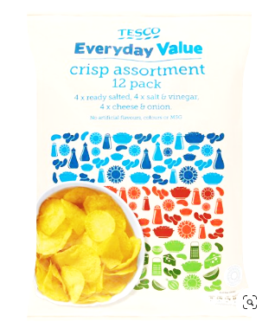Some goods are classed as **normal goods** meaning demand rises as income rises, e.g. Salmon, Steak and so on. These goods have **positive income elasticity** but of less than 1 (i.e. <1).

Other goods may find that their demand falls as incomes rise – these are **inferior goods**.

For example, demand for Tesco everyday value crisps (an inferior good) would have income elasticity which is negative - meaning that sales have fallen as incomes have risen - Demand for Tesco everyday value crisps would be described as having **negative income elasticity**.

However, concert tickets for Billie Eilish may well have also have **positive income elasticity**.

This is because her concert tickets are seen as **luxury goods**. Although there are some consumers who would never be able to afford to go and see her concert, she has 2.9m followers on twitter and many of these fans will be happy to pay high prices for tickets.

Income elasticity is referred to as YED and is calculated in almost the same way as price elasticity:

% change in quantity demanded

% change in **income**

Income elasticity can be a bit confusing; you need to decide if demand is income elastic or income inelastic then what type of product it might be e.g. a luxury good or an inferior good?

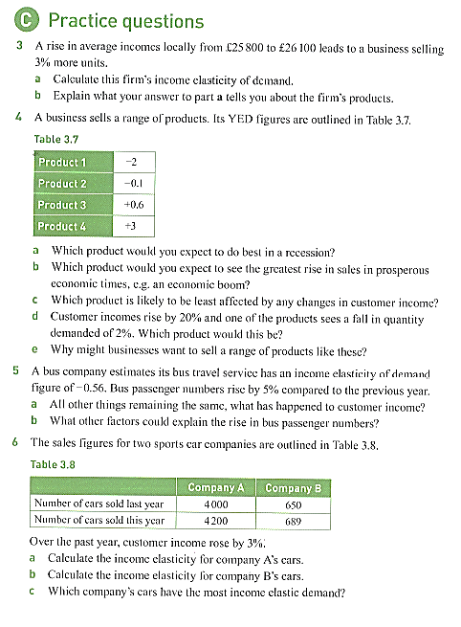

|  |  |
| --- | --- |
| Income elasticity | Explanation |
| - 0.3 | Sales have fallen as incomes rise but only minimal – **an inferior good**. |
| - 2 | If incomes raise then sales will fall dramatically: an **inferior good**. |
| 0.4 | Incomes rise and sales rise by a small amount – **a normal good** |
| 6 | **A luxury good** people buy if they want to treat themselves with additional income |