**REVISION 1 – Indices and Surds**

**Q1.**

(a)  Factorise 2*x*2 − 7*x* + 6

...........................................................

**(2)**



(c)  Write in the form *yb* where *b* is a fraction.

...........................................................

**(2)**

**(Total for question = 8 marks)**

**Q2.**



(b)  Simplify completely          

...........................................................

**(3)**

**(Total for question = 6 marks)**

**Q3.**



Express *x* in terms of *n*

Show your working clearly and simplify your expression.

*x* = ...........................................................

**(Total for question = 3 marks)**

**Q4.**

(a)  Factorise     *a*2 − *b*2

...........................................................

**(1)**

*N* = 222 − 1

(b)  Write *N* as the product of two integers, both of which are greater than 1000

........................................................... × ...........................................................

**(2)**

**(Total for question = 3 marks)**

**Q5.**

(a)  Simplify



...........................................................

**(2)**



(b)  Write as a single fraction

Give your answer in its simplest form.

...........................................................

**(2)**

**(Total for question = 7 marks)**

**Q6.**



(a) Simplify

...........................................................

**(2)**

(b) Given that 2*p* × 8*q* = 2*n*

express *n* in terms of *p* and *q*.

*n* = ...........................................................

**(2)**

**(Total for question is 4 marks)**

**Q7.**

(b)  280 = 2n × 5 × 7

Find the value of *n*.

*n* = ...........................................................

**(2)**

**(Total for Question is 3 marks)**

**Q8.**



(a)  Find the value of *n*.

*n* = ...........................................................

**(2)**

(13–6)4 × 135 = 13*k*

(b)  Find the value of *k*.

*k* = ...........................................................

**(2)**

**(Total for question = 4 marks)**

**Q9.**



(b)  Work out

Give your answer in standard form.

...........................................................

**(3)**

**(Total for question = 4 marks)**

**Q10.**



Simplify fully

...........................................................

**(Total for question = 3 marks)**

**Q11.**



(a)  Simplify

...........................................................

**(2)**



(b)  Work out the value of *k*.

*k* = ...........................................................

**(3)**

**(Total for question = 5 marks)**

**Q12.**



Simplify fully

...........................................................

**(Total for question = 3 marks)**

**Q13.**

*g* = 23 × 3 × 72               *h* = 2 × 3 × 73

(a)  Express *gh* as a product of powers of its prime factors.

Simplify your answer.

...........................................................

**(2)**



(b)  Find the value of *a*, the value of *b* and the value of *c*.

*a* = ...........................................................

*b* = ...........................................................

*c* = ...........................................................

**(2)**

(c)  Show that (7 − 2√5)(7 + 2√5) = 29

Show your working clearly.

**(2)**



(d)  Work out the exact value of *n*.

...........................................................

**(3)**

**(Total for question = 9 marks)**

**Q14.**

(3 + √*c*)(2√*c* − 3) = 1 + *k*√*c*

where *c* and *k* are prime numbers.

(a)  Find the value of *c* and the value of *k*.

*c* = ..............................   *k* = ..............................

**(3)**



(b)  Find the value of *m*.

*m* = ...........................................................

**(3)**

**(Total for question = 6 marks)**

**Q15.**



(a)  Show that

Show each stage of your working.

**(3)**



(b)  Simplify fully

...........................................................

**(3)**

**(Total for question = 6 marks)**

**Q16.**



Given that

express *n* in terms of *x* and *y*.

...........................................................

**(Total for Question is 3 marks)**

**Q17.**

*m* = 8 × 109*n* where *n* is an integer.

Express in standard form.   
Give your answer, in terms of *n*, as simply as possible.



...........................................................

**(Total for question = 3 marks)**

**Q18.**

Solve 3 × 42*k*+8 = 24   
Show your working clearly.

*k* = ...........................................................

**(Total for question = 4 marks)**

**Q19.**



Solve the equation   = 1

Show clear algebraic working.

...........................................................

**(Total for Question is 3 marks)**

**Q20.**



(a) Write down the value of

(i)  *p*

*p* = ...........................................................

(ii)  *q*

*q* = ...........................................................

(iii)  *r*

*r* = ...........................................................

**(3)**

(b)  Show that



You must write down each stage of your working.

**(2)**

(*e* − 2√3)2 = *f* − 20√3 where *e* and *f* are integers.

(c)  Find the value of *e* and the value of *f*

*e* = ...........................................................

*f* = ...........................................................

**(3)**

**(Total for question = 8 marks)**

**Q21.**



Without using a calculator, show that

Show your working clearly.

**(Total for question = 3 marks)**

**Q22.**



(b)  Rationalise the denominator of

Show each stage of your working.



Give your answer in the form   where *a* and *b* are fractions in their simplest forms.

**(3)**

**(Total for question = 5 marks)**

**Q23.**

A trapezium *ABCD* has an area of 5√6 cm2.

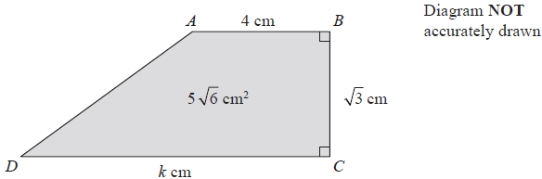

*AB* = 4 cm.   
*BC* = √3 cm.   
*DC* = *k* cm.

Calculate the value of *k*, giving your answer in the form *a*√*b* − *c*  
where *a*, *b* and *c* are positive integers.   
Show each step in your working.

*k* = ...........................................................

**(Total for Question is 3 marks)**

**Q24.**

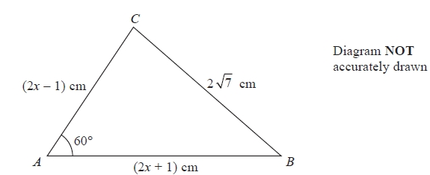

The diagram shows a triangle *ABC*.   
*AB* = (2*x* + 1) cm, *AC* = (2*x* − 1) cm and *BC* = 2 7 cm.   
Angle *BAC* = 60°

Work out the value of *x*.   
Show clear algebraic working.

*x* = ...........................................................

**(Total for question = 3 marks)**

**Q25.**

(b)   where *p* and *q* are integers.



Find the value of *q*.

*q* = ...........................................................

**(3)**

**(Total for Question is 5 marks)**

**Q26.**



(a)  Rationalise the denominator of where *a* is an integer and *b* is a prime number.

Simplify your answer.

**(3)**



(b)  Given that where *x* ≠ *y*

find the value of *m*.

*m* =

**(1)**

**(Total for question = 4 marks)**

**Q27.**

The area of a rectangle is 18 cm2



The length of the rectangle is cm.

Without using a calculator and showing each stage of your working,

find the width of the rectangle.   
Give your answer in the form where *a*, *b* and *c* are integers.



........................................................... cm

**(Total for question = 3 marks)**

**Q28.**



(a)  Simplify fully

Show clear algebraic working.

...........................................................

**(3)**

(b)  Given that *a* is a positive integer, show that



is always a multiple of 3

**(3)**

**(Total for question = 6 marks)**

**Q29.**



Show that can be written in the form , where *a* and *b* are integers.

Show each stage of your working clearly and give the value of *a* and the value of *b*.

**(Total for question = 3 marks)**

**Q30.**

Given that where *x* is a prime number and *y* is an integer,



find the value of *x* and the value of *y*.   
Show each stage of your working clearly.

*x* = ...........................................................

*y* = ...........................................................

**(Total for question = 3 marks)**

**Q31**

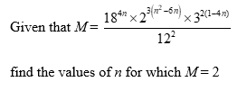

.......................................................

**(Total for Question 21 is 5 marks)**

**Mark Scheme**

Q1.

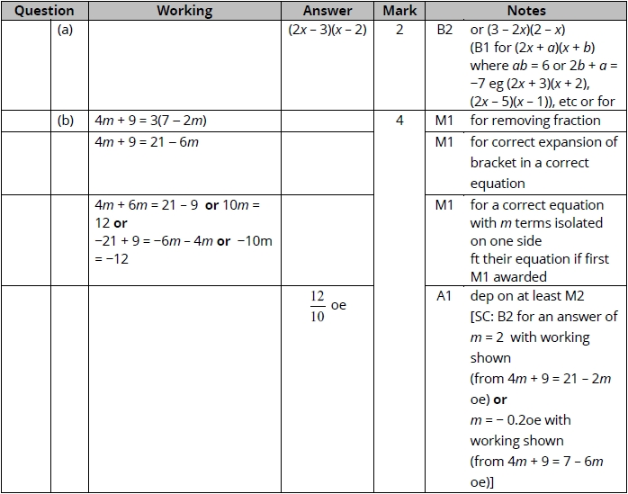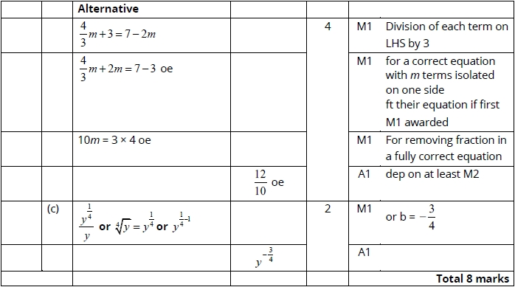

**Q2.**

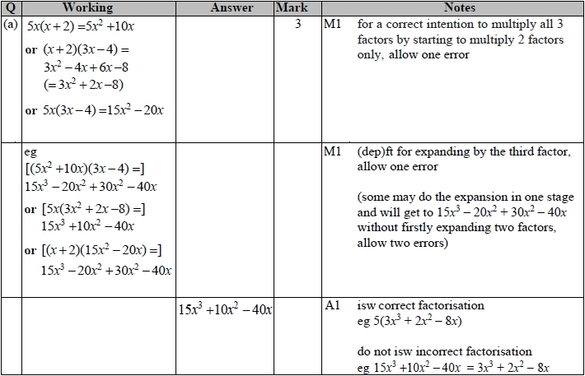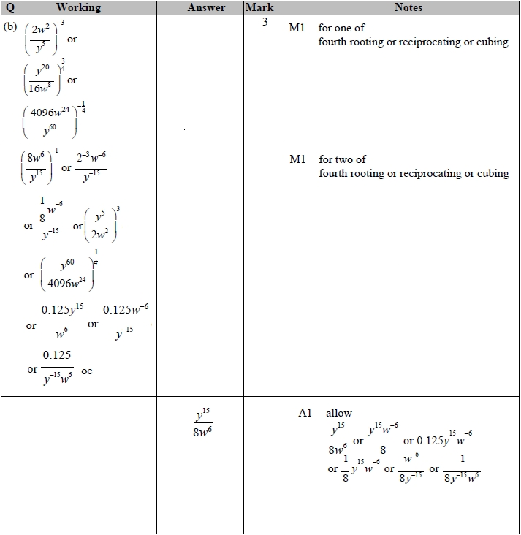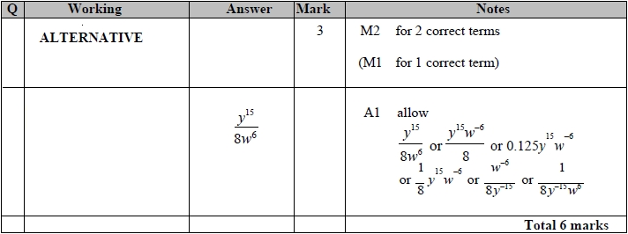

**Q3.**

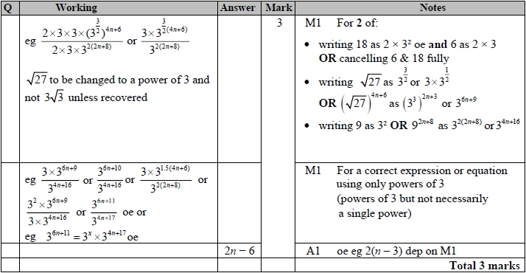

**Q4.**

The correct answer, unless clearly obtained by an incorrect method, should be taken to imply a correct method.

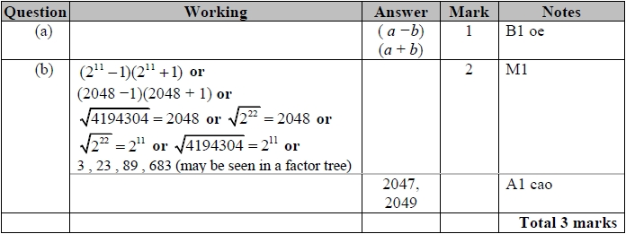

**Q5.**

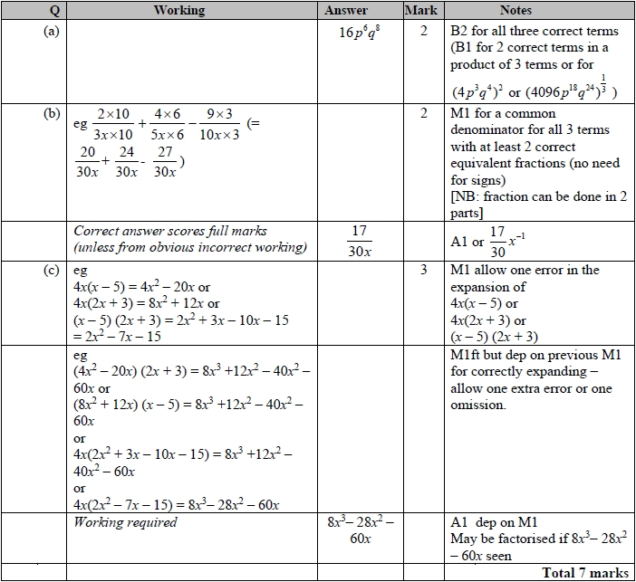

**Q6.**

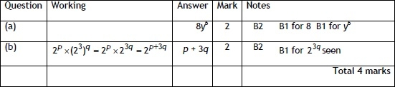

**Q7.**

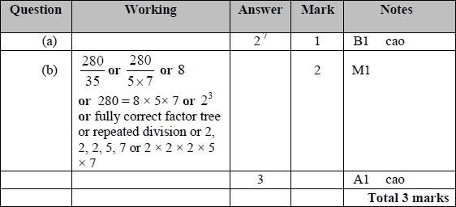

**Q8.**

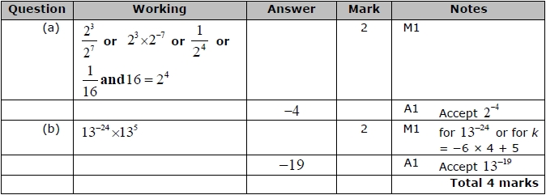

**Q9.**

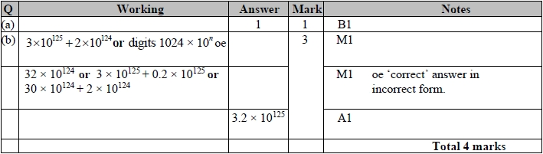

**Q10.**

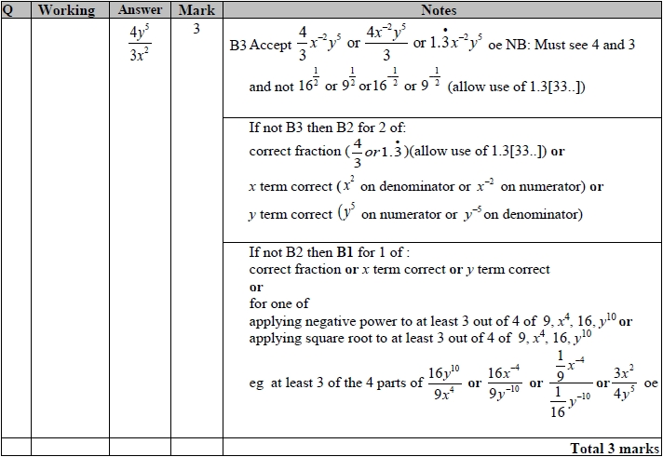

**Q11.**

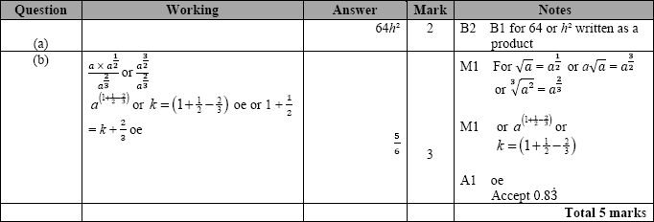

**Q12.**

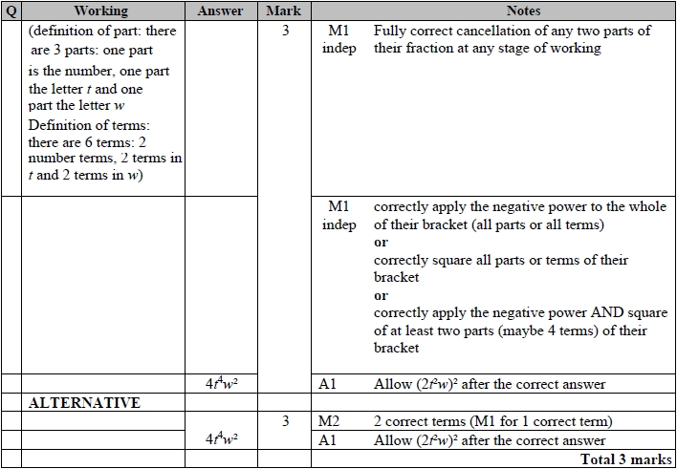

**Q13.**

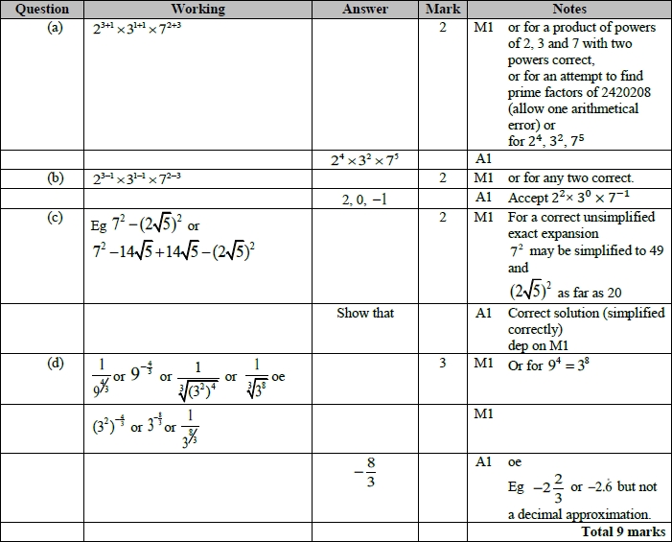

**Q14.**

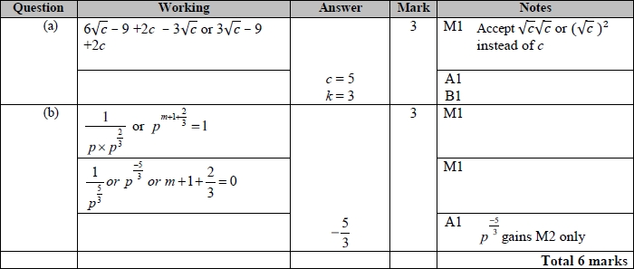

**Q15.**

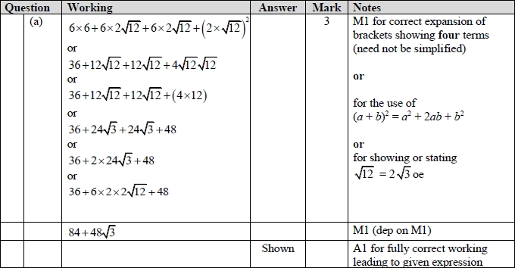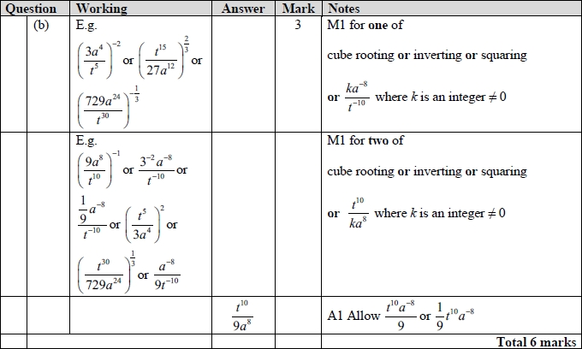

**Q16.**

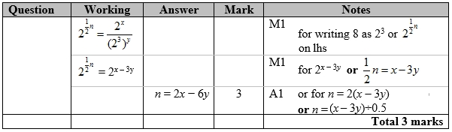

**Q17.**

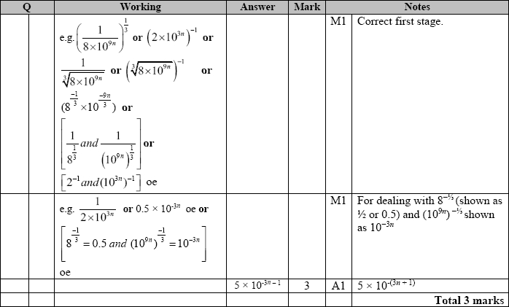

**Q18.**

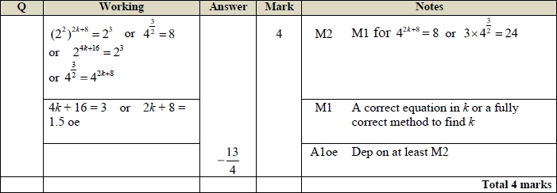

**Q19.**

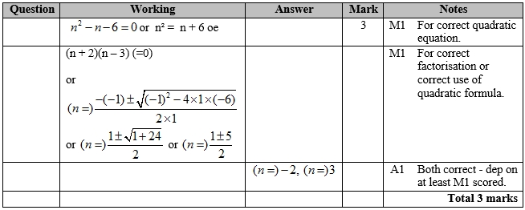

**Q20.**

Apart from b, where the mark scheme states otherwise, the correct answer, unless clearly obtained by an incorrect method, should be taken to imply a correct method.

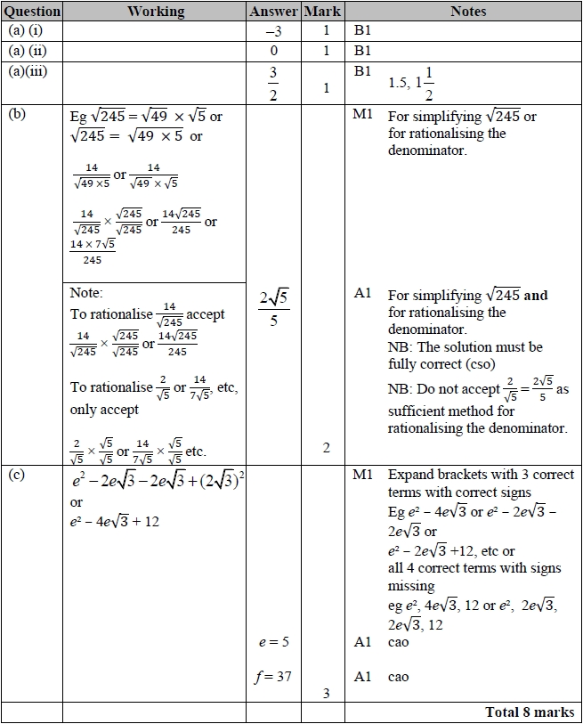

**Q21.**

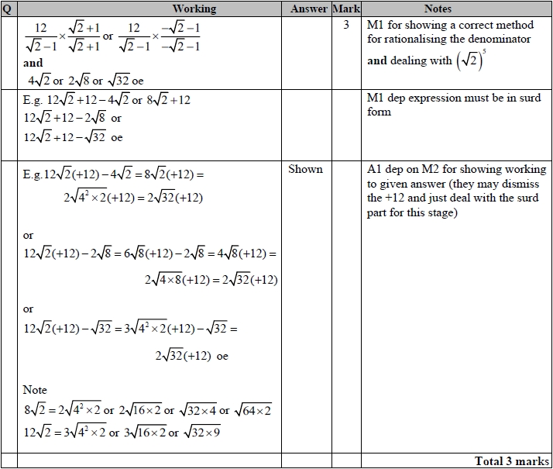

**Q22.**

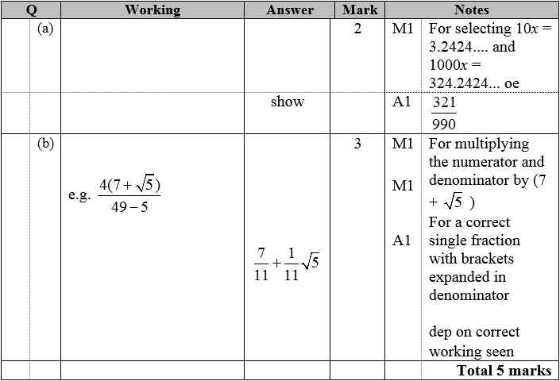

**Q23.**

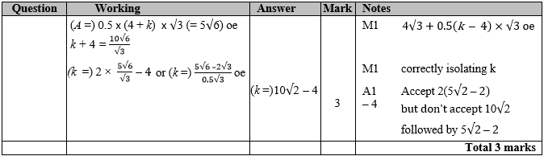

**Q24.**

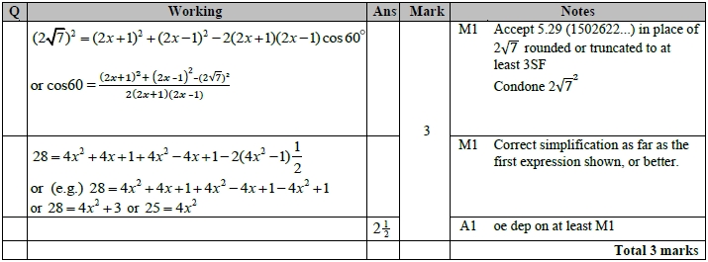

**Q25.**

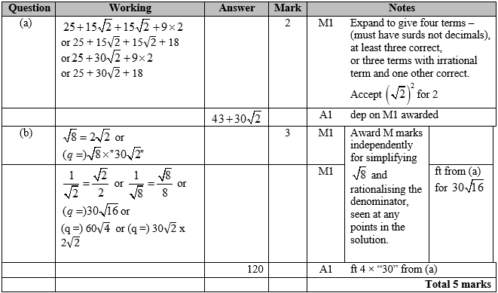

**Q26.**

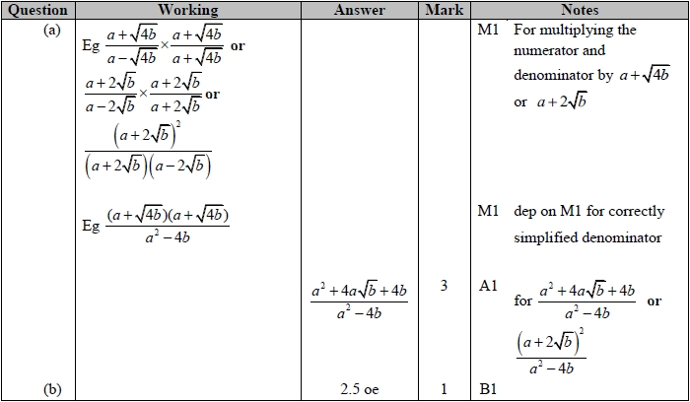

**Q27.**

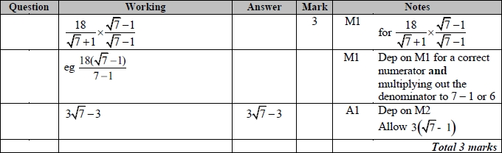

**Q28.**

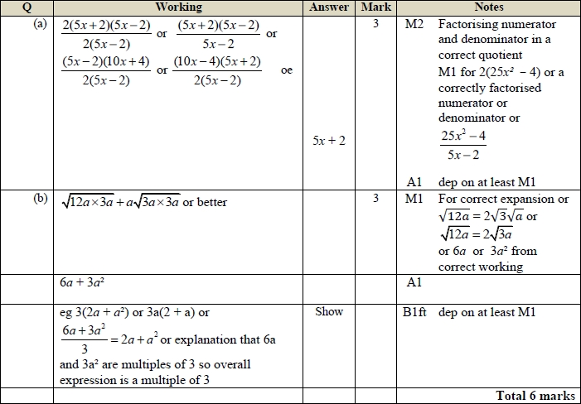

**Q29.**

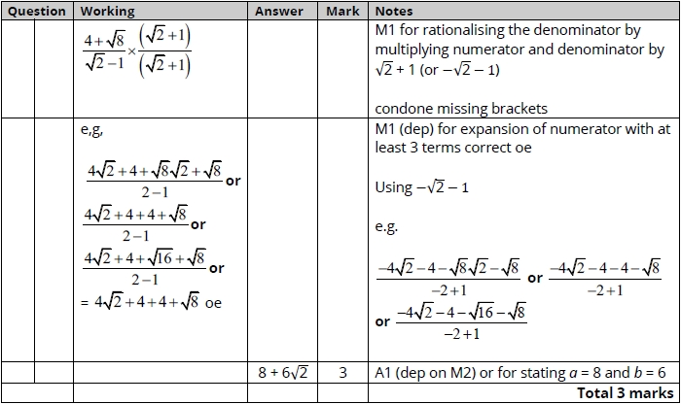

**Q30.**

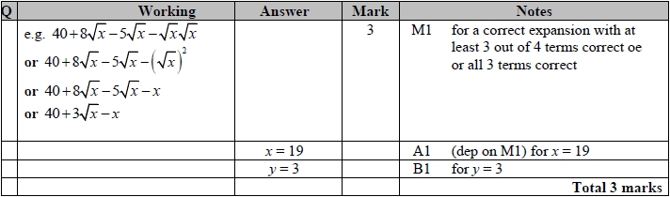

**Q31**

