

**Higher IGCSE (9 – 1) Revision Pack**

**Vectors**

**Name --------------------------------**

**Questions**

**Q1.**

*ABCD* is a parallelogram.

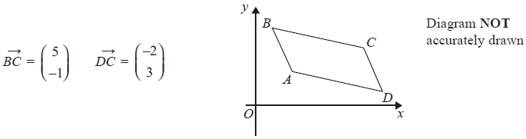

Find  as a column vector.

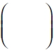

**(Total for question = 2 marks)**

**Q2.**

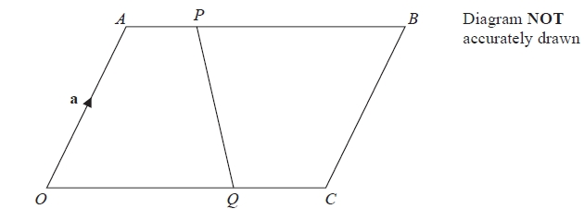

*OABC* is a parallelogram.

 = **a** and  = **c**

*P* is the point on *AB* such that *AP* = 1⁄4*AB*.

*Q* is the point on *OC* such that *OQ* = 2⁄3*OC*.

Find, in terms of **a** and **c**, .

Give your answer in its simplest form.

...........................................................

**(Total for Question is 3 marks)**

**Q3.**

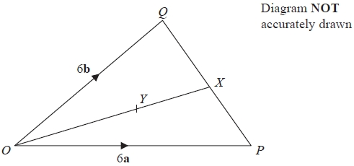

  
In triangle *OPQ*, = 6**a** and = 6**b**

*X* is the midpoint of *PQ*.

(a)  Find, in terms of **a** and **b**, the vector

Give your answer in its simplest form.

...........................................................

**(2)**

  
*Y* is the point on *OX* such that *OY* : *YX* = 2 : 1

(b)  Find, in terms of **a** and **b**, the vector

Give your answer in its simplest form.

...........................................................

**(2)**

**(Total for question = 4 marks)**

**Q4.** Here is the parallelogram *ABCD*.

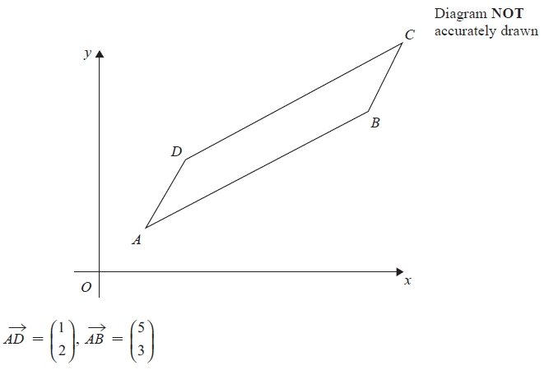

(a)  Find the magnitude of .

Give your answer correct to 3 significant figures.

...........................................................

**(2)**

The point *A* has coordinates (4, 2)

(b)  Work out the coordinates of the point *C*.

...........................................................

**(3)**

The diagonals of the parallelogram *ABCD* cross at the point *E*.

(c)  Find as a column vector, 

...........................................................

**(3)**

**(Total for question = 8 marks)**

**Q5.**

The diagram shows trapezium *ABCD*.

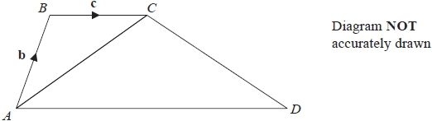

*BC* is parallel to *AD*  
*AD* = 3*BC*



(a)  Find, in terms of **b** and **c**, the vector 

Give your answer in its simplest form.

...........................................................

**(2)**

The point *P* lies on the line *AC* such that *AP* : *PC* = 2 : 1

(b)  Is *BPD* a straight line?

Show your working clearly.

**(4)**

**(Total for question = 6 marks)**

**Q6.**

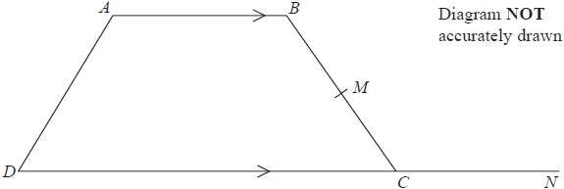

*AB* is parallel to *DC*  
*DC* = 2*AB*  
*M* is the midpoint of *BC*  
 = 2**b**  
 = 4**a**

(a)  Find in terms of **a** and **b**.

Give your answer in its simplest form.

...........................................................

**(2)**

*N* is the point such that *DCN* is a straight line and *DC* : *CN* = 2 : 1

(b)  Show that *AMN* is a straight line.

**(2)**

**(Total for question = 4 marks)**

**Q7.**

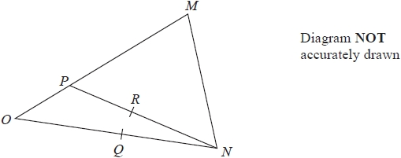

*OMN* is a triangle.

*P* is the point on *OM* such that *OP* = *OM*

*Q* is the midpoint of *ON*

*R* is the midpoint of *PN*

 = **p**    = **q**

(a)  Find, in terms of **p** and **q**,

(i) 

...........................................................

(ii) 

...........................................................

**(2)**

(b)  Use a vector method to prove that *QR* is parallel to *OP*

**(2)**

**(Total for question = 4 marks)**

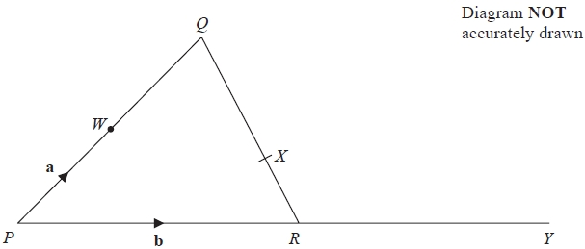**Q8.**

*PQR* is a triangle.   
The midpoint of *PQ* is *W*.   
*X* is the point on *QR* such that *QX* : *XR* = 2 : 1   
*PRY* is a straight line.



(a)  Find, in terms of **a** and **b**,

(i)  

...........................................................

(ii)  

...........................................................

(iii)  

...........................................................

**(3)**

*R* is the midpoint of the straight line *PRY*.

(b)  Use a vector method to show that *WXY* is a straight line.

**(2)**

**(Total for question = 5 marks)**

**Q9.**

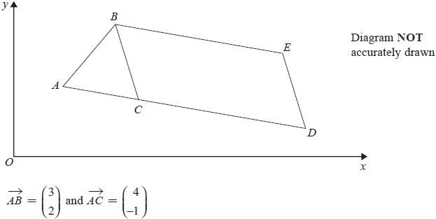

(a)  Find, as a column vector, 

...........................................................

**(2)**

*BCDE* is a parallelogram.



(b)  Find the length of *CE*.

Give your answer correct to 2 decimal places.

...........................................................

**(3)**

**(Total for question = 5 marks)**

**Q10.**

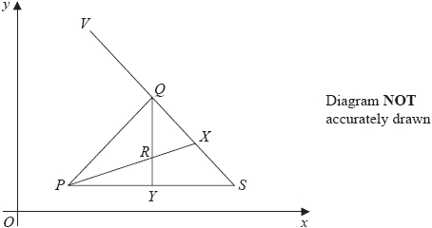

*PQS* is a triangle.   
*X* is the midpoint of *QS* and *Y* is the midpoint of *PS*.

*R* is the point of intersection of *PX* and *QY*.   
*V* is a point so that *VQXS* is a straight line.

 = **a**       = **b**

(a)  Find, in terms of **a** and **b**,

(i)  

...........................................................

(ii)  

...........................................................

(iii)  

...........................................................

**(3)**

*P* has coordinates (3, 1) and



(b)  Work out the coordinates of *V*.

( ................ , ................ )

**(3)**

**(Total for question = 6 marks)**

**Q11.**

The diagram shows a grid of equally spaced parallel lines.   
The point *P* and the vectors **a** and **b** are shown on the grid.

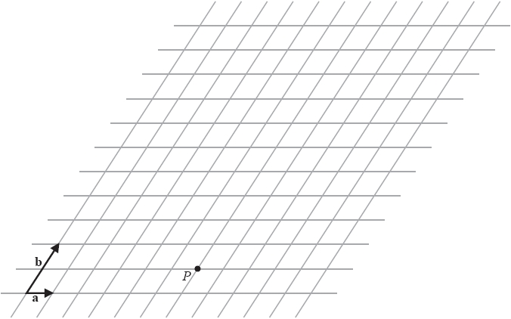

 = 3**a** + 4**b**

(a)  On the grid, mark the vector 

**(1)**

 = −4**a** + 2**b**

(b)  On the grid, mark the vector 

**(1)**

(c)  Find, in terms of **a** and **b**, the vector 

 = ...........................................................

**(1)**

The point *M* lies on *PR* such that *PM* = *PR*



The point *N* lies on *PQ* such that *PN* = *PQ*

(d)  Show that  = *k***a** where *k* is a constant.

State the value of *k*.

*k* = ...........................................................

**(3)**

**(Total for question = 6 marks)**

**Q12.**

The diagram shows a parallelogram, *PQRS*.

M is the midpoint of PS.



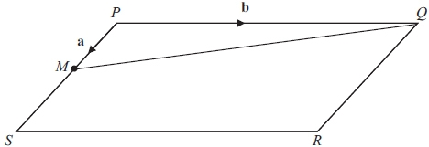

(a) Find, in terms of **a** and/or **b**,

(i)

...........................................................

(ii) 

...........................................................

(iii) 

...........................................................

**(3)**

*N* is the point on *MQ* such that *MN* = 1/3*MQ*

(b) Use a vector method to prove that *PNR* is a straight line.

**(2)**

**(Total for question = 5 marks)**

**Q13.**

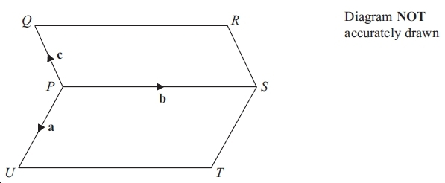

*PQRS* and *PSTU* are parallelograms.



Find, in terms of **a**, **b** and **c**

(i) 

..............................................................

(ii)  where *X* is the midpoint of *TQ*.

Simplify your answer as much as possible.

..............................................................

**(Total for question = 3 marks)**

**Q14.**

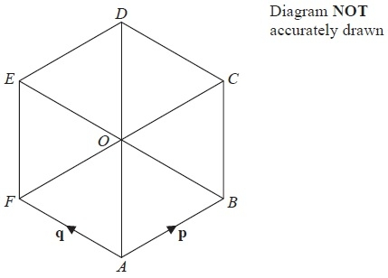

*ABCDEF* is a regular hexagon, centre *O*.



(a)  Express in terms of **p** and **q**

(i)  

...........................................................

(ii)  

...........................................................

(iii)  

...........................................................

**(3)**

(b)  Given that **p** = centimetres,

find the length of a side of the hexagon.

........................................................... cm

**(2)**

**(Total for Question is 5 marks)**

**Q15.**

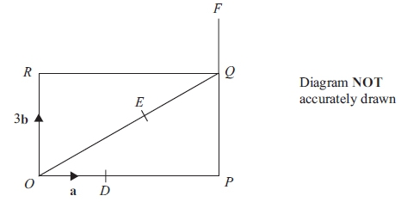

*OPQR* is a rectangle.  
*D* is the point on *OP* such that *OD* =   
*E* is the point on *OQ* such that *OE* =   
*PQF* is the straight line such that *QF* = 



(a) Find, in terms of **a** and **b**,

(i) 

...........................................................

(ii) 

...........................................................

(iii) 

...........................................................

**(3)**

(b) Use a vector method to prove that *DEF* is a straight line.

**(2)**

**(Total for question is 5 marks)**

**Q16.**

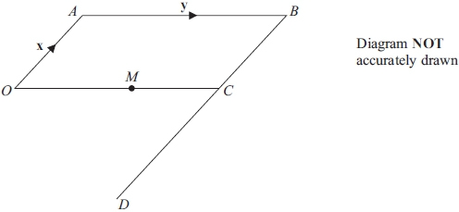

*OABC* is a parallelogram.  
*BCD* is a straight line.  
*BD* = 3*BC*.

*M* is the midpoint of *OC*.



(a) Find, in terms of *x* and *y*,



(i)

  
  
  
...........................................................

(ii)

...........................................................

**(2)**

(b) Use your answers to (a)(i) and (ii) to write down two different geometric facts about   
the lines *AM* and *OD*.

      ..............................................................................................................................................

      ..............................................................................................................................................

**(2)**

**(Total for question = 4 marks)**

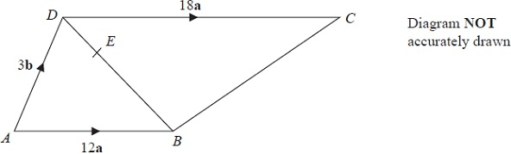**Q17.**

*ABCD* is a trapezium.   
*AB* is parallel to *DC*.

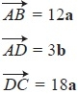

  
*E* is the point on the diagonal *DB* such that *DE* = *DB*

(a)  Find, in terms of **a** and **b**,

(i)  

...........................................................

(ii)  

...........................................................

(iii)  

...........................................................

**(3)**

(b)  Show by a vector method that *BC* is parallel to *AE*.

**(2)**

**(Total for Question is 5 marks)**

**Q18.**

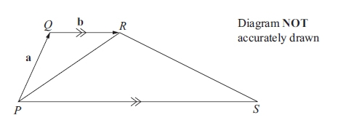

The diagram shows a trapezium *PQRS*.  
*PS* is parallel to *QR*. *PS* = 4*QR*.



(a) Find, in terms of *a* and/or *b*,

(i) 

...........................................................

(ii) 

...........................................................

(iii) 

...........................................................

**(3)**

The point *T* lies on the line *PR* such that *PT* : *TR* = 4 : 1

(b) Given that , find the value of *k*.

*k* = ...........................................................

**(3)**

**(Total for question = 6 marks)**

**Q19.**



(a) Write, as a column vector, 2**a**

  
...........................................................

**(1)**

(b) Write, as a column vector, 3**b** − **c**

  
...........................................................

**(2)**

(c) Work out the magnitude of **a**

Give your answer as a surd.

...........................................................

**(2)**

**(Total for question = 5 marks)**

**Q20.**

The diagram shows triangle ABD.

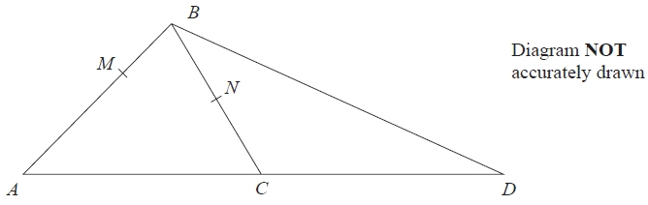

*N* is the midpoint of *BC*.   
*C* is the midpoint of *AD*.   
*M* is the point on *AB* such that *AM* : *MB* = 3 : 1



(a)  Express, in terms of **p** and **q**,

(i) 

...........................................................

(ii) 

...........................................................

**(3)**

(b)  State, giving reasons, two different geometric facts relating *MN* and *BD*.

**(2)**

**(Total for question = 5 marks)**

**Q21.**

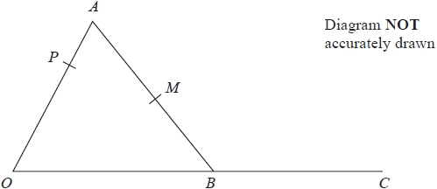

*OAB* is a triangle.   
*P* is the point on *OA* such that *OP* : *PA* = 2 : 1

*C* is the point such that *B* is the midpoint of *OC*.   
*M* is the midpoint of *AB*.



Show that *PMC* is a straight line.

**(Total for question = 5 marks)**

**Q22.**

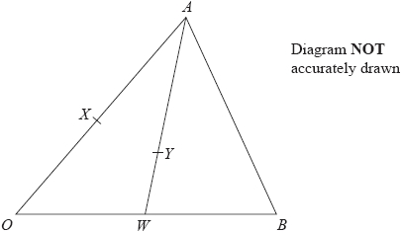

*OAB* is a triangle.

*X* is the midpoint of *OA* and *W* is the midpoint of *OB*.

*Y* is the point on *AW* such that *AY* : *YW* = 2 : 1

 = 3**a** and  = 3**b**

(a)  Express in terms of **a** and **b**

(i)  

...........................................................

(ii)  

...........................................................

(iii)  

...........................................................

**(3)**

(b)  Show by a vector method that *XYB* is a straight line.

**(2)**

**(Total for question = 5 marks)**