**River Processes Questions**

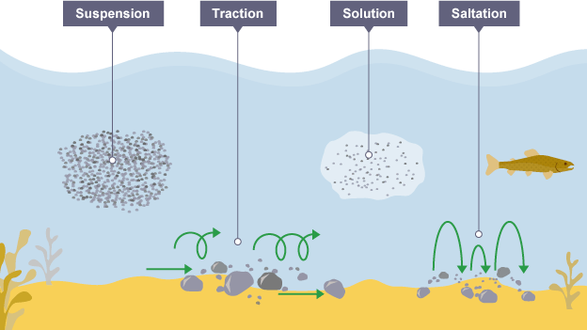

1. Which of the following is NOT a type of erosion? *(1 mark)*

Attrition

Traction

Hydraulic action

Abrasion

2. Which of the following statements about deposition is NOT correct? *(1 mark)*

Deposition is more common at the source of a river

Deposition occurs when a river loses energy

Deposition may occur when the river is shallow

Deposition may occur when the volume of water decreases

3. Explain how a river can transport its load *(4 marks)*

**T: name and outline all 4 processes.**

4. Define the term attrition. *(2 marks)*

5. Apart from attrition, name and outline two types of erosion that occur within a river. *(4 marks)*

Look at **Figure 1**, an aerial photograph of an estuary

**Figure 1**

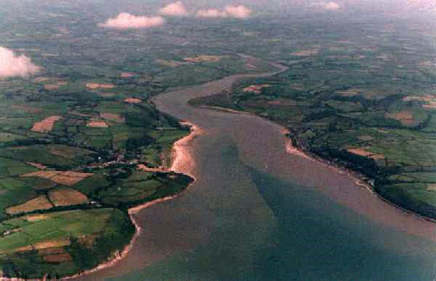

6. Name the geographical process that is responsible for the estuary in Figure 1. *(1 mark)*

7. Provide reasons for deposition within a river. *(6 marks)*

***T: remember to use your class notes for a variety of factors e.g. hydraulic radius.***

8. Explain how velocity can affect fluvial processes. *(6 marks)*

***Hint: this should consider how a high velocity affects processes such as erosion, transportation and deposition as well as how a low velocity affects these processes.***

**Total: 25 marks**