

**Foundation IGCSE (9 – 1) Revision Pack**

**Probability**

**Name --------------------------------**

**Questions**

**Q1.**

Abid is waiting for a bus.  
 The probability that his bus will be early is 0.2  
 The probability that his bus will be on time is 0.7

Work out the probability that his bus will be either early or on time.

      ..............................................................................................................................................

**(Total for question = 2 marks)**

**Q2.**

A box contains four different kinds of chocolates.  
 Debbie takes at random a chocolate from the box.  
 The table shows the probability of Debbie taking an Orange or a Coffee or a Caramel chocolate.

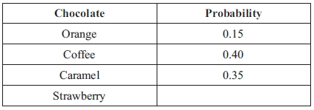

(a) Work out the probability that Debbie takes a Strawberry chocolate.

............................................................

**(2)**

(b) Work out the probability that Debbie takes an Orange chocolate or a Coffee chocolate.

............................................................

**(2)**

**(Total for question = 4 marks)**

**Q3.**

Every morning, Samath has one glass of fruit juice with his breakfast.  
 He chooses at random orange juice or pineapple juice or mango juice.  
 The probability that he chooses orange juice is 0.6  
 The probability that he chooses pineapple juice is 0.3

(a) Work out the probability that he chooses mango juice.

............................................................

**(2)**

(b) There are 30 days in April.

Work out an estimate for the number of days in April on which Samath chooses  
 orange juice.

............................................................

**(2)**

**(Total for question = 4 marks)**

**Q4.**

A box contains some coloured cards.  
 Each card is red or blue or yellow or green.  
 The table shows the probability of taking a red card or a blue card or a yellow card.

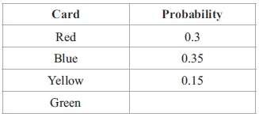

George takes at random a card from the box.

(a) Work out the probability that George takes a green card.

...........................................................

**(2)**

George replaces his card in the box.  
 Anish takes a card from the box and then replaces the card.  
 Anish does this 40 times.

(b) Work out an estimate for the number of times Anish takes a yellow card.

...........................................................

**(2)**

**(Total for question = 4 marks)**

**Q5.**

Steve throws a 6-sided dice.   
The dice can land on 1 or on 2 or on 3 or on 4 or on 5 or on 6

He also spins a coin.   
The coin can land on heads (H) or on tails (T).

List all the possible combinations he could get.

**(Total for question = 2 marks)**

**Q6.**

Hanako has two fair spinners.   
Spinner A is 3-sided and can land on 1, 2 or 3   
Spinner B is 4-sided and can land on 2, 4, 6 or 8

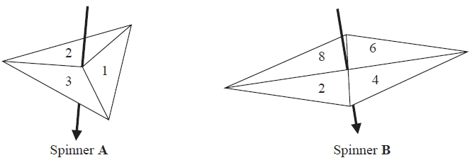

Hanako spins each spinner once.

She adds together the number that spinner **A** lands on and the number that spinner **B** lands on to get her total score.

(a)  Complete the table to show all possible total scores.

Four total scores have been done for you.

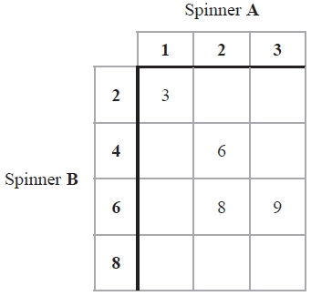

**(2)**

(b)  Find the probability that

(i)  Hanako's total score is 8

...........................................................

(ii)  Hanako's total score is less than 7

...........................................................

**(2)**

**(Total for question = 4 marks)**

**Q7.**

Here are two fair spinners.

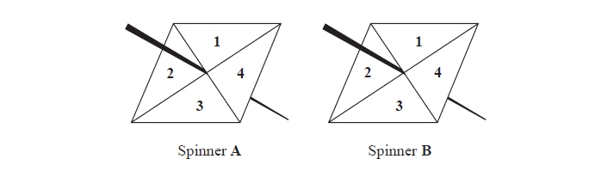

Shola spins each spinner once.

The score is the sum of the number spinner **A** lands on and the number spinner **B** lands on.

(a)  Complete the table to show the possible scores.

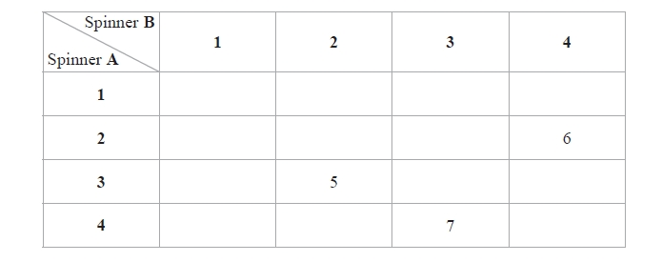

**(2)**

(b)  Find the probability that the score will be 3 or less.

..........................................................

**(2)**

(c)  Find the probability that the number spinner **A** lands on will be greater than the   
       number spinner **B** lands on.

..........................................................

**(2)**

**(Total for question = 6 marks)**

**Q8.**

Here are two bags A and B.  
 Each bag contains 3 discs.  
 Each disc has a number on it.

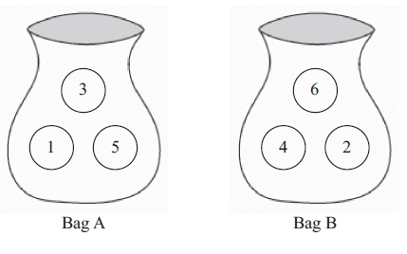

Anton takes, at random, a disc from bag A and a disc from bag B.  
 His score is the sum of the numbers on these two discs.

(a) Complete the table to show all his possible scores.

**(2)**

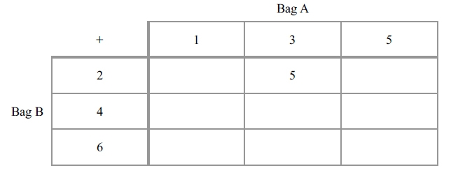

(b) Find the probability that his score is 7

...........................................................

**(2)**

**(Total for question = 4 marks)**

**Q9.**

Paul has a fair 3-sided spinner and a fair 6-sided dice.

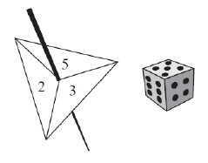

The spinner can land on 2, 3 or 5.

Paul spins the spinner once and throws the dice once.

(a)  Complete the table to show all the possible outcomes.

Four outcomes have been done for you.

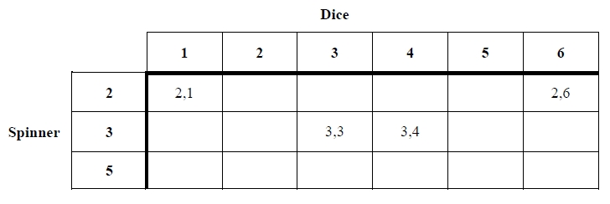

**(2)**

Paul spins the spinner once and throws the dice once.

(b)  Find the probability that the number the spinner lands on is greater than the number shown on the dice.

...........................................................

**(2)**

**(Total for question = 4 marks)**

**Q10.**

Becky has a biased 6-sided dice.

The table gives information about the probability that, when the dice is thrown, it will land on each number.

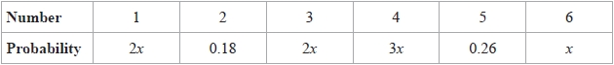

Becky is going to throw the dice 200 times.

Work out an estimate for the number of times that the dice will land on an even number.

...........................................................

**(Total for question = 4 marks)**

**Q11.**

In a game, a fair dice is rolled once and a fair spinner is spun once.

The dice has dots showing 1, 2, 3, 4, 5 and 6   
The spinner has three sections numbered 1, 2 and 3

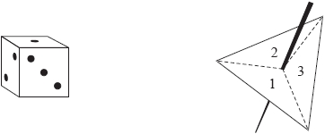

The score is found by subtracting the smaller number from the larger number.

(a)  Complete the sample space diagram to show all the possible scores.

Seven scores are shown for you.

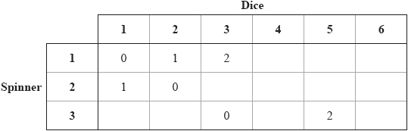

**(2)**

Pau plays the game.

(b)  Find the probability that his score is

(i)  5

...........................................................

(ii)  2 or 4

...........................................................

**(2)**

**(Total for question = 4 marks)**

**Q12.**

Here is a fair 5-sided spinner.

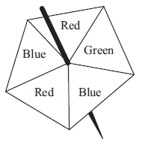

Hans spins the spinner 30 times.

Work out an estimate for the number of times the spinner lands on Red.

...........................................................

**(Total for question is 2 marks)**

**Q13.**

A bag contains only red beads, blue beads, green beads and yellow beads.

The table gives the probabilities that, when a bead is taken at random from the bag,   
the bead will be blue or the bead will be yellow.

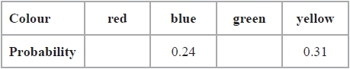

The probability that the bead will be green is twice the probability that the bead will be red.

Sofia takes at random a bead from the bag.   
She writes down the colour of the bead and puts the bead back into the bag.

She does this 180 times.

Work out an estimate for the number of times she takes a red bead from the bag.

...........................................................

**(Total for question = 4 marks)**

**Q14.**

At a school fete, Colin is selling drinks.   
He sells tea, coffee and juice.   
Marion is selling food.   
She sells burgers and pizzas.

Jenson buys one drink and one food item.

(a)  Write down all the possible combinations Jenson can buy.

.............................................................................................................................................

.............................................................................................................................................

.............................................................................................................................................

**(2)**

Each burger costs £1.65   
Each pizza costs £3.10

Caroline buys 3 burgers and 4 pizzas.

She pays with a £20 note.

(b)  Work out how much change she should get.

£ ...........................................................

**(3)**

**(Total for question = 5 marks)**

**Q15.**

Three rectangular cards are numbered 1, 3 and 5

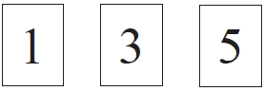

Sanjay takes at random one of these cards.

(a)   Find the probability that the number on the card he takes is

(i)   5

...........................................................

(ii)   an even number.

...........................................................

**(2)**

Three circular cards are numbered 2, 3 and 4



Shondra takes at random one of these circular cards.

(b)   Find the probability that the number on the card she takes is an even number.

...........................................................

**(1)**

Amrit has all six cards.   
She takes at random one rectangular card and one circular card.   
She adds together the numbers on the two cards to find the total for these two cards.

(c)   Complete the table to show all possible totals.

Three totals have been done for you.

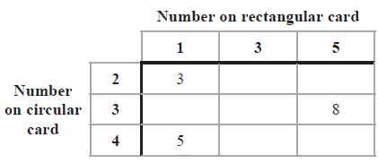

**(2)**

(d)   Work out the probability that the total is

(i)   8

...........................................................

(ii)   5 or 7

...........................................................

**(2)**

**Q16.**

There are 20 counters in a bag.   
3 of the counters are red.   
8 of the counters are blue.   
The rest of the counters are yellow.

Zakir takes at random a counter from the bag.

Work out the probability that Zakir takes a yellow counter.

...........................................................

**(Total for Question is 2 marks)**

**Q17.**

The diagram shows a pointer that spins about the centre of a circle.

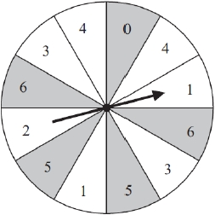

The circle is divided into 12 equal sectors.   
When the pointer spins, it is equally likely to stop in any one of the sectors.   
Each sector has a number.

Andrea spins the pointer.

(a)  Find the probability that the pointer stops in a shaded sector.

...........................................................

**(1)**

(b)  Find the probability that the pointer stops in an unshaded sector with an odd number.

...........................................................

**(1)**

Andrea now spins the pointer twice and adds together the two numbers in the sectors that the pointer stops in.



The probability that the total of the two numbers is 7 or more is

(c)  Work out the probability that the total of the two numbers is less than 7.

...........................................................

**(2)**

**(Total for question = 4 marks)**

**Q18.**

Here is a biased five-sided spinner.

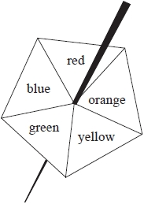

When the spinner is spun, it can land on red, orange, yellow, green or blue.   
The probabilities that it lands on red, orange and yellow are given in the table.

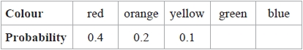

The probability that the spinner lands on green is the same as the probability that the spinner lands on blue.

Michael spins the spinner once.

(a)  Work out the probability that the spinner lands on green.

...........................................................

**(3)**

Jenny spins the spinner 200 times.

(b)  Work out an estimate for the number of times the spinner lands on red.

...........................................................

**(2)**

**(Total for question = 5 marks)**

**Q19.**

At a coffee morning, Mairi is selling drinks.   
She sells coffee and tea.   
Mairi is also selling cakes.   
She sells brownies, doughnuts and flapjacks.

Frankie buys one drink and one cake.

Write down all the possible combinations Frankie can buy.

.............................................................................................................................................

.............................................................................................................................................

.............................................................................................................................................

**(Total for question = 2 marks)**

**Q20.**

**Write your answers in the spaces provided.**

**You must write down all the stages in your working.**

All the teachers at a school are either left footed or right footed.   
At the school

the number of left footed teachers : the number of right footed teachers = 3 : 13

A teacher at the school is picked at random.

(a)  Find the probability that this teacher is left footed.

**(1)**

At the school, there are 18 left footed teachers.

(b)  How many right footed teachers are there?

**(2)**

**(Total for question = 3 marks)**

**Q21.**

Javier has two sets of cards.   
Each set contains 4 cards, one marked **A**, one marked **B**, one marked **C** and one marked **D**.

Javier is going to take at random one card from each set.   
The table shows all possible pairs of cards that Javier could take.

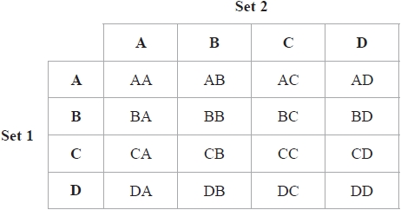

(a)  Find the probability that Javier will take at least one card marked **C**.

...........................................................

**(2)**

Javier is going to take at random one card from each set, note the letter on each card and replace the cards.

He is going to do this a total of 80 times.

(b)  Work out an estimate for the number of times that Javier will take at least one card marked **C**.

...........................................................

**(2)**

**(Total for question = 4 marks)**

**Q22.**

In a game, a fair 3-sided spinner is spun once and a fair dice is rolled once.

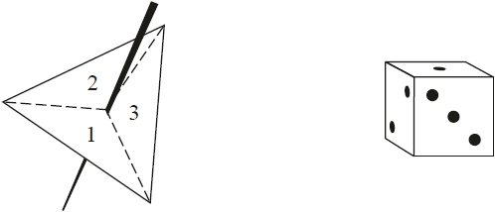

The spinner can land on 1, 2 or 3   
The dice can land on 1, 2, 3, 4, 5 or 6

In the game, the score is found by multiplying the number the spinner lands on by the number the dice lands on.

(a)  Complete the table to show all possible scores.

Eleven of the scores have been done for you.

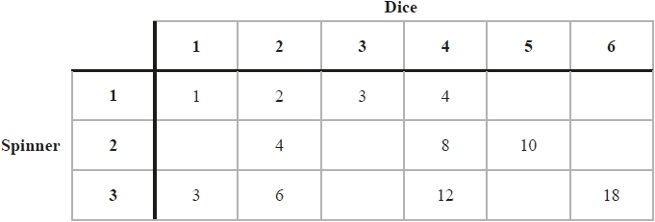

**(2)**

Steven plays the game once.

(b)  Work out the probability that his score is greater than 10

...........................................................

**(2)**

Adam plays the game and Carmen plays the game.

Adam gets a prize if his score is 5 or less.   
Carmen gets a prize if her score is a multiple of 6

Carmen says the game is unfair because Adam is more likely to get a prize.

(c)  Is the game unfair?

You must give a reason for your answer.

.............................................................................................................................................

.............................................................................................................................................

.............................................................................................................................................

**(2)**

**(Total for question = 6 marks)**

**Q23.**

The diagram shows a fair 6-sided spinner.

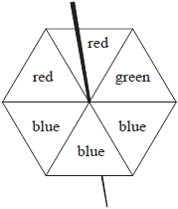

Rami is going to spin the spinner once.

(a)  Circle the word in the space below that best describes the likelihood that the spinner will land on green.



**(1)**

(b)  On the probability scale below, mark with a cross () the probability that the spinner will land on blue.



**(1)**

(c)  On the probability scale below, mark with a cross () the probability that the spinner will land on yellow.



**(1)**

**(Total for question = 3 marks)**

**Q24.**

**Write your answers in the spaces provided.**

**You must write down all the stages in your working.**

Here is a biased 5-sided spinner.

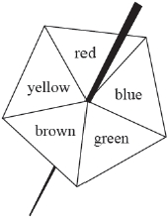

Kenny spins the spinner once.   
The table gives the probabilities that the spinner lands on red or on blue or on green.

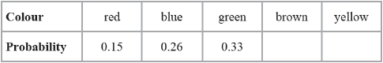

(a)  Work out the probability that the spinner lands on red or blue.

**(1)**

When the spinner is spun once, the probability that the spinner lands on brown is 0.06 more than the probability that the spinner lands on yellow.

Jenine spins the spinner 150 times.

(b)  Work out an estimate for the number of times the spinner lands on yellow

**(4)**

**(Total for question = 5 marks)**

**Q25.**

The diagram shows a fair spinner.

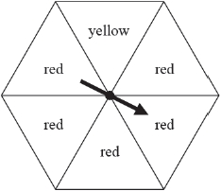

Mikail spins the arrow on the spinner once.



(a)  Write down the word from the box that best describes the likelihood that the arrow will land on

(i)  red,

(i)  blue,

**(2)**

10 balls are in a bag.   
3 of these balls are green.

Jill takes at random a ball from the bag.

(b)  On the probability scale below, mark with a cross () the probability that the ball is green.

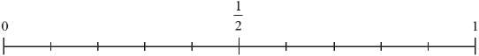

**(1)**

**(Total for question = 3 marks)**

**Q26.**

Daniel has five bags of coloured sweets.   
He picks at random a sweet from each bag.   
The table shows the probability that the sweet he picks from each bag is red.

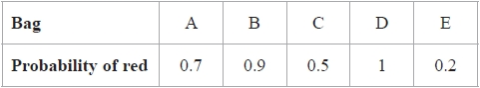

(a)  From which bag is Daniel least likely to pick a red sweet?

...........................................................

**(1)**

(b)  Which bag contains only red sweets?

...........................................................

**(1)**

(c)  From which bag is Daniel equally likely to pick a red sweet as a sweet of another colour?

...........................................................

**(1)**

**(Total for question = 3 marks)**

**End of questions**