Gateways School

**Synthesis & NMR & Chromatography**

**Revision PPQ Answers**

50 marks

**Q1.**

(a)     (i)      CDCl3 or CD2Cl2 or C6D6 or CCl4

*Not D2O Allow CD3Cl*

**1**

(ii)     4 **or four**

**1**

(iii)    Triplet or 3 or three

**1**

(iv)    1,4-dichloro-2,2-dimethylbutane

*Do not penalise different or missing punctuation or extra spaces.*

*Spelling must be exact and order of letters and numbers as here.*

**1**

(b)     (i)      3 or three

**1**

(ii)     190-220 (cm−1)

*Allow a single number within the range.*

***OR*** *a smaller range entirely within this range.*

**1**

(iii)    hexan**e**-2,5-dione

*Do not penalise different or missing punctuation or extra spaces.*

*Spelling must be exact and order of letters and numbers as here.*

*NB so must have middle e*

**1**

**[7]**

**Q2.**

(a)     (i)      Single / one (intense) peak / signal ***OR*** *all H or all C in same environment* ***OR*** *12 equiv H or 4 equiv C*

***Do not allow non-toxic or inert (both given in Q)***

*Any 2 from three*

*Ignore peak at zero*

***OR***

Upfield / to the right of (all) other peaks ***OR*** *well away from others* ***OR*** *doesn’t interfere with other peaks*

*Ignore cheap*

*Ignore non-polar*

***OR***

Low bp ***OR*** *volatile* ***OR*** *can easily be removed*

*Ignore mention of solubility*

**2**

(ii)  
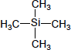

*Allow Si(CH3)4*

**1**

(b)    (i)  
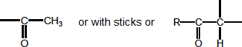

*Ignore any group joined on other side of CO  
Ignore missing trailing bond  
Ignore charges*

**1**

(ii)  


*Ignore any group joined on other side of −O−  
Ignore missing trailing bond  
Ignore charges as if MS fragment*

**1**

(iii)  


*Ignore missing trailing bonds  
Ignore charges as if MS fragment*

**1**

(iv)  

**1**

(c)    (i)      Check structure has 6 carbons

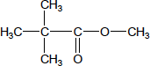

*Allow (CH3)3CCOOCH3 or (CH3)3CCO2CH3*

**1**

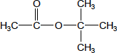

*Allow CH3COOC(CH3)3 or CH3CO2C(CH3)3*

**1**

(ii)     Check structure has 6 carbons

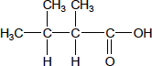

*Allow (CH3)2CHCH(CH3)COOH or (CH3)2CHCH(CH3)CO2H*

*Penalise C3H7*

**1**

(iii)    Check structure has 6 carbons



***OR***

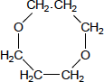

*Allow*

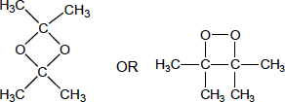

**1**

**[11]**

**Q3.**

(a)     **If 2 stage test for one compound, award no marks for that compound, eg no mark for ROH or RX to alkene then Br2 test. If reagent is wrong or missing, no mark for that test; if wrong but close/incomplete, lose reagent mark but can award for correct observation. In each test, penalise each example of wrong chemistry, eg AgClr2**

propan-1-ol

acidified potassium dichromate

sodium

Named acid + conc H2SO4

named acyl chloride

PCl5 M1

**1**

(orange) turns green

effervescence

Sweet smell

Sweet smell /misty fumes

Misty fumes

M2

**1**

propanal

add Tollens or Fehlings / Benedicts

acidified potassium dichromate

*if dichromate used for alcohol cannot be used for aldehyde*

M3

**1**

Tollens: silver mirror or Fehlings/ Benedicts: red ppt

(orange) turns green

Yellow or orange ppt M4

**1**

propanoic acid

Named carbonate/ hydrogencarbonate

water and UI (paper)

Named alcohol + conc H2SO4

sodium or magnesium

*if sodium used for alcohol cannot be used for acid*

M5

**1**

effervescence

orange/red

Sweet smell

effervescence

Misty fumes M6

**1**

1-chloro propane

NaOH then acidified AgNO3

AgNO3

*If acidification missed after NaOH, no mark here but allow mark for observation*

M7

**1**

white ppt

white ppt M8

**1**

(b)      oxidation (of alcohol by oxygen in air)

M1

**1**

absorption at 1680 -1750 (due to C=O)

*Must refer to the spectrum*

M2

**1**

comparison of polarity of molecules or correct imf statement:  
propanone is less polar OR propan-2-ol is more polar  
OR propanone has dipole-dipole forces  
OR propan-2-ol has hydrogen bonding

M3

**1**

about attraction to stationary phase or solubility in moving phase  
Propan-2-ol has greater affinity for stationary phase or vice versa  
OR propanone is more soluble in solvent/moving phase or vice versa

M4

**1**

**[12]**

**Q4.**

|  |  |
| --- | --- |
| **Mark Range** | The marking scheme for this part of the question includes an overall assessment for the Quality of Written Communication (QWC). There are no discrete marks for the assessment of QWC but the candidates’ QWC in this answer will be one of the criteria used to assign a level and award the marks for this part of the question  **Descriptor** an answer will be expected to meet most of the criteria in the level descriptor |
| 4-5 | –    claims supported by an appropriate range of evidence  –    good use of information or ideas about chemistry, going beyond those given in the question  –    argument well structured with minimal repetition or irrelevant points  –    accurate and clear expression of ideas with only minor errors of grammar, punctuation and spelling |
| 2-3 | –    claims partially supported by evidence  –    good use of information or ideas about chemistry given in the question but limited beyond this  –    the argument shows some attempt at structure  –    the ideas are expressed with reasonable clarity but with a few errors of grammar, punctuation and spelling |
| 0-1 | –    valid points but not clearly linked to an argument structure  –    limited use of information or ideas about chemistry  –    unstructured  –    errors in spelling, punctuation and grammar or lack of fluency |

(a)     (i)      Mr of C6H5NH2 = 93    Mr of CH3COCl = 78.5  
total Mr of reagents = 264.5

**1**

% atom economy =  × 100 QWC

**1**

=  × 100 = 51.0 %

**1**

(ii)     expected yield =  × 0.5 × 135 = 7.26 kg

**1**

% yield =  × 100 = 74.1 %

**1**

(iii)     Although yield appears satisfactory (74%) % atom economy  
is only 51% QWC

**1**

nearly half of the material produced is waste and must be  
disposed of QWC

**1**

(b)     (nucleophilic) addition-elimination

**1**

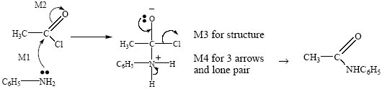

QWC (2)

**4**

(c)     HNO3 + 2H2SO4 → NO2+ + H3O+ + 2HSO4–

**1**

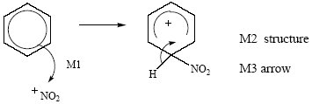

**3**

**[16]**

**Q5.**

C

**[1]**

**Q6.**

B

**[1]**

**Q7.**

D

**[1]**

**Q8.**

C

**[1]**