

**Higher IGCSE (9 – 1) Revision Pack**

**Graphs Part 1**

**Name --------------------------------**

**Questions**

**Q1.**



(a)  Complete the table of values for *y* =

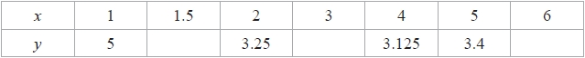

**(2)**

(b)  Draw the graph of *y* = for values of *x* from 1 to 6



**(2)**

(c)  Use the graph to find estimates for the solutions of the equation *x* + = 7



...........................................................

**(2)**

**(Total for question = 6 marks)**

**Q2.**

(a)  Complete the table of values for *y* = *x*2 – 4*x* + 2

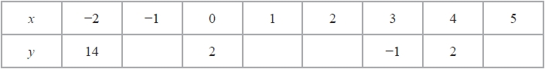

**(2)**

(b)  On the grid, draw the graph of *y* = *x*2 – 4*x* + 2 for values of *x* from –2 to 5

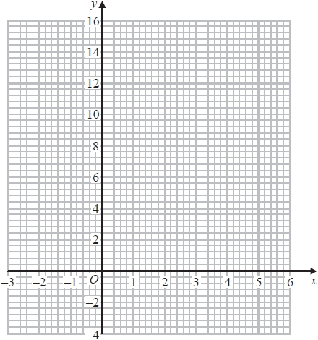

**(2)**

The point *P* (*k*, 4) where *k* > 0 lies on the graph of *y* = *x*2 – 4*x* + 2

(c)  Use your graph to find an estimate for the value of *k*.

...........................................................

**(1)**

**(Total for question = 5 marks)**

**Q3.**

(a)  Complete the table of values for *y* = *x*3 − 3*x*2 + 5

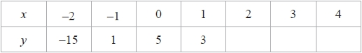

**(1)**

(b)  On the grid, complete the graph of *y* = *x*3 − 3*x*2 + 5 for −2 ≤ *x* ≤ 4

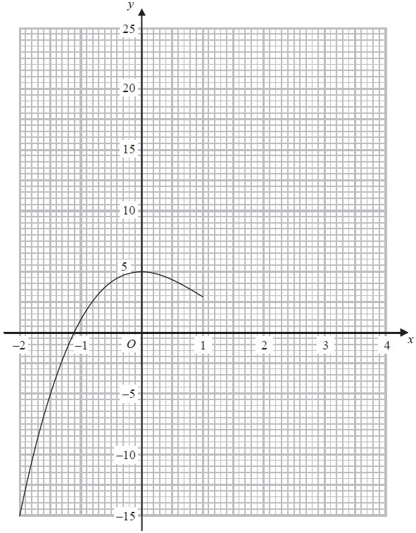

**(1)**

(c)  Use the graph to find an estimate for the solution of the equation *x*3 − 3*x*2 + 5 = 0

*x* = ...........................................................

**(1)**

(d)  By drawing a suitable straight line on the grid, find an estimate for the solution of the equation *x*3 − 3*x*2 + 2*x* + 4 = 0

*x* = ...........................................................

**(3)**

**(Total for question = 6 marks)**

**Q4.**

Here is the graph of *y* = *x*3 – 0.2*x*2 – 9*x* + 7  for  –4 ≤ *x* ≤ 3

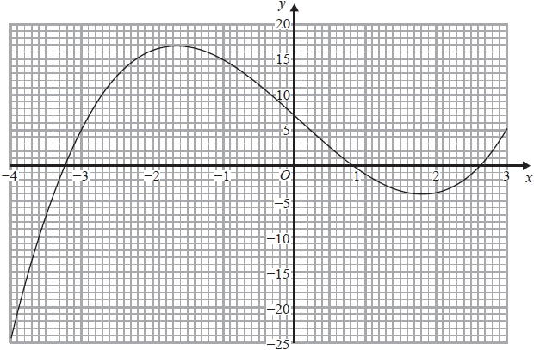

(a)  Use the graph to find an estimate for the solution of the equation *x*3 – 0.2*x*2 – 9*x* + 7 = –5

...........................................................

**(2)**

(b)  By drawing a suitable straight line on the grid, find an estimate for the solution of the equation

*x*3 – 0.2*x*2 – 4*x* + 7 = 0

...........................................................

**(3)**

**(Total for question = 5 marks)**

**Q5.**

Here is the graph of   *y* = h (*x*)

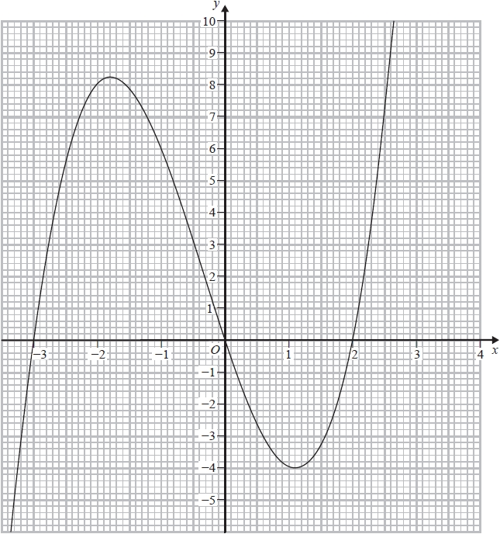

(a)  Use the graph to find an estimate for the gradient of the curve  *y* = h (*x*)  at  (–1,6)

...........................................................

**(3)**

(b)  By drawing a suitable straight line on the grid, find an estimate for the solution of the equation

h (*x*) = 7 – 2*x*

Give your answer correct to 1 decimal place.

...........................................................

**(2)**

The equation   h (*x*) = *k*   has 3 different solutions for   *a* < *k* < *b*

(c)  Use the graph to find an estimate for the value of *a* and the value of *b*.

*a* = ...........................................................

*b* = ...........................................................

**(2)**

**(Total for question = 7 marks)**

**Q6.**

(a)   Complete the table of values for *y* = *x*2 + 2*x* − 3

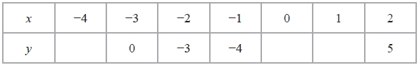

**(2)**

(b)   On the grid, draw the graph of *y* = *x*2 + 2*x* − 3 for values of *x* from −4 to 2

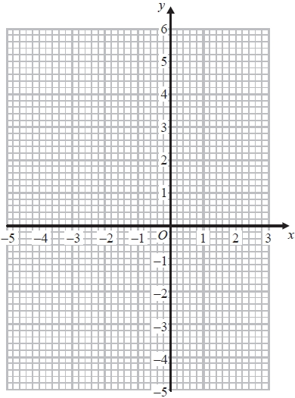

**(2)**

**(Total for Question is 4 marks)**

**Q7.**

The diagram shows part of a sketch of the curve *y* = sin x°

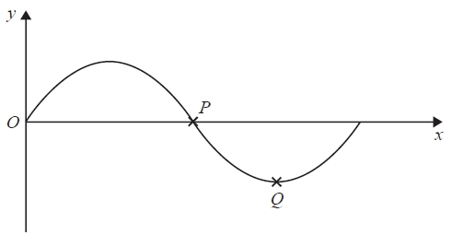

(a)  Write down the coordinates of

(i)  the point *P*

( ................ , ................ )

(ii)  the point *Q*

( ................ , ................ )

**(2)**

(b)  Sketch the graph of    *y* = tan *x*    for    0° ≤ *x* ≤ 360°

Show the coordinates of any points of intersection with the coordinate axes.

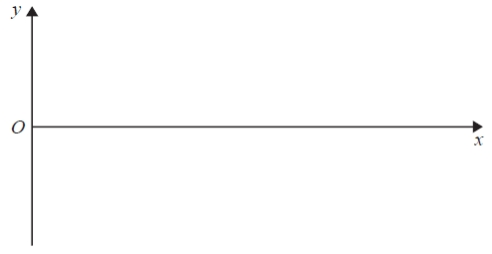

**(2)**

**(Total for question = 4 marks)**

**Q8.**

(a)  Complete the table of values for *y* = *x*3 – 5*x* + 2

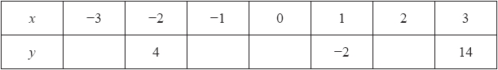

**(2)**

(b)  On the grid, draw the graph of *y* = *x*3 – 5*x* + 2  for  –3 ≤ *x* ≤ 3

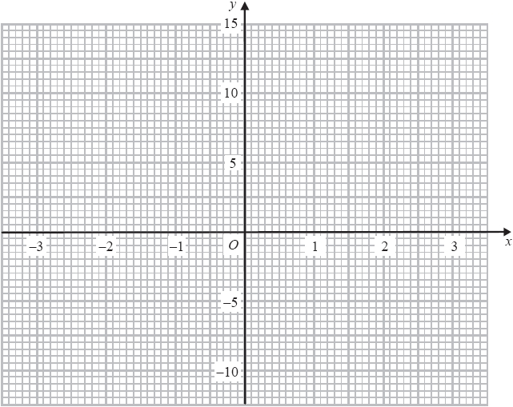

**(2)**

The equation *x*3 – 6*x* + *m* = 0, where *m* is an integer, has one negative solution and two   
positive solutions.

(c)  Given that *x* = 1 is one of the positive solutions, show that *m* = 5

**(1)**

(d)  By drawing a suitable straight line on the grid, find an estimate for the negative solution of

*x*3 – 6*x* + 5 = 0

Give your estimate to 1 decimal place.

...........................................................

**(2)**

**(Total for question = 7 marks)**

**Q9.**

(a)   Complete the table of values for *y* = *x*2 − 5*x* + 4

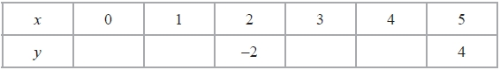

**(2)**

(b)   On the grid, draw the graph of *y* = *x*2 − 5*x* + 4 for all values of *x* from *x* = 0 to *x* = 5

**(2)**

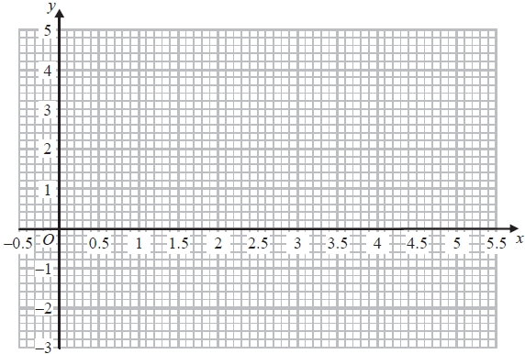

**(Total for Question is 4 marks)**

**Q10.**

(a)  Complete the table of values for *y* = *x*2 – 5*x* + 6

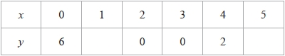

**(1)**

(b)  On the grid, draw the graph of *y* = *x*2 – 5*x* + 6 for 0 ≤ *x* ≤ 5

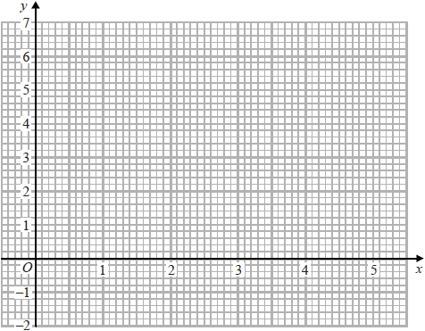

**(2)**

(c)  By drawing a suitable straight line on the grid, find estimates for the solutions of the equation

*x*2 – 5*x* = *x* – 7

**(3)**

**(Total for question = 6 marks)**

**Q11.**

The curve *C* has equation    *y* = *x*2 – 6*x* + 4

Using the axes below, sketch the curve *C*.   
On your sketch show clearly

(i)  the exact coordinates of any points of intersection of *C* with the coordinate axes,

(ii)  the coordinates of the turning point.

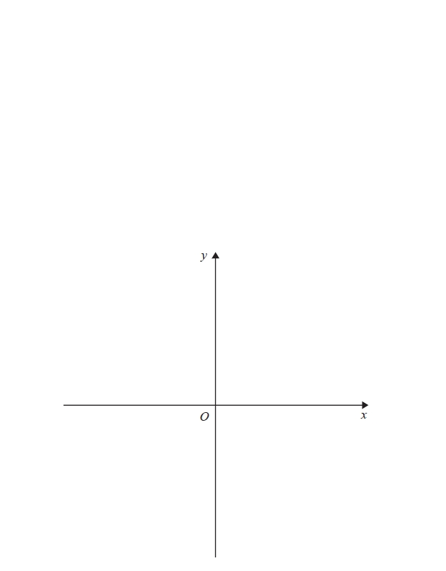

**(Total for question = 6 marks)**

**Q12.**

Here is the graph of *y* = *x*2 − 2*x* − 1

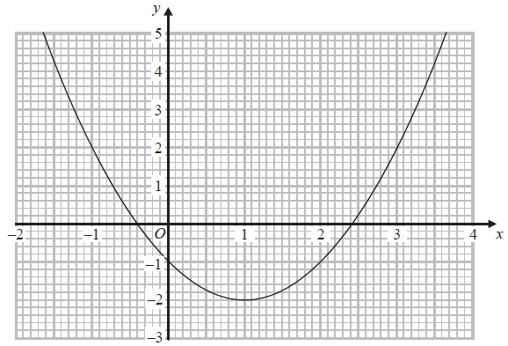

(a)  Use the graph to solve the equation *x*2 − 2*x* − 1 = 2

...........................................................

**(2)**

The equation *x*2 + 5*x* − 7 = 0 can be solved by finding the points of intersection of the line *y* = *ax* + *b* with the graph of *y* = *x*2 − 2*x* − 1

(b)  Find the value of *a* and the value of *b*.

*a* = ...........................................................

*b* = ...........................................................

**(2)**

**(Total for question = 4 marks)**

**Q13.**

The graph of *y* = f(*x*) is shown on the grid.

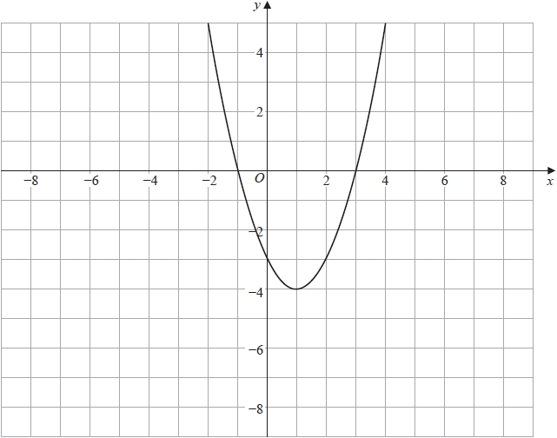

(a)  On the grid above, sketch the graph of

**(2)**

The graph of *y* = f(*x* + *k*) is shown on the grid below.

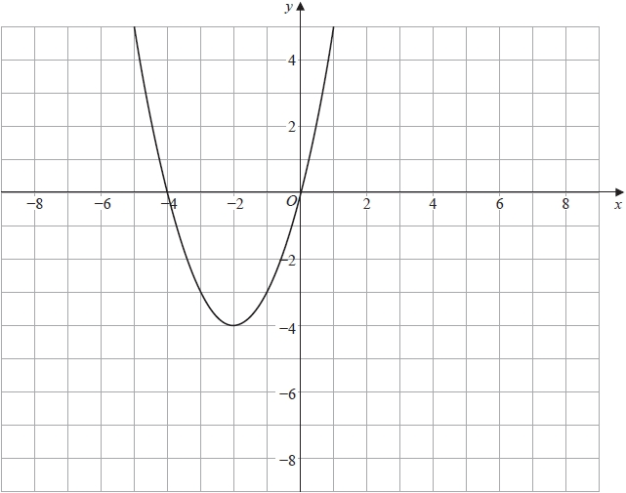

(b)  Write down the value of *k*

**(1)**

**(Total for question = 3 marks)**

**Q14.**

The diagram shows part of the curve with equation *y* = f(*x*)

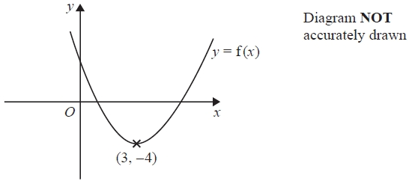

The coordinates of the minimum point on this curve are (3, –4)

(a)  Write down the coordinates of the minimum point on the curve with equation

(i)  *y* = f(*x* – 4)

( ................ , ................ )

(ii)  *y* = 3f(*x*)

( ................ , ................ )



(iii)  *y* =

( ................ , ................ )

**(3)**

The curve with equation *y* = f(*x*) is translated to give curve *C*.

*C* has a minimum at the point with coordinates (3, 5)

The equation of *C* is *y* = f(*x*) + *k*

(b)  Write down the value of *k*

*k* = ...........................................................

**(1)**

**(Total for question = 4 marks)**

**Q15.**

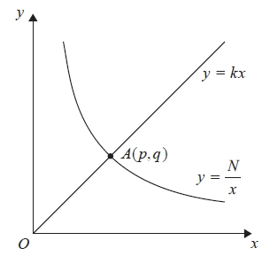

The diagram shows the straight line with equation *y* = *kx* intersecting the curve with equation at the point *A*(*p*, *q*).



(a)  Find *p* and find *q*.

Give each answer in its simplest form, in terms of *k* and *N*.

*p* = ...........................................................

*q* = ...........................................................

**(3)**

Given that *p* = 2*q*

(b)  find the value of *k*.

*k* = ...........................................................

**(2)**

**(Total for question = 5 marks)**

**Q16.**

(a) Complete the table of values for *y* = *x*2 + 2/*x*

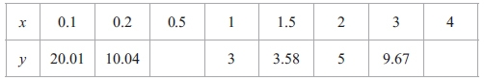

**(1)**

(b) On the grid, draw the graph of *y* = *x*2 + 2/*x* for 0.1 ≤ *x* ≤ 4

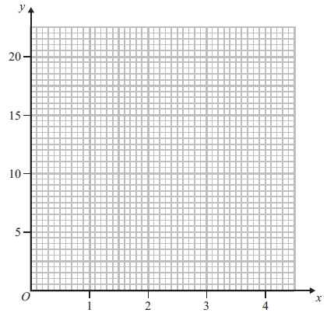

**(2)**

(c) Use your graph to find estimates for the solutions of *x*2 + 2/*x* = 14   
in the interval 0.1 ≤ *x* ≤ 4

Give your estimates correct to 1 decimal place.

...........................................................cm2

**(2)**

(d) *x* = 1 is one solution of the equation *x*2 + 2/*x* = *mx*

(i) Find the value of *m*.

*m* = ...........................................................

(ii) Draw a suitable straight line on your graph to find an estimate for the second positive solution of the equation *x*2 + 2/*x* = *mx* for the value of *m* found in part (d)(i).

Give your estimate correct to 1 decimal place.

*x* = ...........................................................

**(3)**

**(Total for question = 8 marks)**

**End of questions**