|  |
| --- |
| Name: _______________________________________________ |
|  |
|  |
|  |
|  |
| **Transport in plants** |
|  |
| **Date:** |
|  |
|  |
|  |
|  |
| **Time:** 19 minutes |
|  |
| **Total marks available:** 19 |
|  |
| **Total marks achieved:** ______ |
|  |
|  |
|  |
|  |
|  |
|  |
|  |
|  |
|  |
|  |
|  |
|  |
|  |
|  |
|  |
|  |
|  |
|  |
|  |
|  |
|  |
|  |
|  |
|  |
|  |
|  |

**Questions**

**Q1.**

The photograph below shows an electronmicrograph of xylem tissue.

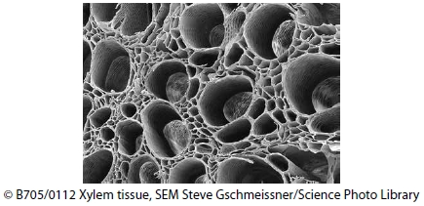

Give **three** ways in which xylem tissue is adapted for its functions.

**(3)**

.............................................................................................................................................

.............................................................................................................................................

.............................................................................................................................................

.............................................................................................................................................

.............................................................................................................................................

.............................................................................................................................................

**(Total for question = 3 marks)**

**Q2.**

The diagram shows a section of plant stem with a vascular bundle stained with phloroglucinol.

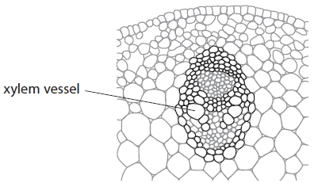

Phloroglucinol stains xylem vessels.

These xylem vessels can then be seen more easily and their size measured using a light microscope and an eyepiece graticule (micrometer).

(i)  The xylem vessel labelled is 0.133 mm in diameter.   
Calculate the magnification used. Give your answer to two significant figures.

**(1)**

Answer ...........................................................

(ii)  A student cut a section of plant stem from a shoot tip and stained it with phloroglucinol. She used an eyepiece graticule (micrometer) to measure the diameter of a xylem vessel.

She found that the xylem vessel was 0.39 mm in diameter.

Explain how you would extend this procedure to obtain valid data showing that xylem vessels are larger in older parts of the plant.

**(3)**

.............................................................................................................................................

.............................................................................................................................................

.............................................................................................................................................

.............................................................................................................................................

.............................................................................................................................................

.............................................................................................................................................

**Q3.**

Cellulose can be used to produce biofuel. The xylem tissue in wood is a good   
source of cellulose. The cell walls of this tissue are heavily lignified.

(i)  Explain what is meant by the term **tissue**.

**(2)**

.............................................................................................................................................

.............................................................................................................................................

.............................................................................................................................................

.............................................................................................................................................

.............................................................................................................................................

(ii)  The cellulose in the xylem tissue of wood has to be broken down by enzymes   
before it can be used to produce biofuels.

The lignin has to be removed before the enzymes can be used to break down   
the cellulose.

The photographs below show fibres containing cellulose before and after the   
removal of lignin.

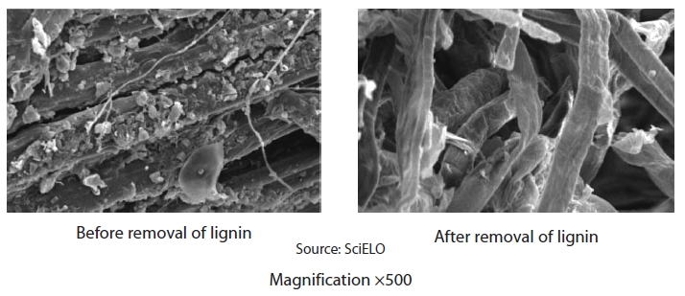

Using the information from the photographs, suggest how lignin adds   
strength to xylem tissue.

**(2)**

.............................................................................................................................................

.............................................................................................................................................

.............................................................................................................................................

.............................................................................................................................................

.............................................................................................................................................

**Q4.**

Mineral ions such as calcium, nitrate and magnesium are transported in the xylem   
vessels. These mineral ions are dissolved in water.

Describe how the structure of xylem vessels allows them to transport water.

**(2)**

.............................................................................................................................................

.............................................................................................................................................

.............................................................................................................................................

.............................................................................................................................................

.............................................................................................................................................

.............................................................................................................................................

**Q5.**

A student used a potometer to investigate the effect of temperature on the uptake of water by a plant shoot. The potometer was set up in a room at 30 °C and the volume of water taken up by the shoot was recorded for a period of 20 minutes.

The potometer was then moved to a room at 20 °C. After a period of acclimatisation, the volume of water taken up by the shoot was recorded for a further 20 minutes.

The results of the investigation are shown in the graph.

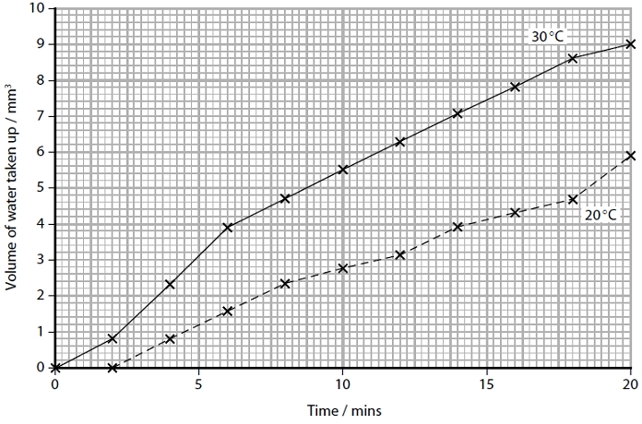

(a)  Calculate the mean transpiration rate for this shoot at 30 °C between 6 and 18 minutes.

**(3)**

Answer ...........................................................

(b)  Explain how an increase in temperature increases the transpiration rate of shoots.

**(3)**

.............................................................................................................................................

.............................................................................................................................................

.............................................................................................................................................

.............................................................................................................................................

.............................................................................................................................................

**(Total for question = 6 marks)**

**Q1.**No Examiner's Report available for this question

**Q2.**No Examiner's Report available for this question

**Q3.**

***(i)***

Candidates are expected to be able to provide definitions of tissues and organs. Most candidates scored full marks here, having learnt the definition well.

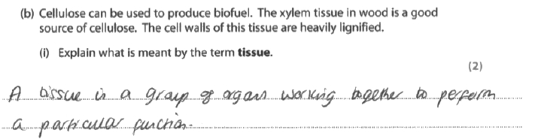

**Results Plus: Examiner Comments**

A careless error here cost a mark - 'organs' instead of 'cells'. If this response was worded ' a tissue is a group of cells working together to perform a particular function' it would have gained 2 marks instead of only 1.

**Results Plus: Examiner Tip**

Always check your answer - this candidate obviously knew the answer, but examiners cannot give marks if the answer is incorrect.

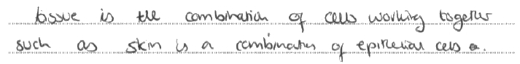

**Results Plus: Examiner Comments**

This answer missed out on the aspect of the cells in a tissue working together to carry out a particular function.

It only gained 1 mark for the idea of a group of cells.

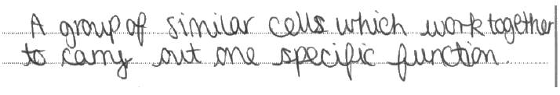

**Results Plus: Examiner Comments**

A very good answer which covered a 'group of similar cells' and 'working together to carry out one specific function'.

***(ii)***

This question provided plenty of information, including the fact that the photographs showed **fibres** containing cellulose before and after the removal of lignin. The question then instructed candidates to use '**information from the photographs**'. Those who read the question and studied the photographs should have been able to state that the lignin held the fibres together and parallel to one another.

The fact that few candidates achieved full marks and that they referred to lignin holding xylem together, instead of the fibres, suggested that many failed to read the information provided.

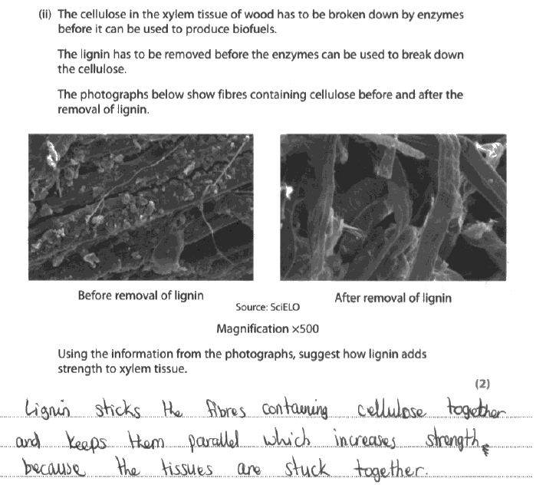

**Results Plus: Examiner Comments**

An excellent answer, which clearly described the fact that the lignin 'sticks' the fibres together and keeps them 'parallel'.

2/2

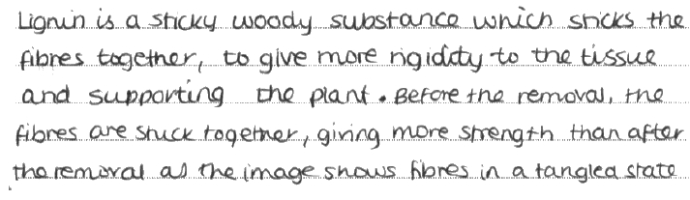

**Results Plus: Examiner Comments**

This response gained the mark for recognising that the lignin holds the fibres together, but failed to refer to them being in a parallel arrangement.

1/2

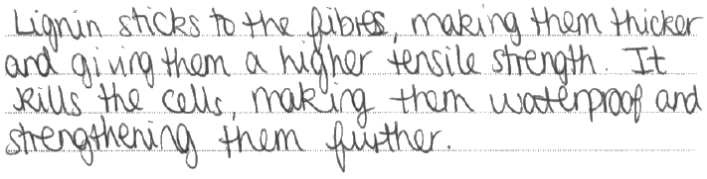

**Results Plus: Examiner Comments**

This response just failed to gain any marks. It referred to the lignin sticking to the fibres, but not to it sticking them together. It then went on to describe the waterproofing property of lignin, which does not provide the fibres with strength and cannot be ascertained from the photographs.

**Q4.**

This question was well answered, with many good descriptions of how the structure of xylem allows the transport of water, had been learnt well. Many referred to the hollow nature of the xylem vessel, with no cytoplasm, the lack of end walls and the presence of pits in the walls.

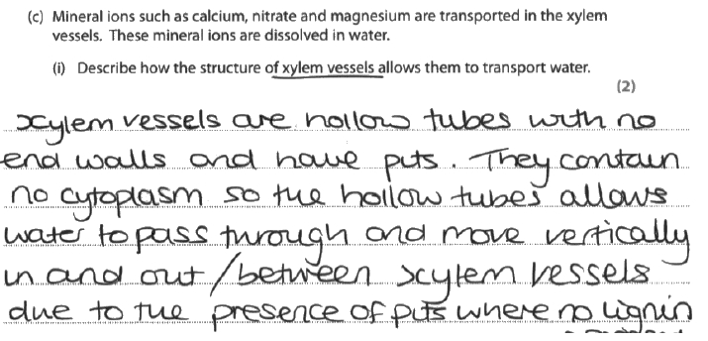

**Results Plus: Examiner Comments**

An excellent answer, which referred to hollow tubes, no end walls and pits in the opening sentence.

2/2

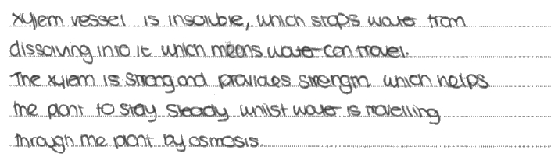

**Results Plus: Examiner Comments**

If this answer referred to lignin making the walls of the xylem impermeable to water - instead of just stating that xylem vessels are insoluble - it would have gained 1 mark.

0/2

**Q5.**No Examiner's Report available for this question

**Mark Scheme**

**Q1.**

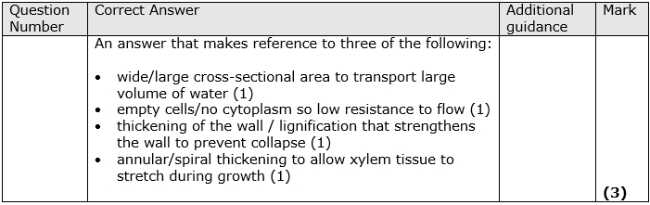

**Q2.**

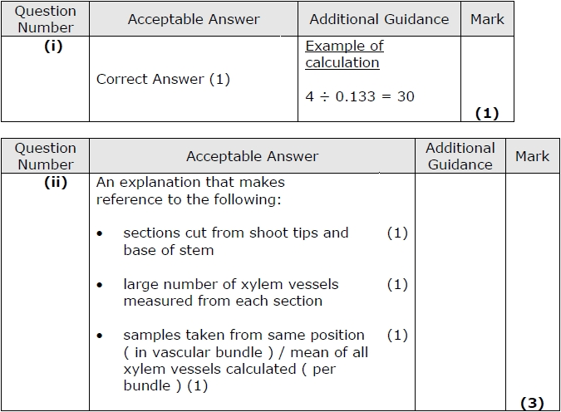

**Q3.**

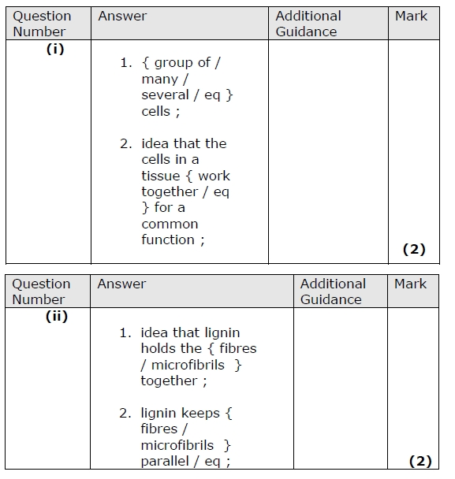

**Q4.**

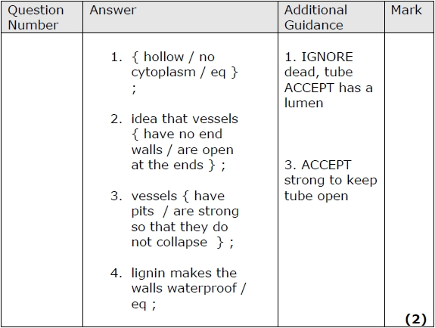

**Q5.**

