

**IGCSE (9 – 1) Revision Pack**

**Percentages**

**Marking Scheme**

**Mark Scheme**

Q1.

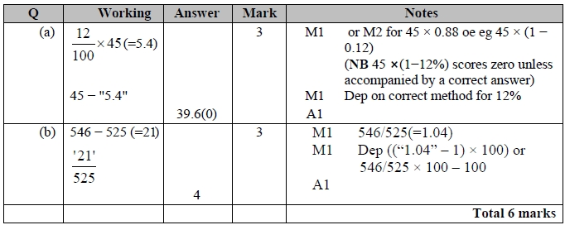

**Q2.**

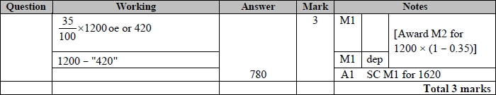

**Q3.**

The correct answer, unless clearly obtained by an incorrect method, should be taken to imply a correct method.

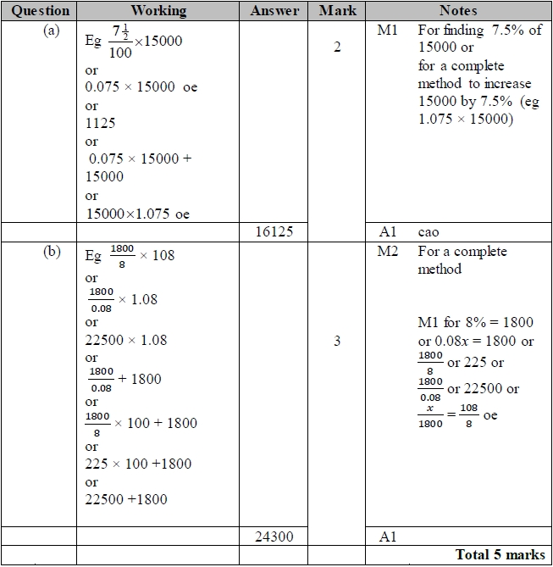

**Q4.**

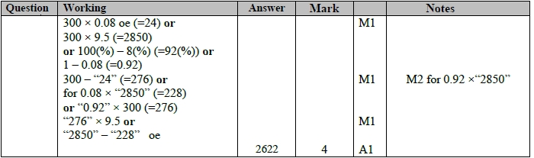

**Q5.**

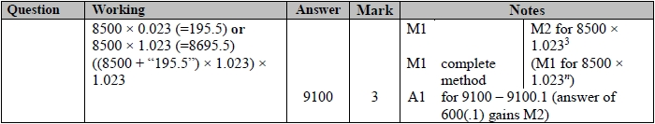

**Q6.**

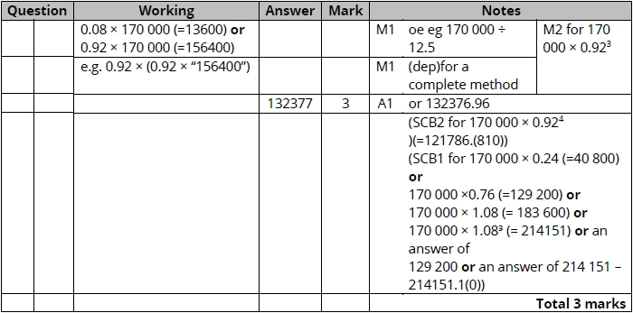

**Q7.**

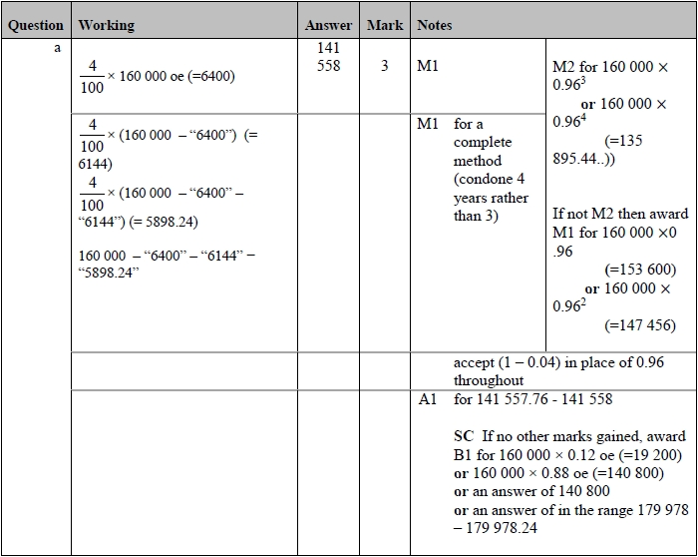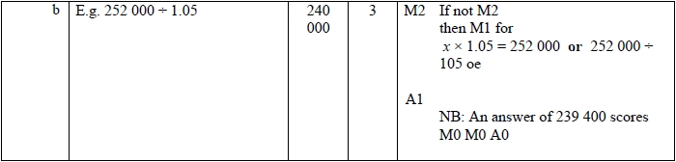

**Q8.**

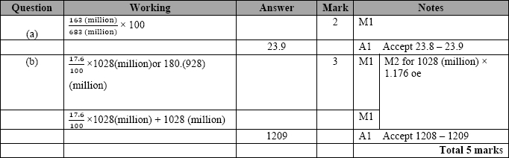

**Q9.**

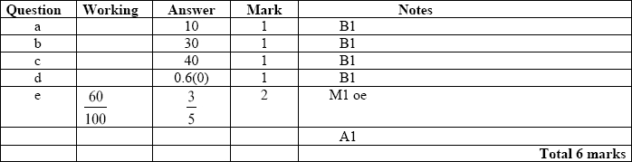

**Q10.**

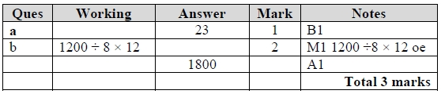

**Q11.**

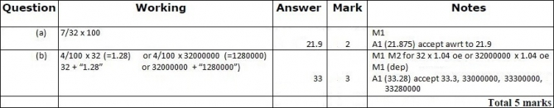

**Q12.**

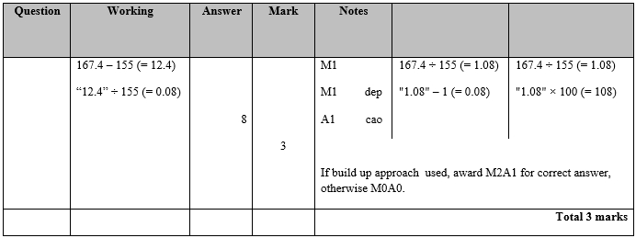

**Q13.**

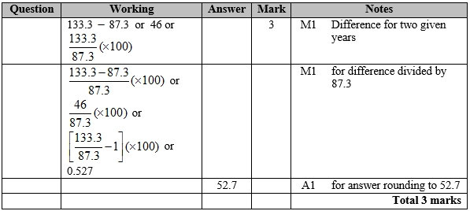

**Q14.**

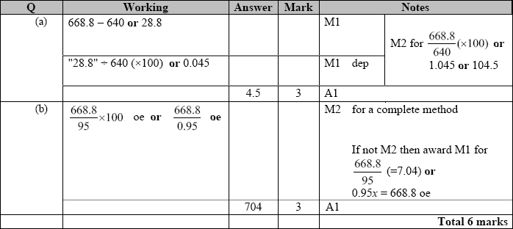

**Q15.**

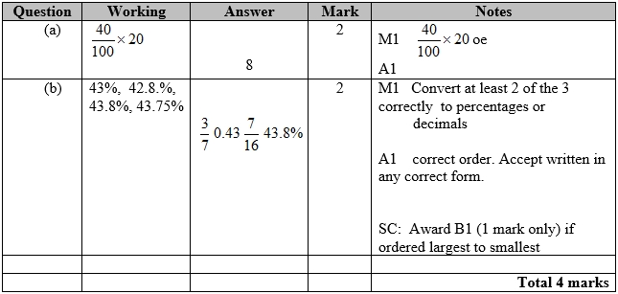

**Q16.**

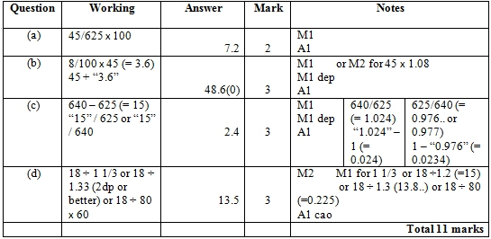

**Q17.**

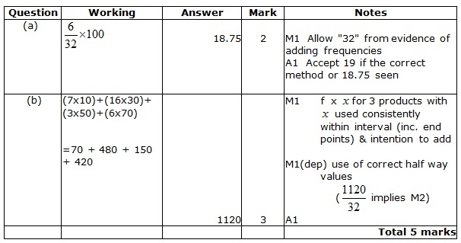

**Q18.**

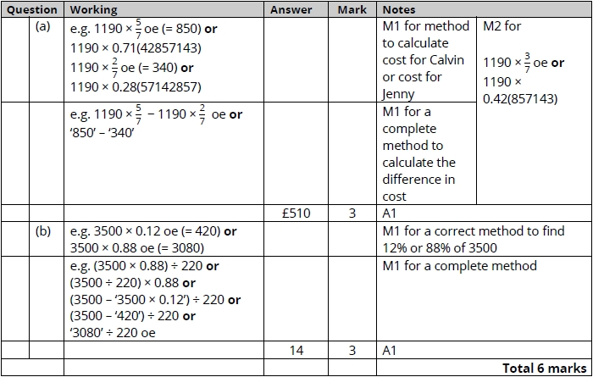

**Q19.**

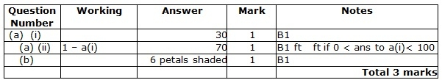

**Q20.**

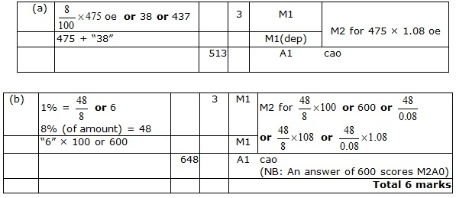

**Q21.**

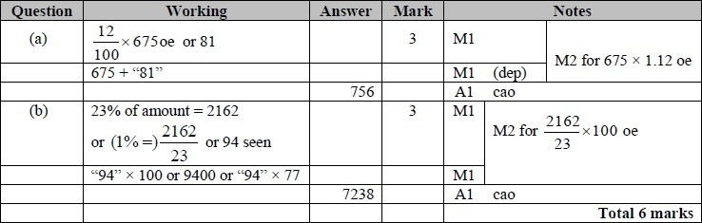

**Q22.**

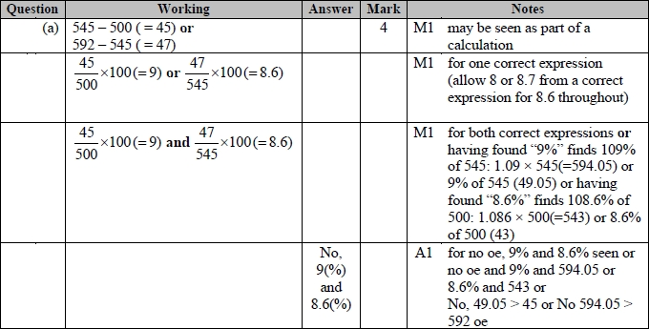

**Q23.**

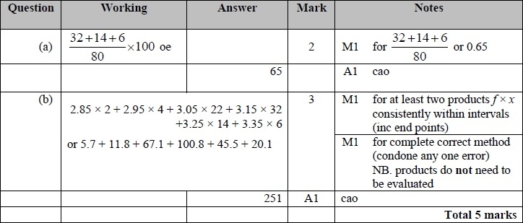

**Q24.**

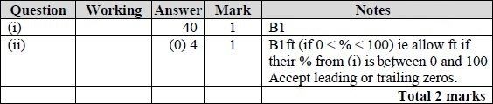

**Q25.**

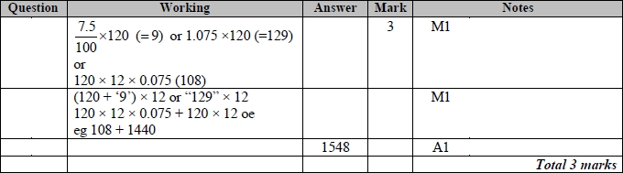

**Q26.**

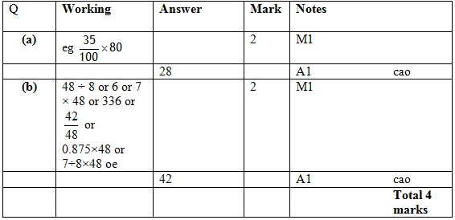

**Q27.**

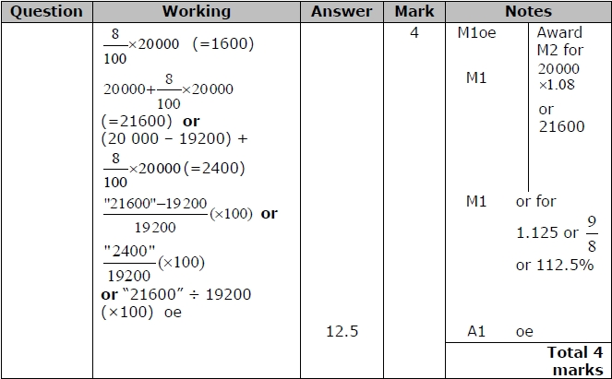

**Q28.**

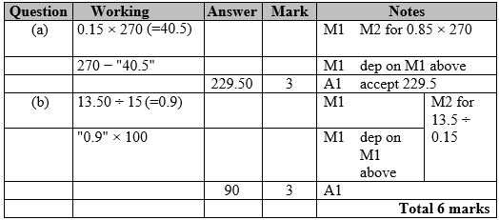

**Q29.**

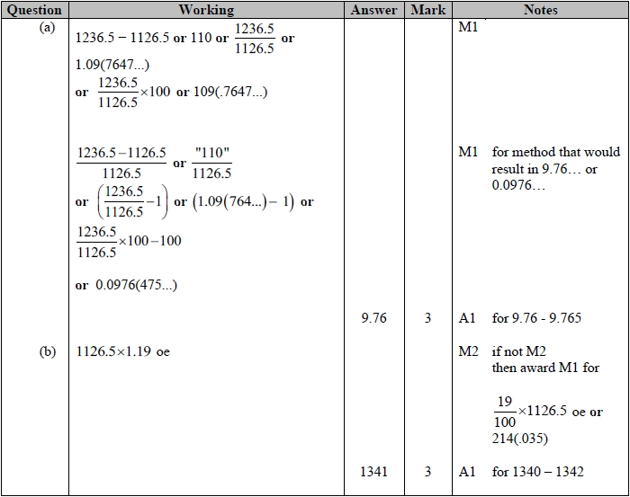

**Q30.**

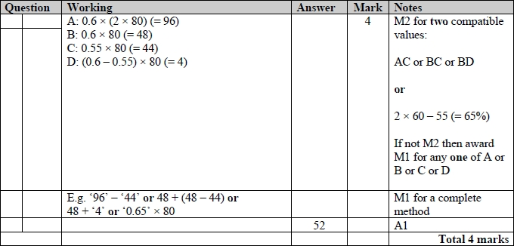

**Q31.**

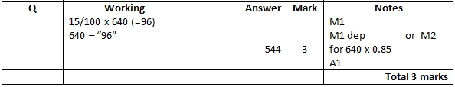

**Q32.**

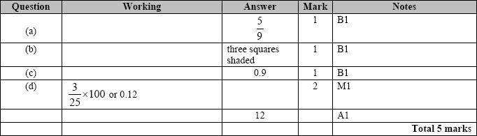

**Q33.**

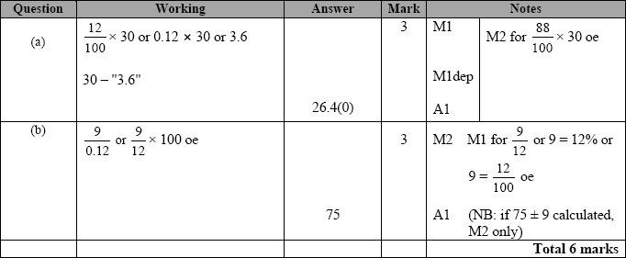

**Q34.**

For all questions, the correct answer, unless clearly obtained by an incorrect method, should be taken to imply a correct method.

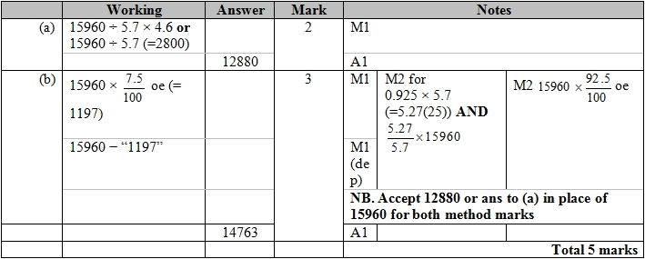

**Q35.**

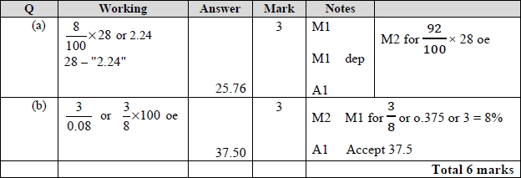

**Q36.**

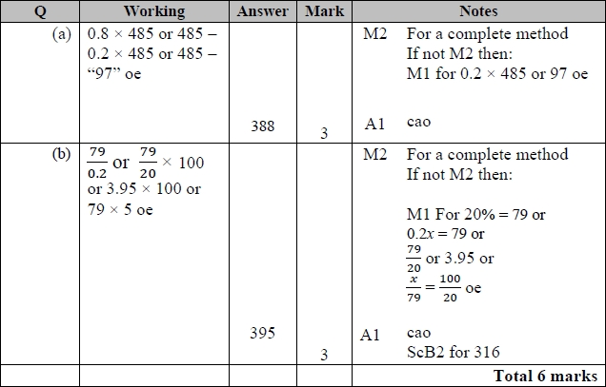

**Q37.**

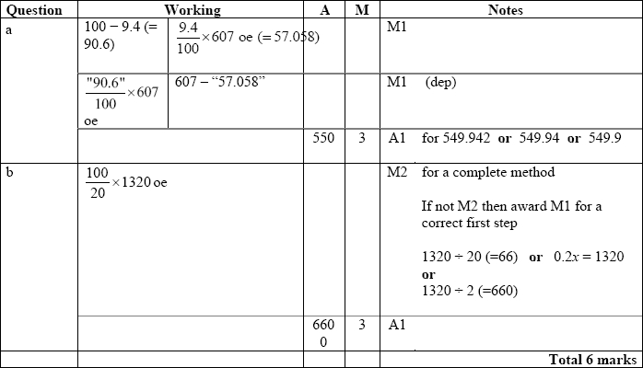

**Q38.**

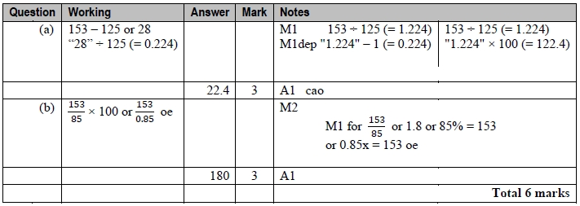

**Q39.**

For all questions, the correct answer, unless clearly obtained by an incorrect method, should be taken to imply a correct method.

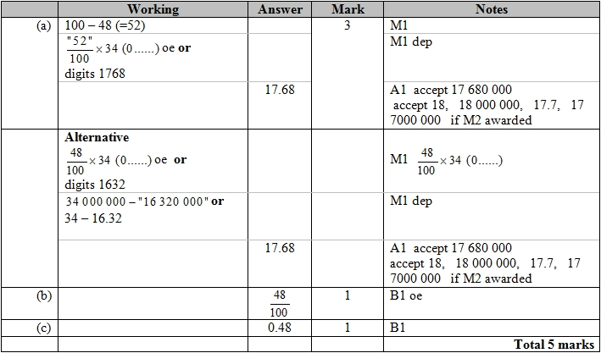

**Q40.**

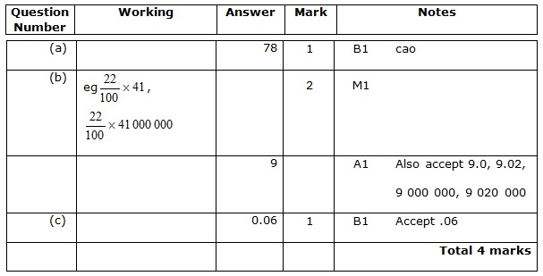

**Q41.**

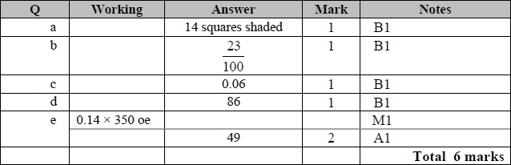

**Q42.**

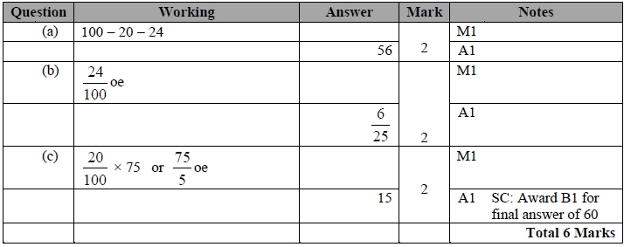

**Q43.**

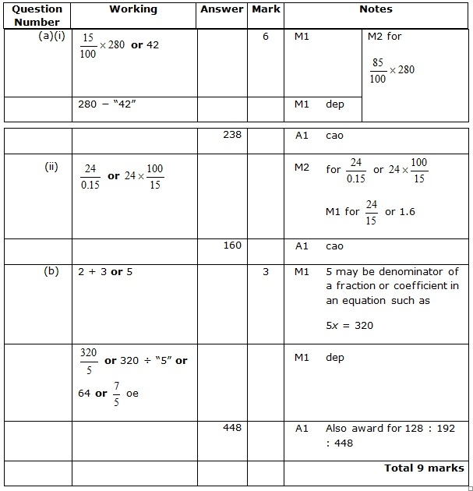

**Q44.**

