Confidence intervals.

When carrying out or looking at research a firm has to think about how confident they can be that the results are accurate and do represent the target market – how likely it is that the results will be correct. This is known as the confidence interval.

For example, if a firm looks at predicted sales into the future, they cannot know exactly what the value of sales will be but they may be able to get an approximate idea from research. The table below is from Statsita.com and shows the expected revenue and sales volume for UK passenger car sales to 2021.

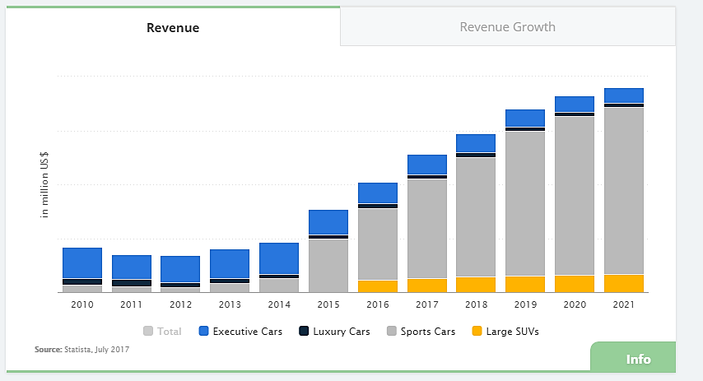

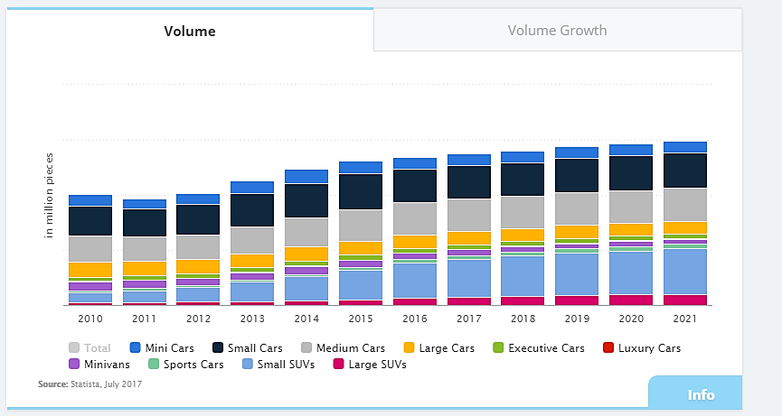

**Why would this information be of use to a car manufacturer in the UK?**

In reality it is very difficult to be certain about what will happen to sales and volume growth, because of the uncertainty firms turn to confidence levels to help with their decision making.

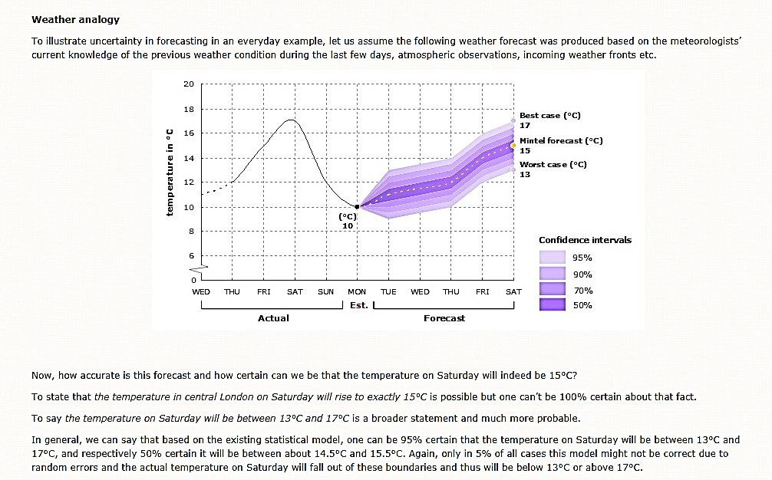For example, look at the Mintel research below about weather forecasting…

So, confidence levels are about looking at the chance that something is likely to happen.

Sampling can provide an insight into the target population as a whole but if you have not asked every member of the target population, then the results will not be 100% accurate.

The degree of confidence will depend upon:

* The size of the sample – the greater the size, the more accurate it is likely to be.
* The sampling method chosen.

The degree of confidence also depends on the *margin of error, t*his is also known as the **confidence interval**. For example, the researchers might be 95% confident that sales will be somewhere between £250,000 and £300,000. The confidence interval might also be expressed as say + or – a certain amount.

So, a researcher might say that they are 90% confident that 36% of the entire target population may purchase the product with a confidence interval + or – 4. This means that they think between 32% and 40% of the target population might purchase the product.

# How is this information used in practice?

Look at the question below, we can calculate the best and worst case scenarios from this information.

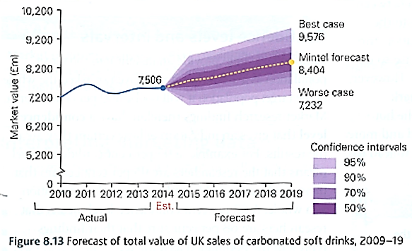At a 90% confidence level, we can see that the best case scenario for the sales would be £9200m and the worst case would be £7400m. We can therefore work out the range of likely sales values with a confidence interval of 90% as we know those are top and bottom points of the likely range.

**We can easily read off the figures for the 90% confidence interval by just looking across…**

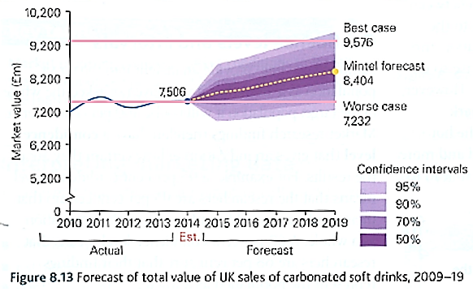

**Why does the confidence interval become higher as it moves away from the trend line?**

**Why do you think the interval becomes wider as it moves further into the future?**

**How would this look in an exam paper:**

Here is an example from a specimen paper:

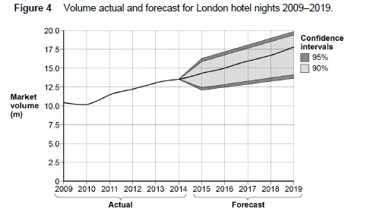

From this diagram we can see that there is forecast growth in the London hotel market.

The likely trend is upwards and there is a 90% confidence that the sales in 2019 will be between 14m and 19m (the light grey).

However, we can also see that, in the worst case scenario growth is static – i.e. in 2014 the actual figure is around 13m and the worst case figure in 2019 (the bottom of the dark grey 95% confidence interval) is also 13m.