**Instructions**

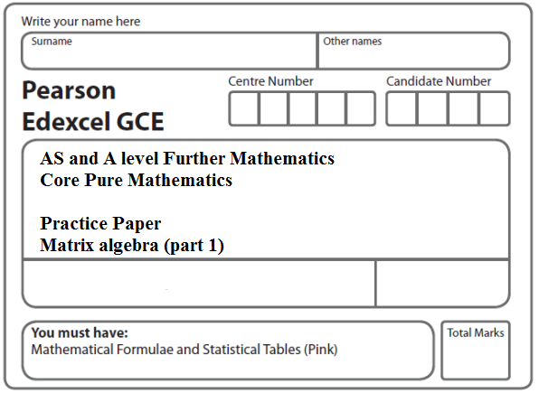

* Use black ink or ball-point pen.
* If pencil is used for diagrams/sketches/graphs it must be dark (HB or B).
* Fill in the boxes at the top of this page with your name, centre number and candidate number.
* Answer all the questions and ensure that your answers to parts of questions are clearly labelled.
* Answer the questions in the spaces provided – there may be more space than you need.
* You should show sufficient working to make your methods clear. Answers without working may not gain full credit.
* Inexact answers should be given to three significant figures unless otherwise stated.

**Information**

* A booklet ‘Mathematical Formulae and Statistical Tables’ is provided.
* There are 13 questions in this question paper. The total mark for this paper is 100.
* The marks for each question are shown in brackets – use this as a guide as to how much time to spend on each question.
* Calculators must not be used for questions marked with a * sign.

**Advice**

• Read each question carefully before you start to answer it.

• Try to answer every question.

• Check your answers if you have time at the end.

• If you change your mind about an answer, cross it out and put your new answer and any working underneath.

**1.**

**M** = 

Given that the matrix **M** is singular, find the possible values of *x*.

**(Total 4 marks)**

**___________________________________________________________________________**

**2.**

** **

(*a*)Find **A**–1

**(2)**

The transformation represented by the matrix **B** followed by the transformation represented

by the matrix **A** is equivalent to the transformation represented by the matrix **P**.

(*b*)Find **B**, giving your answer in its simplest form.

**(3)**

**(Total 5 marks)**

**___________________________________________________________________________**

**3.** (i) , where *k* is a constant

Given that **B** = **A** + 3**I**

where **I** is the 2 × 2 identity matrix, find

(*a*) **B** in terms of *k*,

**(2)**

(*b*) the value of *k* for which **B** is singular.

**(2)**

(ii) Given that , **D** = (2 –1 5)

and **E** = **CD**

find **E**.

**(2)**

**(Total 6 marks)**

**___________________________________________________________________________**

**4.** (*a*) Given that **A** =  and **B = ,**

find **AB**.

**(2)**

(*b*) Given that **C** =  and **D =** , where *k* is a constant

and **E** = **C** + **D**,

find the value of *k* for which **E** has no inverse.

**(4)**

**(Total 6 marks)**

**___________________________________________________________________________**

**5.** **A** = , **B = **

(*a*) Find **AB**.

**(3)**

Given that **C** = 

(*b*) describe fully the geometrical transformation represented by **C**,

**(2)**

(*c*) write down **C**100.

**(1)**

**(Total 6 marks)**

**___________________________________________________________________________**

**6.** (*a*) Given that **A** = ,

(i) find **A**2,

(ii) describe fully the geometrical transformation represented by **A**2.

**(4)**

(*b*) Given that **B** = ,

describe fully the geometrical transformation represented by **B**.

**(2)**

(*c*) Given that **C** = ,

where *k* is a constant, find the value of *k* for which the matrix **C** is singular.

**(3)**

**(Total 9 marks)**

**___________________________________________________________________________**

**7.** (i) Given that  and ,

(*a*) find **AB**.

(*b*) Explain why **AB** ≠ **BA**.

**(4)**

(ii) Given that , where *k* is a real number

find **C**–1, giving your answer in terms of *k*.

**(3)**

**(Total 7 marks)**

**___________________________________________________________________________**

**8.** The transformation *U*, represented by the 2 × 2 matrix **P**, is a rotation through 90° anticlockwise about the origin.

(*a*) Write down the matrix **P**.

**(1)**

The transformation *V*, represented by the 2 × 2 matrix **Q**, is a reflection in the line *y* = −*x*.

(*b*) Write down the matrix **Q**.

**(1)**

Given that *U* followed by *V* is transformation *T*, which is represented by the matrix **R**,

(*c*) express **R** in terms of **P** and **Q**,

**(1)**

(*d*) find the matrix **R**,

**(2)**

(*e*) give a full geometrical description of *T* as a single transformation.

**(2)**

**Total 7 marks)**

**___________________________________________________________________________**

**9.** A right angled triangle *T* has vertices *A*(1, 1), *B*(2, 1) and *C*(2, 4). When *T* is transformed by the matrix **P** = , the image is *T* ′.

(*a*) Find the coordinates of the vertices of *T* ′.

**(2)**

(*b*) Describe fully the transformation represented by **P**.

**(2)**

The matrices **Q** =  and **R** =  represent two transformations. When *T* is transformed by the matrix **QR**, the image is *T* ″.

(*c*) Find **QR**.

**(2)**

(*d*) Find the determinant of **QR**.

**(2)**

(*e*) Using your answer to part (*d*), find the area of *T* ″.

**(3)**

**(Total 11 marks)**

**___________________________________________________________________________**

**10.** (i)

** **

where *p* is a constant.

(*a*)Find, in terms of *p*, the matrix **AB**

**(2)**

Given that

**AB +** 2**A =** *k***I**

where *k* is a constant and **I** is the 2 × 2 identity matrix,

(*b*)find the value of *p* and the value of *k*.

**(4)**

(ii)

, where *a* is a real constant

Triangle *T* has an area of 15 square units.

Triangle *T* is transformed to the triangle *T'* by the transformation represented by the

matrix **M**.

Given that the area of triangle *T'* is 270 square units, find the possible values

of *a*.

**(5)**

**(Total 11 marks)**

**___________________________________________________________________________**

**11.** **A** = , where *a* and *b* are constants.

Given that the matrix **A** maps the point with coordinates (4, 6) onto the point with coordinates (2, −8),

(*a*) find the value of *a* and the value of *b*.

**(4)**

A quadrilateral *R* has area 30 square units.

It is transformed into another quadrilateral *S* by the matrix **A**.

Using your values of *a* and *b*,

(*b*) find the area of quadrilateral *S*.

**(4)**

**(Total 8 marks)**

**___________________________________________________________________________**

**12.**

****.

(*a*)Describe fully the single geometrical transformation *U* represented by the matrix **P**.

**(2)**

The transformation *U* maps the point *A*, with coordinates (*p*, *q*), onto the point *B*, with coordinates (6√2, 3√2).

(*b*)Find the value of *p* and the value of *q*.

**(3)**

The transformation *V*, represented by the 2 × 2 matrix **Q**, is a reflection in the line with equation *y* = *x*.

(*c*)Write down the matrix **Q**.

**(1)**

The transformation *U* followed by the transformation *V* is the transformation *T*. The transformation *T* is represented by the matrix **R**.

(*d*)Find the matrix **R**.

**(3)**

(*e*)Deduce that the transformation *T* is self-inverse.

**(1)**

**(Total 10 marks)**

**___________________________________________________________________________**

**13*.***

 and 

Given that **M** = (**A** + **B**)(2**A** – **B**),

(*a*) calculate the matrix **M**,

**(6)**

(*b*) find the matrix **C** such that **MC** = **A**.

**(4)**

**(Total 10 marks)**

**TOTAL FOR PAPER: 100 MARKS**