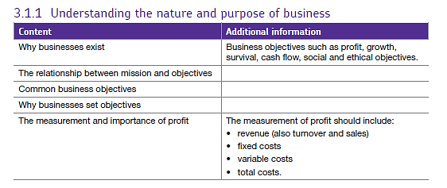3.1.1 Understanding the nature and purpose of business

# What is a Business?

A business is an organisation that exists to provide **goods** and **services** on a commercial basis to customers.

* **Goods** are **physical or tangible products**: e.g. consumer electronics, industrial components, e.g. cars, circuit boards, chairs
* **Services** are **intangible products**: e.g. insurance, dental services, cleaning

Customers can be individuals (buying on their own behalf or for households), businesses or other organisations.

# Why Businesses Exist

Businesses exist because they are formed by **entrepreneurs** and are subsequently developed if they manage to get beyond the survival stage.

Most businesses exist in order to earn a **return** for the business owners, and the potential for profit is a key motive for entrepreneurial activity. However, there are other potential business objectives, which are explored further during your studies.

Businesses play a key role in wider society. In particular they:

* Create and sustain employment & develop the skills of people
* Drive innovation through research & development (R&D) and new products
* Contribute to the infrastructure of the country
* Pay taxes on profits earned & collect taxes on behalf of government
* Create wealth by providing returns on investment

# Role of Entrepreneurs

Entrepreneurs (and the enterprise that they demonstrate) play a key role in the formation and development of businesses.

In particular, entrepreneurs:

* Spot business opportunities
* Take (calculated) risks in order to gain possible future returns
* Act a catalyst for the creation & growth of new business enterprises

# Business objectives.

A good definition of business objectives is:

**"Objectives are statements of specific outcomes that are to be achieved"**

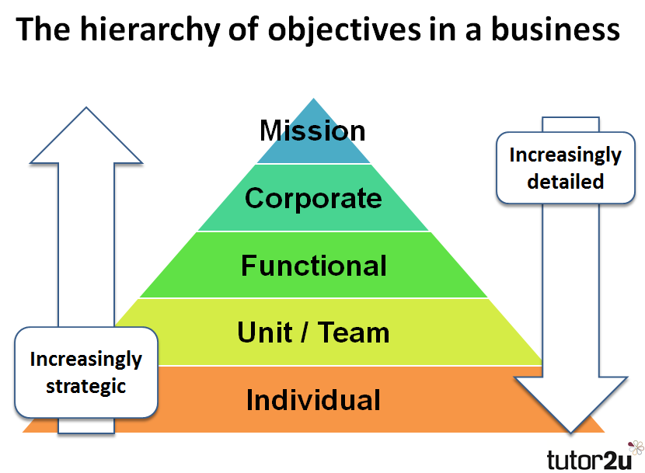

Objectives are set at various levels in a business - from the top (corporate) and through the layers underneath (functional and unit).

Objectives are often set in financial terms. That means that the objective is expressed in terms of a financial outcome that is to be achieved. Those could include:

* Desired sales or profit levels
* Rates of growth
* Amount of cash generated
* Value of the business or dividends paid to shareholders

However, it is incorrect to say that objectives have to be expressed in money terms, or that they have to be able to be measured. Some objectives are hard to measure, but are often important.

For example, an objective to be:

* An innovative player in the market
* A leading in the quality of customer service
* To provide an ethical product or service
* To provide a business which fulfils a social need e.g. a housing association

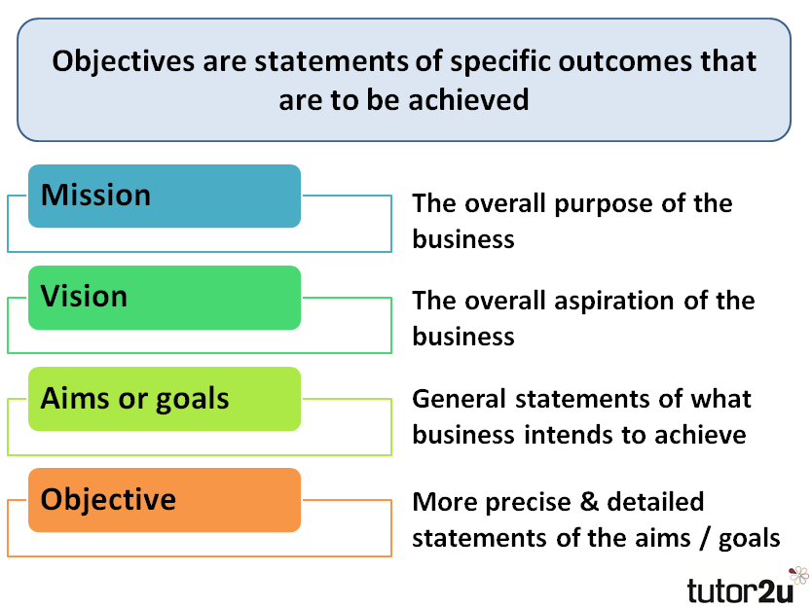A popular way to look at objectives is to see them as part of a **hierarchy** of forward-looking terms which help **set and shape the strategy of a business**. That hierarchy can be summarised as follows:

# Mission and objectives.

The mission of a business is the **overriding goal of the business** and the reason for its existence. A mission provides a **strategic perspective** for the business, a vision for the future.

## Relationship between Mission and Objectives

An effective mission statement:

* Differentiates the business from its competitors
* Defines the markets or business in which the business wants to operate
* Is relevant to all major stakeholders - not just shareholders and managers
* Excites, inspires, motivates & guides – particularly important for employees

Mission statements are often criticised because they are:

* Not always supported by actions of the business
* Often too vague and general or merely statements of the obvious
* Viewed as a public relations exercise
* Sometimes regarded cynically by employees
* Not supported wholeheartedly by senior management

# Costs and profits.

Costs are the amounts that a business incurs in order to make goods and/or provide services.

Costs are important to business because they:

* Are the thing that **drains away the profits** made by a business
* Are the difference between making a good and a poor **profit margin**
* Are the **main cause of cash flow problems** in business
* **Change as the output or activity of a business changes**

## Fixed (indirect) and Variable (direct) Costs

An important distinction needs to be made between variable and fixed costs.

**Variable (direct) costs**

Variable costs are costs which **change as output varies, they are normally expressed per unit.**

* Examples include:
* Raw materials or Bought-in stocks
* Wages based on hours worked or amount produced
* Marketing costs based on sales (e.g. % commission)

nb: some costs can be semi-variable – e.g. if someone is paid a salary but then can also receive a bonus – the salary is a fixed cost but the bonus for achievement will be variable so might be classed as a semi-variable cost.

**Fixed (indirect) costs**

Fixed costs **do not change in relation to output.** They do change - but not as a consequence of output changing.

Examples include:

* Rent & rates
* Salaries
* Advertising
* Insurance, banking & legal fees
* Software Research and development

# Calculating total costs

The total costs of a business can be calculated using this formula:

**Total Costs = Fixed Costs + (Variable Cost per unit x units)**

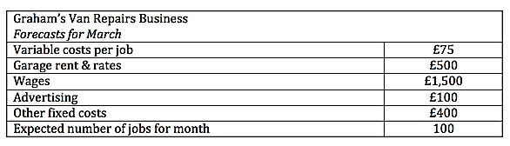Here’s a simple example of how total costs can be calculated using the following example data:

What would Graham’s costs be in March if his forecasts prove correct?

1. calculate variable costs: = £75 x 100 = £7,500
2. add together the fixed costs = (£500 + £1,500 + £100 + £400) = £2,500
3. add variable to fixed costs - total costs = (7,500 + £2,500) = £10,000

The costs incurred by a business are often relatively easy to estimate.  You know how much salary someone is paid or what price your supplier is charging. However, this is not always the case – some costs are uncertain:

* Raw materials – affected by wastage
* Product returns or refunds – affected by quality
* Where a business or entrepreneur does not have detailed experience of a market

# Profit

Profit is the money which the firms has left after all costs have been deducted. Profit can be calculated by deducting total costs from total revenue.

**Profit = Total Revenue – Total Costs**

**Revenue = selling price x units sold**

If Graham charges £1200 per job, his profit will be

|  |  |  |  |
| --- | --- | --- | --- |
| **Total Revenue** |  | **Total cost** | **Profit** |
| 100 jobs x £120 = £12000 | - | £10,000 | = 2000 |