**BIOLOGY NOTES – UPPER 4**

**4.1 Cell biology**

Cells are the basic unit of all forms of life. The structural differences between various types of cells enable them to perform specific functions within the organism. These differences in cells are controlled by genes in the nucleus. For an organism to grow, cells must divide by mitosis producing two new identical cells. If cells are isolated at an early stage of growth before they have become too specialised, they can retain their ability to grow into a range of different types of cells. This phenomenon has led to the development of stem cell technology. This is a new branch of medicine that allows doctors to repair damaged organs by growing new tissue from stem cells.

**4.1.1 Cell structure**

**Eukaryotes and prokaryotes**

**Plant and animal cells (eukaryotic cells)** have a cell membrane, cytoplasm and genetic material enclosed in a nucleus.

**Bacterial cells (prokaryotic cells)** are much smaller in comparison. They have cytoplasm and a cell membrane surrounded by a cell wall. The genetic material is not enclosed in a nucleus. It is a single DNA loop and there may be one or more small rings of DNA called plasmids.

* Unicellular – survive as one cell (by themselves)
* 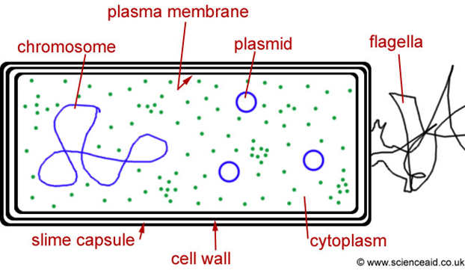Have bacterial chromosomes
* Contain circular pieces of DNA

called plasmids.

* They **DO NOT** have a nucleus
* Have a tail (flagellum) to move

towards food.

**Animal cells**

Most animal cells have the following parts:

* Nucleus, which controls the activities of the cell
* Cytoplasm, in which most of the chemical reactions take place
* Cell membrane, which controls the passage of substances into and out of the cell
* Mitochondria, which is where most energy is released in respiration
* Ribosomes, which is where protein synthesis occurs.

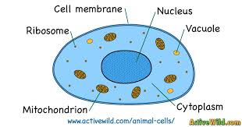

In addition to the parts found in animal cells, plant cells often have:

* Chloroplasts, which absorb light energy to make food
* Permanent vacuole filled with cell sap.
* Cell wall made of cellulose to provide strength and structural support.

Plant and algal cells have a cell wall made of cellulose, which strengthens the cell.

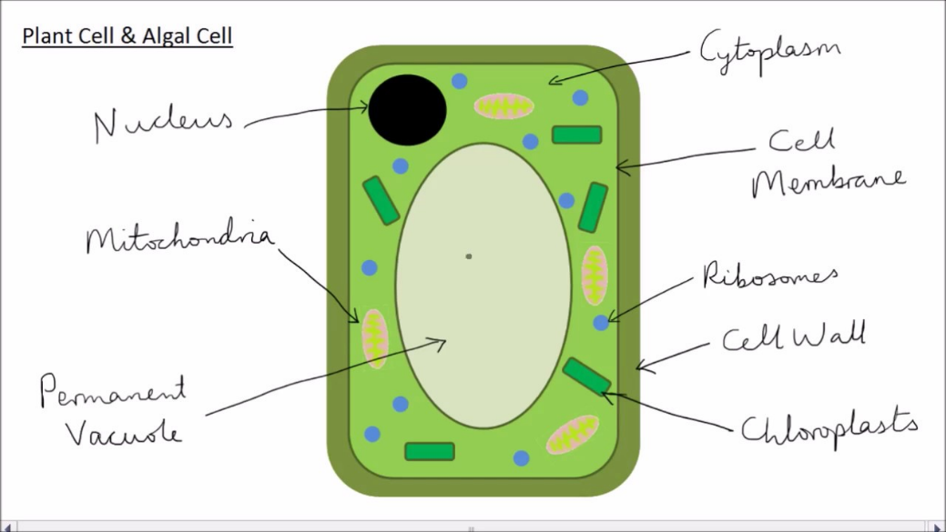

**Summary of structure to related to function of organelles**

|  |  |  |  |
| --- | --- | --- | --- |
| Organelle | Animal Cells | Plant Cells | Function |
| Chloroplasts | NO | YES | Site of photosynthesis |
| Cell Wall | NO | YES | Made of cellulose gives the cell structural support |
| Sap Vacuole | NO | YES | Acts as a store of water or waste products |
| Chlorophyll | NO | (in chloroplasts) | Needed for photosynthesis |
| Cytoplasm | YES | YES | Site of chemical reactions in the cell |
| Cell Membrane | YES | YES | Selectively permeable, and controls what enters/leaves |
| Nucleus | YES | YES | Contains nucleic acids (DNA) |
| Mitochondria | YES | YES | Site of respiration |
| Ribosomes | YES | YES | Where proteins are made |
| Size | 50чm | 150чm |  |
| Shape | No fixed shape | Rectangular |  |

**Cell specialisation**

Cells may be specialised to carry out a particular function:

• sperm cells, nerve cells and muscle cells in animals

• root hair cells, xylem and phloem cells in plants.

Animal and plant cells may be specialised to function within a tissue, an organ, organ systems, or whole organisms.

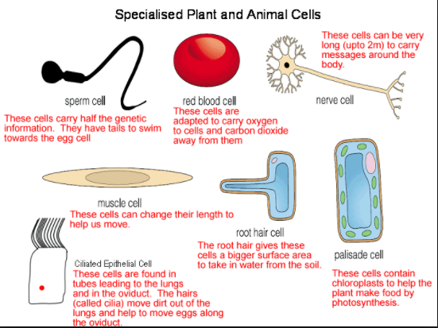

**Microscopy**

An electron microscope has a much **higher magnification and resolving power** (resolution) than a light microscope. This means that it can be used to study cells in much finer detail. This has enabled biologists to see and understand many more sub-cellular structures.

Magnification = size of image / size of real object

With light microscopes, individual cells and large subcellular structures like the nucleus can be seen. With electron microscopes, using a beam of electrons instead of a beam of light, a much higher resolution is gained seeing much smaller objects e.g. the structures of mitochondria, chloroplasts, ribosomes and plasmids.

[Link to core practical 1](https://www.youtube.com/watch?v=WcpYQF15iis)

[Link to core practical 1 part 2](https://www.youtube.com/watch?v=RYDFMf1B3rk)

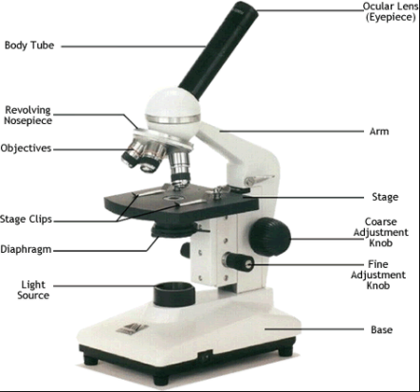

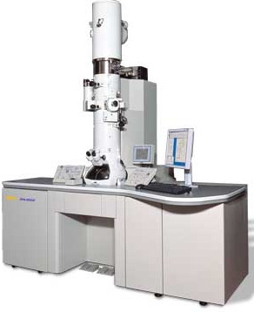

**4.1.2 Cell division**

**Chromosomes**

The nucleus of a cell contains chromosomes made of coiled DNA molecules, they are the genetic information. Each chromosome carries a large number of genes. In body cells the chromosomes are normally found in pairs.

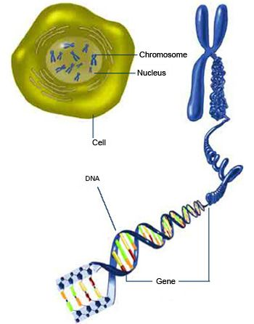

**Mitosis and the cell cycle**

Cells divide in a series of stages called the cell cycle. There are several stages of the cell cycle, including mitosis.

During the cell cycle the genetic material is doubled and then divided into two identical cells.

Before a cell can divide it needs to grow and increase the number of sub-cellular structures such as ribosomes and mitochondria. The DNA replicates to form two identical arms of the chromosome (the x shape structure)

In mitosis, one arm of the chromosome (one chromatid) is pulled to each end of the cell and the nucleus divides.

Finally the cytoplasm and cell membranes divide to form two genetically identical cells.

Cell division by mitosis is important in the growth and development of multicellular organisms.

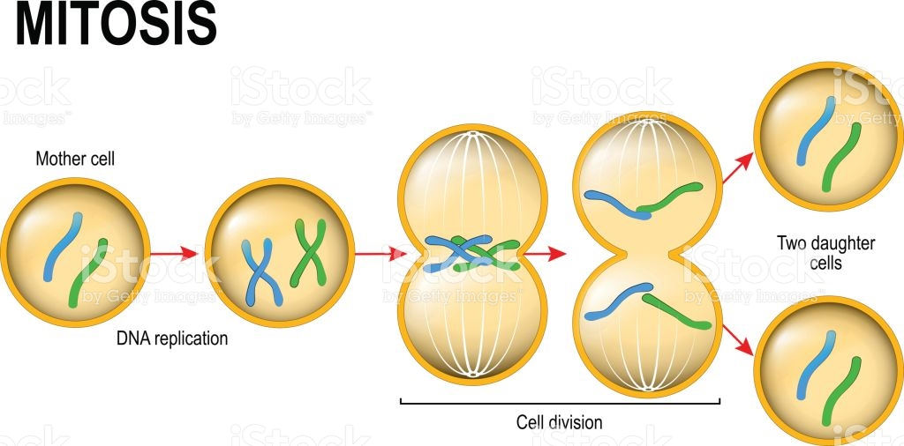

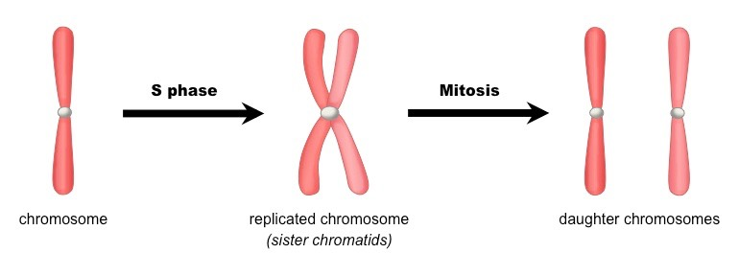

**Why do cells need to divide by mitosis:**

Repair of damaged cells

Growth to increase the cell number

Replacement of lost cells – e.g. skin cells

**Stem cells**

A stem cell is an undifferentiated cell of an organism which is capable of giving rise to many more cells of the same type, and from which certain other cells can arise from differentiation. Stem cells have an important role to play in embryos, in adult animals and in the meristems in plants.

Stem cells from human embryos can be cloned and made to differentiate into most different types of human cells. Stem cells from adult bone marrow can form many types of cells including blood cells.

Meristem tissue in plants can differentiate into any type of plant cell, throughout the life of the plant.

Treatment with stem cells may be able to help conditions such as diabetes and paralysis.

In therapeutic cloning an embryo is produced with the same genes as the patient. Stem cells from the embryo can be rejected by the patient’s body so they may be difficult to use for medical treatment.

The use of stem cells has potential risks such as transfer of viral infection, and some people have ethical or religious objections.

Stem cells from meristems in plants can be used to produce clones of plants quickly and economically.

* Rare species can be cloned to protect from extinction.
* Crop plants with special features such as disease resistance can be cloned to produce large numbers of identical plants for farmers.

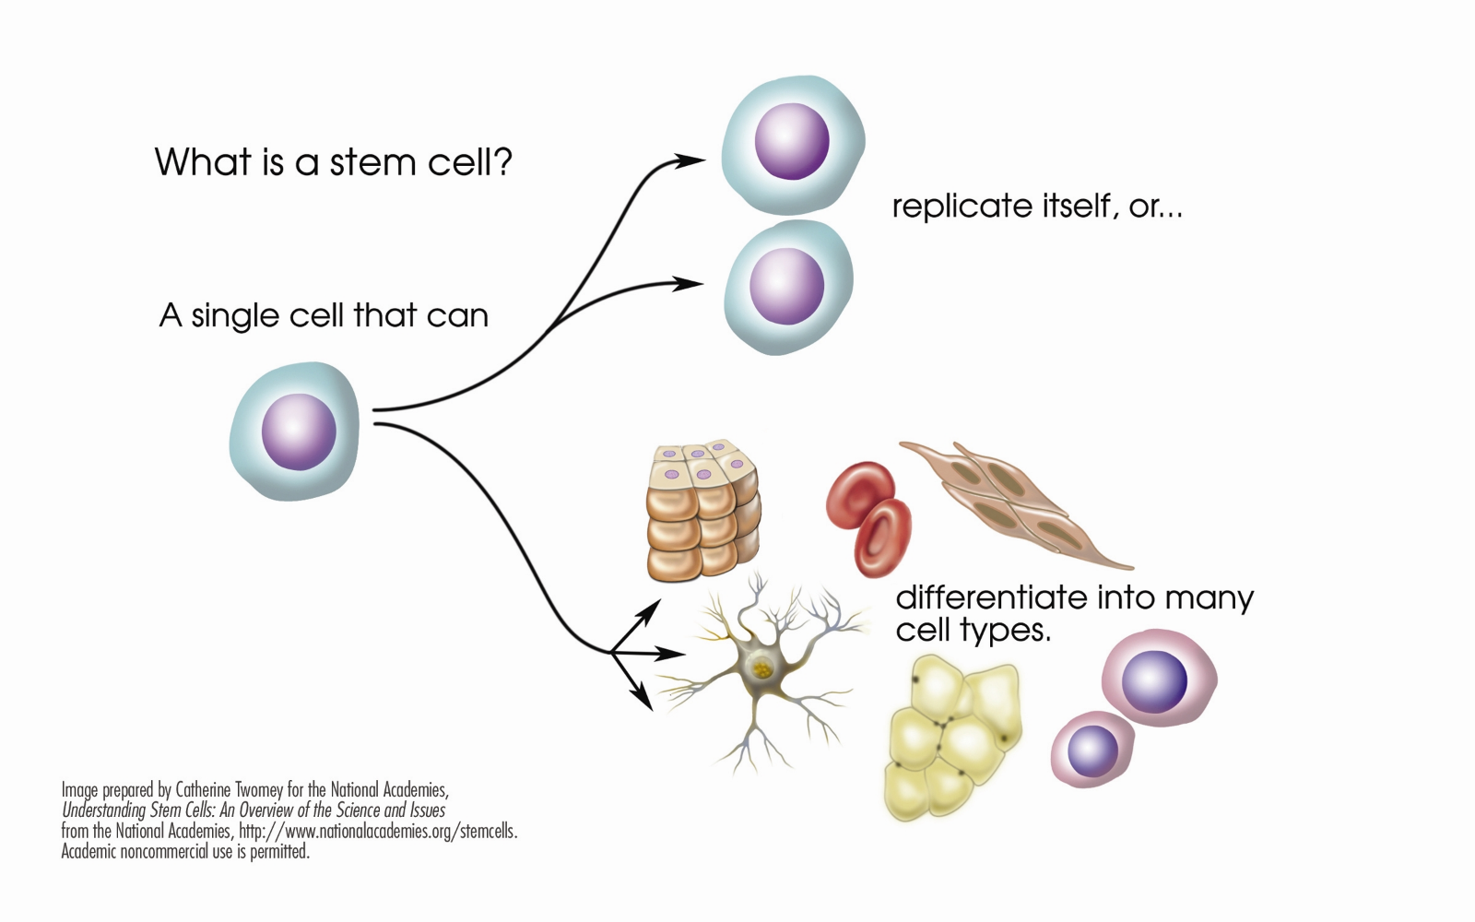

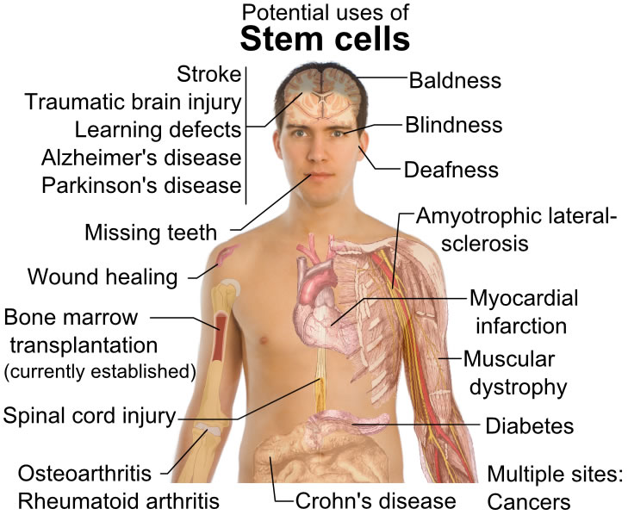

**A better kind of stem cell**

**Induced Pluripotent Stem Cells** (**iPS**) iPSC are derived from skin or blood **cells** that have been reprogrammed back into an embryonic-like pluripotent state that enables the development of an unlimited source of any type of human cell needed for therapeutic purposes. As these cells are taken from the patient’s body, so they will **not** be rejected.

**4.1.3 Transport in cells**

**Dissolved substances**

Substances may move into and out of cells across the cell membranes via diffusion.

Diffusion is the spreading out of the particles of any substance in solution, or particles of a gas, resulting in a net movement from an area of higher concentration to an area of lower concentration.

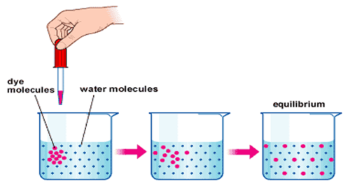

Some of the substances transported in and out of cells by diffusion are oxygen and carbon dioxide in gas exchange, and some waste products such as urea from cells into the blood plasma for excretion in the kidney.

Factors which affect the rate of diffusion are:

* the difference in concentrations (concentration gradient)
* the temperature
* the surface area of the membrane.

A single-celled organism has a relatively large surface area to volume ratio. This allows sufficient transport of molecules into and out of the cell to meet the needs of the organism.

**Exchange surfaces**

There is a need for exchange surfaces and a transport system in multicellular organisms, so exchange surfaces have a large surface area to volume ratio. The small intestine and lungs in mammals, gills in fish, and the roots and leaves in plants, are adapted for exchanging materials.

In multicellular organisms, surfaces and organ systems are specialised for exchanging materials. This is to allow sufficient molecules to be transported into and out of cells for the organism’s needs.

Gas and solute exchange surfaces in humans and other organisms are adapted to maximise effectiveness.

The size and complexity of an organism increases the difficulty of exchanging materials.

The effectiveness of an exchange surface is increased by:

* having a large surface area
* being thin, to provide a short diffusion path
* (in animals) having an efficient blood supply
* (in animals, for gaseous exchange) being ventilated.

|  |  |  |  |
| --- | --- | --- | --- |
| **Exchange surface** | **Large Surface area provided by:** | **Short diffusion path provided by:** | **Steep concentration gradient provided by** |
| Human lung | Millions of alveoli | Alveoli are only 1 cell thick | Constant ventilation of the lungs and good blood supply to carry away the oxygen and deliver carbon dioxide to the lungs |
| Fish gills | Many feathery like structures where exchange takes place | Gills are only one cell thick | Constant movement of water across the gills and a good blood supply to carry carbon dioxide and oxygen efficiently. |
| Leaves | Flat leaf structure containing many stomata | Many air spaces for quick movement of gases from the bottom to the upper surface of the leaf | Carbon dioxide is used in the palisade cells and a fresh supply of carbon dioxide is always brought to the cells. |

**Osmosis**

Dissolved substances move by diffusion and by active transport.

Water often moves across boundaries by osmosis. Osmosis is the diffusion of water from a dilute to a more concentrated solution through a partially permeable membrane that allows the passage of water molecules.

Differences in the concentrations of the solutions inside and outside a cell cause the water to move into or out of the cell by osmosis.

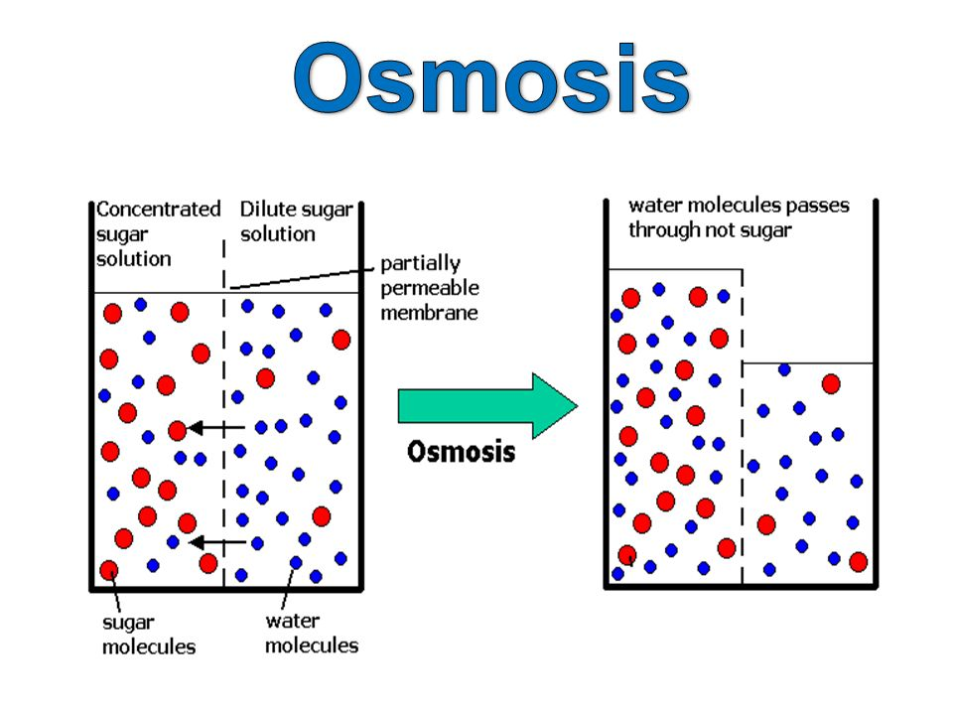

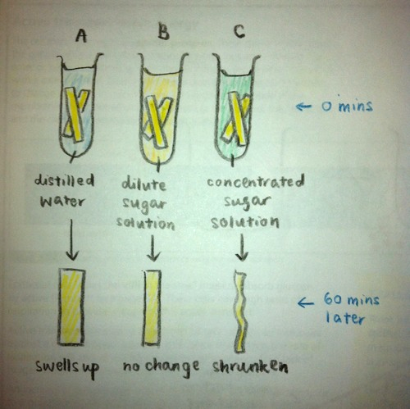

In A, the concentration of solute is **higher in the potato**, so water molecules from the distilled water move through the cell membranes and **into** the plant cells of the potato, causing the cells in the potato to **increase** in size, hence the potato core **swells** **up**. We describe the swollen cell as **turgid**.

In B, osmosis **did not take place** as the concentration of solute is the **same** for the cores and the solution, so plant cells’ size **did not change**.

In C, the concentration of solute is **higher** **in** **solution**, so water molecules from the potato core move **out** of the cells and through the cell membrane, causing the volume of the cell to **decrease**. This causes the cells to become **flaccid**. Flaccid cells are also known as **plasmolysed** cells.

If similar experiment is to be conducted with **animal cells**, the result would be similar as above. However, because they **don’t have cell walls**, they cannot prevent themselves to stop swelling. So when too much water moves into animal cells, they will **burst**.

**A typical graph for the investigation on the effect of sugar concentration on percentage change in mass of potato tissue.**

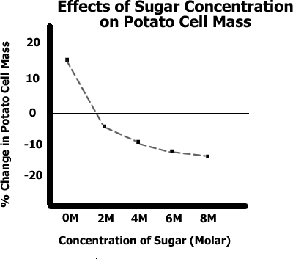

[Core practical 2 - osmosis](https://www.youtube.com/watch?v=oieXYuQm_xE)

**Active Transport**

Active transport moves substances from a more dilute solution to a more concentrated solution (against a concentration gradient). This requires energy from respiration.

This process enables cells to absorb substances from very dilute solutions.

2 examples:

* Active transport allows mineral ions to be absorbed into plant root hairs from very dilute solutions in the soil. Plants require ions for healthy growth.
* It also allows sugar molecules to be absorbed from lower concentrations in the gut into the blood which has a higher sugar concentration. Sugar molecules are used for cell respiration.

**4.2 Organisation**

The human digestive system provides the body with nutrients and the respiratory system provides it with oxygen and removes carbon dioxide. In each case they provide dissolved materials that need to be moved quickly around the body in the blood by the circulatory system.

Damage to any of these systems can be debilitating if not fatal. Although there has been huge progress in surgical techniques, especially with regard to coronary heart disease, many interventions would not be necessary if individuals reduced their risks through improved diet and lifestyle.

The plant’s transport system is dependent on environmental conditions to ensure that leaf cells are provided with the water and carbon dioxide that they need for photosynthesis.

**4.2.1 Principles of organisation**

Cells are the basic building blocks of all living organisms.

A tissue is a group of cells with a similar structure and function.

Organs are aggregations of tissues performing specific functions.

Organs are organised into organ systems, which work together to form organisms.

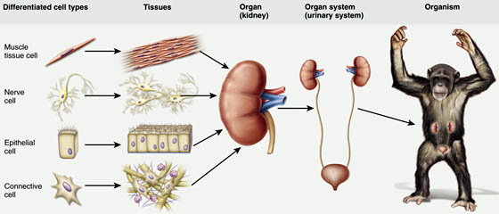

**4.2.2 Animal tissues, organs and organ systems**

**Animal organs**

Large multicellular organisms develop systems for exchanging materials. During the development of a multicellular organism, cells differentiate so that they can perform different functions.

A tissue is a group of cells with similar structure and function. Examples of tissues include:

* Muscular tissue, which can contract to bring about movement
* Glandular tissue, which can produce substances such as enzymes and hormones
* Epithelial tissue, which covers some parts of the body.

Organs are made of tissues. One organ may contain several tissues. The stomach is an organ that contains:

* Muscular tissue, to churn the contents
* Glandular tissue, to produce digestive juices
* Epithelial tissue, to cover the outside and the inside of the stomach.

**The human digestive system**

The digestive system is an example of an organ system in which several organs work together to digest and absorb food.

The digestive system includes:

* Glands, such as the pancreas and salivary glands, which produce digestive juices
* Stomach and small intestine, where digestion occurs
* Liver, which produces bile
* Small intestine, where the absorption of soluble food occurs
* Large intestine, where water is absorbed from the undigested food, producing faeces.

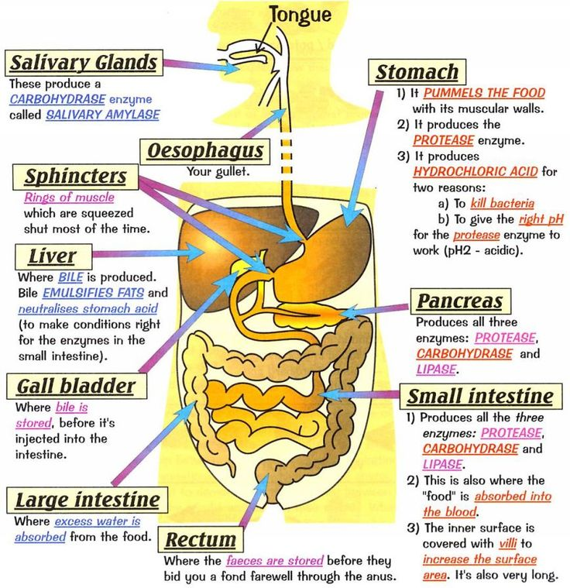

**Enzymes**

Catalysts increase the rate of chemical reactions. Biological catalysts are called enzymes. Enzymes are proteins that are responsible for various metabolic reactions in our bodies.

Enzymes catalyse specific reactions in living organisms due to the shape of their **active site**. High temperatures change the shape of the active site and denatures enzymes. Different enzymes work best at different pH values.

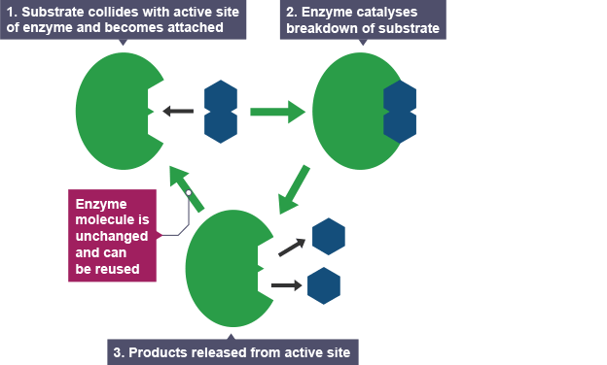

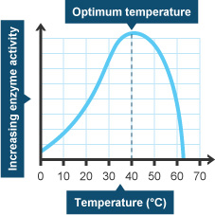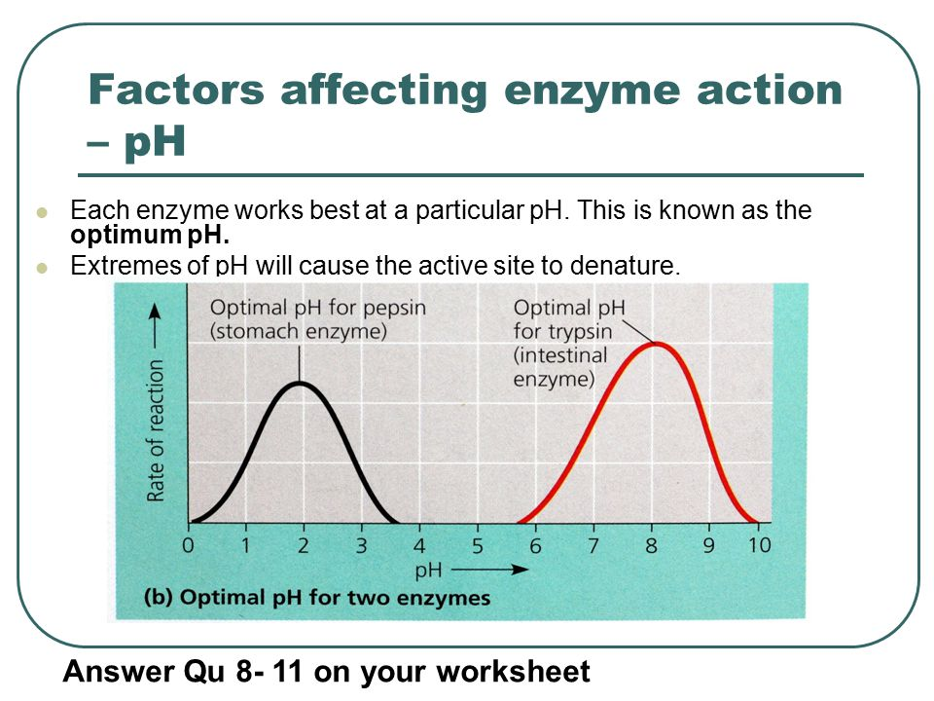

Some enzymes work outside the body cells. The digestive enzymes are produced by specialised cells in glands and in the lining of the gut. The enzymes then pass out of the cells into the gut where they come into contact with food molecules. They catalyse the breakdown of large molecules into smaller molecules.

* The enzyme amylase is produced in the salivary glands, the pancreas and the small intestine. This enzyme catalyses the breakdown of starch into sugars in the mouth and small intestine.
* Protease enzymes are produced by the stomach, the pancreas and the small intestine. These enzymes catalyse the breakdown of proteins into amino acids in the stomach and the small intestine.
* 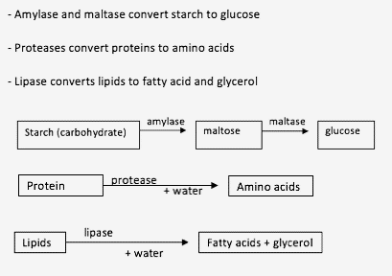Lipase enzymes are produced by the pancreas and small intestine. These enzymes catalyse the breakdown of lipids (fats and oils) into fatty acids and glycerol in the small intestine.

The stomach also produces hydrochloric acid. The enzymes in the stomach work most effectively in these acid conditions.

The liver produces bile, which is stored in the **gall bladder** before being released into the small intestine. Bile **neutralises the acid** that was added to food in the stomach.

Bile also **emulsifies** fats to allow lipase to break down the fat at a faster rate.

**The chemistry of food**

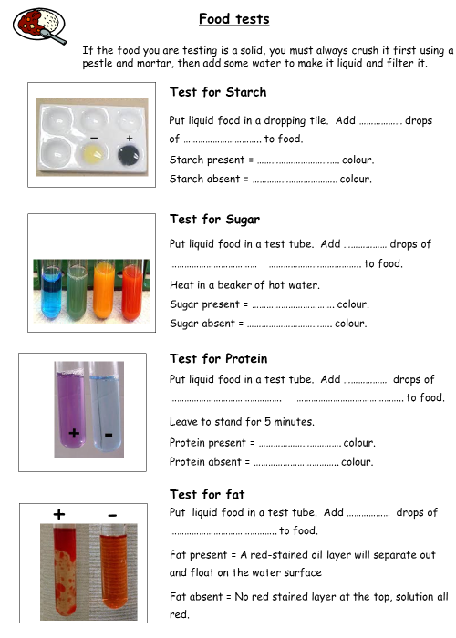 Carbohydrates are made up of units of sugar.

Complex carbohydrates contain long chains of simple sugar units bonded together. Starch turns yellow-red iodine solution blue-black.

Simple sugars are carbohydrates that contain only one or two sugar units – they turn blue Benedict’s solution brick red on heating.

Protein molecules are made up of long chains of amino acids. Biuret reagent turns from blue to purple in the presence of proteins.

Lipids consist of three molecules of fatty acids bonded to a molecule of glycerol. If fat is present a red stained layer will float on the surface

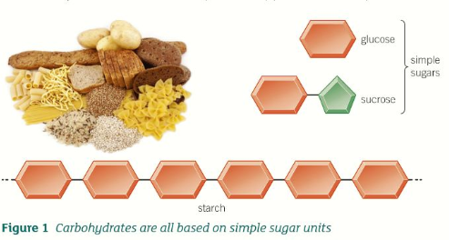

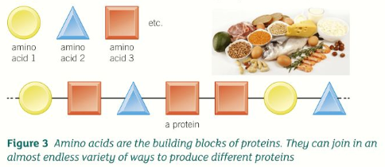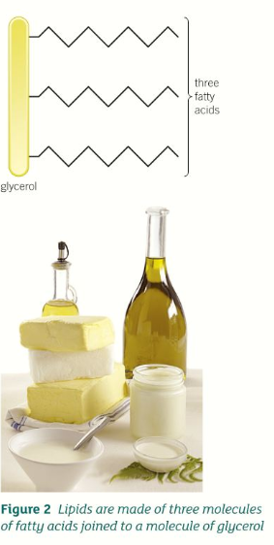

**4.2.3 Plant tissues, organs and systems**

**Plant tissues**

The structures of plant tissues are related to their functions.

Plant organs include stems, roots and leaves. Examples of plant tissues include:

* Epidermal tissues, which cover the plant
* Mesophyll, which carries out photosynthesis
* Xylem and phloem, which transport substances around the plant.
* Meristem tissue found at the growing tips of shoots and roots

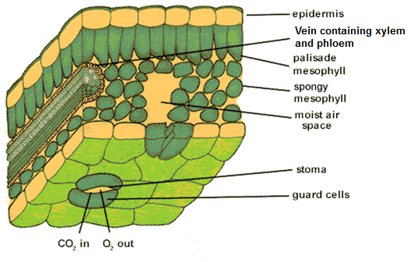

**Plant organ system**

The structure of root hair cells, xylem and phloem are adapted to their functions.

Root hair cells are adapted for the efficient uptake of water by osmosis, and mineral ions by active transport.

Xylem tissue transports water and mineral ions from the roots to the stems and leaves. It is composed of hollow tubes strengthened by lignin adapted for the transport of water in the transpiration stream.

The role of stomata and guard cells are to control gas exchange and water loss.

Phloem tissue transports dissolved sugars from the leaves to the rest of the plant for immediate use or storage. The movement of food molecules through phloem tissue is called translocation. Phloem is composed of tubes of elongated cells. Cell sap can move from one phloem cell to the next through pores in the end walls.