**Logic Gate Workbook**

**Question 1**

The diagram below is for a NOT gate. Complete the truth table for this gate.

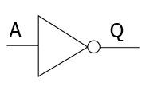

|  |  |
| --- | --- |
| **A** | **Q** |
| 0 | 1 |
| 1 |  |

**Question 2**

The diagram below is for an AND gate. Complete the truth table for this gate

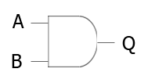

|  |  |  |
| --- | --- | --- |
| **A** | **B** | **Q** |
| 0 | 0 | 0 |
| 0 | 1 |  |
| 1 | 0 |  |
| 1 | 1 |  |

**Question 3**

The diagram below is for an OR gate. Complete the truth table for this gate.

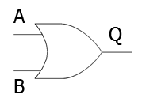

|  |  |  |
| --- | --- | --- |
| **A** | **B** | **Q** |
| 0 | 0 | 0 |
| 0 | 1 |  |
| 1 | 0 |  |
| 1 | 1 |  |

**Question 4**

Complete this table to show every possible combination of logic inputs for A and B

|  |  |
| --- | --- |
| **A** | **B** |
| 0 | 0 |
|  |  |
|  |  |
|  |  |

**Question 5**

Complete this table to show every possible combination of logic inputs A, B and C

|  |  |  |
| --- | --- | --- |
| **A** | **B** | **C** |
| 0 | 0 | 0 |
| 0 | 0 | 1 |
| 0 | 1 | 0 |
| 0 | 1 |  |
| 1 |  |  |
| 1 |  |  |
|  |  |  |
|  |  |  |

**Question 6.**

Logic gates can be combined to make a circuit.

You can use partial tables to help work out the complete truth table for the circuit.

The complete truth table only ever includes the actual inputs plus the final output but not the in-between points.

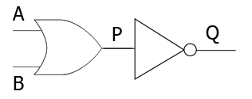

1. Fill out all possible values of B in the logic circuit shown above

|  |  |
| --- | --- |
| **A** | **B** |
| 0 | 0 |
| 0 | 1 |
| 1 |  |
| 1 |  |

1. Complete the truth table for point P

|  |  |  |
| --- | --- | --- |
| **A** | **B** | **P** |
| 0 | 0 | 0 |
| 0 | 1 |  |
| 1 | 0 |  |
| 1 | 1 |  |

1. Complete the truth table for Q given every value of P from above.

|  |  |
| --- | --- |
| **P** | **Q** |
| 0 |  |
| 1 |  |
| 1 |  |
| 1 |  |

1. Now use the above tables to complete this truth table.

|  |  |  |
| --- | --- | --- |
| **A** | **B** | **Q** |
| 0 | 0 |  |
| 0 | 1 |  |
| 1 | 0 |  |
| 1 | 1 |  |

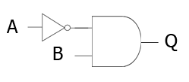

**Question 7**

Complete the truth table for this circuit.

|  |  |  |
| --- | --- | --- |
| **A** | **B** | **Q** |
| 0 | 0 | 0 |
| 0 | 1 |  |
| 1 | 0 |  |
| 1 | 1 |  |

**Question 8**

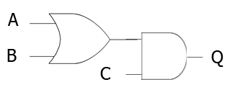The logic circuit below has 3 inputs and so there are 8 possible combinations of A, B and C.

a) Complete the table below to show all the possible values of A, B and C

|  |  |  |
| --- | --- | --- |
| **A** | **B** | **C** |
| 0 | 0 | 0 |
| 0 | 0 | 1 |
| 0 | 1 | 0 |
| 0 | 1 | 1 |
| 1 |  |  |
| 1 |  |  |
|  |  |  |
|  |  |  |

b) By using the table above, fill out the possible values of the OR gate

|  |  |  |  |
| --- | --- | --- | --- |
| **A** | **B** | **C** | **A OR B** |
| 0 | 0 | 0 |  |
| 0 | 0 | 1 |  |
| 0 | 1 | 0 |  |
| 0 | 1 | 1 |  |
| 1 | 0 | 0 |  |
| 1 | 0 | 1 |  |
| 1 | 1 | 0 |  |
| 1 | 1 | 1 |  |

Now work out every value of Q for the circuit

|  |  |  |  |  |
| --- | --- | --- | --- | --- |
| **A** | **B** | **C** | **A OR B** | **Q** |
| 0 | 0 | 0 |  |  |
| 0 | 0 | 1 |  |  |
| 0 | 1 | 0 |  |  |
| 0 | 1 | 1 |  |  |
| 1 | 0 | 0 |  |  |
| 1 | 0 | 1 |  |  |
| 1 | 1 | 0 |  | 0 |
| 1 | 1 | 1 |  | 1 |

**Question 9**

This logic circuit is for an AND gate.



This AND gate can be written as Q = A AND B



Now write down the equivalent statement for the OR gate for the logic circuit on the right

|  |
| --- |
| STATEMENT: |

**Question 10**

Write down the logic statement for the gate shown below

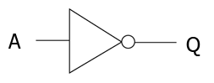

|  |
| --- |
| STATEMENT: |