

**Higher IGCSE (9 – 1) Revision Pack**

**Statistical Measures**

**Questions 1 – 29**

**Name --------------------------------**

**Questions**

**Q1.**

The cumulative frequency table shows information about the diameters of 60 oranges.

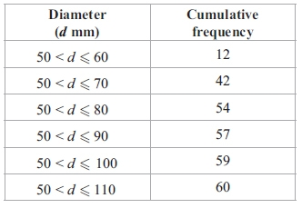

(a) On the grid, draw a cumulative frequency graph for the table.

**(2)**

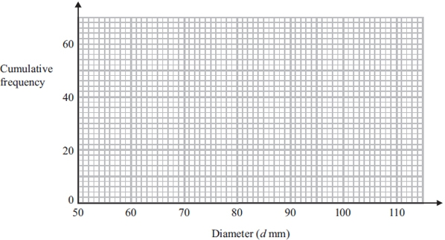

(b) Use your graph to find an estimate for the median diameter of the 60 oranges.

...........................................................mm

**(2)**

**(Total for question = 4 marks)**

**Q2.**

The mean of four numbers is 2.6   
One of the four numbers is 5

Find the mean of the other three numbers.

...........................................................

**(Total for Question is 3 marks)**

**Q3.**

Zara must take 5 tests.   
Each test is out of 100   
After 4 tests, her mean score is 64%.

What score must Zara get in her 5th test to increase her mean score in all 5 tests to 70%?

...........................................................

**(Total for Question is 4 marks)**

**Q4.**

The cumulative frequency graph shows information about the length, in minutes, of each of 80 films.

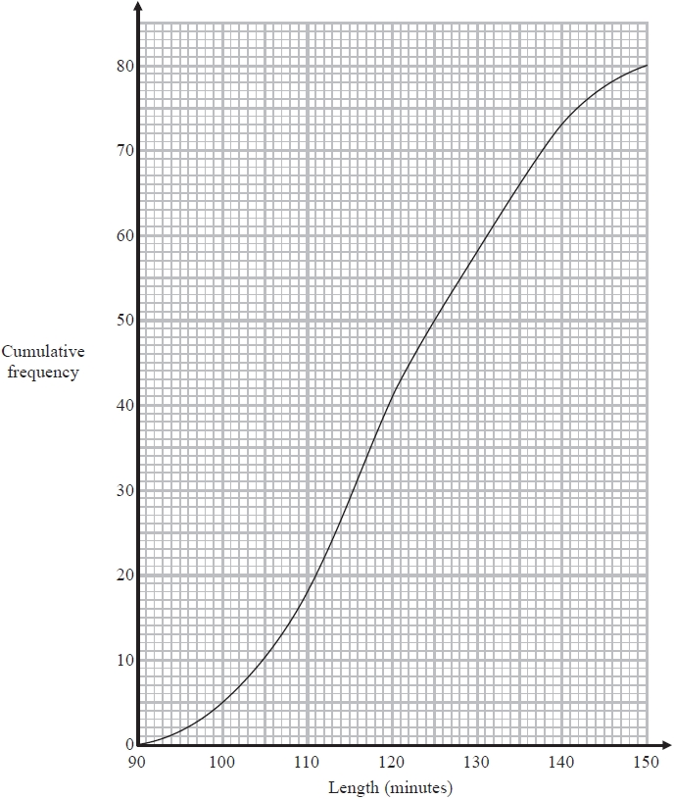

(a)  Find an estimate for the interquartile range.

........................................................... minutes

**(2)**

(b)  Find an estimate for the percentage of the 80 films that lasted more than 125 minutes.

........................................................... %

**(3)**

**(Total for question = 5 marks)**

**Q5.**

Here are the marks that James scored in eleven maths tests.

16      12      19      18      17      13      13      20      11      19      17

(a)  Find the interquartile range of these marks.

...........................................................

**(3)**

Sunil did the same eleven maths tests.   
The median mark Sunil scored in his tests is 17   
The interquartile range is 8

(b)  Which one of Sunil or James has the more consistent marks?   
Give a reason for your answer.

.............................................................................................................................................

.............................................................................................................................................

**(1)**

Sunil did four more maths tests.   
His scores in these four tests were 16, 20, 18 and 10

(c)  How does his new median mark for the fifteen tests compare with his median mark of   
17 for the eleven tests?

Tick  one box.



Explain your answer.

.............................................................................................................................................

.............................................................................................................................................

**(1)**

**(Total for question = 5 marks)**

**Q6.**

15 students took an English test.   
The same 15 students took a Maths test.   
Both tests were marked out of 30

For the English test results

the median was 21

the interquartile range was 14

The Maths test results are shown below.

18    18    19    20    24    25    25    26    28    28    29    29    29    30    30

Use the information above to compare the English test results with the Maths test results.   
Write down **two** comparisons.

1 ..........................................................................................................................................

.............................................................................................................................................

2 ..........................................................................................................................................

.............................................................................................................................................

**(Total for question = 4 marks)**

**Q7.**

The grouped frequency table gives information about the ages of 200 elephants.

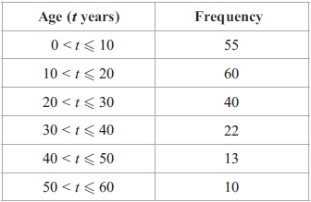

(a) Complete the cumulative frequency table.

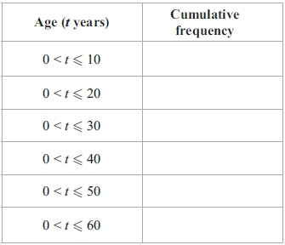

**(1)**

(b) On the grid, draw a cumulative frequency graph for your table.

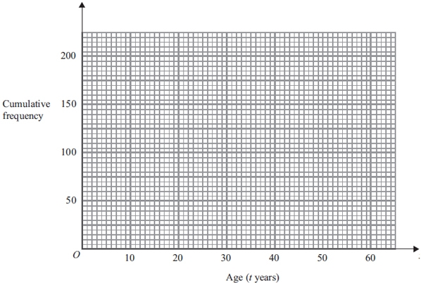

**(2)**

(c) Use the graph to find an estimate for the number of elephants with ages of more than   
26 years.

...........................................................

**(2)**

**(Total for question is 5 marks)**

**Q8.**

The table below shows information about the number of goals scored by a football club in each of its last 45 games.

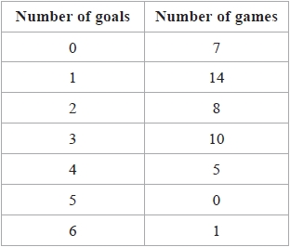

Find the median number of goals.   
Show your working clearly.

...........................................................

**(Total for question = 2 marks)**

**Q9.**

The frequency table gives information about the lengths of time 100 people spent in a coffee shop.

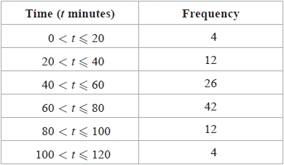

(a)  Complete the cumulative frequency table.

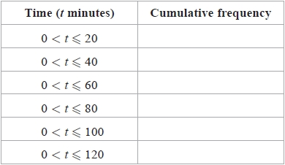

**(1)**

(b)  On the grid, draw a cumulative frequency graph for your table.

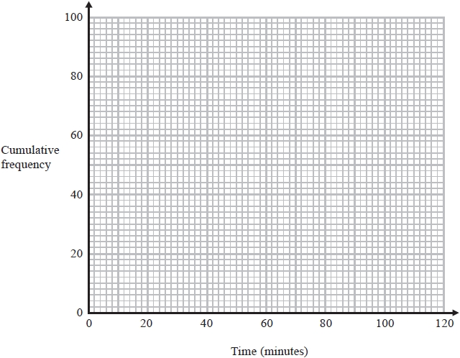

**(2)**

(c)  Use your graph to find an estimate for the lower quartile.

........................................................... minutes

**(1)**

(d)  Use your graph to find an estimate for the number of these people who spent longer than 70 minutes in the coffee shop.

...........................................................

**(2)**

**(Total for question = 6 marks)**

**Q10.**

Here are Ryan's scores in nine French tests.

4           6           4           7           8           *a*           6           7           7

The mean of Ryan's nine scores is 6

Work out the value of *a*.

*a* = ...........................................................

**(Total for Question is 3 marks)**

**Q11.**

The cumulative frequency table shows information about the times, in minutes, 80 people waited at an airport.

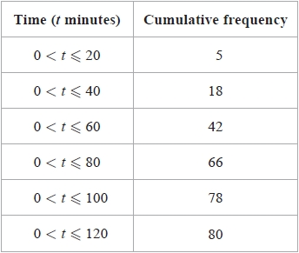

(a)  On the grid opposite, draw a cumulative frequency graph for the table.

**(2)**

(b)  Use your graph to find an estimate for the median time.

........................................................... minutes

**(2)**

(c)  Use your graph to find an estimate for the number of these people who waited more than  hours at the airport.

...........................................................

**(2)**

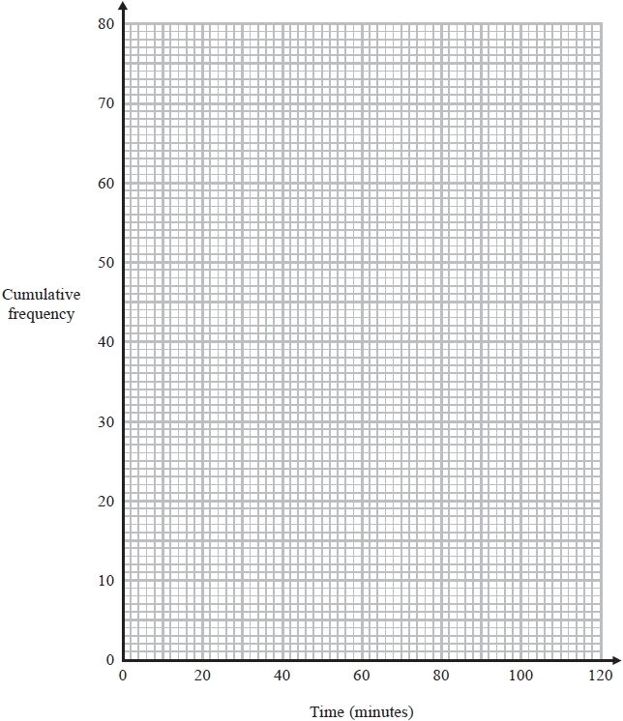

**(Total for question = 6 marks)**

**Q12.**

*w*, *x*, *y* and *z* are 4 integers written in order of size, starting with the smallest.

The mean of *w*, *x*, *y* and *z* is 13   
The sum of *w*, *x* and *y* is 33

(a)  Find the value of *z*.

*z* = ...........................................................

**(2)**

Given also that the range of *w*, *x*, *y* and *z* is 10,

(b)  work out the median of *w*, *x*, *y* and *z*.

...........................................................

**(2)**

**(Total for question = 4 marks)**

**Q13.**

The table shows information about the weights of 80 parcels.

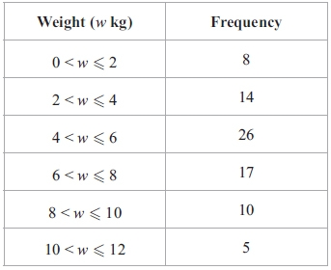

(a) Work out an estimate for the total weight of the 80 parcels.

........................................................... kg

**(3)**

(b) Complete the cumulative frequency table.

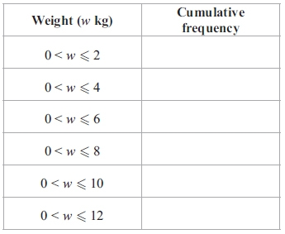

**(1)**

(c) On the grid, draw a cumulative frequency graph for your table.

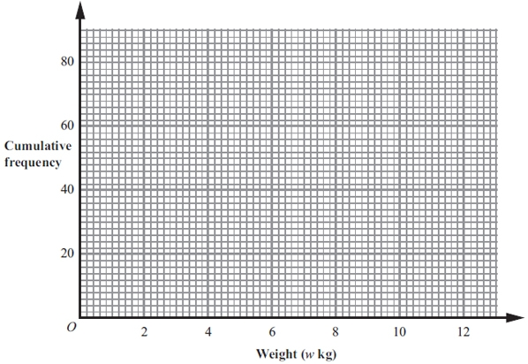

**(2)**

(d) Use the graph to find an estimate for the number of parcels which weighed less than   
5.2 kg.

...........................................................

**(2)**

**(Total for question = 8 marks)**

**Q14.**

The table shows information about the lengths of time that 120 people spent in a supermarket.

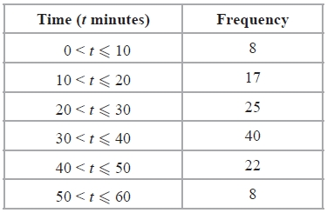

(a)  Complete the cumulative frequency table.

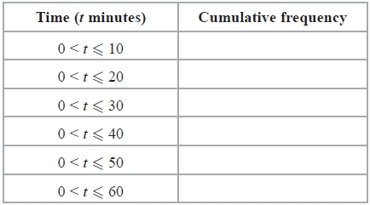

**(1)**

(b)  On the grid, draw a cumulative frequency graph for your table.

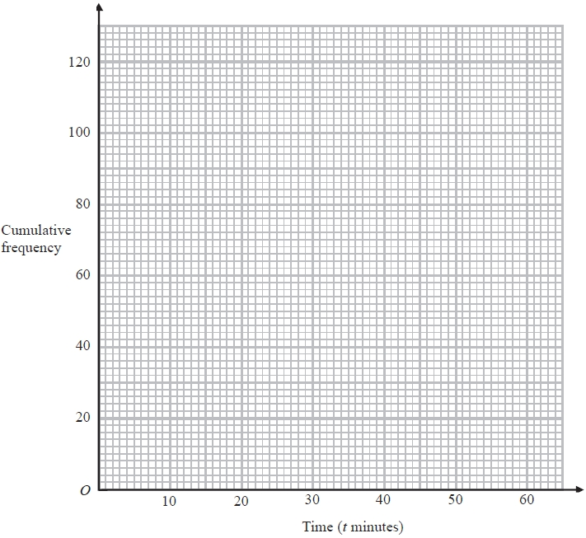

**(2)**

(c)  Use your graph to find an estimate for the median length of time spent in the supermarket by these people.

........................................................... minutes

**(2)**

**(Total for question = 5 marks)**

**Q15.**

The table shows information about the times, in minutes, taken by 50 people to get to work.

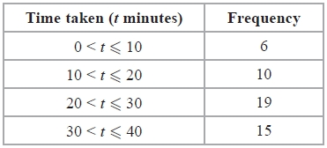

Work out an estimate for the mean time taken to get to work.

........................................................... minutes

**(Total for Question is 4 marks)**

**Q16.**

The frequency table shows information about the weights of 80 adults.

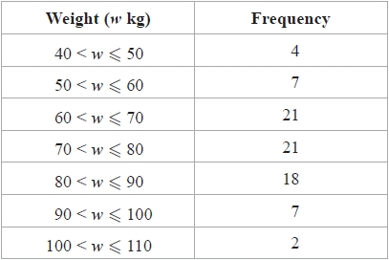

(a)  Complete the cumulative frequency table.

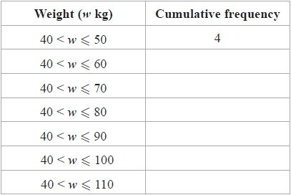

**(1)**

(b)  On the grid, draw a cumulative frequency graph for your table.

**(2)**

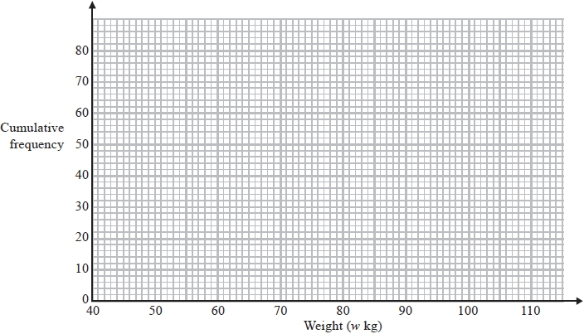

(c)  Use your graph to find an estimate for the number of adults with weight more than 85 kg.

...........................................................

**(2)**

(d)  Use your graph to find an estimate for the interquartile range of the weights of the adults.

........................................................... kg

**(2)**

**(Total for question = 7 marks)**

**Q17.**

Three positive whole numbers have a mean of 4 and a range of 7

Find the three positive whole numbers.

...................  ....................  ....................

**(Total for question = 2 marks)**

**Q18.**

The table gives some information about the incomes, £*I*, of 100 people in the UK.

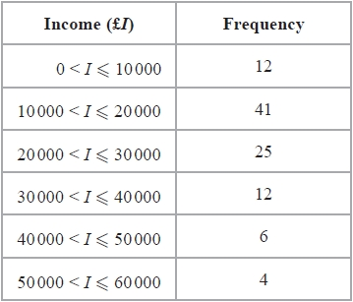

(a)  Complete the cumulative frequency table.

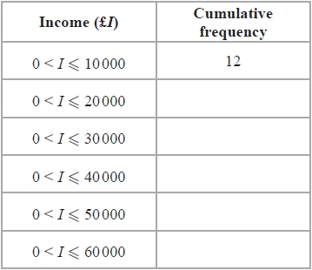

**(1)**

(b)  On the grid, draw a cumulative frequency graph for your table.

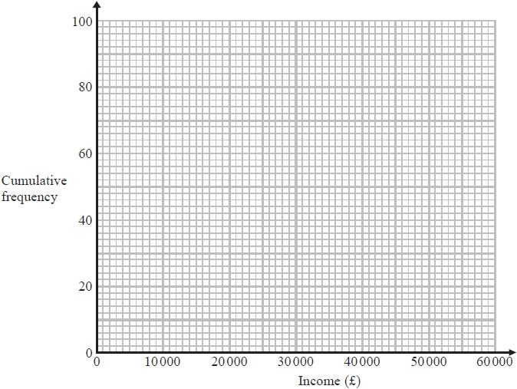

**(2)**

(c)  Use your graph to find an estimate for

(i)  the median,

£ ...........................................................

(ii)  the interquartile range.

£ ...........................................................

**(3)**

**(Total for question = 6 marks)**

**Q19.** *a*, *b*, *c* and *d* are four integers.   
Their mean is 8   
Their mode is 7

Their median is 7.5

(a)   Find the value of the largest of the four integers.

...........................................................

**(2)**

(b)   Find the mean value of the numbers (2*a* − 3), (2*b* − 3), (2*c* − 3) and (2*d* − 3).

...........................................................

**(2)**

**(Total for Question is 4 marks)**

**Q20.**

The table shows information about the amount of money, in dollars, spent in a shop in  
one day by 80 people.

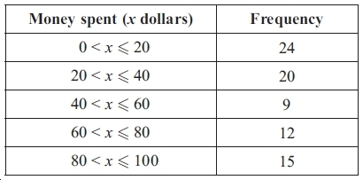

Work out an estimate for the total amount of money spent in the shop that day.

............................... dollars

**(Total for question = 3 marks)**

**Q21.**

Here are the marks scored in a test by the girls in class 8C.

2     8     10     12     15     16     16     17     18     19     20

(a)  Work out the interquartile range of the girls' marks.

...........................................................

**(2)**

The boys in class 8C did the same test.   
The boys' marks had a range of 19 and an interquartile range of 11 marks.

Gareth says that the girls' marks are more spread out than the boys' marks.

(b)  Is Gareth right?

Tick () the appropriate box.



Give a reason for your answer.

.............................................................................................................................................

.............................................................................................................................................

**(1)**

**(Total for question = 3 marks)**

**Q22.**

The table shows information about the number of goals scored in each of the 25 matches in a hockey tournament.

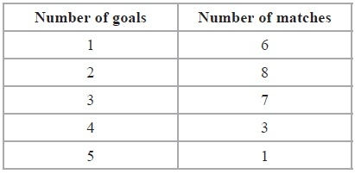

Work out the mean number of goals.

...........................................................

**(Total for Question is 3 marks)**

**23.**

The mean height of a group of 6 children is 165 cm.   
One child, whose height is 155 cm, leaves the group.

Find the mean height of the remaining 5 children.

........................................................... cm

**(Total for question = 3 marks)**

**Q24.**

There are 32 students in Mr Newton's class.   
20 are boys and 12 are girls.

The mean height of the boys is 151 cm.   
The mean height of the girls is 148 cm.

Calculate the mean height of all the students in Mr Newton's class.

........................................................... cm

  **(Total for question = 3 marks)**

**Q25.**

Jordan's school awards certificates for outstanding work.   
The table shows information about the numbers of certificates awarded in Jordan's class during a term.

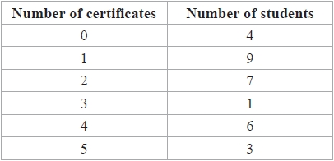

(a)  Work out the median number of certificates awarded.

...........................................................

**(2)**

(b)  Work out the interquartile range of the numbers of certificates awarded.

...........................................................

**(3)**

**(Total for question = 5 marks)**

**Q26.**

Six numbers have a mean of 5

Five of the numbers are



The other number is *x*.

Work out the value of *x*.

*x* = ...........................................................

**(Total for question = 3 marks)**

**Q27.**

Mr Rowland has a class of 30 students.   
He gave them 24 words to spell.   
The table shows information about the number of correct spellings for each student.

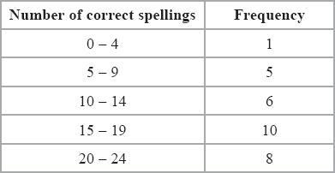

(a)  Write down the modal class.

...........................................................

**(1)**

(b)  Work out an estimate for the mean number of correct spellings.

Give your answer to 1 decimal place.

...........................................................

**(4)**

**(Total for question = 5 marks)**

**Q28.**

Kim asked 40 people how many text messages they each sent on Monday.   
The table shows her results.

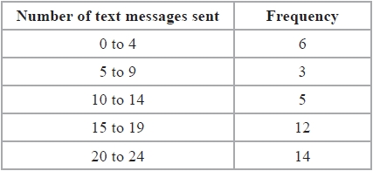

(a)  Write down the modal class.

...........................................................

**(1)**

(b)  Calculate an estimate for the mean number of text messages sent.

...........................................................

**(4)**

(c)  What percentage of these 40 people sent 20 or more text messages?

...........................................................%

**(2)**

**(Total for question = 7 marks)**

**Q29.**

The table gives information about the speed, in km/h, of 180 vehicles passing a speed checkpoint.

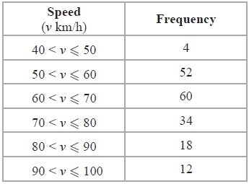

(a)   Write down the modal class.

...........................................................

**(1)**

(b)   Work out an estimate for the probability that the next vehicle passing the speed checkpoint will have a speed of 60 km/h or less.

...........................................................

**(2)**

(c)   Complete the cumulative frequency table.

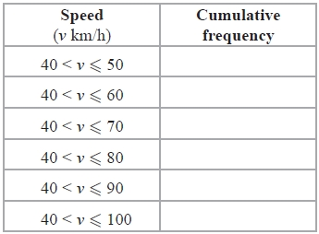

**(1)**

(d)   On the grid, draw a cumulative frequency graph for your table.

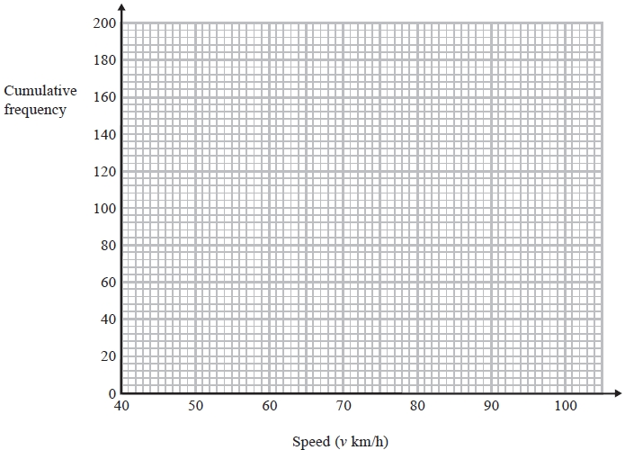

**(2)**

(e)   The police decide to fine the driver of any vehicle passing the speed checkpoint at a speed of more than 84 km/h.   
Use your graph to find an estimate for the number of drivers the police decide to fine.   
Show your method clearly.

...........................................................

**(2)**

**(Total for Question is 8 marks)**

**End of questions**