3.8.1 - Strategic direction (Ansoff’s matrix)

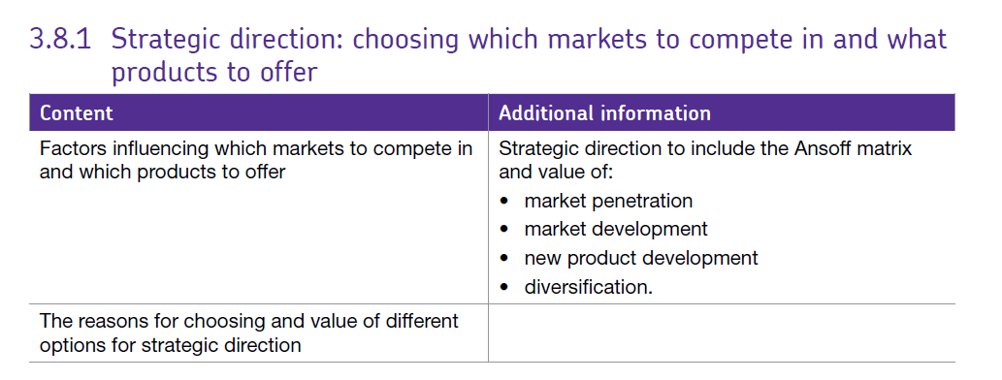

Larger firms all consider their strategic direction based on their vision and mission and will look to develop corporate strategies to help them to achieve their objectives within the vision and mission.

Strategies must be based on what is achievable for the business, they may be developed using data or based on a hunch but they must be specific to the company and have measurable outcomes i.e. they should be SMART.

It can sometimes be difficult for firms to decide how best to compete. Some firms may find they are performing poorly in a market and want to reposition themselves or they may feel their market is suffering and need to make a change if the future prospects are looking weak. It is unlikely that a firm can compete in all areas with all other businesses so they have to think about the best way forward for their business and that depends on many internal and external factors such as:

* Likely growth in the current market
* Availability of finance – profitability and gearing
* The nature of the product and developments in that product / industry area
* Level of competition
* Brand loyalty
* Social factors e.g. demographics
* Economic climate

These areas are all really covered by the 2 models SWOT and PEST(EL) where a business would be looking at its internal and external environment and using that information to develop strategies.

One way in which firms can think about strategies is by considering Ansoff’s matrix which categorises strategies based on where the firm moves in terms of markets and products.

Ansoff’s product/market growth matrix suggests that a business’ attempts to grow depend on whether it markets new or existing products in new or existing markets.

These are shown in the diagram below:

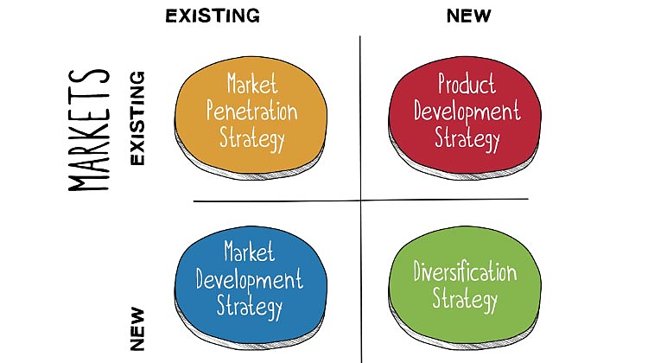

# Market penetration

Market penetration is the name given to a growth strategy where the business focuses on **selling existing products into existing markets**. This is generally regarded as the safest option – the firm is already in this market with a product and is simply trying to sell more of its current product to its current customers.

Market penetration seeks t**o achieve four main objectives:**

* Maintain or increase the market share of current products – this can be achieved by a combination of competitive pricing strategies, advertising, sales promotion and perhaps more resource**s dedicated to personal selling**
* Secure dominance of growth markets
* Restructure a mature market by driving out competitors; this would require a much more aggressive promotional campaign, supported by a pricing strategy designed to make the market unattractive for competitors
* Increase usage by existing customers – for example by introducing loyalty schemes

A market penetration marketing strategy is very much about “business as usual”. The business is focusing on markets and products it knows well. It is likely to have good information on competitors and on customer needs. It is unlikely, therefore, that this strategy will require much investment in new market research.

# Market development

Market development is the name given to a growth strategy where the business seeks to **sell its existing products into new markets**. This strategy carries some risk especially if the new markets are international / global as the firm may be unfamiliar with a country’s working practices, customer needs or may experience coordination diseconomies of scale.

There are many possible ways of approaching this strategy, including:

* New geographical markets; for example exporting the product to a new country
* New product dimensions or packaging: for example
* New distribution channels (e.g. moving from selling via retail to selling using e-commerce and mail order)
* Different pricing policies to attract different customers or create new market segments

Market development is a more risky strategy than market penetration because of the targeting of new markets.

# Product development

Product development is the name given to a growth strategy where a business aims to **introduce new products into existing markets.** This strategy may require the development of new competencies and requires the business to develop modified products which can appeal to existing markets.

A strategy of product development is particularly suitable for a business where the product needs to be differentiated in order to remain competitive. It carries less risk as the market is already known to the firm and the developments may be a case of differentiation of a currently successful product – enhancement of the firm’s product portfolio. A successful product development strategy places the marketing emphasis on:

* Research & development and innovation
* Detailed insights into customer needs (and how they change)
* Being first to market

# Diversification

Diversification is the name given to the growth strategy where a business markets **new products in new markets**.

This is an inherently more risk strategy because the business is moving into markets in which it has little or no experience. This option carries the highest level of risk for the firm as it may lose its capital investment but also may face issues of brand damage and loss of reputation.

For a business to adopt a diversification strategy, therefore, it must have a clear idea about what it expects to gain from the strategy and an honest assessment of the risks. However, for the right balance between risk and reward, a marketing strategy of diversification can be highly rewarding.