**3.1.10 Equilibrium constant *Kp* for homogenous systems**

**AS Link:**

**3.1.6 Equilibria**

**Review of equilibria**

Remember a **dynamic equilibrium** is:

***Definitions***:

A **dynamic** process is one in which both the forwards and back **proceed at equal rates**

At **equilibria** the **concentration** of reactions and products **is constant**

**Reversible** reactions obey **Le Chatelier’s principle** which **predicts** the **effect of change** in **temperature**, **pressure** and **concentration** on the **position of equilibria**.

***Definition***: **Le Châtelier’s principle** states that a system at equilibrium will **respond** to **oppose** any **change** imposed on it.

***Task: Review questions***

1. Define dynamic.

Forward and reverse reactions proceed at the same rate.

1. Define equilibria.

Concentration of reactions and products are constant.

1. State Le Chatelier’s principle.

Any system at equilibria will respond to oppose any change made on it.

1. What effect does a catalyst have on a reversible reaction?

Does not affect the position of equilibria but it will be reached faster.

1. In an endothermic reaction what would be the effect on the yield if the temperature was increased?

Yield would increase.

1. In an exothermic reaction what would be the effect on the rate of attainment if the temperature was increased?

It would be reached faster.

Equilibrium constant *Kc*

***Definition***:

The **equilibrium constant** for a reaction is obtained by multiplying together the **concentrations of the products**, each **raised** to the **power** of its **coefficient** in the stoichiometric equilibrium equation, and **dividing** this by the **concentrations** of the **reactants**, each also **raised** to the appropriate **power**.

For any reaction that reaches equilibrium an equation can be written:

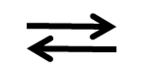

aA (aq) + bB (aq) cC (aq) + dD (aq)

Providing the **temperature** is **constant** then the expression **is constant** and the constant is referred to as the **equilibrium** **constant,** **Kc**. It is **different** for **different reactions**.

P

R

Kc = [C]eqmc [D]eqmd

[A]eqma [B]eqmb

The **equilibrium constant will change with temperature** and can be **calculated from the concentrations** at **constant temperature** of the species involved in the equilibrium.

The **value of Kc** indicates whether the **equilibrium** lies to **right or left**:

Kc **<** 1 equilibrium lies to **LHS**

Kc **>** 1 equilibrium lies to **RHS**

Since **Kc varies with temperature** the **units** will **also vary** and so they **must be worked out** for each reaction.

**N.B.**

Units of **rate** are **constant** mol dm-3 s-1

Units of **equilibrium** and **rate constant vary** with **temperature** but are **not** **affected** by a change in **concentration**, **pressure** or adding a **catalyst**

Calculations using Kc

The following principles will help when carrying out calculations for equilibria:

* At the **start** of the reaction there will be an **initial number of moles of reactants** and **an initial number of moles of products** (this could be zero but may not)
* Once **equilibrium** is reacted some of the reactants will have converted into products (i.e. **lost**) and so there will be a **reduction in reactant moles** and an **increase in product moles by the same amount** (according to the mole ratio)
* **Molar ratios apply** both **initially** and when calculating the **change of reactants and products**, i.e. lost and gain.

Follow this order when calculating:

**I**nitial moles

**C**hange in moles

**E**quilibrium moles

This example shows how to carry out these calculations:

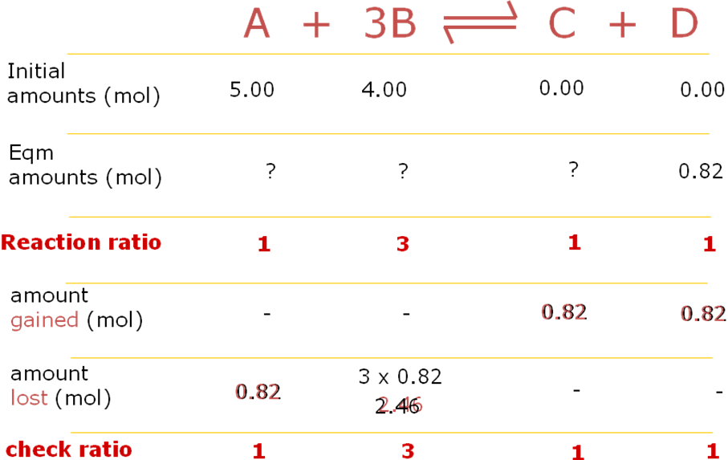

**Moles at equilibrium**

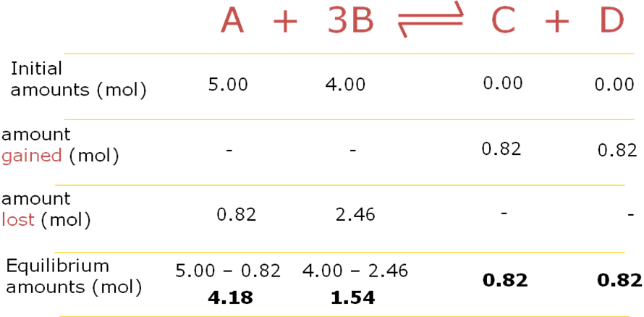

Calculating the value of Kc

The **value of Kc** is **found by experiment** for any particular reaction at a given temperature.

**Rules** to be followed when carrying out these calculations:

1. Write equation

If only moles given must divide by total volume or use V.

1. Show equilibrium moles  
   Show equilibrium concentration
2. Substitute [eqm] into Kc expression

**Equilibrium concentrations**

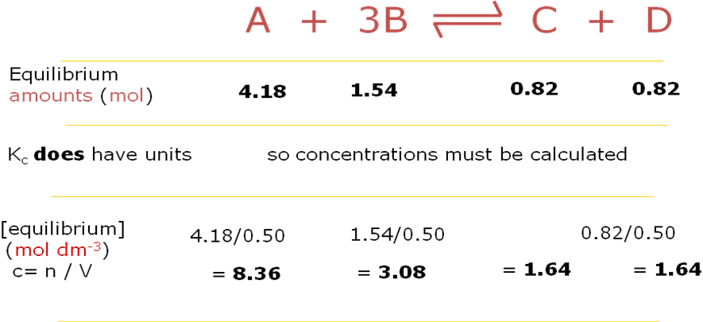

Value of equilibrium constant, Kc

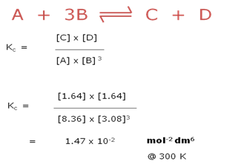

***Sheet: Equilibrium review questions*Partial pressure**

In a **mixture** of gases, **each gas contributes to the total pressure**. The contribution is called the **partial pressure *p*** and is the pressure the gas would exert if it occupied the container on its own. If gases are present in **equal quantities** in a mixture they will **exert** the **same pressure**.

**Example**

|  |  |
| --- | --- |
| Air is a mixture of approximately 20% oxygen molecules and 80% nitrogen molecules and has a total pressure of approximately  (at sea level) 100kPa. |  |

So the approximate partial pressure of oxygen in air is 20 kPa and the partial pressure of nitrogen is 80 kPa.

**Total pressure = *p*O2 + *p*N2**

The total pressure is the sum of the partial pressure.

**Example – CGP69**

When 3.00 moles of gas PCl5 is heated, it decomposes into PCl3 and Cl2.



PCl5 (g) PCl3 (g) + Cl2 (g)

In a sealed vessel at 500K, the equilibrium mixture contains chlorine with a partial pressure of 263 kPa. If the total pressure of the mixture is 714 kPa, what is the partial pressure of PCl5?

PCl3 and Cl2 are produced in equal quantities so they will exert the same partial pressure at equilibrium.

Total pressure = *p*PCl5 + *p*PCl3 + *p*Cl2

714 = *p*PCl5 + 263 + 263

*p*PCl5 = 714 – 263 – 263 = **188 kPa**

Mathematically the **partial pressure** is given by its **mole fraction multiplied** by the **total** **pressure**.

**mole fraction = number of moles of gas**

**total number of moles of gas in the mixture**

**Example – CGP70**

**partial pressure = mole fraction of gas x total pressure of the mixture**

When 2.00 moles of gas PCl5 is heated in a sealed vessel, the equilibrium mixture contains 1.25 mol Cl2. What is the mole fraction of PCl5?



Write the chemical equation: PCl5 (g) PCl3 (g) + Cl2 (g)

nPCl3 = 1.25 mol (same molar ratio as Cl2)

nPCl5 = 2.00 – 1.25 = 0.75 mol (at equilibrium 1.25 mol PCl5 decomposed)

Total moles at equilibrium = 0.75 + 1.25 +1.25 = 3.25 mol

Mole fraction PCl5 = 0.75 / 3.25 = **0.231** (3 s.f.)

***Task: Calculate the partial pressure of oxygen***

A mixture of 8.02g nitrogen and 2.42g oxygen is contained in a sealed vessel; the total pressure of the mixture is 921 kPa.

nN2 = 8.02 / 28 = 0.286 mol

nO2 = 2.42 / 32 = 0.0756 mol

Total moles at equilibrium = 0.286 + 0.0756 = 0.362 mol

Mole fraction O2 = 0.0756 / 0.362 = 0.209 mol (3 s.f.)

Partial pressure = mole fraction x total pressure = 0.208 x 921 = **192 kPa** (3 s.f.)

**Gas equilibrium constant, *Kp***

An **equilibrium constant**, ***Kp*** can be derived for a reaction involving **gases** in the same way as *Kc* can be derived for reactions involving solutions. ***Kp* is temperature dependent**.



Reaction: aA(g) + bB(g) dD(g) + eE(g)

This corresponds to the equilibrium law expression for concentration.

*Kp* = (*p*D)d (*p*E)e

(*p*A)a (*p*B)b

**Example – CGP71**

Write an expression for *Kp* for the following reaction.



O3 (g) + H2O (g) H2 (g) + 2O2 (g)

***Kp* = (*p*O2)2 (*p*H2)**

**(*p*O3) (*p*H2O)**

The **gas equilibrium constant has units**, just like K**c** so must be **worked out** each time.

If the pressure of the gases in the reaction above are measured in Pascals, the units for Kp would be.

*Kp* = (*p*O2)2 (*p*H2) ~~(Pa)~~~~2~~(Pa) so units are **Pa**

(*p*O3) (*p*H2O) ~~(Pa) (Pa)~~

***Task: Write out Kp and work out the units for the following***

 N2 (g) + 3H2 (g) 2NH3 (g)

|  |  |
| --- | --- |
| *Kp* = (*p*NH3)2  (*p*N2) (pH2)3 | Units ~~(Pa)~~~~2~~ **Pa-2**  ~~(Pa)~~ (Pa)~~3~~ 2 |

**Example – CGP71**

Calculate *Kp* for the decomposition of PCl5 gas at 500K. The partial pressures of each gas are: PCl5  = 188 kPa, PCl3 = 263 kPa, Cl2 = 263 kPa



Chemical equation: PCl5 (g) PCl3 (g) + Cl2 (g)

*Kp* = (*p*PCl3) (*p*Cl2) = 263 x 263 = 368

(*p*PCl5) 188

Units: kPa x ~~kPa~~ kPa

~~kPa~~

*Kp* = **368 kPa**

***Task (Oxford41)***

If the following reaction started with pure HI, and the initial pressure of HI was 100 kPa, what would be the partial pressure of hydrogen at equilibrium? *Kp* is 0.020 for this reaction.

2HI (g) H2 (g) + I2 (g)

At start (kPa): 100 0 0

At eqm (kPa): (100-2x) x x

*Kp* = (*p*H2) (*p*I2) = x2 = 0.02

(*p*HI)2 (100-2x)2

Take the square root of each side: 0.141 = x

(100-2x)

0.141 x (100-2x) = x

14.1 – 0.282x = x

14.1 = 1x + 0.282x = 1.282x

x = 14.1 / 1.282 = 10.99

So ***p*H2 = 11 kPa** (2 s.f.)

Extension:

Partial pressure I2 at equilibrium must be the same as H2 so *p*I2 = 11 kPa

Partial pressure HI at equilibrium must be 100 – (2 x 11) so *p*HI = 78 kPa

***Application: CGP72 PQ1-4***

***Fact recall: CGP72 Q1-3***

**Effect of changing temperature and pressure**

Le **Chatelier’s principle applies to gaseous equilibria** in the same way as to equilibria in solution. The only difference is that the **partial pressure** of reactants and products **replaces concentration**.

Temperature **Affects *Kp***

**Increasing** the temperature will move the equilibrium in the **endothermic** direction and **decreasing** the temperature will move it in the **exothermic** direction. So changing the temperature will **change *Kp***.

There is no change to pressure.

**Example CGP73**



2SO2 (g) + O2 (g) 2SO3 (g) ∆H = -197 kJ mol-1

For this **exothermic** reaction, **increasing** the **temperature** will force the **equilibrium** to the **left** hand side so that the increase in heat energy can be absorbed and the **yield** of **sulphur trioxide** will **decrease**.

*Kp* = (*p*SO3)2 less product so **partial pressure reduces** – value smaller

(*p*SO2)2 (pO2) more reactants so **partial pressures increase** – value bigger

This will cause ***Kp* to decrease**.

**Increasing** the **temperature** will **increase the rate at which equilibrium is reached** as there will be **more frequent collisions between molecules**.

Pressure **Does not affects *Kp***

**Increasing** the pressure will move the equilibrium to the side with **fewer molecules** and **decreasing** the pressure will move it to the side with **more molecules**.

However, this **does not affect** ***Kp***. The position of the equilibrium shifts so that the **partial pressures** of the reactants and products at the **new equilibrium position** **keep** ***Kp*** **constant**.

At a **given temperature** the **equilibrium constant is fixed**. So, if the **number of moles** of any one species **changes** then the number **moles** of all the **other species will change** so the value of ***Kp* will remain constant**.

**Changing** the **overall** **pressure** will **change** **all** the **partial** **pressures** because partial pressure is mole fraction times total pressure.

**Example CGP73**



2SO2 (g) + O2 (g) 2SO3 (g)

**Increasing** the **pressure** forces the **equilibrium** to **reduce** the **pressure**, **favouring** the side with **fewer molecules** on the **right hand side**.

*Kp* = (*p*SO3)2 **partial pressure increases** – value bigger

(*p*SO2)2 (pO2) **partial pressures also increase** – value bigger

This will cause ***Kp* to remain constant**.

**Increasing** the **pressure** will also **increase the rate at which equilibrium is reached** as there will be **more collisions between molecules**.

Catalysts **Does not affects *Kp***

Catalysts have **no effect on the position of equilibrium** and so **do not affect** the value of ***Kp*** because they **don’t affect the amount of product**. They **affect** both the **forward** and **backward** **reactions** by the **same amount**, but using a **catalyst** will **increase** the **rate** at which the **equilibrium is reached**.

***Application: CGP74 PQ1-2***

***Fact recall: CGP74 Q1-4***

***Sheet: Equilibrium constant, Kp multi-choice questions***

***Exam questions: Oxford p43 Q1-6***