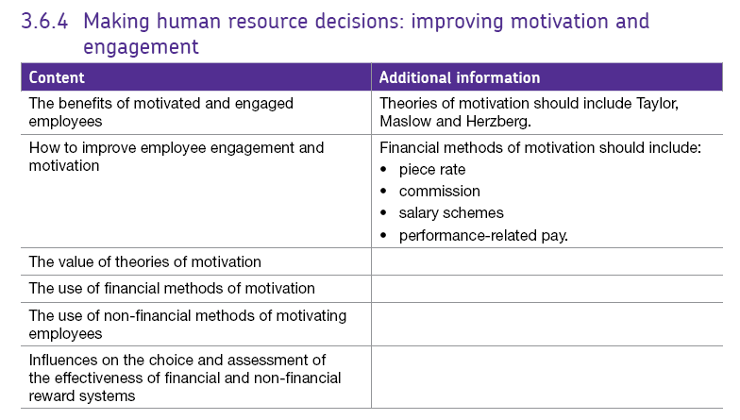3.6.4 Improving motivation and employee engagement

Motivation comes from the enjoyment of the work itself and/or from the desire to achieve certain goals e.g. earn more money or achieve promotion.

## Why does motivation matter in business?

The performance of employees is a product of both their abilities (e.g. skills & experience) and motivation. A talented employee who feels de-motivated is unlikely to perform well at work, whereas a motivated employee can often deliver far more than is expected from them. A well-motivated workforce can provide the following advantages:

* **Better productivity**. This can lead to lower unit costs of production and so enable a firm to sell its product at a lower price
* **Lower levels of absenteeism** as the employees are content with their working lives
* **Lower levels of staff turnover**(the number of employees leaving the business). This can lead to lower training and recruitment costs
* **Improved industrial relations** with trade unions
* Contented workers give the firm a **good reputation** as an employer so making it easier to recruit the best workers
* Motivated employees are likely to **improve product quality** or the customer service associated with a product

There are two types of motivation – **financial and non-financial**.

**Financial motivation** refers to money-based motivation techniques while **non-financial motivation** is concerned with job design.

# Financial methods of motivation

Although some theorists believe that money is not a positive motivator (although lack of it can de-motivate), pay systems are designed to motivate employees. The scientific / Theory X approach, in particular, argues that workers respond to financial rewards. Getting employee pay right is a crucial task for a business.

### Why is pay so important?

* It is an important cost for a business (in some "labour-intensive" businesses, payroll costs are over 50% of total costs)
* People feel strongly about it
* Pay is the subject of business legislation (e.g. national minimum wage; equal opportunities)
* It helps attract reliable employees with the skills the business needs for success
* Pay also helps retain employees – rather than them leave and perhaps join a competitor
* For most employees, the remuneration package is the most important part of a job – and certainly the most visible part of any job offer

There are many methods of financial reward:

* Piece-rate pay
* Commission
* Other performance-related pay (including bonuses)
* Salary schemes - Shares and options

Because pay is a complex issue, there are several ways in which businesses decide how much to pay:

* **Job evaluation / content;** this is usually the most important factor. What is involved in the job being paid? How does it compare with similar jobs?
* **Fairness** – pay needs to be perceived and be seen to match the level of work
* **Negotiated pay rates** – the rate of pay may have been determined elsewhere and the business needs to ensure that it complies with these rates.
* **Market rates** – another important influence – particularly where there is a standard pattern of supply and demand in the relevant labour market. If a business tries to pay below the "market rate" then it will probably have difficulty in recruiting and retaining suitable staff
* **Individual performance** – increasingly, businesses include an element of "performance-related" reward in their pay structures.

However, it is important to remember that pay is only **one element of motivation** and will work best where management also give attention to non-financial factors such as:

* Developing good management and supervision
* Designing jobs and organising work groups to make them as satisfying as possible
* Providing feedback to staff about their performance and training and development
* Making effective arrangements for communications and consultation

## [Motivation - Taylor (Scientific Management)](https://youtu.be/z4qdXvodZaE)

Taylor put forward the idea that workers are motivated mainly by pay. His **Theory of Scientific Management**argued the following:

Taylor's methods were widely adopted as businesses saw the benefits of increased productivity levels and lower unit costs. Taylor's approach has close links with the concept of an **autocratic management style** (managers take all the decisions and simply give orders to those below them) and Macgregor's Theory X approach to workers (workers are viewed as lazy and avoid responsibility).

However, workers soon came to dislike Taylor's approach as they were only given boring, repetitive tasks to carry out. Firms could also afford to lay off workers as productivity levels increased. This led to an increase in strikes and other forms of industrial action by dissatisfied workers

**Key summary for Taylor:**

* Workers given one repetitive task so they can learn to master it
* Managers should give orders and closely control workers
* Workers should be paid per item they produced – piece rate

## [Herzberg’s two-factor theory](https://youtu.be/f-qbGAvR4EU)

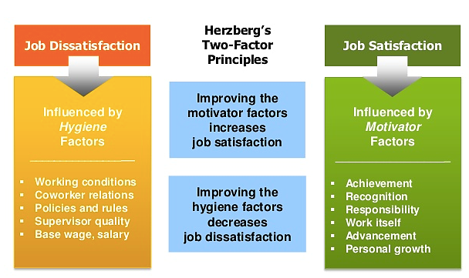Herzberg had close links with Maslow and believed in a **two-factor theory of motivation**. He argued that there were certain factors that a business could introduce that would directly motivate employees to work harder (**motivators**).

However, there were also factors that would de-motivate an employee if not present but would not in themselves actually motivate employees to work harder (**hygiene** **factors**)

**Motivators are more concerned with the actual job itself - the job design or non-financial motivators**. For instance, how interesting the work is and how much opportunity it gives for extra responsibility, recognition and promotion. **Hygiene factors** are factorswhich **'surround the job**' rather than the job itself. For example, a worker will only turn up to work if a business has provided a r**easonable level of pay and safe working conditions** but these factors will not make the employee work harder at their job once they are there.

Herzberg believed that businesses should motivate employees by adopting a democratic approach to management and by improving the nature and content of the actual job through certain methods. Some of the methods managers could use to achieve this are:

* **Job enlargement** – workers being given a greater variety of tasks to perform (not necessarily more challenging) which should make the work more interesting.
* **Job enrichment** - involves workers being given a wider range of more complex and challenging tasks surrounding a complete unit of work. This should give a greater sense of achievement.
* **Empowerment** means delegating more power to employees to make their own decisions over areas of their working life.

**Key summary for Herzberg:**

* Workers motivated to work harder by motivators e.g. more responsibility, more interesting work, more praise for good work
* Workers can become de-motivated if hygiene factors are not met e.g. pay, working conditions, relationships with colleagues

Because of Herzberg’s focus on job design - job enlargement enrichment and empowerment, his theory complements that of Hackman and Oldham.

## [Maslow’s hierarchy of needs.](https://youtu.be/3St5OoLYTJ0)



Maslow focused on the psychological needs of employees. Maslow put forward a theory that there are five levels in a hierarchy of human needs that employees need to have fulfilled at work.

All of the needs are structured into a hierarchy and only once a lower level of need has been fully met, would a worker be motivated by the opportunity of having the next need up in the hierarchy satisfied. For example, a person who is dying of hunger will be motivated to achieve a basic wage in order to buy food before worrying about having a secure job contract or the respect of others.

A business should therefore offer different incentives to workers in order to help them fulfil each need in turn and progress up the hierarchy. Managers should also recognise that workers are not all motivated in the same way and do not all move up the hierarchy at the same pace. They may therefore have to offer a slightly different set of incentives from worker to worker.

**Key summary for Maslow:**

* Workers motivated by having each level of need met in order as they move up the hierarchy
* Levels of needs are: Physical, Security, Social, Self-esteem, Self-fulfilment
* Workers must have lower level of needs fully met by firm before being motivated by next level

# Factors affecting choice of motivation.

A successful business manages to get the balance right between financial and non-financial factors. There are many factors to consider here:

1. Type of firm.

A traditional tall structured firm is more likely to use financial motivators especially if there is little opportunity for delegation and the work is repetitive, workers earn money and then go home and have their social life and home comforts. This supports Taylor’s view that money motivates.

On the other hand, an organisation with highly skilled employees may find that they are more concerned with how their job is designed and hoe w much autonomy they have in their role supporting Herzberg’s 2-factor theory.

1. Organisational design

In a flat structure it is easier to delegate and empower employees, also larger firms with many departments often use teams and have good communication so employees are engaged whereas in a tall structure decision making is centralised and the management may be more ‘tell’ so maintaining motivation may be difficult without financial reward.

1. Nature of the job and the employees.

Not everyone wants to be empowered and have responsibility given to them, some people just want to do their job and go home again. This doesn’t necessarily relate to the job-type but more to the character of the person. Some people working in a hospital admin team may be very productive and want to gain promotion whilst others just want to earn their money and go home – thus they can’t necessarily be motivated in the same way – there is no ‘one size fits all’.

Other factors might include:

* 1. Clarity of the business objectives
  2. Quality of communication
  3. Timescale / urgency
  4. Size of the firm and available budget