**3.3.12 Polymers**

**AS Link:**

**3.3.1 – Introduction to organic molecules (nomenclature)**

**3.3.4 – Alkenes (addition polymers)**

**A level Link:**

**3.3.13 – Amino acids, proteins and DNA**

**Introduction**

**Polymers** are **large molecules** built from small molecules called monomers. **Monomers** are **small molecules** that join together in a **polymerisation** reaction.

***Task: Name some naturally occurring polymers***

DNA, proteins, starch, cellulose

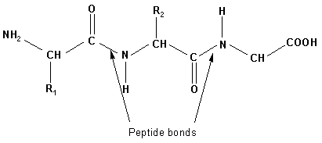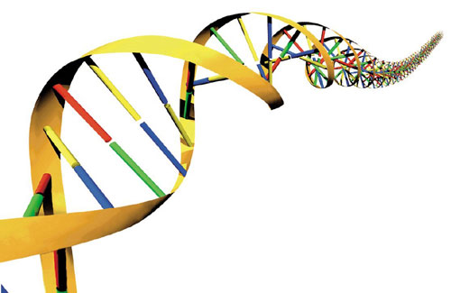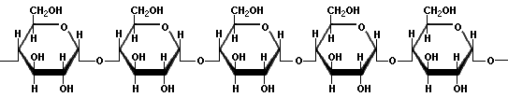

**All plastics are polymers but not all polymers are plastics.**

History timeline (not in specification)

The first plastic was Bakerlite made in 1907, now there are many different types of polymers with a wide range of properties and uses.

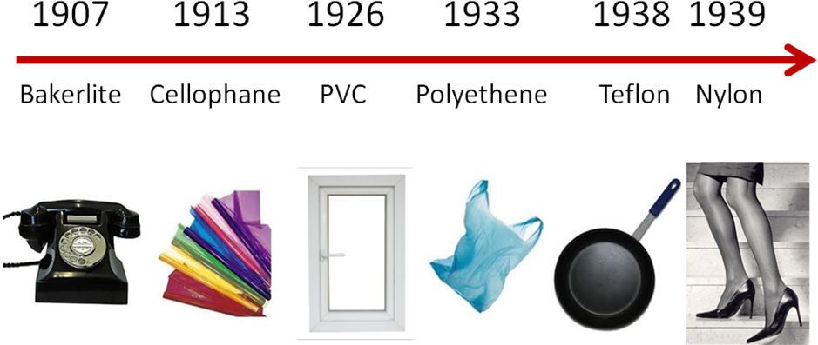

Polymers are classified based on type of reaction by which they are made.

There are 2 main types:

* Addition
* Condensation

***Demo: Examples of polymers*Addition polymers**

These are made by **addition of monomers** to end of chain to give **one product**, they are also sometimes called **chain-growth** polymers. The end is reactive because it is a **free radical** (unpaired electron) and **catalysts** are used in the process.

The **monomers** have a **C=C** **double bond**, represented by **RCH=CH2**, where the R groups can be different to give different polymers, e.g. R = H, CH3, C6H5, Cl, CN. Some monomers have two or more functional groups on the alkene.

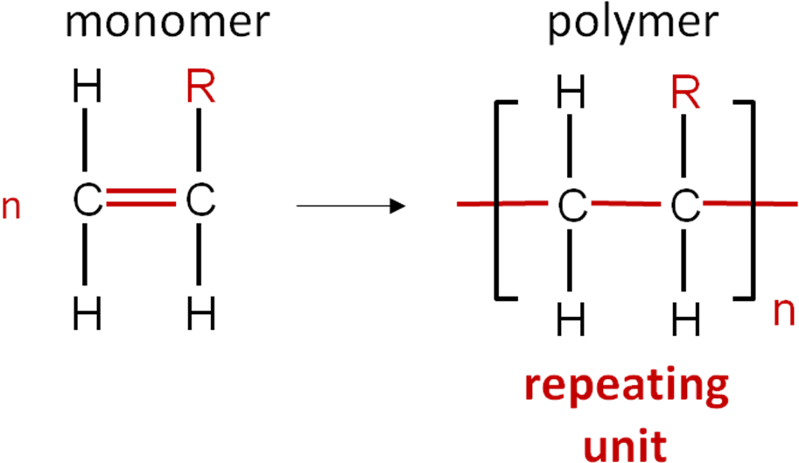

The repeating unit is enclosed by brackets, where n is a variable number (~100 to >10,000)

***Demo: Molymods***

|  |  |  |  |
| --- | --- | --- | --- |
| **Monomer** | **R =** | **Polymer repeat** | **N.B. Polymer is not an alkene but name is written with brackets to show monomer** |
| ethene | H | poly(ethene) |
| propene | CH3 | poly(propene) |
| phenylethene | C6H5 | poly(phenylethene) |
| chloroethene | Cl | poly(chloroethane) |
| propenenitrile | CN | poly(propenenitrile) |

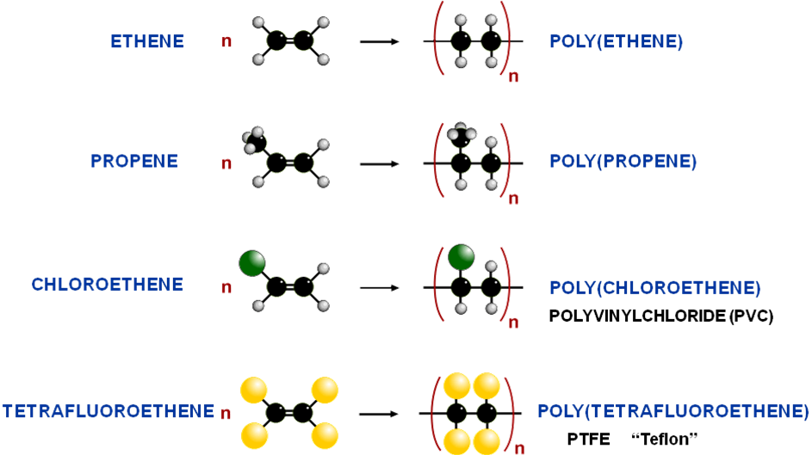

***Sheet: Polymers – addition*** *Hint: Monomer must have double bond*

***Starter: 7.3 – Poly(alkenes)***

***Demo: Disappearing poly(styrene) – poly(styrene) cup & propanone***

**Condensation polymers**

Condensation polymers are made in a **condensation reaction** between **two functional groups** with the **elimination of small molecule**. The molecules that is eliminated depends on the two functional groups that react together, they are usually H2O, HCl or CH3OH. They can be formed by reacting **identical monomers** (with two different functional groups) or **two different** **monomers** (each with different functional groups).

When **two or more different monomers** form a polymer it is referred to as a **co-polymer**, they can also be referred to as **step-growth** polymers.

Polypeptides are examples of condensation polymers.

There are 2 main types of synthetic condensation polymers:

* **Polyesters**
* **Polyamides**

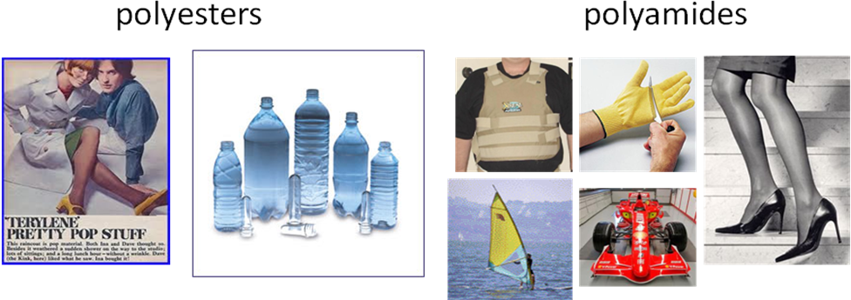

Polyesters

**Esterification** to produce an ester is an example of **condensation** reaction; a **carboxylic acid** and **alcohol** react with **water eliminated.** Polyesters have the **ester link –COO–** repeated over and over again.

***Task: Show an esterification reaction between any carboxylic acid & alcohol***

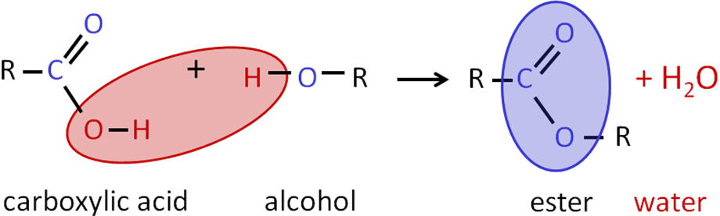

***Demo: PET bottle, biscuit wrapper, polyester fabric***

Uses:

* Textiles
* Drinks bottles
* Food wrappers

**Polyesters** are formed when **dicarboxylic acids** and **diols** react in the presence of an **acid catalyst** or **enzyme** with the formation of an **ester link** between the monomers.

**H**

**O**

C

O

R

C

O

**O**

**H**

n

+

dicarboxylic acid

diol

**HO**

**OH**

R’

C

O

R

C

O

O

R’

O

n

+ **2n H2O**

polyester

n

strong acid or specific enzyme

Ester link

*Hint: Draw monomers with functional groups horizontal along paper, makes it easier to draw polymer, also draw horizontal*

**Naming monomers**

|  |  |
| --- | --- |
| *Dicarboxylic acids* | *Diols* |
| ethanedioic acid | ethane-1,2-diol |

**Terylene** (know as PET – poly(ethylene terephthalate)) also contains ester links and is made from **benzene-1,4-dicarboyxlic acid** (terephthalic acid or ethylene terephthalate) and **ethane-1,2-diol**.

***Task: Draw the monomers (ethane-1,2-diol & benzene-1,4-dicarboyxlic acid) and one repeating unit of the polymer***

Reverse reaction is hydrolysis

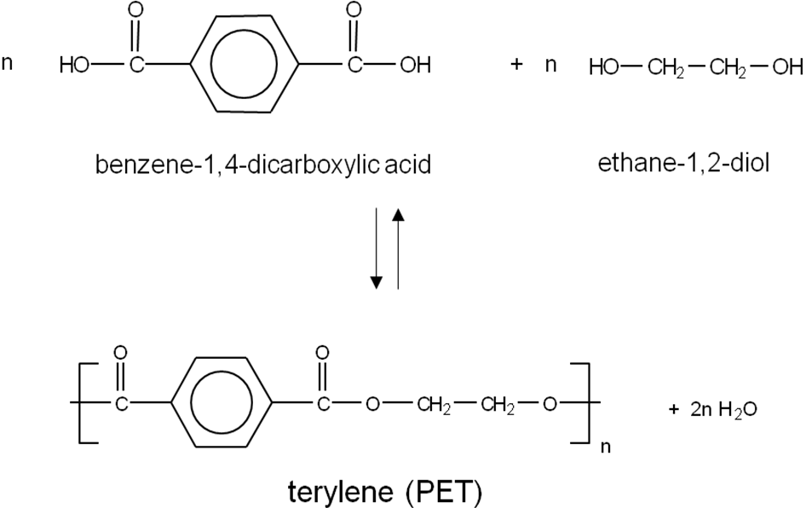

Polyamides

**Amides** are formed when **carboxylic acids** and **amines react** with the **elimination** of a **water** molecule.

***Task: Show carboxylic acid and amine reacting to produce an N-substituted amide***

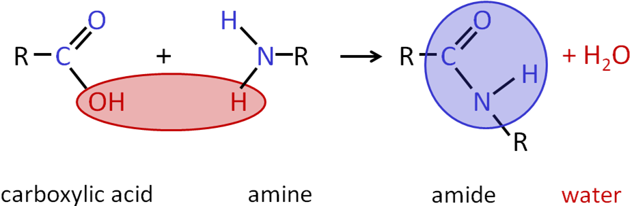

**Polyamides** are made through the reaction of **two** **different monomers** **dicarboxylic** **acids** and **diamines** presence of an **acid catalyst** or **enzyme** with the formation of **amide links –CONH–** between the monomers.

The monomers have identical functional groups at both ends; **dicarboxylic acid** have two carboxylic acid groups and **diamines** have twoamine groups.

|  |  |
| --- | --- |
| H  O  C  O  R  C  O  O  H  n  +  dicarboxylic acid  diamine  H2  N  N  H2  R’  C  O  R  C  N  O  H  R’  N  H  n  + 2n H2O  polyamide  n  strong acid or specific enzyme | Uses:   * Tights * Textiles * Carpets * Fishing lines * Ropes * Tyre cords |

Two examples of polyamides are:

* **Nylon**
* **Kevlar**

**Nylon** is a polyamide and was originally as a replacement for silk during war. There are different **types of nylon depending on the monomers** used, it is named according to the number of carbon atoms in each monomer.

**Nylon-6,6** is made from a **6-carbon dicarboxylic acid** (hexanedioic acid) and a **6-carbon diamine** (hexane-1,6,-diamine).

***Task: Draw the monomers (hexanedioic acid & hexane-1,6,-diamine) and one repeating unit of the polymer***

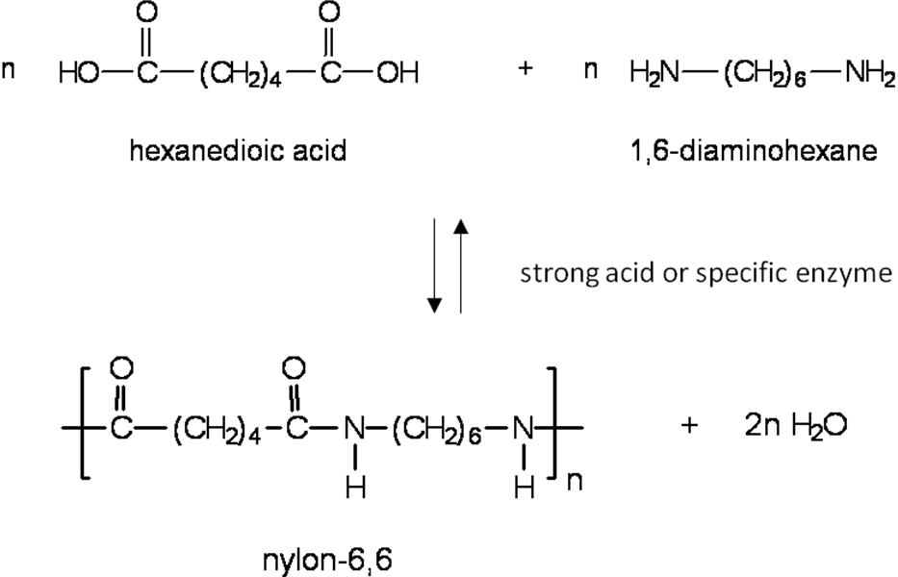

***Demo: Making nylon***

**Kevlar** is another example of a polyamide and is made from **benzene-1,4-dicarboxylic acid and benzene-1,4-diamine** to form an **aromatic polyamide** (aramid).

It has very **specific properties** due to the **intermolecular bonding** between the polymer chains so it is **fire resistant** and both **lightweight and strong** (5x stronger than steel weight for weight)

Uses:

* Bullet proof vests
* Flame resistant clothing
* Boat construction
* Aircraft wings
* F1 fuel tanks

***Task: Draw monomers (benzene-1,4-dicarboxylic acid and benzene-1,4-diamine)*** ***and one repeating unit of the polymer***

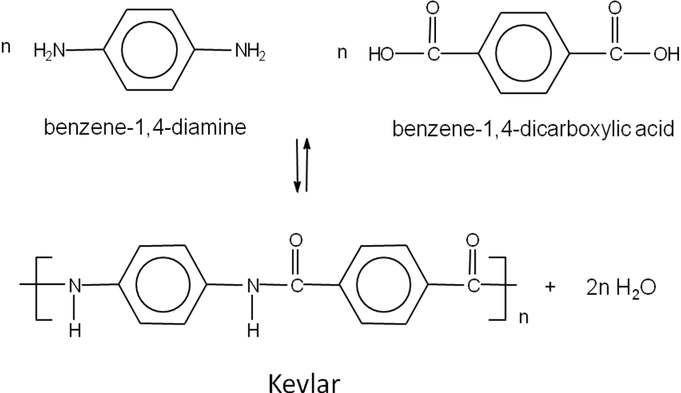

Polypeptides

**Amino acids** contain an **amine group** and a **carboxylic acid** group so react together in a **condensation reaction** to form **polyamides**. These are more commonly called **polypeptides**.

***Task: Draw dipeptide of alanine (2-amino propanoic acid)***

|  |  |  |
| --- | --- | --- |
| Monomers |  | Two monomers needed with two functional groups  – amine & carboxylic acid |
| Dipeptide |  | 1 molecule of water also produced |

Amide link often called a peptide bond in a polypeptide.

Some **amino acids can by polymerised** to make synthetic a **polyamide**, e.g. **nylon-6** can be made from 6-aminohexanoic acid [H2N(CH2)5COOH]. This is an example of **one monomer** being used but it must have **different functional groups**, i.e. -NH2 and -OH.

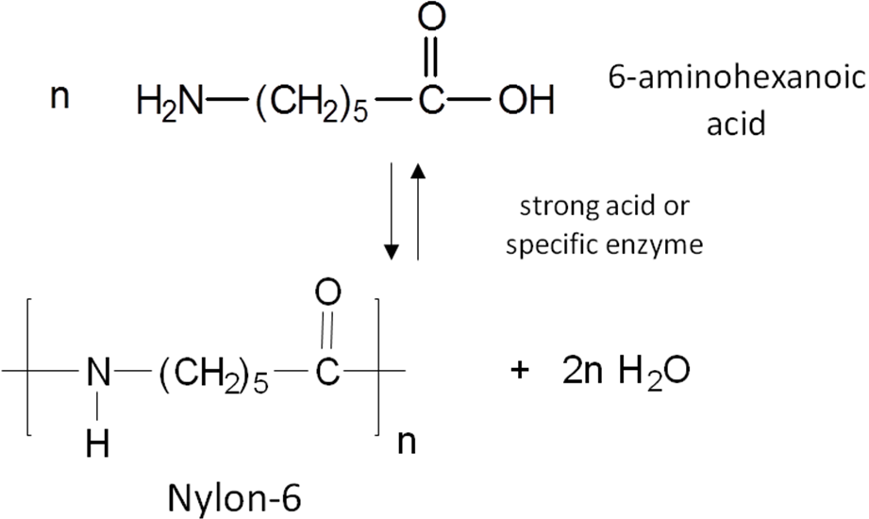

***Starter: 7.2 – Condensation polymers***

More complex condensation polymers

**Other condensation polymers** can be made from single monomers with two different functional groups such as a carboxylic acid and **alcohol or amine**. A molecule with both an **alcohol and amine** group can **react with a dicarboxylic acid** monomer to form a **polymer** with **both amide and ester links**.

**Example CGP227**

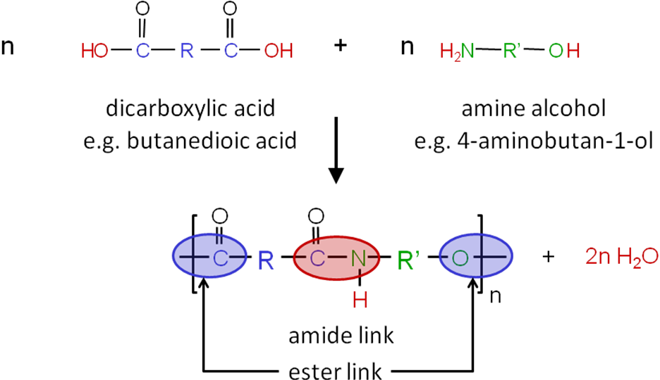

**Hydrolysis of condensation polymers**

The **ester** or **amide** **link** in condensation polymers can be **broken** by **hydrolysis**, where a **water** molecule is **added back** in and the links are broken with the **formation** of the **monomers**. It is the reverse of condensation.

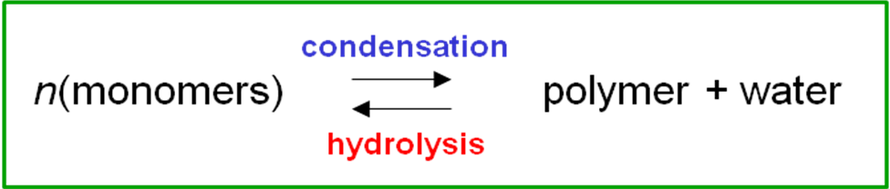

**Hydrolysis** using just **water** is very **slow** so in the lab an **acid or alkali** is used to **speed** **up** the reaction. Polyesters more easily in alkaline conditions. Polyamides are hydrolysed more easily in acidic conditions because they are basic. **Enzymes** can **also** be **used**.

**Hydrolysis of polyester:**

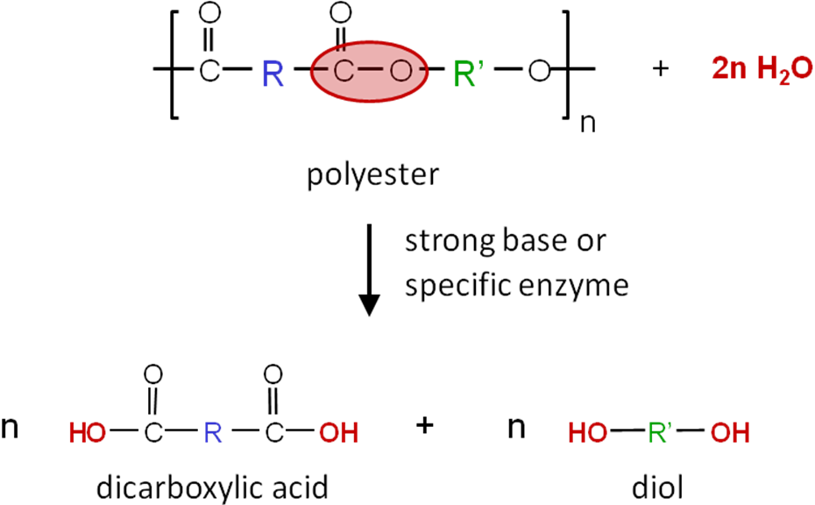

**Hydrolysis of polyamide:**

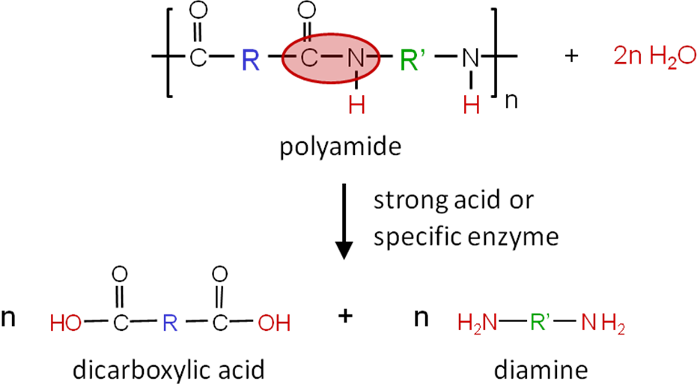

**Bonding between polymer chains**

|  |  |
| --- | --- |
| **Condensation polymers** are generally **stronger** and **more rigid** than addition polymers because they are made of chains that contain **polar bonds** such as **C=O, C-N or C-O**. In **addition polymers only van der Waal forces** can exist between the polymer chains but in **condensation polymers** **permenant dipole-dipole** and stronger **hydrogen bonds** can form. | Polyamide |
| The hydrogen bonds and the fact that the polymer contain benzene rings is why **Kevlar** is so strong. |  |

***Fact recall: CGP223 Q1-5***

**Monomers and repeating units**

Identifying repeating units

Condensation polymers are made up of **repeating units**. The pairs of monomers that react together form a repeating unit.

**Working out the repeating unit:**

* Draw monomers next to each other
* Remove OH from dicarboxylic acid and H from one of the diamines or alcohols – giving H2O
* Join C=O and N together to form an amide link or C=O and O together to form an ester link
* Take OH of the other –COOH group and H off other amine or alcohol

**Example CGP224**

Condensation of 1,2-diaminobutane (H2N(CH2)4NH2) and decandioic acid (HOOC(CH2)8COOH)

Repeating units can also be identified from long sections of polymers. The repeating unit should have a C=O at one end and the –O- or –NH from the alcohol or amine at the other.

Identifying monomers

It’s also important to be able to **identify the monomers** that would form from a condensation reaction. It’s important to **recognise the links** formed between the functional groups.

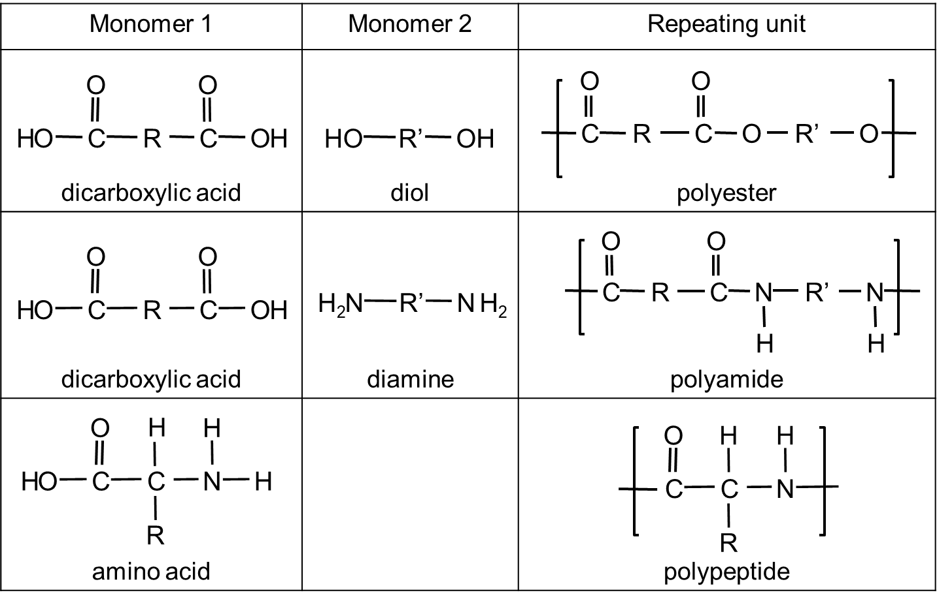

**Working out the monomer:**

* Identify the repeating unit
* Break the link – C-O for a polyester and N-H for a polyamine
* Add the components of water for each ester or amine link

|  |  |
| --- | --- |
| Polyester | Polyamide |
|  |  |

***Sheet: Polymers – condensation***

***Application: CGP227 PQ1-2***

***Starter: 7.1 – Common polymers***

**Disposal of plastic waste**

Information:

* plastic uses 4% of oil stock plus 4% in energy supplies
* 56% of all plastics waste is used packaging
* estimated that only 7% of total plastic waste are recycled
* 57% of litter found on beaches in 2003 was plastic

There are 3 main methods of disposal:

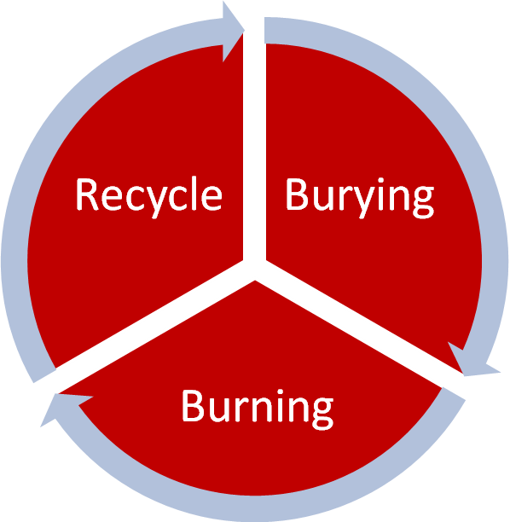

Burying plastics - landfill

Addition polymers are **chemically inert** due to the **lack of bond polarity (non-polar)** and they consist of strong C-C and C-H bonds, they are therefore **non-biodegradable**. They can’t be broken down by micro-organisms (which use enzymes).

**Polyamides** and **polyesters** are **susceptible to hydrolysis** so they can be broken down into their monomers, they are therefore **biodegradable**. However, it is very slow and needs **enzymes, strong acid** or a **base** (e.g. HCl, NaOH, Na2CO3). They **attack** the **amide/ester bond** due to it being **polar**.

Some plastics are completely biodegradable by the action of sunlight and others can be made **degradable by the addition of cellulose, starch or proteins** – but these are more expensive.

Burning plastics - incineration

**Addition polymers** **will burn** and are **highly flammable**, poly(alkenes) burn to give carbon dioxide (adds to greenhouse effect) and water and also produce **energy** for power generation or heating homes.

-[-CH2-]-n + 1½ *n*O2 → *n*CO2 + *n*H2O

Polystyrene may release **toxic** gases, although complete combustion would give CO2 and H2O only.

Waste:

* CO2 greenhouse gas
* NO acid rain
* SO2 acid rain
* HCl (from PVC)
* Particulates unburnt carbon

Recycling plastics

There are 50 different groups of plastics, with hundreds of different varieties. All types of plastic are recyclable. To make sorting and recycling easier identify the main types of plastic have a code:

|  |  |  |
| --- | --- | --- |
|  | PET | Polyethylene terephthalate - Fizzy drink bottles and oven-ready meal trays. |
|  | HDPE | High-density polyethylene - Bottles for milk and washing-up liquids. |
|  | PVC | Polyvinyl chloride - Food trays, cling film, bottles for squash, mineral water and shampoo. |
|  | LDPE | Low density polyethylene - Carrier bags and bin liners. |
|  | PP | Polypropylene - Margarine tubs, microwaveable meal trays. |
|  | PS | Polystyrene - Yoghurt pots, foam meat or fish trays, hamburger boxes and egg cartons, vending cups, plastic cutlery, protective packaging for electronic goods and toys. |
|  | OTHER | Any other plastics that do not fall into any of the above categories. - An example is melamine, which is often used in plastic plates and cups. |

There are some **disadvantages** to recycling plastics. They must be **sorted** prior to melting down and reforming (this is only possible with thermoplastics such as addition polymers). However, the plastic **may not be suitable for its original purpose**.

**Recycling plastic can have several advantages:**

* Conservation of non-renewable fossil fuels
* Reduced consumption of energy
* Reduced amounts of solid waste going to landfill
* Reduced emissions of carbon-dioxide (CO2), nitrogen-oxide (NO) and sulphur-dioxide (SO2), HCl and particulates.

***Task: Summary showing advantages & disadvantage of 3 disposal methods***

|  |  |  |
| --- | --- | --- |
| **Method** | **Advantages** | **Disadvantages** |
| Landfill | Cheap  Easy  Methane gas can be collected and burned for energy | Many plastics non bio-degradable  Unsightly & destroy habitats  Toxic waste released & can leach into water courses  Polluting gases can be released |
| Incineration | Produces energy to supply electricity to homes  Reduced amounts going to landfill | Expensive to build and operate  Release of harmful gases:   * CO2 – greenhouse effect * HCl * NOX/SO2 – acid rain * Particulates |
| Recycling | Conservation of fossil fuels  Reduced consumption of energy  Reduced amounts going to landfill  Reduced emissions of harmful gases | Expensive  Plastics must be transported & sort  Recycled polymer may not be suitable for original purpose |

***Application: CGP230 PQ1***

***Fact recall: CGP230 Q1-5***

***Exam questions: Oxford p198-199 Q1-8***