

**Higher IGCSE (9 – 1) Revision Pack**

**Circle Theorems**

**Name --------------------------------**

**Questions**

**Q1.**

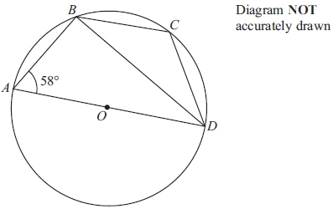

*A*, *B*, *C* and *D* are four points on a circle, centre *O*.  
*AD* is a diameter of the circle.  
 Angle *BAD* = 58°

(a) Calculate the size of angle *ADB*.

...........................................................°

**(2)**

(b) (i) Calculate the size of angle *BCD*.

...........................................................°

(ii) Give a reason for your answer.

      ..............................................................................................................................................

      ..............................................................................................................................................

**(2)**

**(Total for question = 4 marks)**

**Q2.**

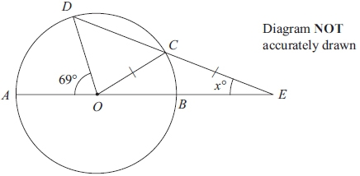

*A*, *B*, *C* and *D* are points on a circle, centre *O*.  
*AOBE* and *DCE* are straight lines.  
*CO* = *CE*.  
 Angle *AOD* = 69º   
 Angle *CEO* = *x*º

Calculate the value of *x*.  
 Show your working clearly.

*x* = ...........................................................

**(Total for question = 6 marks)**

**Q3.**

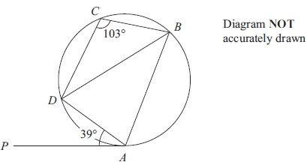

*A*, *B*, *C* and *D* are points on a circle.  
*PA* is a tangent to the circle.  
 Angle *PAD* = 39°  
 Angle *BCD* = 103°

Calculate the size of angle *ADB*.

...........................................................°

**(Total for question = 3 marks)**

**Q4.**

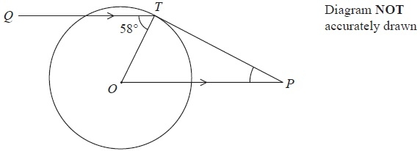

*T* is a point on a circle, centre *O*.   
*Q* is a point such that angle *QTO* = 58°   
*P* is the point such that *OP* is parallel to *QT* and *PT* is a tangent to the circle.

Work out the size of angle *OPT*.

........................................................... °

**(Total for Question is 3 marks)**

**Q5.**

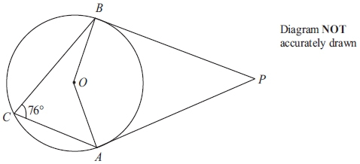

*A*, *B* and *C* are points on a circle, centre *O*.  
 Angle *ACB* = 76°  
*PA* and *PB* are tangents to the circle.

Calculate the size of angle *APB*.

...........................................................°

**(Total for question = 4 marks)**

**Q6.**

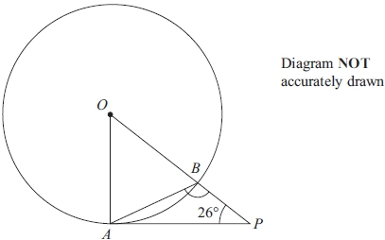

*A* and *B* are points on a circle, centre *O*.  
*PA* is the tangent to the circle at *A*.  
*OBP* is a straight line. Angle *APO* = 26°

Calculate the size of angle *ABP*.

...........................................................°

**(Total for question = 3 marks)**

**Q7.**

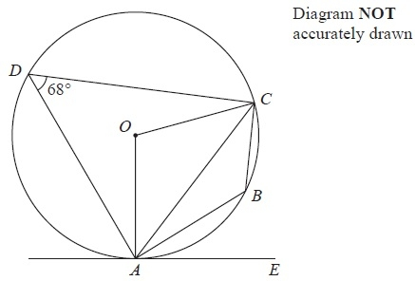

*A*, *B*, *C* and *D* are points on a circle, centre *O*.   
*AE* is a tangent to the circle.   
Angle *ADC* = 68°

(a)  (i)  Find the size of angle *ABC*.

........................................................... °

(ii)  Give a reason for your answer.

.............................................................................................................................................

**(2)**

(b)  (i)  Find the size of angle *AOC*.

........................................................... °

(ii)  Give a reason for your answer.

.............................................................................................................................................

**(2)**

(c)  Find the size of angle *CAE*.

........................................................... °

**(1)**

**(Total for Question is 5 marks)**

**Q8.**

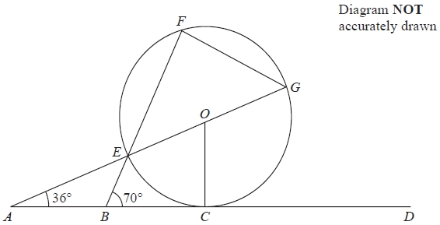

*ABCD* is the tangent at *C* to a circle, centre *O*.   
*E*, *F* and *G* are points on the circle.   
*AEOG* and *BEF* are straight lines.

Angle *BAE* = 36°   
Angle *EBC* = 70°

(a) (i) Find the size of angle *AOC*.

........................................................... °

(ii) Give reasons for your answer.

.............................................................................................................................................

.............................................................................................................................................

**(2)**

(b)   Find the size of angle *CGF*.

........................................................... °

**(3)**

**(Total for Question is 5 marks)**

**Q9.**

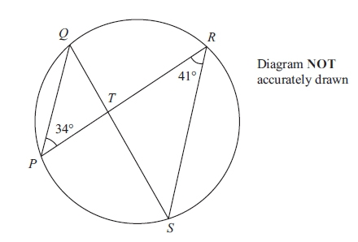

*P*, *Q*, *R* and *S* are points on the circumference of a circle.   
*PR* and *QS* intersect at *T*.   
Angle *QPR* = 34° and angle *PRS* = 41°

(a) (i) Find the size of angle PQS.

........................................................... °

(ii) Give a reason for your answer.

.............................................................................................................................................

.............................................................................................................................................

**(2)**

(b) (i) Find the size of angle *PTS*.

........................................................... °

(ii) Explain why *T* cannot be the centre of the circle.

.............................................................................................................................................

.............................................................................................................................................

**(2)**

**(Total for question is 4 marks)**

**Q10.**

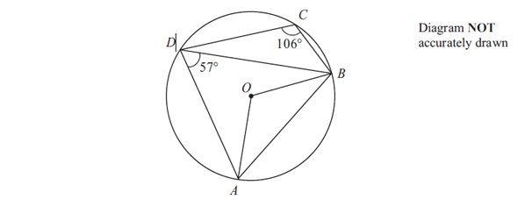

A, B, C and D are points on a circle, centre *O*.  
 Angle *ADB* = 57°.  
 Angle *BCD* = 106°.

(a) (i) Calculate the size of angle *AOB*.

...........................................................°

(ii) Give a reason for your answer.

      ..............................................................................................................................................

      ..............................................................................................................................................

**(2)**

(b) Calculate the size of angle *BAD*.

...........................................................°

**(1)**

**(Total for question = 3 marks)**

**Q11.**

*J*, *K*, *L* and *M* are points on the circumference of a circle.   
*GJH* is the tangent to the circle at *J*.   
*MK* and *JL* intersect at the point *P*.   
*GML* is a straight line.

Angle *HJK* = 62°, angle *JKM* = 21° and angle *JGL* = 78°

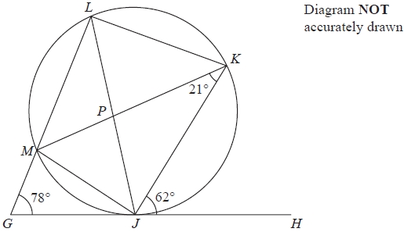

(a)  Write down the size of angle *MLJ*.

...........................................................°

**(1)**

(b)  Write down the size of angle *JLK*.

...........................................................°

**(1)**

(c)  Work out the size of angle *KPL*.

...........................................................°

**(3)**

**(Total for question = 5 marks)**

**Q12.**

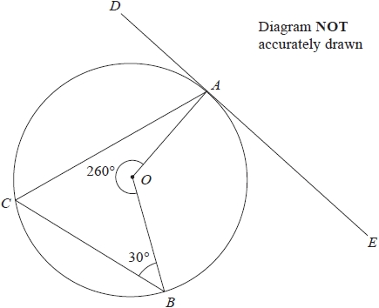

*A*, *B*, and *C* are points on the circumference of a circle, centre *O*.   
*DAE* is a tangent to the circle.

(a)  Work out the size of angle *ACB*.

........................................................... °

**(2)**

(b)  Work out the size of angle *CAD*.

........................................................... °

**(2)**

**(Total for question = 4 marks)**

**Q13.**

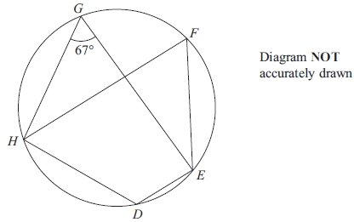

*D*, *E*, *F*, *G* and *H* are points on a circle.  
 Angle *EGH* = 67°

(a) Find the size of angle *EFH*.

...........................................................°

**(1)**

Find the size of angle *EFH*.

...........................................................°

(ii) Give a reason for your answer.

      ..............................................................................................................................................

      ..............................................................................................................................................

**(2)**

**(Total for question = 3 marks)**

**Q14.**

*AEC* and *DEB* are chords of a circle.

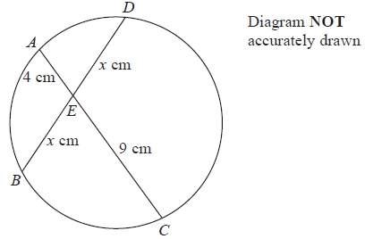

*AE* = 4 cm.   
*CE* = 9 cm.   
*DE* = *BE* = *x* cm.

Calculate the value of *x*.

*x* = ...........................................................

**(Total for Question is 2 marks)**

**Q15.**

*P*, *R*, *Q* and *S* are four points on a circle.

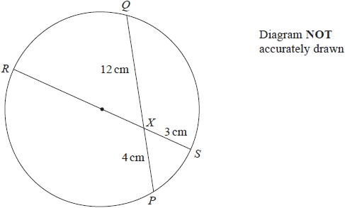

*RXS* is a diameter of the circle.   
*PXQ* is a chord of the circle.

*PX* = 4 cm,  *XQ* = 12 cm,  *SX* = 3 cm.

Work out the radius of the circle.

........................................................... cm

**(Total for question = 3 marks)**

**Q16.**

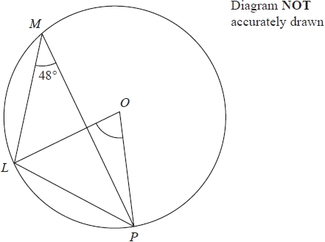

*L*, *M* and *P* are points on a circle, centre *O*  
Angle *LMP* = 48°

(a)  (i)  Write down the size of angle *LOP*

...........................................................°

(ii)  Give a reason for your answer.

.............................................................................................................................................

.............................................................................................................................................

.............................................................................................................................................

**(2)**

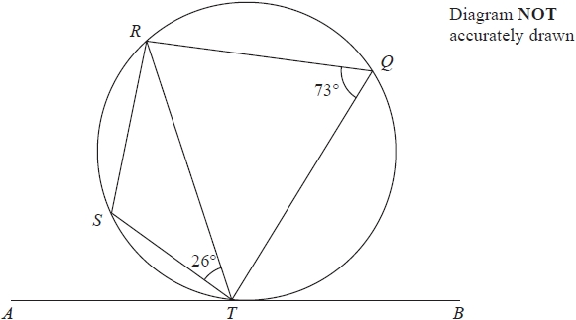

*Q*, *R*, *S* and *T* are points on a circle.   
*ATB* is the tangent to the circle at *T*

Angle *STR* = 26°   
Angle *RQT* = 73°

(b)  Work out the size of angle *STA*  
Give a reason for each stage in your working.

...........................................................°

**(3)**

**(Total for question = 5 marks)**

**Q17.**

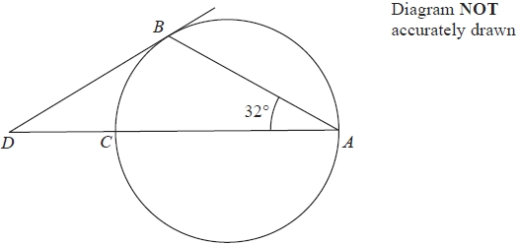

*A*, *B* and *C* are three points on a circle.

*DCA* is a straight line.   
*CA* is a diameter of the circle.   
*DB* is a tangent to the circle.

Calculate the size of angle *CDB*.

...........................................................°

**(Total for question = 3 marks)**

**Q18.**

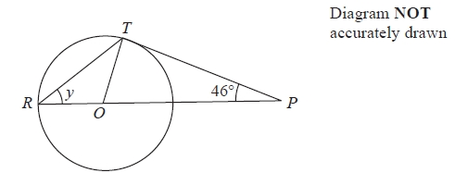

*R* and *T* are points on a circle, centre *O*.   
*ROP* is a straight line.   
*PT* is a tangent to the circle.   
Angle *TPO* = 46°

(a)  Explain why angle *OTP* = 90°

.............................................................................................................................................

.............................................................................................................................................

**(1)**

(b)  Work out the size of angle *y*.

........................................................... °

**(3)**

**(Total for question = 4 marks)**

**Q19.**

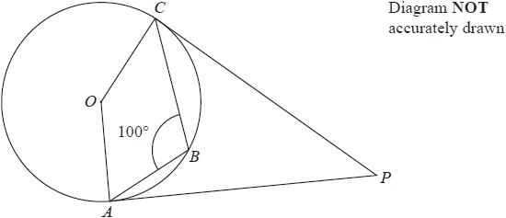

*A*, *B* and *C* are points on a circle, centre *O*.   
*PA* and *PC* are tangents to the circle.   
Angle *ABC* = 100°

Calculate the size of angle *APC*.

........................................................... °

**(Total for question = 3 marks)**

**Q20.**

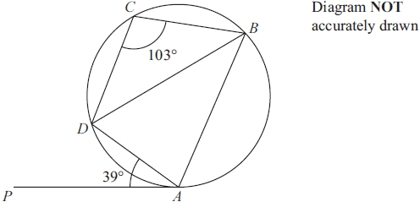

*A*, *B*, *C* and *D* are points on a circle.   
*PA* is a tangent to the circle.   
Angle *PAD* = 39°   
Angle *BCD* = 103°

Calculate the size of angle *ADB*.   
Give a reason for each stage of your working.

........................................................... °

**(Total for question = 5 marks)**

**End of questions**