

**Higher IGCSE (9 – 1) Revision Pack**

**Simultaneous Equations**

**Name --------------------------------**

**Questions**

**Q1.**

Solve the simultaneous equations   
  
*y* − 2*x* = 6  
  
*y* + 2*x* = 6

Show clear algebraic working.

*x* = ...........................................................

*y* = ...........................................................

**(Total for question = 5 marks)**

**Q2.**

Solve the simultaneous equations

4*x* + 5*y* = 4   
   2*x* – *y* = 9

Show clear algebraic working.

*x* =

*y* =

**(Total for question = 3 marks)**

**Q3.**

Solve the simultaneous equations

*x* + 2*y* = −0.5

3*x* – *y* = 16

Show clear algebraic working.

*x* = ...........................................................

*y* = ...........................................................

**(Total for question = 3 marks)**

**Q4.**

Solve the simultaneous equations

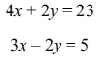

*x* = ...........................................................

*y* = ...........................................................

**(Total for question = 3 marks)**

**Q5.**

Calvin has 8 identical rectangular tiles and 4 identical square tiles.   
He arranges the tiles to fit exactly round the edge of a rectangle, as shown in the diagram below.

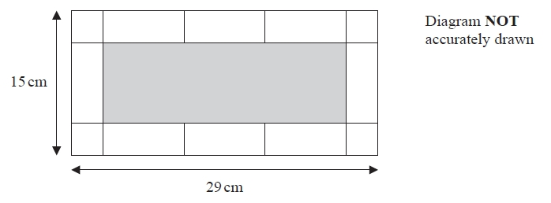

Work out the area of one of Calvin's rectangular tiles.

........................................................... cm2

**(Total for question = 5 marks)**

**Q6.**

Showing clear algebraic working, solve the simultaneous equations

3*a* + 2*b* = 1  
*a* + 2*b* = 5

*a* = ...........................................................

*b* = ...........................................................

**(Total for question = 3 marks)**

**Q7.**

Solve the simultaneous equations

3*x* − *y* = 6

*x* + *y* = 12

Show clear algebraic working.

*x*...........................................................

*y*...........................................................

**(Total for question = 3 marks)**

**Q8.**

Solve the simultaneous equations

5*x* + *y* = 17

*x* + *y* = 3

Show clear algebraic working.

*x* = ...........................................................

*y* = ...........................................................

**(Total for question = 3 marks)**

**Q9.**

Solve the simultaneous equations

6*x* + 4*y* = 19

5*x* + *y* = 3

Show clear algebraic working.

*x* = ...........................................................

*y* = ...........................................................

**(Total for question = 3 marks)**

**Q10.**

Solve    *x* − 5*y* = 14

3*x* + 5*y* = 2

Show clear algebraic working.

*x* = ...........................................................

*y* = ...........................................................

**(Total for question = 3 marks)**

**Q11.**

Solve the simultaneous equations.

5*x* − 2*y* = 9.5   
4*x* + 2*y* = 13

Show clear algebraic working.

*x* = ...........................................................

*y* = ...........................................................

**(Total for question = 3 marks)**

**Q12.**

Solve   *x* + 2*y* = 3   
            *x* – *y* = 6

Show clear algebraic working.

*x* = ..........................................................

*y* = ..........................................................

**(Total for question = 3 marks)**

**Q13.**

Solve the simultaneous equations

5*x* − 2*y* = 33

5*x* + 8*y* = 18

Show clear algebraic working.

*x* = ...........................................................

*y* = ...........................................................

**(Total for question = 3 marks)**

**Q14.**

(a)  Solve

7*x* + 2*y* = 16   
5*x* – 2*y* = 20

Show clear algebraic working.

*x* = ...........................................................

*y* = ...........................................................

**(3)**

(b)  Expand and simplify    (*k* + 9)(*k* – 5)

...........................................................

**(2)**

**(Total for question = 5 marks)**

**Mark Scheme**

**Q1**.

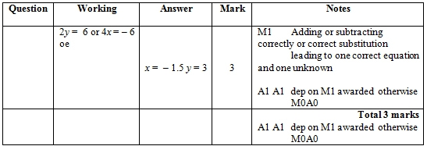

**Q2.**

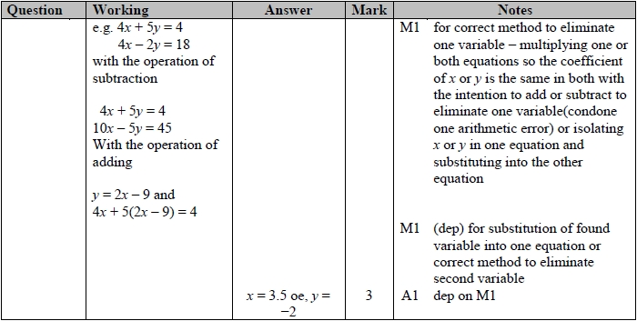

**Q3.**

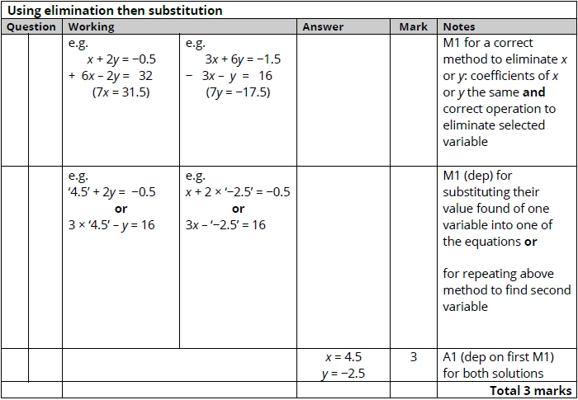

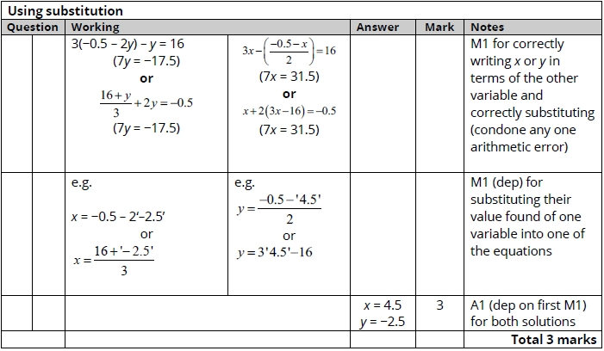

**Q4.**

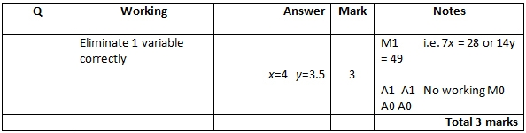

**Q5.**

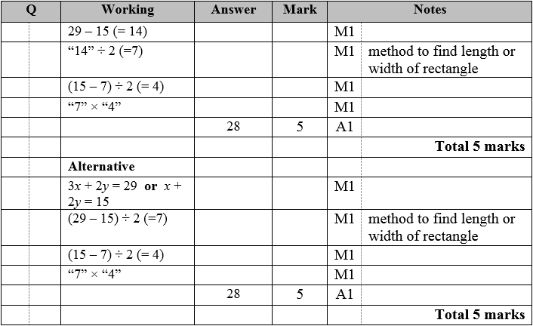

**Q6.**

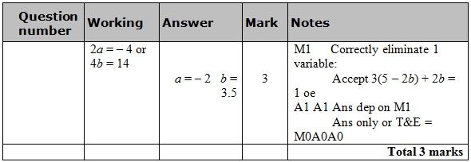

**Q7.**

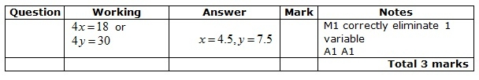

**Q8.**

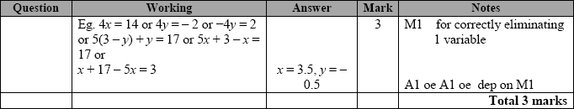

**Q9.**

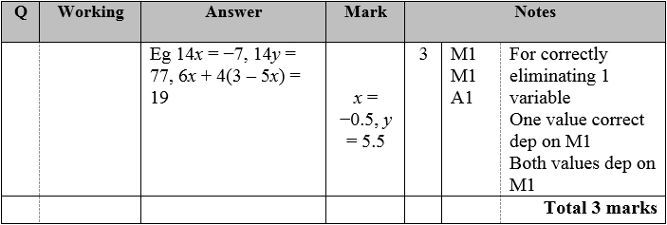

**Q10.**

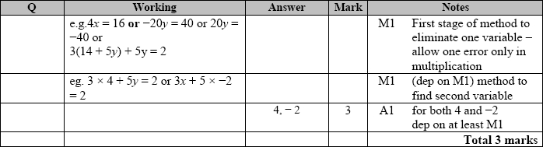

**Q11.**

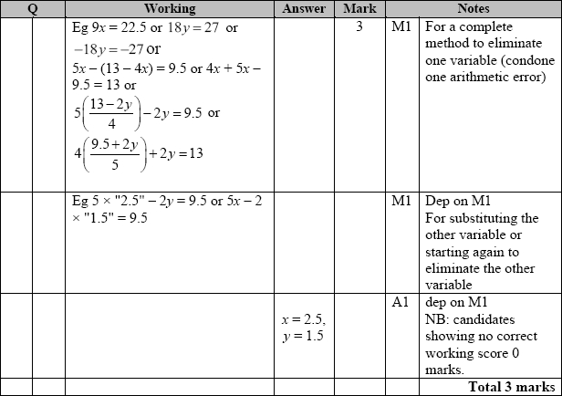

**Q12.**

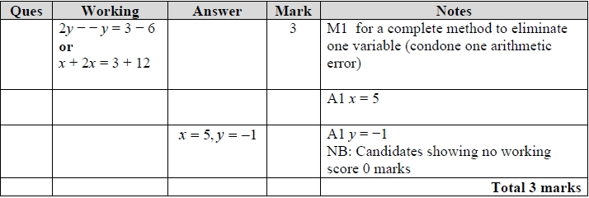

**Q13.**

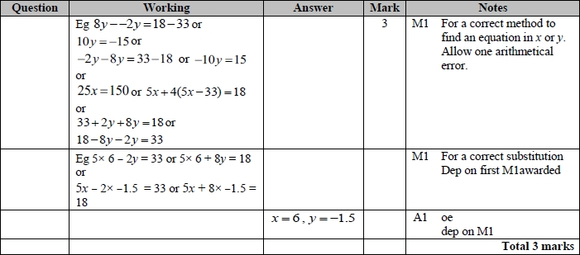

**Q14.**

