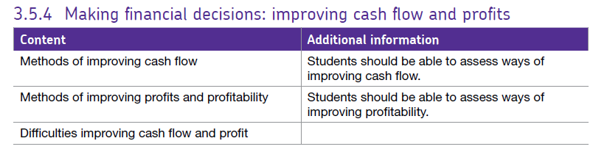3.5.4 – improving cash flow, and profits.

# Causes of cash flow problems and difficulties of managing cash flow

Producing a cash flow forecast is essential if a business is to identify when the business is likely to experience cash flow problems. In order to solve cash flow problems, the business must establish the cause of the difficulty. Causes include:

1. **Overtrading**

This occurs when a business expands quickly without organising funds to finance the expansion. Rapid growth normally involves paying for labour and raw materials over several months before receiving payment for the final product.

1. **Allowing too much trade credit**

Most businesses which sell to other businesses (B2B) provide **trade credit** of between 30 to 90 days. This will allow businesses to attract customers and in fact favourable credit terms can be a strong USP. However, if the credit terms are too generous, it may lead to cash flow difficulties as cash inflows are delayed.

1. **Poor credit control**

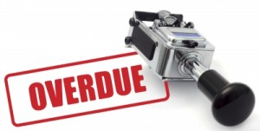Most large businesses have a **credit control department** which monitor and chase up outstanding payments. The department will carry out **credit checks** to ensure customers have a good credit history before they are offered trade credit. However, if any aspect of credit control is inefficient, cash inflows may be delayed and customer pay late or not at all, this is known as a **bad debt**.

1. **Inaccurate cash flow forecasting**

A cash flow forecast is only as good as the data upon which it is based. Inaccurate forecasting may occur because of the inexperience of managers or due to an unforeseen costs increase e.g. the price of fuel for a delivery firm. The business may also over predict expected revenues. If unexpected events do occur, the firm has to assess the significance of the events e.g:

* It might be a one off occurrence which will not happen again.
* It could be due to seasonal variations such as high levels of sales over Christmas or over the summer.
* It could be part of a worrying trend – there will be cash flow issues if sales are either falling or rising steadily.

1. **Seasonal demand**

The demand for some products or services may be seasonal. If this is the case, a business will often have to build up their inventory (stock) off season in preparation for their busy period. This will certainly represent a drain to cash since costs will by high but sales will be low. It may be difficult to improve cash flow in these situations but seasonality is known in advance and therefore it might easier to negotiate a bank overdraft in such cases.

1. **Losses or low profits**

It is important to understand that cash and profit are different but they are connected. If a business fails to cover its costs in a given time period, it is highly likely to experience cash flow problems too. Additionally, investors and banks will be less likely to supply funds if the business is unable to demonstrate that it is profitable.

# Methods of improving cash flow

Once a cash flow problem is identified, solutions must be identified, these might include:

1. **Improving working capital**

Working capital is simply the finance necessary to pay for the day to day activities of the business. It is used to pay wages, raw materials and fuel etc. The **Working Capital Cycle** as shown below is similar to that of most businesses.

The working capital cycle must be managed efficiently as there might be time lags or delays between outflows and inflows. This could be done through:

1. **Negotiate improved terms for credit**

Most firms receive between 30 and 60 days credit from their supplier. If the business can persuade their suppliers to lengthen the trade credit period, it will improve the cash flow position.

1. **Offer less trade credit**

Similarly, a business can offer its customers less favourable credit terms. For example, the business could now request that all customers pay within 30 days instead of the 60 days previously offered. However, this action must be taken with caution as customers may take their business elsewhere.

1. **Debt factoring**

This is a service offered by banks and other financial institutions. If the business has sent invoices to customers and they remain unpaid, they can ‘sell’ on these invoices to gain cash *immediately*. The debt factor will take on the debt and charge up to 5% of the value of the invoice to cover their costs. Many businesses find that the advantage of debt factoring outweighs the disadvantage and can help the business avoid cash flow problems. In addition, the business will save time in not having to chase up late payers.

1. **Overdrafts**

The majority of businesses have an agreed overdraft with their bank. An overdraft allows a business to go overdrawn on its account up to an agreed limit. Interest is paid when the account is overdrawn but interest charges stop when the account goes in to positive figures again. An overdraft is flexible since it is there as and when the business needs it. However, an overdraft can be quite expensive, especially if the overdraft goes above the agreed limit. Also, the overdraft is **instantly recallable** which means that if the bank has reason to believe the business is in some financial difficulty, it can instantly demand the entire overdraft be repaid in full.

1. **Improve credit control**

If the business has a credit control department, it must ensure that it functions efficiently. Outstanding debts must be chased up and credit checks must be carried out on prospective customers before credit is offered. Incentives such as discounts could also be offered for early payment.

1. **Short term loans**

As an alternative to an overdraft, the business may take out a short term loan (repayable with interest within the year). Sometimes the interest rates on a short term loan is lower than the interest which is payable with an overdraft. However, the monthly repayment of loans with interest will be an outflow of cash to the business and will add to fixed costs.

1. **Sale of assets**

The business may have assets (things the business owns which have value) which it can sell to provide an injection of cash into the business. Examples of such assets include machinery, land and buildings. The only downside here is that assets can only be sold once.

1. **Sale and lease back**

In this case, the business may sell assets to a leasing company and then lease them back for a monthly charge. This is ideal if the company has assets to sell but wishes to continue using them after the sale. However, the monthly lease charges will represent an outflow of cash in the business and this will add to fixed costs.

1. **Inventory Management**

Having money tied up in stock can be expensive so efficient management of all elements of stock is essential. For example, the business must ensure that orders of raw materials are carefully managed so that the business does not suffer from ‘stock out’ resulting in disappointed customers and lost orders. Conversely, the business must avoid a situation of having too much stock.

Stock is expensive to store and some forms of stock are perishable such as foodstuffs which must be kept in controlled conditions. Also, some stock may become outdated or customer tastes and preferences might change and the business may be left with stock which they are unable to sell.

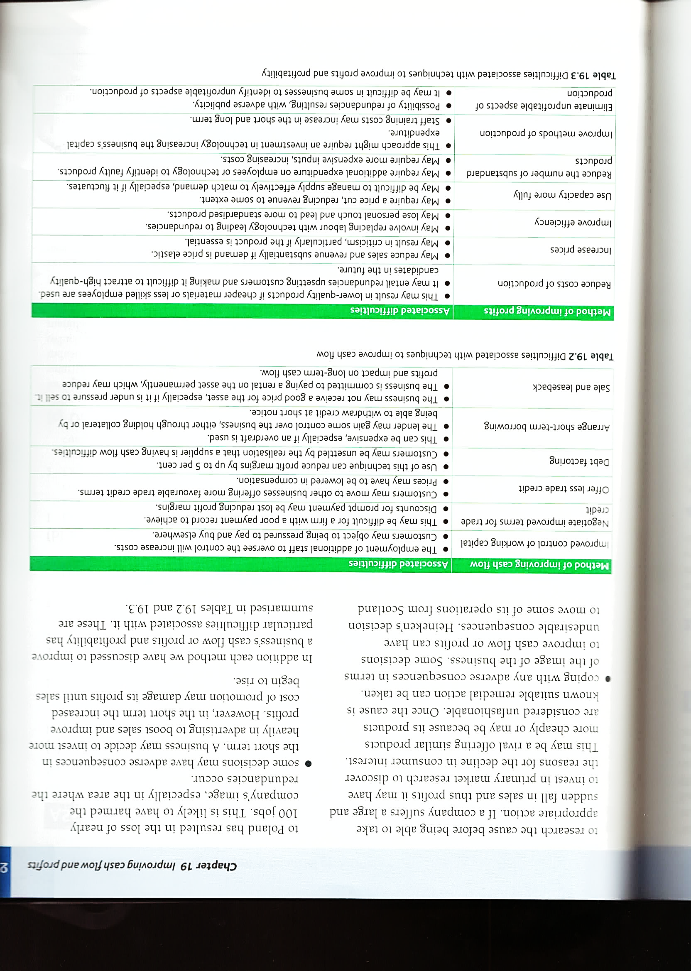There are several drawbacks associated with the methods of improving cash flow and some of these are shown in the table below:

## The benefits of good cash flow management

A business can benefit in a number of ways from good cash flow management. Benefits include:

* It limits the possibility of bankruptcy from liquidity problems (liquidity is another term for cash).
* If the business can manage working capital effectively and take appropriate action, it may not need to resort to external sources of finance such as loans and overdrafts. This will reduce interest charges which in turn will reduce the fixed costs facing the business leading to higher profits.
* If cash is managed well, the business is more likely to pay suppliers on time. Prompt payment will result in a good working relationship with suppliers and the possibility of extended credit terms and discounts in the future.
* A business experiencing cash flow problems may encounter public image difficulties. For example, customers fearing the collapse of the company will be reluctant to place orders. Suppliers will be reluctant to allow credit and the bank may instantly recall overdrafts. Good cash flow management will avoid all of these difficulties.

# Profits and profitability

It is important here that you understand the difference between profits and profitability. **Profit** is the amount the business has left over from sales revenue once all costs have been deducted.

However, **profitability** is a measure of the financial performance that compares a business’s profits to some other factor such as revenue. For example, what percentage of sales revenue can be regarded as profit? This can be done using ratios such as the Gross Profit Margin or the Operating Profit Margin.

## Improving profits

Many businesses will cite profit maximisation as their main objective. There are a number of methods which can be used to achieve this objective. These are:

1. **Reduced costs of production**

This is perhaps an obvious starting point when increasing profits. If a business can maintain prices while also reducing costs, then profit margins will increase. For example, a business could seek cheaper raw materials but they may also compromise the quality of the finished product if the cheaper raw materials are inferior and fail to meet customer expectations. Or a business could seek to limit wage costs by moving production overseas (off-shoring) or outsourcing the labour intensive aspects of production to a low wage economy. However, making workers redundant may result in bad publicity for the company which could damage the brand.

1. 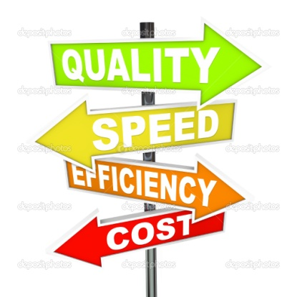**Improving business efficiency**

Essentially, efficiency is when the business achieves maximum output at minimum cost. Many businesses are now adopting flexible working contracts such as zero hour contracts in an effort to ensure only the correct amount of staff are employed at any one time.

1. **Use capacity more fully**

This point relates to that made above. A business’s capacity is the maximum amount that it can produce at any one time. If the capacity is fully utilised, then the fixed costs are spread across more units of output resulting in lower average costs. If prices remain unchanged, then a reduction in average costs will result in an increase in the profit margin and profit.

1. **Improve the quality of goods in production and reduced wastage**

If goods produced on the production line are of an inferior quality and are rejected, time will need to be spent on either reworking them or scrapping them and starting again. Either way, this is a waste of time and resources which will result in an increase in costs and a drain to profits. It is it is better to achieve the desired quality required in production consistently and this might require additional staff training on quality control methods.

1. **Improved methods of production**

Up to date and efficient technology is more productive than using out-dated equipment.

1. **Eliminating unprofitable aspects of the business**

This might entail selling off the less profitable elements of the business and downsizing. The business can then focus on the more profitable elements which remain.

1. **Improve motivation in the workplace**

Motivated employees are generally more productive and are less likely to take time off work. Overall, this will result in a reduction in costs and an increase in profits.

1. **Sell more products**

If the business sells more products while leaving the price unchanged, then profits will increase. An increase in sales could be achieved by a new marketing campaign for example. However, the ability to sell more also depends on external factors such as consumer income, the size of the market, market share and on competitor reaction to a marketing campaign.

1. **Increased selling price**

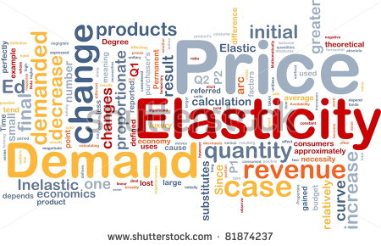This is another obvious option to increase profits. An increase in selling price will represent a boost to sales revenue and if average costs do not increase, then an increase in profits will result. However, there are risks involved in this strategy. For example, if the product or service is **price elastic** then an increase in selling price will result in an even greater decrease in the quantity demanded by consumers. If this is the case, then an increase in selling price will result in a reduction in profit.