**Comparing the Advantages and Disadvantages of Microscopes**

Below is a table that shows the differences between light microscopes (the ones we have in school) and electron microscopes.

|  |  |
| --- | --- |
| **Light Microscope** | **Electron microscope** |
| used for hundreds of years | very recently invented |
| uses light rays which pass through the specimen | uses electron beams of high energy |
| specimen can be living | specimen is dead |
| Up to 1000-2000x magnification | Up to 2,000,000x magnification |
| not possible to see internal structures inside the cytoplasm | internal structures inside the cytoplasm are possible to see |
| quite cheap | very expensive |
| anyone can use this and observe images | highly trained scientists needed to operate and analyse results |
| not much space needed | lots of space required |
| 2D image only | 3D image can be produced |
| not possible to get better magnification with this technology | technology can be improved over time |

1. Explain why we need to use microscopes to view cells?
2. Which microscope is more expensive?
3. What is the magnification on an electron microscope?
4. What is the magnification on a light microscope?
5. Which microscope can observe living specimens?
6. Which microscope can be used to observe mitochondria?
7. Which microscope could you use to observe an onion cell?
8. Which microscope produces a detailed 3D image?
9. What part of a light microscope would you use to make an image bigger?
10. What part of a light microscope would you use to make an image clearer?
11. Why could you not use an electron microscope to observe an embryo for implantation?
12. A picture containing keyboard

    Description automatically generated Which microscope has produced the image? Explain how you know.
13. 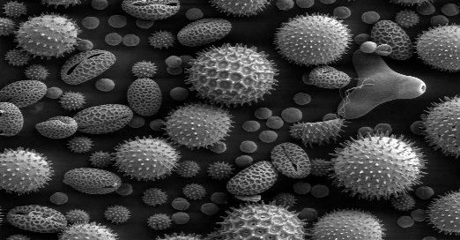 Which microscope has produced the image? Explain how you know.
14. Complete the table

|  |  |  |
| --- | --- | --- |
|  | Advantages | Disadvantages |
| Light |  |  |
| Electron |  |  |

1. Suggest how the development of electron microscopes has contributed to science.
2. A student says:

“In school we use electron microscopes because they are less expensive and smaller.”

1. Is this student correct?
2. Explain why electron microscopes are not commonly found in school labs but light microscopes are.