

**Higher IGCSE (9 – 1) Revision Pack**

**Probability Part one**

**Name --------------------------------**

**Questions**

**Q1.**

Joaquim takes part in two cycle races.

The probability that he wins the first race is 0.6   
The probability that he wins the second race is 0.7

(a)  Complete the probability tree diagram.

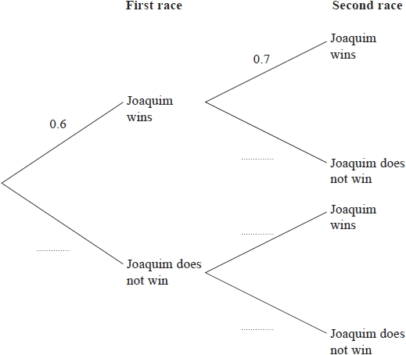

**(2)**

(b)  Work out the probability that Joaquim wins both races.

...........................................................

**(2)**

Joaquim takes part in a third cycle race.   
The probability that Joaquim wins the third race is 0.2

(c)  Work out the probability that he wins exactly one of the three races.

...........................................................

**(3)**

**(Total for question = 7 marks)**

**Q2.**

In a bag there is a total of 20 coins.

10 coins are 20 cent coins  
6 coins are 10 cent coins  
4 coins are 5 cent coins

Emma takes at random two of the coins from the bag.

(a)  Complete the probability tree diagram.

**(2)**

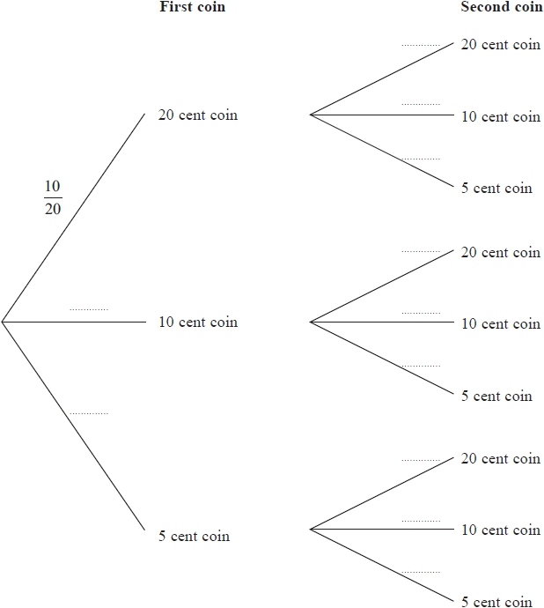

(b)  Work out the probability that Emma takes two 5 cent coins.

...........................................................

**(2)**

(c)  Work out the probability that the total value of the two coins is 20 cents or less.

...........................................................

**(3)**

**(Total for question = 7 marks)**

**Q3.**

Sarah has a biased 4-sided spinner.   
The spinner can land on 1, 2, 3 or 4

The probability that the spinner will land on 1, 2 or 4 is given in the table.

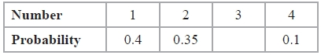

(a)   Work out the probability that the spinner will land on 3

...........................................................

**(2)**

Ryan is going to spin the spinner 80 times.

(b)   Work out an estimate for the number of times he should expect the spinner to land on 2

...........................................................

**(2)**

**(Total for Question is 4 marks)**

**Q4.**

Abid is waiting for a bus.  
 The probability that his bus will be early is 0.2  
 The probability that his bus will be on time is 0.7

Work out the probability that his bus will be either early or on time.

...........................................................

**(Total for question = 2 marks)**

**Q5.**

Morse Code uses dots () and dashes () to represent each letter of the alphabet.   
Here are 10 cards.   
Each card has the Morse Code for a letter on it.

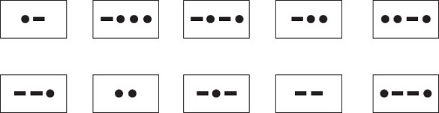

(a)  Kelly takes at random one of the cards.

Find the probability that she takes a card with 2 dots or a card with 3 dots.

...........................................................

**(2)**

(b)  Hashim has the 10 cards.   
He takes at random a card 200 times.   
He replaces the card each time.

Work out an estimate for the number of times he will take a card with exactly 2 dots.

...........................................................

**(2)**

(c)  Shani takes at random two of the 10 cards without replacement.

Calculate the probability that

(i)  there is exactly 1 dot on each card she takes,

...........................................................

(ii)  there is a total of 4 dots on the two cards she takes.

...........................................................

**(5)**

**(Total for Question is 9 marks)**

**Q6.**

Here are 8 dominoes.





The 8 dominoes are put in a bag.

Riaz takes at random a domino from the bag.

(a) Find the probability that he takes a domino with a total of 8 spots or a domino with   
a total of 9 spots.

...........................................................

**(2)**

Helima takes at random 2 dominoes from the bag of 8 dominoes without replacement.

(b) Work out the probability that

(i) the total number of spots on the two dominoes is 18

...........................................................

(ii) the total number of spots on the two dominoes is 17

...........................................................

**(5)**

**(Total for question is 7 marks)**

**Q7.**

There are 52 cards in a pack.   
12 cards are picture cards.   
40 cards are number cards.

Melina takes at random a card from the pack.   
She keeps the card and then takes at random a second card from the remainder of the pack.

(a)  Complete the probability tree diagram.

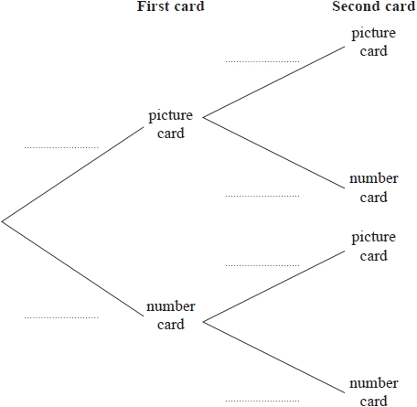

**(3)**

(b)  Work out the probability that the two cards Melina takes are both picture cards or both number cards.

...........................................................

**(3)**

**(Total for question = 6 marks)**

**Q8.**

Hugo competes in the high jump at a school athletics competition.   
He has up to 3 attempts to clear the bar at each height.   
When he clears the bar, he does not have another attempt at that height.

When the bar is set at a height of 1.60 metres, the probability that Hugo will clear the bar on any attempt is 0.4   
The probability tree diagram shows the possible outcomes of Hugo's attempts at 1.60 metres.

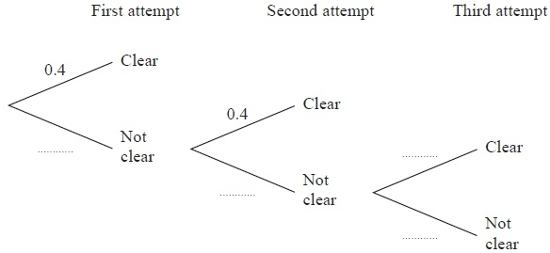

(a)  Complete the probability tree diagram to show the four missing probabilities.

**(1)**

(b)  Work out the probability that Hugo does not clear the bar on his first two attempts and then does clear the bar on his third attempt at 1.60 metres.

...........................................................

**(2)**

Hugo clears the bar at 1.60 metres and the height is raised to 1.65 metres.   
He has up to three attempts to clear the bar at 1.65 metres.

When the bar is set at a height of 1.65 metres, the probability that Hugo will clear the bar on any attempt is 0.3

(c)  Find the probability that Hugo clears the bar at 1.65 metres.

...........................................................

**(3)**

**(Total for Question is 6 marks)**

**Q9.**

Here are seven counters. Each counter has a number on it.

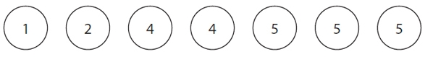

Ali puts the seven counters in a bag.  
 He takes, at random, a counter from the bag and does not replace the counter.  
 He then takes, at random, a second counter from the bag.

Calculate the probability that

(i) the number on the second counter is 2 more than the number on the first counter,

...........................................................

(ii) the number on the second counter is 1 more than the number on the first counter.

...........................................................

**(Total for question = 5 marks)**

**Q10.**

There are 9 red counters and 11 blue counters in a bag.   
There are no other counters in the bag.

Emeka takes at random a counter from the bag and writes down the colour of the counter.   
He puts the counter back in the bag.   
Natasha takes at random a counter from the bag and writes down the colour of the counter.

(a)  Complete the probability tree diagram.

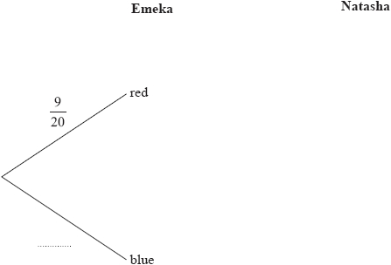

**(2)**

(b)  Work out the probability that Emeka takes a red counter from the bag and Natasha takes a blue counter from the bag.

...........................................................

**(2)**

(c)  Work out the probability that both counters taken from the bag are the same colour.

...........................................................

**(3)**

**(Total for question = 7 marks)**

**Q11.**

Leonidas has a fair dice.

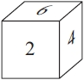

He throws the dice twice.

(a)  Work out the probability that he gets the number 5 both times.

...........................................................

**(2)**

Alicia has a fair dice.

She throws the dice 3 times.

(b)  Work out the probability that she gets the number 5 exactly once.

...........................................................

**(3)**

**(Total for question = 5 marks)**

**Q12.**

Maria has two bags.   
In bag A, there are 5 white counters and 2 red counters.   
In bag B, there are 3 white counters and 2 red counters.

Maria is going to take at random one counter from bag A and one counter from bag B.

(a)   Complete the probability tree diagram.

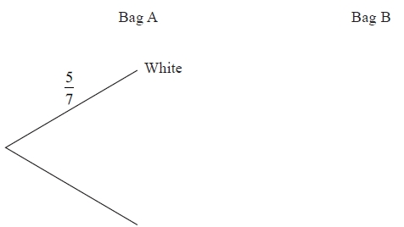

**(2)**

(b)   Work out the probability that both counters will be white.

...........................................................

**(2)**

(c)   Work out the probability that exactly one of the counters will be white.

...........................................................

**(3)**

**(Total for Question is 7 marks)**

**Q13.**

A bag contains *x* counters.  
 7 of the counters are blue.  
 Sam takes at random a counter from the bag and does not replace it.  
 Jill then takes a counter from the bag.  
 The probability they both take a blue counter is 0.2

(a) Form an equation involving *x*.  
  
Show that your equation can be expressed as *x*2 − *x* − 210 = 0

**(2)**

Calculate the value of *x*.

*x* = ...........................................................

**(3)**

**(Total for question = 5 marks)**

**Q14.**

Amberish plays two games of tennis.

Each time he plays a game of tennis, the probability that he will win is 2⁄7

(a)   Complete the probability tree diagram.

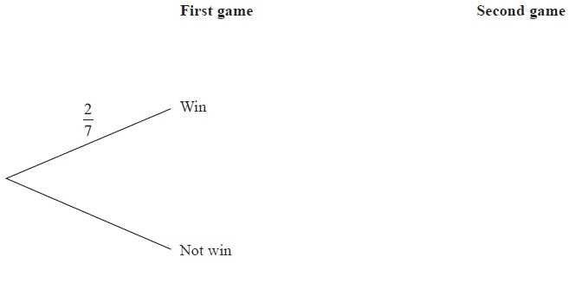

**(3)**

(b)   Calculate the probability that Amberish wins at least one of the two games of tennis.

...........................................................

**(3)**

**(Total for Question is 6 marks)**

**Q15.**

A bag contains 60 beads.   
*x* of the beads are red and the rest are green.   
Altaaf takes at random a bead from the bag.

(a) State, in terms of *x*, the probability that Altaaf takes a red bead.

...........................................................

**(1)**

Altaaf puts his bead back in the bag.   
Another 20 **red** beads are added to those in the bag.   
The probability that Altaaf takes a red bead is now doubled.

(b) (i) Use this information to write down an equation in *x*  
and show that your equation can be expressed as 8*x* = 3(*x* + 20)

(ii) Solve 8*x* = 3(*x* + 20)   
Show your working clearly.

*x* = ...........................................................

**(5)**

**(Total for question is 6 marks)**

**Q16.**

Sophie takes an examination.   
If she fails the examination, she will resit.

The probability that Sophie passes the examination on her first attempt is 0.7   
If she fails the examination on any attempt, the probability she passes on the next attempt is 0.9

Work out the probability that Sophie takes at most 2 attempts to pass the examination.

...........................................................

**(Total for question = 3 marks)**

**Q17.**

There are 6 milk chocolates and 4 plain chocolates in a box.   
Rob takes at random a chocolate from the box and eats it.   
Then Alison takes at random a chocolate from the box and eats it.

(a)  Complete the probability tree diagram.

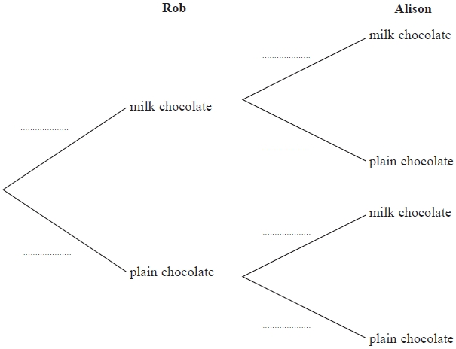

**(3)**

(b)  Work out the probability that there are now exactly 3 plain chocolates in the box.

...........................................................

**(3)**

**(Total for question = 6 marks)**

**Q18.**

The probability that it will rain on Saturday is 0.8

If it rains on Saturday, the probability that it will rain on Sunday is 0.65   
If it does not rain on Saturday, the probability that it will rain on Sunday is 0.4

(a)  Use this information to complete the probability tree diagram.

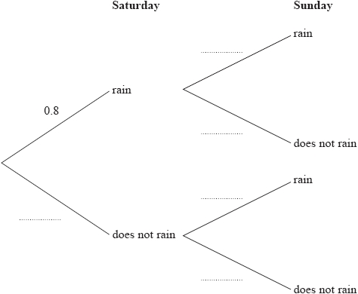

**(2)**

(b)  Work out the probability that it will rain on just one of these two days.

...........................................................

**(3)**

**(Total for question = 5 marks)**

**End of questions**