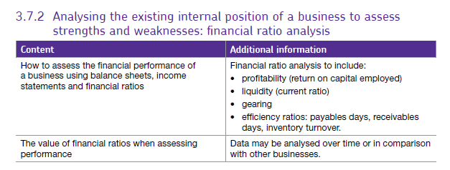3.7.2 Financial documents.

Table of Contents

1. Balance sheets 2

What’s on the balance sheet? 2

The top half 3

The bottom half 4

Net current assets / Working capital: 4

Calculation of Working capital 4

Depreciation. 5

Window dressing 7

2. Income Statements 8

The types of cost are: 9

3. Interpreting Published Accounts - Ratio Analysis 10

3.1 Liquidity Ratios 11

Current ratio 11

How can a firm improve its liquidity? 11

3.2 Financial efficiency Ratios 11

Stock (aka inventory) turnover 11

Receivables (aka debtor) days 11

Creditor (aka Payables) days 12

3.3 Gearing ratio 12

Gearing ratio 12

3.4 Profitability and performance ratios 13

ROCE 13

Strengths and weaknesses of using financial data to assess performance. 14

**Financial documents** are produced by businesses each year to shown how much money they have made and how much the business is worth. Accountants and managers can then look at the documents to find trends and look for future problems, potential new investors might also like to look at the information to decide whether or not to invest.

# Balance sheets

These show what the firm owns and how much money it owes to other businesses e.g. suppliers or a bank. It is like a snapshot or photo of the company's financial situation at that moment in time. It is generally (but not always) published at the end of the financial year – often March 31st.

## What’s on the balance sheet?

Items on the sheet fall into the following 3 groups;

1. Assets

* non-current (fixed) – their value is relatively stable over time - tangible goods e.g. machinery
* current - values vary frequently - can be intangible e.g. receivables are not a physical item they are money owed to the business and have a value. The **CURRENT ASSETS** of a business are its **Stock, Receivables and Cash** at the bank. The current assets are therefore ones that can be quickly converted to money; the values of these assets will change frequently.

**Receivables** are sometimes known as **debtors** – amounts which other firms need to pay to the business

1. Liabilities

A liability is money which a firm owes to a person or another firm. It may be in the form of creditors - who have sold goods to the business but which it has not yet paid for, or it may be money borrowed from a financial institution - loans or overdrafts.

* current: due to be paid in less than 1 year -

e.g. suppliers, dividends to be paid to shareholders, lease payments, overdraft payments, interest payments on loans or loan repayments due.

* non-current (long-term) not due to be paid within the next 12 months. This can include a mortgage or long-term loan repayments

**nb payables** are sometimes known as **trade creditors** – money which other businesses are waiting to receive from the firm.

1. Capital

This is the money invested in the business (equity) plus the value of shares, holdings in other firms and retained profit.

**The Balance sheet is described as being in two halves**

* the **top half** shows where the money is currently being used in the business (the net assets)
* the **bottom half** shows where that money came from (the capital or total equity).

The value of the two halves must be the same i.e.

Assets + (Liabilities) = Capital

Remember that liabilities are a negative figure…

The top half of the balance sheet therefore consists of an assessment of all the assets and liabilities of the firm to find the net value: the net assets.

**Net assets = Total assets – Total liabilities**

This is the value of everything the firm owns minus the value of money owed to other businesses.

It may look as shown below:

|  |  |  |
| --- | --- | --- |
|  | **£ Million** | |
| Non-current assets |  | 200 |
| Current assets stock | 40 |  |
| receivables | 50 |  |
| cash | 20 |  |
| TOTAL current assets |  | 110 |
| Total assets |  | 310 |
| Current liabilities  **Net current assets** (aka Working capital)  = **current assets – current liabilities** | (40) | 70 |
| Total assets – current liabilities | 270 |  |
| Non-current liabilities | (50) |  |
| **Net Assets = (total assets – total liabilities)** |  | **220** |

The bottom half of the balance sheet then shows where this money came from.

The main source of money for a limited company starting up is the issue of shares (**share capital** - the money the original shareholders put into the business). Financial assets are then built up by ploughing **retained profit** back into the business - the other source of money usually included in the bottom half of the balance sheet.

This may therefore look as follows:

|  |  |  |
| --- | --- | --- |
| **Equity:** | **£ million** | **£ million** |
| Share capital | 180 |  |
| Retained profit | 40 |  |
| **Total equity** |  | **220** |

## Net current assets / Working capital:

Working capital tells us how much money the firm has to trade with on a day-to-day basis. All firms need cash to pay for all their day-to-day activities; they have to pay wages, raw materials, electricity, consumables (e.g. printer ink).

Main sources of working capital are the current assets (short-term assets that the firm can use to generate cash quickly), but current liabilities must be taken account of when working out how much working capital a firm has.

## Calculation of Working capital

**Working capital (or Net current assets) =**

Current Assets **(***stock* + *receivables* + *cash***)**  **-** Current liabilities (due within 1 year)

Significance of working capital:

* Firms need funds available to pay their day-to-day bills, wages and so on.
* It is important to manage working capital carefully especially where there is a substantial time lag between making the product and receiving the money for it. In this situation the company has paid out all the costs associated with making the product (labour, raw materials and so on) but not yet got any money for it. They must therefore ensure they have enough cash to do this.
* Sometimes businesses go bankrupt, not because they are unprofitable, but because they had a shortage of working capital. Controlling inventories and receivables are vital here.
* Stock valuations for working capital assume that the firm will only get the minimum stock value if it has to sell it on and also takes account of the fact that some stock may be un-sellable (**net realisable value**).

## Depreciation.

This refers to the value which a fixed asset “loses” over a period of time. E.g. a company van used for deliveries, purchased for £15,000 may only be worth £6000 after a couple of years. Any fixed asset will have some form of depreciation and this needs to be shown in the Balance sheet.

At the end of each year the depreciation and the **Net Book Value** (what the item is now worth) are both shown in the accounts. *The value of the asset decreases each year so the asset value is lowered and the depreciation for that year is shown under current liabilities.*

Eventually the goods will be completely written off – no longer show any net book value. In the Income Statement this is shown as a **provision** – it is not an expense as nothing has been bought.

## The usefulness of the balance sheet to decision making.

The information found on the Balance sheet is useful to

* Compare different firms of the same size in the same industry
* Compare different parts of the same firm e.g. in Tesco there are many divisions, Tesco will have data on each area and be able to compare them with each other <http://www.tescoplc.com/index.asp?pageid=276> This information is all internal to the firm as only the group results are published.
* Trend analysis to establish patterns of trade which are emerging and pinpoint problems quickly.

The data in the balance sheet will help the firm with decision making because they will have relevant and accurate information about the firm’s finances – what they can afford to do.

In terms of strategic decision making, the data will help them with:

Acquisitions - they will need to decide if they can afford to buy another company – if they need to raise finance they will look at different options for this such as share issue, long-term borrowing etc.

Investment – to assess whether one investment is better than another on financial grounds e.g. to expand production facilities themselves or to buy another smaller firm and utilise their facilities.

Functional strategy and corporate strategy – what can the business afford to do e.g. can they afford to move into an overseas market. <http://www.bbc.co.uk/news/business-24040346>

Product portfolio decisions: continual assessment of the profitability of different parts of the product range to ensure they are still viable or to assess future strategy. Companies will use financial data to build a picture of the product lifecycle and make decisions about the future of specific products.

## Assessing the strengths and weaknesses of the balance sheet.

Financial data on its own is meaningless; it must always be viewed in the context of the firm’s circumstances.

Factors which may affect a firm’s financial performance might include:

* Economic climate
* New / strengthening competition
* Supplier / production / quality issues
* A change in the company’s objectives (Greggs)
* Withdrawal from a market (Tesco Fresh and easy)

## Window dressing

This refers to the fact that firms can manipulate the figures to make the accounts look better than they are.

For example

* they may produce the Balance sheet immediately before taking a large loan – which will make their liabilities look less than they are,
* they may under or over value non-current assets to make their assets appear to be more valuable than they are by using different methods of calculating depreciation.

Window dressing is legal and there are notes which are produced with the accounts which explain how the figures have been calculated.

# Income Statements

An income statement shows a firm’s turnover, costs and profit made in the last accounting period. There are different types of costs and profits shown so the firm can assess any changes and identify which types of cost are increasing and may need to be monitored or better controlled. The types of profit are:

1. **Gross profit** is the profit made after the cost of sales have been deducted from turnover:

Gross Profit = Sales Revenue – Cost of Sales

1. **Operating profit** is the profit made after administration and distribution costs (expenses / fixed costs) have been deducted from gross profit

Operating Profit = Gross Profit – admin / distribution costs and any exceptional costs

1. **Net profit before tax** is the profit left after all expenses have been paid excluding tax.

Net profit before tax Operating Profit – finance expenses e.g. interest on bank loans

1. **Profit for the year** (**net profit after tax**) is the profit the firm has left after tax has been corporation deducted.

Profit for the year = Profit before tax - tax

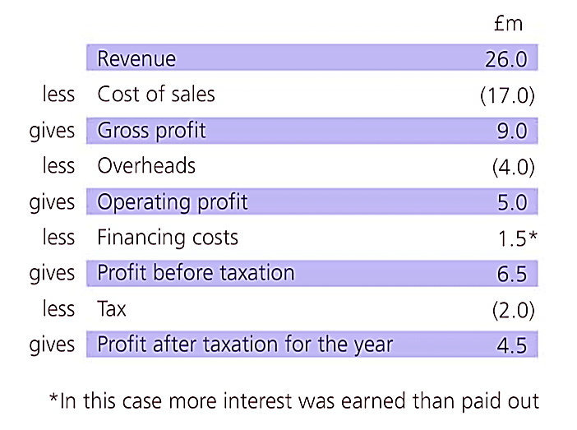

Some of this profit may then be distributed to shareholders in the form of dividends leaving **retained profit**.

These relationships are shown here:

## The types of cost are:

1. **Cost of sales** – these are the direct costs of producing the product / providing the service – the variable costs.
2. **Administration, distribution costs and overheads**
3. **Exceptional costs** (extraordinary items) these are one-off costs which the business has to allow for e.g. If there is a bad debt which they write off because a major customer goes bankrupt or if they want to restructure the firm and have to budget additional funds for that in a particular year.
4. **Finance costs** – if the business has loans on which it is paying interest

A business can also have **Finance income –** obviously this is not a cost it can also be seen here (e.g. if the business has a large amount of money in the bank and receives interest

1. **Taxation**

The Income Statement also sometimes includes an **appropriation account** – this shows where the company profits have been distributed to e.g. how much was paid as dividends, some may be paid to a parent company etc.

**Profit quality.**

Profit quality refers mainly to whether or not the firm’s profit is sustainable into the future or whether it is as a result of a particular action by the business.

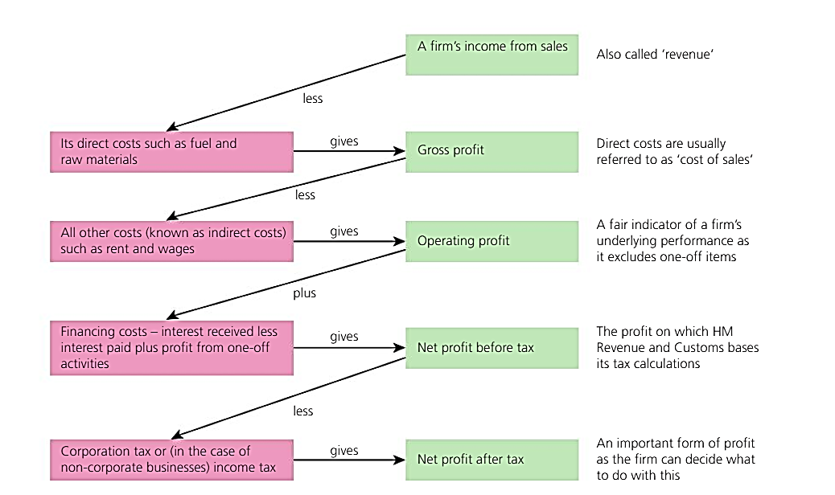For example, if the business sells off several branches or land which it no longer intends to use, this will affect profits and make the firm look more profitable than it is in reality. This one-off boost in profits would be seen as low quality profit as it isn’t sustainable.

# Interpreting Published Accounts - Ratio Analysis

There are a number of different types of ratio:

* Liquidity ratios – can the firm pay its debts – does it have enough cash to do business?
* Financial efficiency ratios – how hard is the firm’s money working?
* Profitability / performance ratios – how much money is the firm making / losing

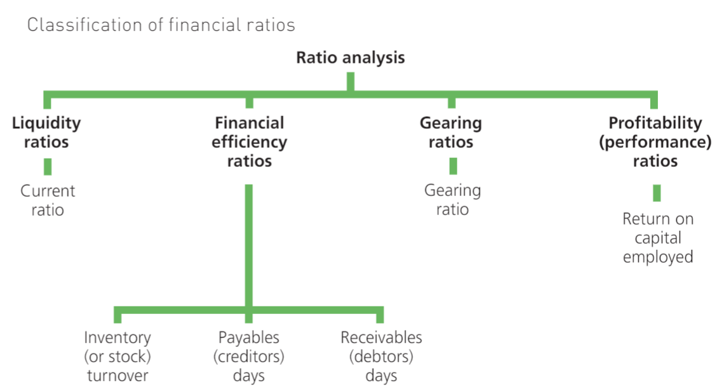

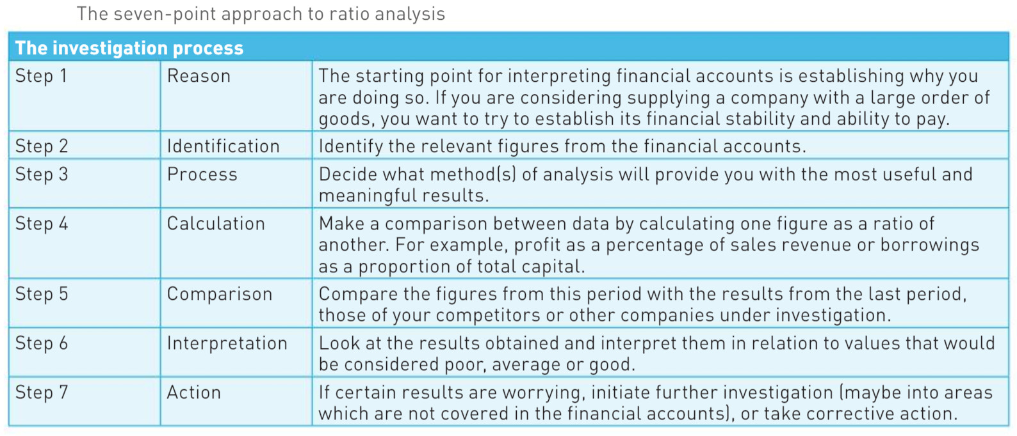**When analysing financial information there are several factors to consider:**

3.1 Liquidity Ratios - refers to the ease with which the firm could pay all its debts if it had to…

The current ratio is the measure of whether or not the firm can pay back its debts. The current ratio measures current assets against current liabilities i.e. if the creditors called in their debts tomorrow, could the firm pay them off?

Current ratio: = Current assets

Current liabilities

### How can a firm improve its liquidity?

* By making sure they are not holding too much stock or holding it for a long period.
* By ensuring that receivables pay on time
* Ensuring they do not have creditors who they are not paying promptly
* Having a reasonable ‘nest-egg’ of cash at the bank.

### What may be the pitfalls?

* Firms can get into trouble quickly of one large debt is called in unexpectedly.
* Long term planning is essential.
* Firm may be too cautious and have money ‘sat around’ not earning anything.

## 3.2 Financial efficiency Ratios

Stock (aka inventory) turnover how many times in a trading year the firm sells the value of its stocks.

= Cost of Sales (in income statement)

Closing Stock (in balance sheet)

High stock turnover is better. This means that stock is being used productively and money is not being tied up unnecessarily. Profit is being returned more quickly. A lower ratio may show that stock is being ordered or used incorrectly or that sales are slowing. Stock which has been around for a while - **Aged stock** may become obsolete and depreciate – losing money.

### Receivables (aka debtor) days

How long it takes receivables to pay up.

= Receivables (debtors) *(on balance sheet)* x 365 (days)

Sales revenue *(in profit and loss account)*

Businesses do usually give credit of 30, 60, 90 or 120 days. Cash flow may be affected if money doesn’t come in within a certain time and firms offer incentives to encourage payment and disincentives to poor payment.

A firm will want to have as low a value as possible, meaning that receivables are paying promptly. Although the finance department will wish for prompt payment, the marketing department may want to offer generous credit facilities to attract customers. Retailers of furniture traditionally offer long credit terms, so high receivables days may be a feature of that trade. Car manufacturers provide garages with credit to encourage them to display a wide range of stocks, leading to high receivables days.

Sometimes debts go on indefinitely and become **aged debtors**; firms must then either take customers to court or look at debt factoring. They should be monitored as a % of total receivables.

### Creditor (aka Payables) days

How long it takes the firm to pay creditors

= Payables *(creditors from balance sheet)* x 365 days (*to work out total days of credit)*

Cost of sales

Businesses sometimes want longer credit periods to help with cash flow esp. if they are a smaller firm. Firms that receive long-term credit from their suppliers may expect a high figure for payables days, but companies that pay suppliers in cash will have a low figure. In general terms, a firm will want to have as high a value as possible, meaning that payables are not being paid quickly. In effect, this means that the business is holding another organisation’s money. However, if a business has a high payables days figure because it has not paid a debt on time, this would not be a good sign.

## 3.3 Gearing ratio

These look at the relationship between the money invested in the firm (capital or equity) and the money the firm has borrowed.

Gearing ratio = Non-current liabilities x 100

Capital employed (where this = total equity + non-current liabilities)

This tells us what % of the money in the firm is borrowed. A reasonable gearing ratio would be 30% to 40%. A figure in excess of 60% may cause worries in case debts are called in and this would be looked at in conjunction with the liquidity of the firm

Firms must also take account of the fact that they have to make regular payments on loans which will normally include interest and can end up costing a large amount. Creditors prefer lending to companies which are lowly geared as there is less risk involved. If the business starts to have financial difficulties, the banks will call in the money much more forcefully.

High gearing may be a good thing if the firm has an expanding market which is likely to continue – they can grow quickly and reap huge rewards by also paying off loans quickly and attracting more investment for private investors.

### Sources of finance and gearing.

Some banks will not lend to firms with high gearing and these companies will have to look at alternative sources of income for example private investors, Government grants etc.

## 3.4 Profitability and performance ratios

Some profit margin calculations are in year 1 and so this section focusses on the remaining profitability ratio - **Return on Capital Employed or ROCE**. This ratio shows the operating profit as a percentage of capital employed.

Operating profit is thought to be the best measure of performance as it focuses on the firm’s main trading activities. However, it is important to use the profit figures *before* tax has been deducted since tax rates vary between countries which would make international comparisons difficult. If financing income and financing costs are included, then the income statement will show operating profit and profit before tax (the latter is when the financing costs and financing income have been taken into account). In this case, use the profit before tax figure.

Capital employed is thought to be the best measure of a firm’s size, it is calculated as:

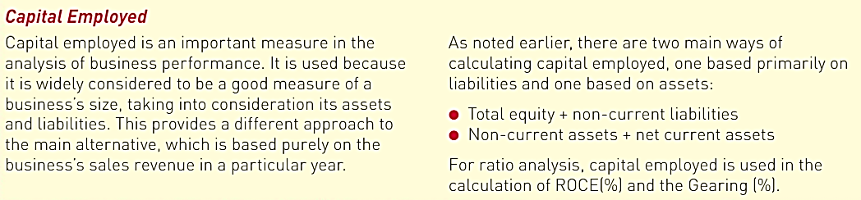**Capital employed = total equity + non-current liabilities**

ROCE = Operating profit *or* profit before tax x 100

Capital employed (Total equity + non-current liabilities)

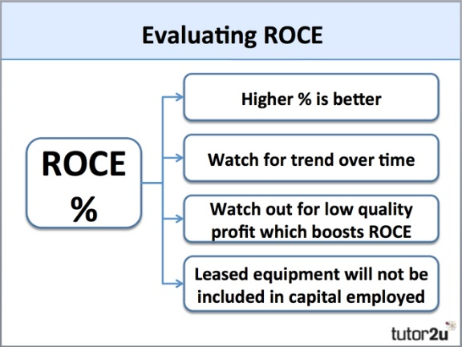

ROCE figures need to be looked at over time. Sometimes a firm may have its profitability worsened or improved by an exceptional item and these can make the figures appear much better or worse so it’s important to look at the information you have been given.

## Limitations upon use of ratios.

* Only show a fixed position
* Do not take account of external factors
* Can be misleading
* Don’t take account of inflation
* Don’t take account of any internal changes.
* Ratios over a period of time, problems of drawing solid conclusions from data.

Ratios are based on historic information. This means that by the time the reader sees it the situation may already have changed; investors may therefore worry unnecessarily – or be cheery when they should be worried…

## Strengths and weaknesses of using financial data to assess performance.

Key performance indicators such as profit margins and ROCE can give the firm an overall picture of their position but cannot be used in isolation.

If accounts are ‘window-dressed’ then the info will be distorted and qualitative factors must also be considered e.g. economic climate, supplier issues, competitor actions etc.

A significant weakness of ratio analysis is that it only considers the financial aspects of a business’s performance. While this is important, other elements of a business should be taken into account when evaluating performance.

* The market in which the business is trading. A business that is operating in a highly competitive market might experience relatively low profits, reducing the results of ratios such as the return on capital employed (ROCE).
* The position of the firm within the market. A market leader might be expected to provide better returns than a small firm struggling to establish itself. However, the small struggling firm may be investing heavily in developing new products and establishing a brand identity. The struggling firm may generate large profits in the future.
* The quality of the workforce and management team. These are important factors in assessing a business, but not ones that will be revealed directly through ratio analysis. Indeed, a business that invests heavily in its human resources may appear to be performing relatively poorly through the use of ratio analysis.
* The economic environment. In general, businesses might be expected to perform better during periods of prosperity and to produce better results from ratio analysis. As the UK economy has enjoyed strong rates of economic growth (over 2.5 per cent annually) since the start of 2014, it is reasonable to expect the financial performance of many (but not all) businesses to improve.