Remember with contingency tables, if it is only a 2 by 2 table you have to use Yates correction – you must memorise the formula, it is NOT in the formula book:

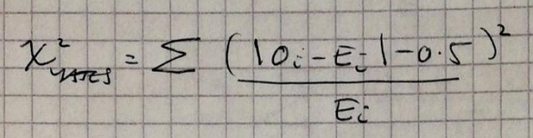

See eg 3.4 p 43

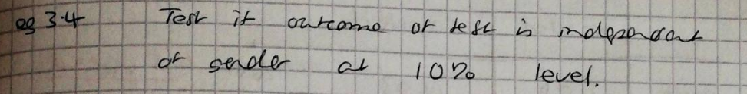

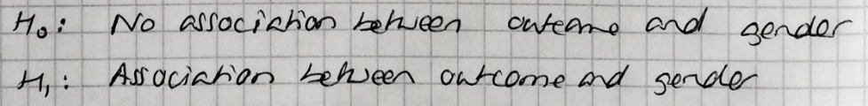

10% level, (ALWAYS 1-tail)

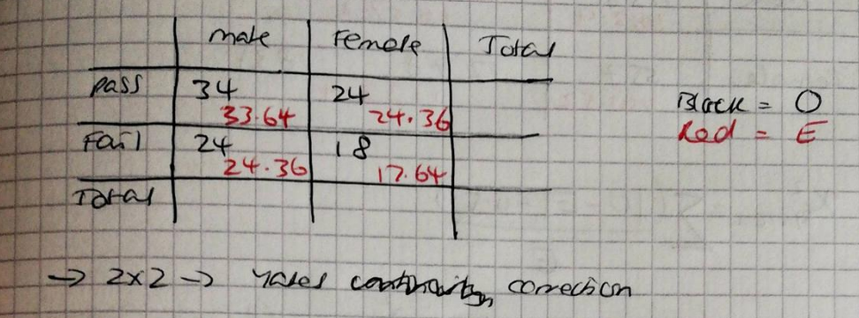

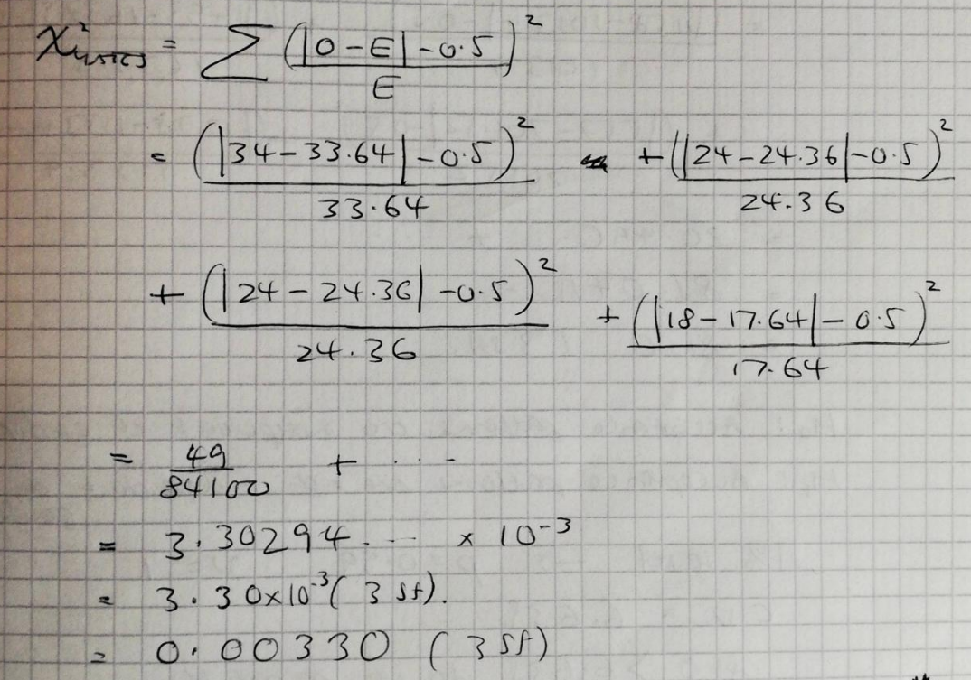

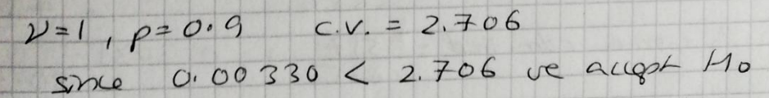

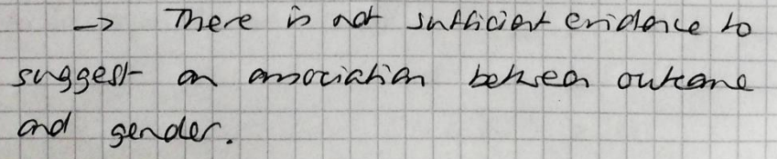

Further example showing giving a conclusion ‘in context’

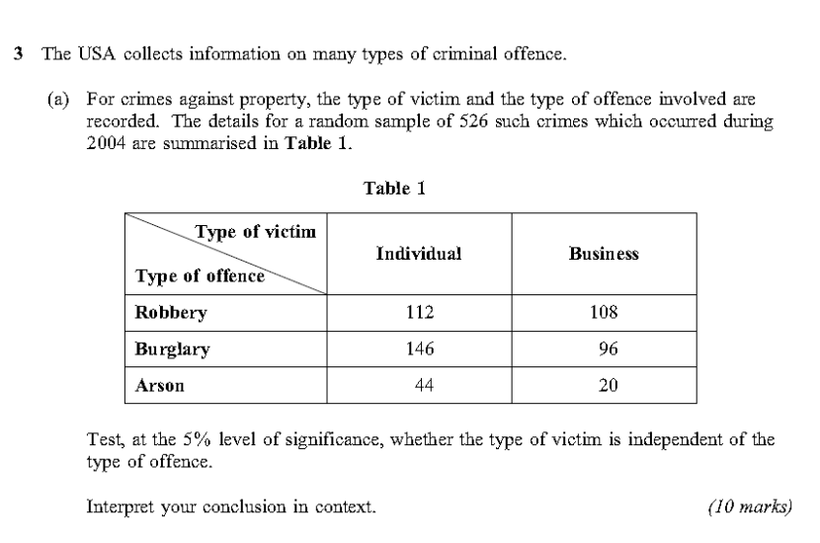

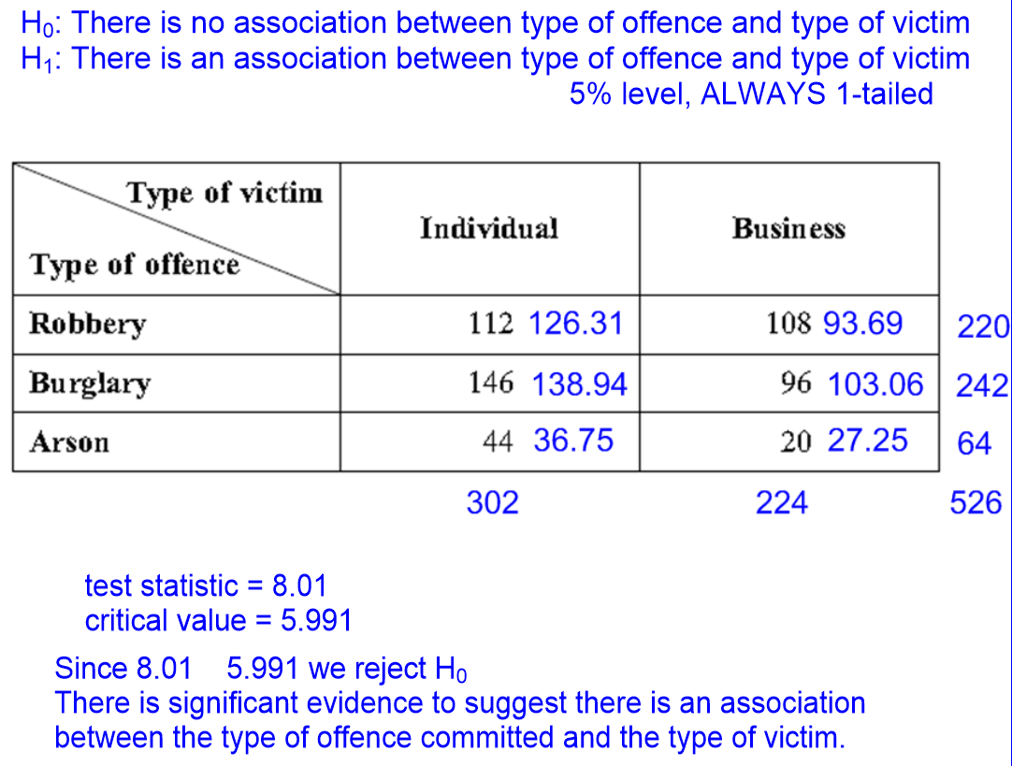

Less individuals than expected were affected by robbery but more were victims of burglary and arson.

More businesses than expected were hit by robbery, less than expected were affected by burglary or arson.