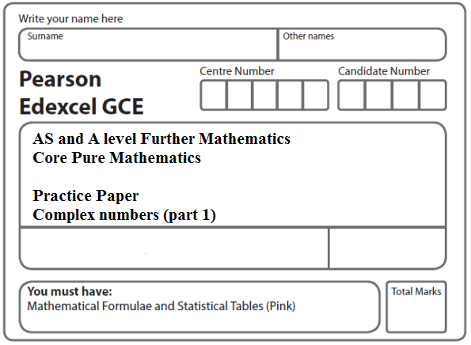

**Instructions**

* Use black ink or ball-point pen.
* If pencil is used for diagrams/sketches/graphs it must be dark (HB or B).
* Fill in the boxes at the top of this page with your name, centre number and candidate number.
* Answer all the questions and ensure that your answers to parts of questions are clearly labelled.
* Answer the questions in the spaces provided – there may be more space than you need.
* You should show sufficient working to make your methods clear. Answers without working may not gain full credit.
* Inexact answers should be given to three significant figures unless otherwise stated.

**Information**

* A booklet ‘Mathematical Formulae and Statistical Tables’ is provided.
* There are 15 questions in this question paper. The total mark for this paper is 100.
* The marks for each question are shown in brackets – use this as a guide as to how much time to spend on each question.
* Calculators must not be used for questions marked with a * sign.

**Advice**

• Read each question carefully before you start to answer it.

• Try to answer every question.

• Check your answers if you have time at the end.

• If you change your mind about an answer, cross it out and put your new answer and any working underneath.

**1.** f(*x*) = 9*x*3 – 33*x*2 – 55*x* – 25.

Given that *x* = 5 is a solution of the equation f(*x*) = 0, use an algebraic method to solve f(*x*) = 0 completely.

**(Total 5 marks)**

**___________________________________________________________________________**

**2.** f(*x*) = 2*x*3 – 6*x*2 – 7*x* − 4.

(*a*) Show that f(4) = 0.

**(1)**

(*b*) Use algebra to solve f(*x*) = 0 completely.

**(4)**

**(Total 5 marks)**

**___________________________________________________________________________**

**3*.***The roots of the equation

2*z*3 – 3*z*2 + 8*z* + 5 = 0

are *z*1, *z*2 and *z*3.

Given that *z*1 = 1 + 2i, find *z*2 and *z*3.

**(5)**

**(Total 5 marks)**

**___________________________________________________________________________**

**4.** The complex numbers *z*1 and *z*2 are given by

*z*1 = *p* + 2i and *z*2 = 1 – 2i

where *p* is an integer.

(*a*) Find  in the form *a* + *b*i where *a* and *b* are real. Give your answer in its simplest form in terms of *p*.

**(4)**

Given that ,

(*b*) find the possible values of *p*.

**(4)**

**(Total 8 marks)**

**___________________________________________________________________________**

**5.** The complex numbers *z* and *w* are given by

*z* = 8 + 3i, *w* = –2i

Express in the form *a* + *b*i, where *a* and *b* are real constants,

(*a*) *z* – *w*,

**(1)**

(*b*) *zw*.

**(2)**

**(Total 3 marks)**

**___________________________________________________________________________**

**6.** Given that  =1 − i,

(*a*) find arg ().

**(2)**

Given also that  = 3 + 4i, find, in the form *a* + i*b*, *a*, *b* ∈ ℝ,

(*b*) ,

**(2)**

(*c*) .

**(3)**

In part (*b*) and part (*c*) you must show all your working clearly.

**(Total 7 marks)**

**___________________________________________________________________________**

**7.** *z* = 5 – 3i, *w* = 2 + 2i

Express in the form *a + b*i, where *a* and *b* are real constants,

(*a*) *z*2,

**(2)**

(*b*) .

**(3)**

**(Total 5 marks)**

**___________________________________________________________________________**

**8.**  = − 2 + i

(*a*) Find the modulus of .

**(1)**

(*b*) Find, in radians, the argument of , giving your answer to 2 decimal places.

**(2)**

The solutions to the quadratic equation

*z*2 − 10*z* + 28 = 0

are and .

(*c*) Find and , giving your answers in the form *p* ± i√*q*, where *p* and *q* are integers.

**(3)**

(*d*) Show, on an Argand diagram, the points representing your complex numbers , and .

**(2)**

**(Total 8 marks)**

**___________________________________________________________________________**

**9.** *z* = .

Find, in the form a + i*b* where *a*, *b* ∈ ℝ,

(*a*) *z*,

**(2)**

(*b*) *z*2.

**(2)**

Find

(*c*) ⏐*z*⏐,

**(2)**

(*d*) arg *z*2, giving your answer in degrees to 1 decimal place.

**(2)**

**(Total 8 marks)**

**___________________________________________________________________________**

**10.** Given that 2 and 1 – 5i are roots of the equation

*x*3 + *px*2 + 30*x* + *q* = 0, *p*, *q* ∈ ℝ

(*a*) write down the third root of the equation.

**(1)**

(*b*) Find the value of *p* and the value of *q*.

**(5)**

(*c*) Show the three roots of this equation on a single Argand diagram.

**(2)**

**Total 8 marks)**

**___________________________________________________________________________**

**11.** Given that *x* =  is a root of the equation

2*x*3 – 9*x*2 + *kx* – 13 = 0, *k* ∈ ℝ

find

(*a*) the value of *k*,

**(3)**

(*b*) the other 2 roots of the equation.

**(4)**

**(Total 7 marks)**

**___________________________________________________________________________**

**12.** (i) The complex number *w* is given by



where *p* is a real constant.

(*a*)Express *w* in the form *a* + *b*i, where *a* and *b* are real constants.

Give your answer in its simplest form in terms of *p*.

**(3)**

Given that arg *w* = 

(*b*)find the value of *p*.

**(2)**

(ii) The complex number *z* is given by

*z* = (1 – 𝜆 i)(4 + 3i)

where 𝜆is a real constant.

Given that

|*z*|= 45

find the possible values of 𝜆.

Give your answers as exact values in their simplest form.

**(3)**

**(Total 8 marks)**

**___________________________________________________________________________**

**13.**  = 3i and  = .

(*a*) Express  in the form *a* + i*b*, where *a* and *b* are real numbers.

**(2)**

(*b*) Find the modulus and the argument of , giving the argument in radians in terms of *π*.

**(4)**

(*c*) Show the three points representing ,  and ( + ) respectively, on a single Argand diagram.

**(2)**

**(Total 8 marks)**

**___________________________________________________________________________**

**14.** The complex number *z* is given by



where *p* is an integer.

(*a*)Express *z* in the form *a* + *b*i where *a* and *b* are real. Give your answer in its simplest form in terms of *p*.

**(4)**

(*b*)Given that arg(*z*) = *θ*, where tan *θ* = 1 find the possible values of *p*.

**(5)**

**(Total 9 marks)**

**___________________________________________________________________________**

**15.** f(*x*) = (4*x*2 +9)(*x*2 – 2*x* + 5)

(*a*) Find the four roots of f(*x*) = 0.

**(4)**

(*b*) Show the four roots of f(*x*) = 0 on a single Argand diagram.

**(2)**

**(Total 6 marks)**

**TOTAL FOR PAPER: 100 MARKS**