

**Higher IGCSE (9 – 1) Revision Pack**

**Probability Part two**

**Name --------------------------------**

**Questions**

**Q1.**

The probability that it will rain on Saturday is 0.8

If it rains on Saturday, the probability that it will rain on Sunday is 0.65   
If it does not rain on Saturday, the probability that it will rain on Sunday is 0.4

(a)  Use this information to complete the probability tree diagram.

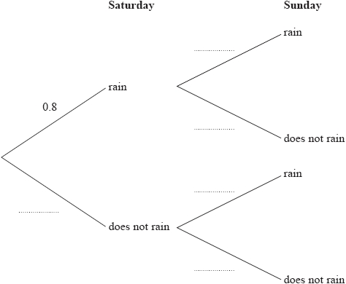

**(2)**

(b)  Work out the probability that it will rain on just one of these two days.

...........................................................

**(3)**

**(Total for question = 5 marks)**

**Q2.**

Here are ten counters.  
 Each counter has a number on it.

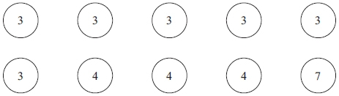

Fern puts the ten counters in a bag.  
 She takes at random a counter from the bag.

(a) Find the probability that the number on the counter is 3 or 4

...........................................................

**(2)**

Fern puts the counter back into the bag.  
 Then Rajan takes at random one of the ten counters from the bag.  
 He does not put the counter back into the bag.  
 He then takes at random a second counter from the bag.

(b) Calculate the probability that 3 is the number on each of the two counters he takes.

...........................................................

**(2)**

(c) Calculate the probability that the sum of the numbers on the two counters he takes is   
an odd number.

...........................................................

**(3)**

**(Total for question = 7 marks)**

**Q3.**

Linford and Alan race against each other in a competition.

If one of them wins a race, he wins the competition.   
If the race is a draw, they run another race.

They run a maximum of three races.

Each time they race, the probability that Linford wins is 0.35   
Each time they race, the probability that there is a draw is 0.05

(a)  Complete the probability tree diagram.

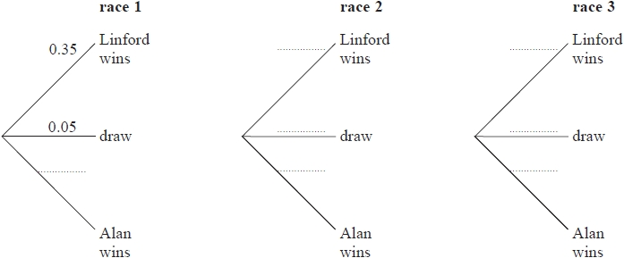

**(2)**

(b)  Calculate the probability that Linford wins the competition.

...........................................................

**(3)**

**(Total for question = 5 marks)**

**Q4.**

Here are nine counters.   
Each counter has a number on it.

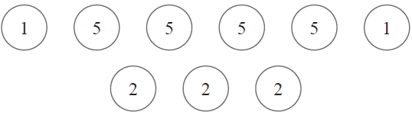

The counters are turned over to hide their numbers and are then mixed up.

Susan takes at random a counter and turns it over to reveal its number.   
She takes at random a second counter, from the remaining eight counters, and turns it over to reveal its number.

(a)   Calculate the probability that the number 5 is on both of the two counters Susan takes.

...........................................................

**(2)**

(b) Calculate the probability that the sum of the numbers on the two counters Susan takes is divisible by 3

...........................................................

**(3)**

**(Total for Question is 5 marks)**

**Q5.**

Chaiwat either cycles to work or goes by bus.

On any day that he goes to work, the probability that he cycles is 0.6   
When he cycles, the probability that he is late is 0.1   
When he goes by bus, the probability that he is late is 0.3

(a)  Complete the probability tree diagram.

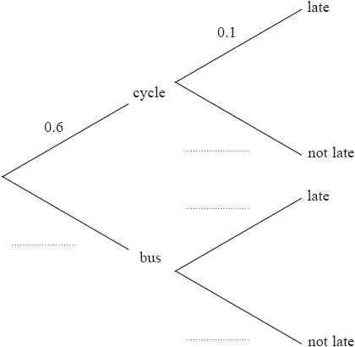

**(2)**

(b)  Calculate the probability that on a day Chaiwat goes to work, he cycles and is late for work.

...........................................................

**(2)**

(c)  Calculate the probability that on a day Chaiwat goes to work, he is **not** late for work.

...........................................................

**(3)**

**(Total for question = 7 marks)**

**Q6.**

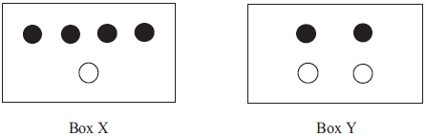

In Box X, there are 4 black discs and 1 white disc.  
In Box Y, there are 2 black discs and 2 white discs.

Vikram takes at random a disc from Box X and puts it in Box Y.  
He then takes at random a disc from Box Y.

(a) Calculate the probability that the disc he takes from Box X and the disc he takes   
from Box Y will both be black discs.

...........................................................

**(2)**

(b) Calculate the probability that the disc he takes from Box Y will be a white disc.

...........................................................

**(3)**

**(Total for question = 5 marks)**

**Q7.**

Peter travels to work either by bus or by bike.

The probability that Peter will travel to work by bus on any one day is 0.7

Whenever Peter travels to work by bus, the probability that he will be late is 0.1   
Whenever Peter travels to work by bike, the probability that he will be late is 0.05

Peter is going to go to work on Monday and on Tuesday.

Work out the probability that he will be late for work on at least one of these days.

...........................................................

**(Total for question = 5 marks)**

**Q8.**

Peter wants to pass his driving test.   
The probability that he passes at his first attempt is 0.7   
When Peter passes his driving test, he does not take it again.   
If he fails, the probability that he passes at the next attempt is 0.8

(a)  Complete the probability tree diagram for Peter's first two attempts.

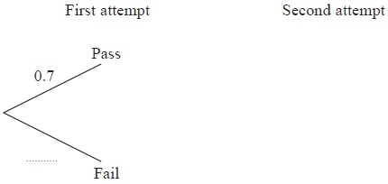

**(2)**

(b)  Calculate the probability that Peter needs exactly two attempts to pass his driving test.

...........................................................

**(2)**

(c)  Calculate the probability that Peter passes his driving test at his third or fourth attempt.

...........................................................

**(3)**

**(Total for Question is 7 marks)**

**Q9.**

The table shows information about the 40 coins in Karam's money box.

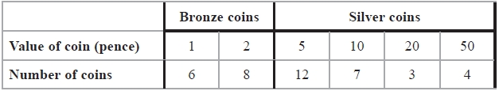

Karam shakes his money box until a coin falls out at random.   
He does not replace the coin in the money box.   
Karam shakes his money box again until a second coin falls out at random.

(a)   Work out the probability that both the coins that fall out are silver coins.

...........................................................

**(2)**

(b)   Work out the probability that the total value of the two coins that fall out is 60 pence or more.

...........................................................

**(3)**

**(Total for Question is 5 marks)**

**Q10.**

A jar contains coloured beads.   
Ajit takes at random a bead from the jar.

The probability that the bead is yellow is 0.08   
The probability that the bead is pink is 0.1   
The probability that the bead is blue is 0.25

(a)  (i)  Find the probability that the bead is yellow or blue.

...........................................................

(ii)  Find the probability that the bead is neither yellow nor pink.

...........................................................

**(4)**

Ajit replaces the first bead in the jar.   
He then takes at random a second bead from the jar.

(b)  Find the probability that the first bead is yellow and the second bead is blue.

...........................................................

**(2)**

A second jar contains 100 coloured beads.   
20 of these beads are brown.

Ajit takes at random a bead from the jar.   
He records the colour of the bead and then returns the bead to the jar.   
He does this 60 times.

(c)  Work out an estimate for the number of times Ajit records a brown bead.

...........................................................

**(2)**

**(Total for question = 8 marks)**

**Q11.**

Here is a biased five-sided spinner.

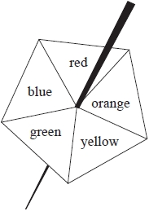

When the spinner is spun, it can land on red, orange, yellow, green or blue.   
The probabilities that it lands on red, orange and yellow are given in the table.

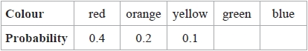

The probability that the spinner lands on green is the same as the probability that the spinner lands on blue.

Michael spins the spinner once.

(a)  Work out the probability that the spinner lands on green.

...........................................................

**(3)**

Jenny spins the spinner 200 times.

(b)  Work out an estimate for the number of times the spinner lands on red.

...........................................................

**(2)**

**(Total for question = 5 marks)**

**Q12.**

A box contains 20 nails.

The table shows information about the length of each nail.

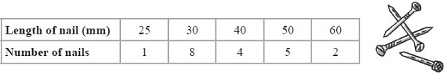

(a)  Viraj takes at random one nail from the box.

Find the probability that the length of the nail he takes is

(i)  50 mm or 60 mm,

...........................................................

(ii)  less than 35 mm.

...........................................................

**(4)**

(b)  Jamila puts all 20 nails into a bag.   
She takes at random one of the nails and records its length.   
She replaces the nail in the bag.   
She then takes at random a second nail from the bag and records its length.

Calculate the probability that the two nails she takes

(i)  each have a length of 60 mm,

...........................................................

(ii)  have a total length of 80 mm.

...........................................................

**(5)**

**(Total for Question is 9 marks)**

**Q13.**

A target has a black circle and a white region.  
Arrows can hit the black circle, the white region or miss the target.



Peter shoots two arrows at the target.

On each shot, the probability that Peter's arrow misses the target is 0.1  
 On each shot, the probability that Peter's arrow hits the white region is twice the  
 probability that it hits the black circle.

(a) Complete the probability tree diagram for Peter's two arrows.

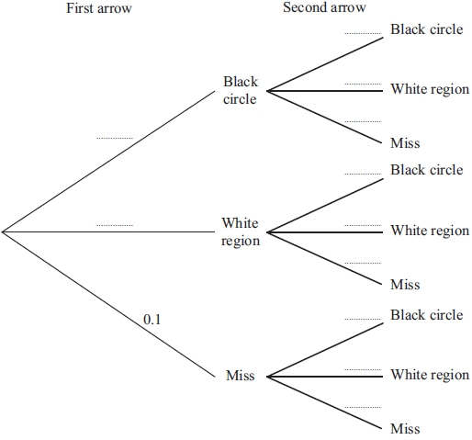

**(3)**

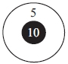

(b) An arrow which hits the black circle scores 10 points.   
An arrow which hits the white region scores 5 points.  
An arrow which misses the target scores 0 points.

Calculate the probability that Peter scores exactly 10 points with his 2 arrows.

...........................................................

**(3)**

**(Total for question = 6 marks)**

**Q14.**

When a fair dice is thrown the probability of scoring 6 is 

Arun throws four fair dice.

Work out the probability that he scores 6 with at least one of the four dice.

...........................................................

**(Total for question = 3 marks)**

**Q15.**

Naveed has two bags of tiles, bag **A** and bag **B**.

There are 10 tiles in bag **A**.   
7 of these tiles are red.   
The other 3 tiles are white.

There are 8 tiles in bag **B**.   
5 of these tiles are red.   
The other 3 tiles are white.

Naveed takes at random one tile from each bag.

(a)  Work out the probability that the tiles are the same colour.

...........................................................

**(3)**

All 18 tiles are put in a box.   
Naveed takes at random one tile from the box.   
He does not replace the tile.   
Naveed then takes at random a second tile from the box.

(b)  Work out the probability that both tiles are red.

...........................................................

**(2)**

**(Total for question = 5 marks)**

**Q16.**

Parveen travels to school either by bicycle or by bus.

The probability that, on any day, she will travel by bicycle is 0.7  
 When she travels by bicycle, the probability that she will be late for school is 0.2  
 When she travels by bus, the probability that she will be late for school is 0.1

(a) Calculate the probability that, on a randomly chosen day, Parveen will travel by bus   
and be late for school.

...........................................................

**(2)**

(b) Calculate the probability that, on a randomly chosen day, Parveen will not be late for   
school.

...........................................................

**(3)**

**(Total for question = 5 marks)**

**End of questions**